AI13 — Foundation Session
Foundations of AI Thinking & Systems Architecture
Day 1: Critical Thinking, Systems Thinking & AI Mindset

Instructor: Dr. JB Simha
Student: Utsav
Session Date: November 7, 2026
Total Duration: 3 Hours 00 Minutes (Two Recorded Sessions: 1h 35m + 1h 21m)

Table of Contents
This document uses structured Microsoft Word heading hierarchy. To refresh all page numbers, right-click anywhere on the field below and select "Update Field" (or press F9).
[Table of Contents Field — Updates Automatically in Microsoft Word]

Session Overview
• Establishes the foundational cognitive, analytical, and conceptual architecture for the entire AI13 program, asserting that technical tools are subordinate to disciplined human thought.
• Synthesizes two exhaustive foundation sessions totaling approximately three hours, delivered by Dr. JB Simha to the AI13 cohort on November 7, 2026.
• Introduces Critical Thinking as the indispensable defense against model hallucinations, cognitive complacency, and unverified industry consensus.
• Establishes Systems Thinking as the operational framework for modeling inputs, functional mappings, measured outputs, feedback latency, and environmental context.
• Demystifies intelligence by contrasting biological evolutionary survival with statistical machine learning and generative multi-agent architectures.
• Documents structured Socratic student interactions, analyzing classroom debates on survival heuristics, perceptual consensus, and specialized tutoring system design.
• Formulates a non-negotiable two-year pedagogical contract: 1,500 hours of deliberate practice driven by the daily Read-Write-Experiment triad and 15-minute micro-calibration loops.

Learning Objectives
After completing this session and its accompanying practical exercises, you will be able to:
• Differentiate between passive belief and validated knowledge across technical architectures, domain datasets, and organizational practices.
• Apply disciplined critical inquiry to formulate uncomfortable diagnostic questions that expose cognitive blind spots and model failure modes.
• Construct formal models of enterprise workflows as closed-loop systems, explicitly specifying inputs, functional transformations, outputs, and feedback loops.
• Deconstruct complex problem spaces into controllable internal parameters versus uncontrollable external contextual constraints.
• Define intelligence operationally in terms of survival capability, environmental adaptation, and stakeholder validation criteria.
• Contrast classical deductive programming, statistical machine learning function approximation, and modern agentic specification development.
• Design multi-agent collaborative workflows incorporating adversarial validation agents to audit code readability, correctness, and security.
• Execute the daily Read-Write-Experiment learning triad, calibrating personal comprehension through rapid micro-failures within 15-minute intervals.

Topic 1: The AI Landscape, Career Realities, and Mindset Transformation
The contemporary artificial intelligence landscape is characterized by rapid automation of routine coding and shifting employment dynamics. Success in this environment requires a fundamental psychological shift: abandoning the passive posture of an employee seeking external reassurance and adopting the mindset of an autonomous problem solver. Rather than seeking refuge in credentials or black-belt certifications, practitioners must develop self-evident technical competence and deep internal conviction.
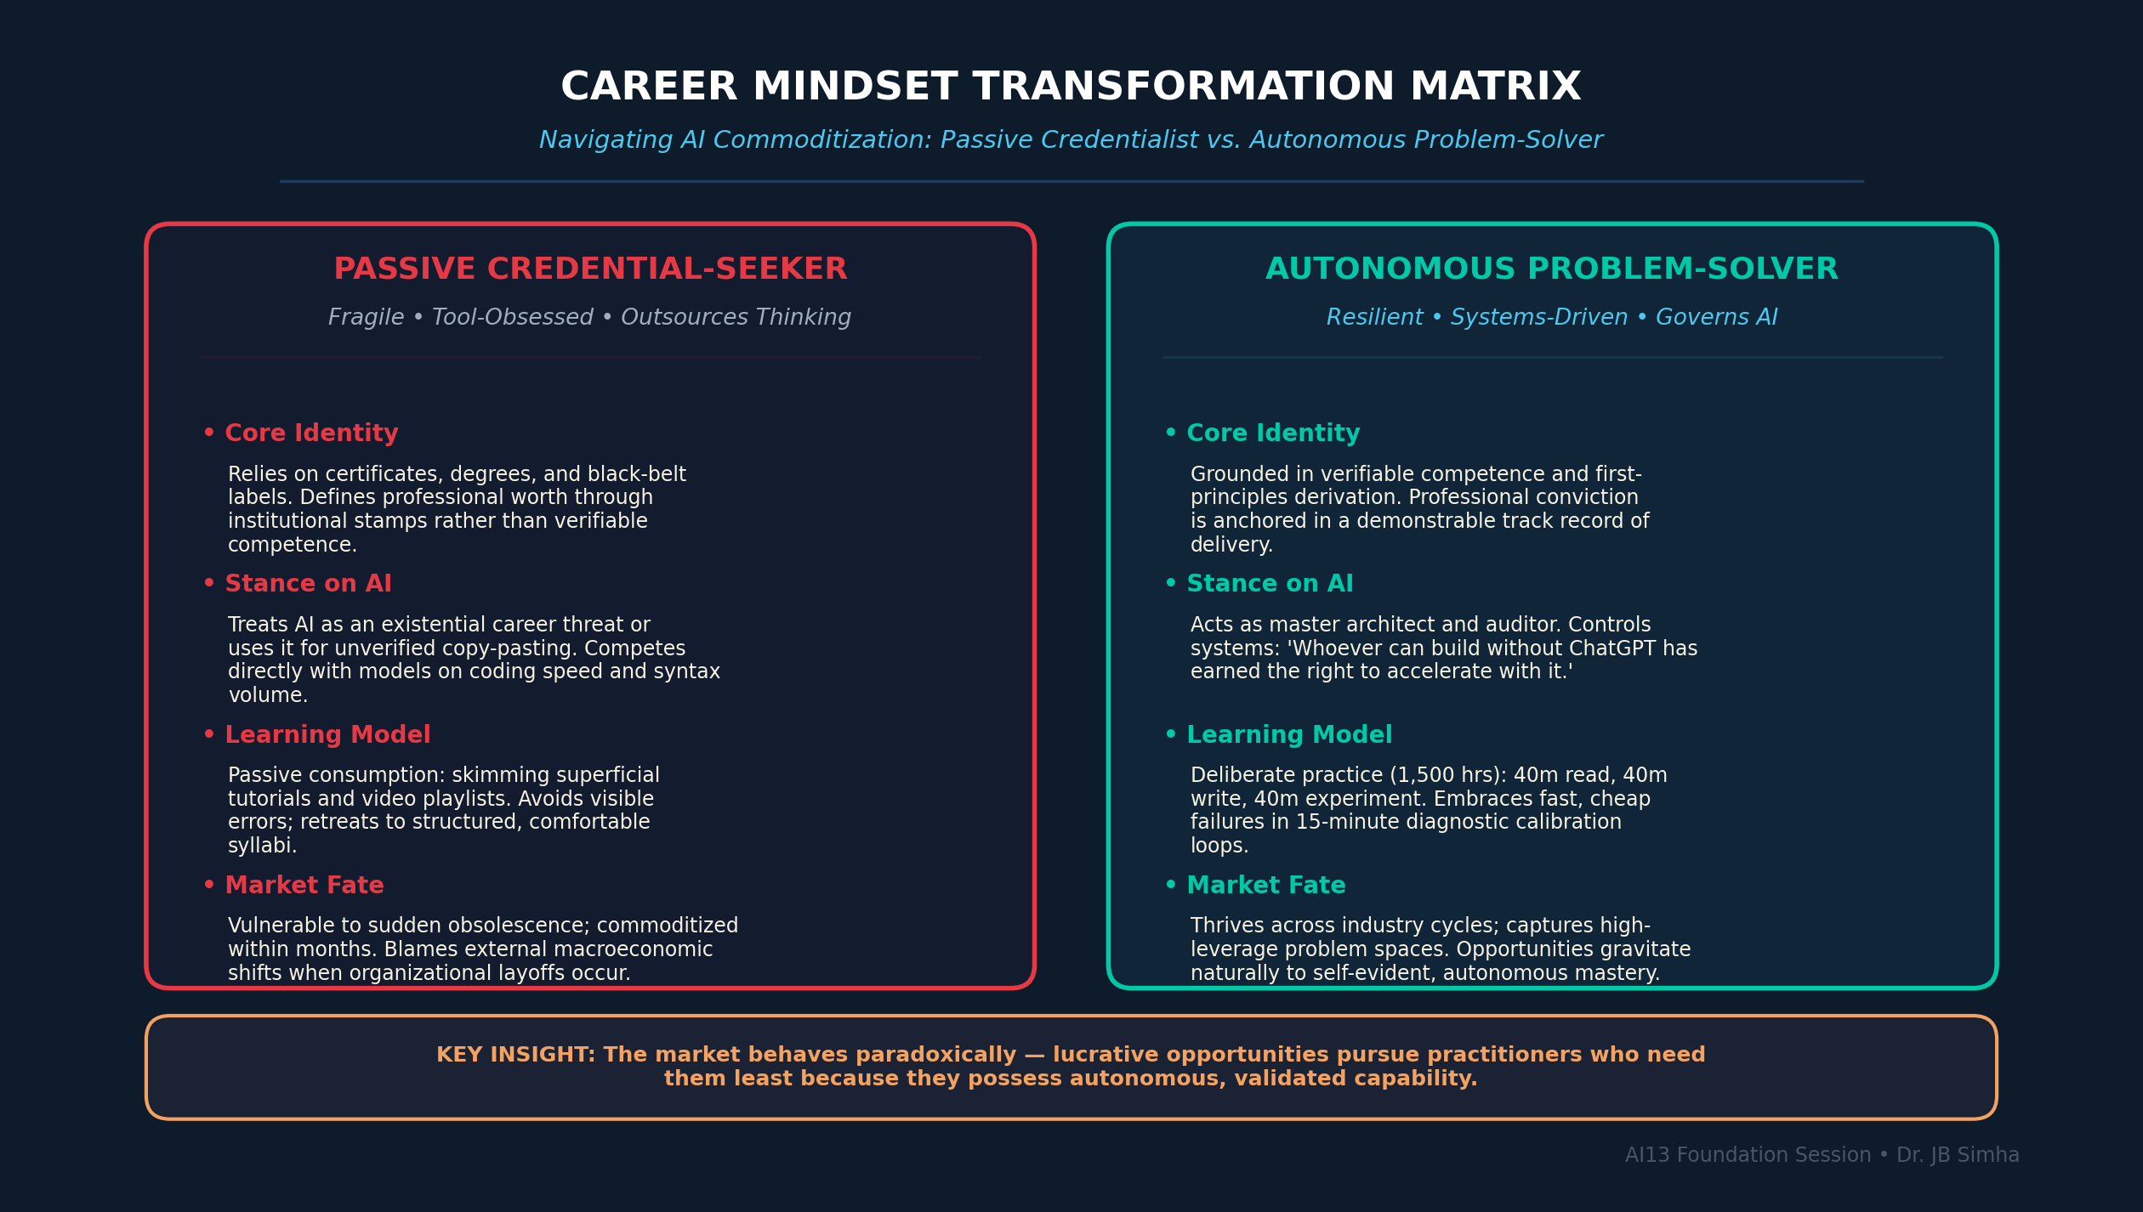
Figure 1. Career Mindset Transformation Matrix: Contrasting the passive credentialist against the autonomous AI problem-solver in an automated software economy. [Generated infographic — AI13 Foundations Series.]

Core Analytical Principles (20 Key Points)
1. Artificial intelligence is transitioning from speculative industry hype to operational enterprise reality, fundamentally altering software engineering employment.
2. The threat of career displacement cannot be mitigated through credential accumulation or passive degree acquisition, but only through demonstrated problem-solving competence.
3. Authentic professional security resides in an engineer's validated capability to deliver business value, rendering formal corporate safety nets secondary.
4. Technological evolution is continuous; the present artificial intelligence paradigm will inevitably yield to future frontiers, including quantum computing.
5. A technical practitioner must formulate independent, data-grounded viewpoints rather than passively adopting prevailing corporate or industry consensus.
6. While personal opinions must remain intellectually flexible and adapt immediately to empirical evidence, core professional conviction must remain immovable.
7. Passion must be rigorously distinguished from unviable personal preference; an interest that generates no economic return constitutes a spiritual endeavor rather than a professional discipline.
8. Genuine intellectual freedom demands the moral courage to state rigorous empirical truths regardless of institutional orthodoxy or political correctness.
9. Personal and cognitive transformation cannot alter external physical nature, but it fundamentally expands the practitioner's capacity to navigate complex challenges.
10. An unshakeable conviction in one's capacity to solve difficult technical problems constitutes the non-negotiable bedrock of advanced technical training.
11. Human cognitive uniqueness lies in the capacity to perceive subtle phenomena, synthesize novel hypotheses, and independently validate findings against reality.
12. Passive acceptance of an instructor's claims without probing inquiry represents intellectual subservience rather than genuine academic learning.
13. Advanced training aims to break the corporate hypnotic state where practitioners equate institutional tenure with guaranteed professional relevance.
14. Technological disruption does not merely eliminate labor; as historically documented by bodies such as the World Economic Forum, it creates net-new functional roles requiring higher-order judgment.
15. The contemporary software industry increasingly rewards professionals who can conceptualize, architect, and sell complete products over those who only write routine syntax.
16. Attempting to compete with artificial intelligence on raw coding speed or syntax volume is futile; engineers must learn to govern and direct automated models.
17. Adult technical learners experience cognitive resistance because prior academic success often produces intellectual pride and an acute fear of appearing uninformed.
18. Evaluation anxiety in adulthood stems from a fragile professional identity rather than the intrinsic conceptual difficulty of technical subject matter.
19. Enduring, unshakeable professional confidence is forged exclusively through public, embarrassing failures rather than simulated classroom perfection.
20. The employment market behaves paradoxically: lucrative opportunities pursue practitioners who possess validated mastery and need them least, while eluding those who seek them from desperation.

📌 TEACHER'S NOTE
"If your passion does not give you money, it is spiritual. In this profession, your value is not your degree, your institute, or your knowledge — it is you, and whether you can deliver."
— Dr. JB Simha

KEY TERMS
• COGNITIVE AGILITY — The capacity to unlearn obsolete paradigms rapidly and adopt new conceptual frameworks in response to empirical data.
• HYPNOTIC STATE — A condition of passive compliance where a practitioner accepts industry norms, career tracks, and technical claims without independent verification.
• CONVICTION VS. OPINION — Opinions are flexible viewpoints that yield to new empirical data; conviction is the immovable internal resolve to pursue mastery and truth.

Topic 2: Critical Thinking as the Foundation of Artificial Intelligence
Critical thinking is the central intellectual pillar upon which all meaningful artificial intelligence expertise is constructed. Far from an abstract academic luxury, it serves as an active, uncomfortable cognitive discipline dedicated to deconstructing assumptions and unearthing structural flaws. In artificial intelligence workflows, where automated models produce fluent yet flawed hallucinations, critical thinking constitutes the practitioner's primary defense against catastrophic analytical failure.
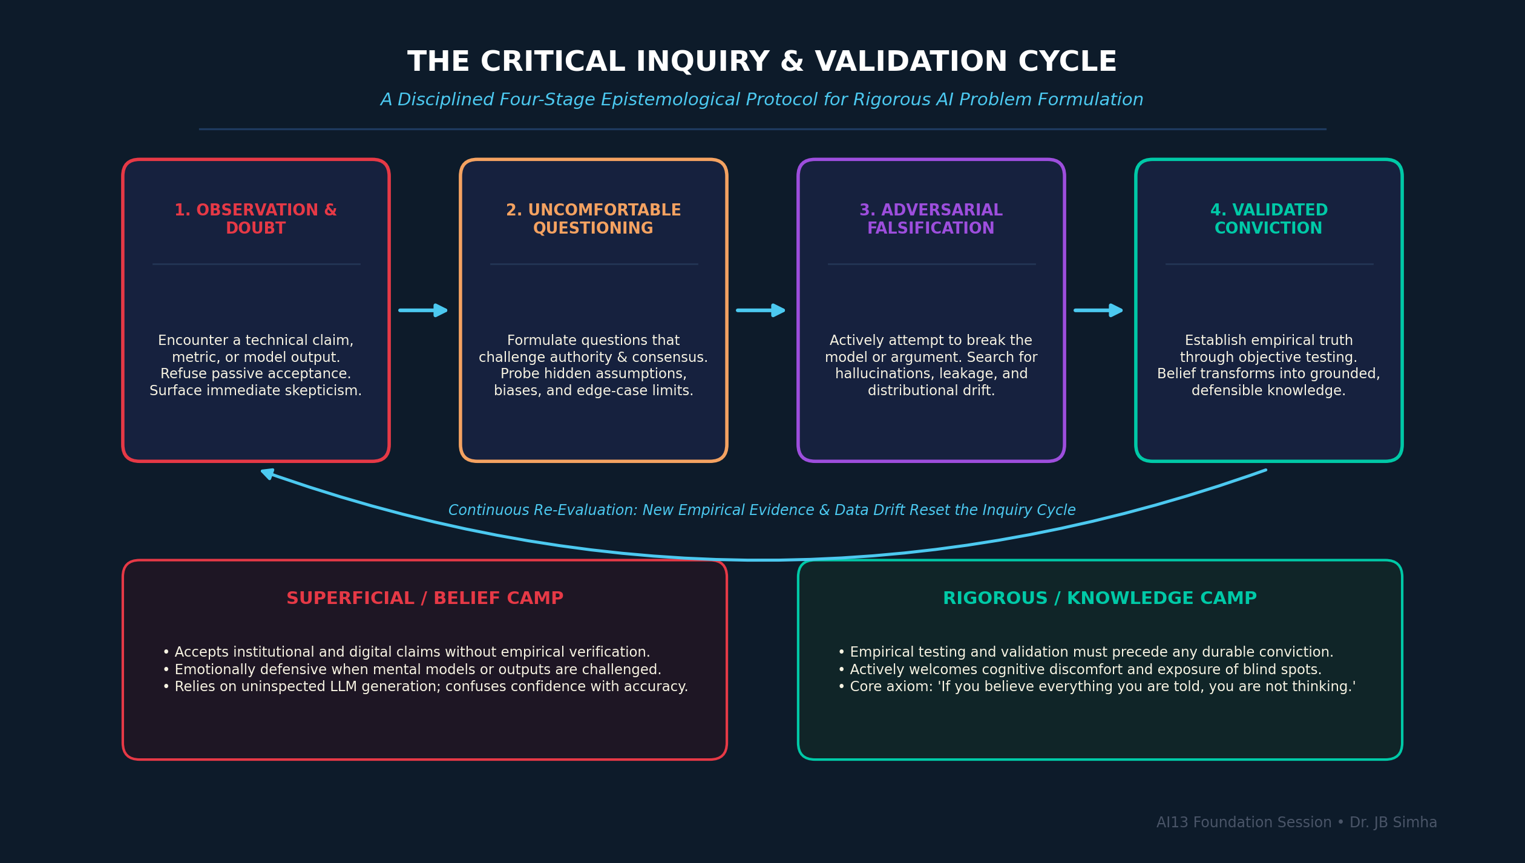
Figure 2. The Critical Inquiry & Validation Cycle: A disciplined four-stage epistemological protocol moving from observation to adversarial falsification and validated conviction. [Generated companion infographic.]

Core Analytical Principles (20 Key Points)
1. Critical thinking is the foundational prerequisite for artificial intelligence engineering, superseding tool proficiency, programming languages, and mathematical packages.
2. Conventional academic institutions and corporate hierarchies systematically fail to teach critical thinking, prioritizing compliance and procedural execution over inquiry.
3. An engineer who has mastered critical thinking can deconstruct and conquer any technical domain, making fixed course syllabi secondary to disciplined inquiry.
4. A rigorous boundary separates unvalidated belief from empirical knowledge: that which is accepted without independent verification remains mere superstition.
5. Authentic critical inquiry requires the courage to ask uncomfortable questions that expose contradictions in institutional, technical, or corporate narratives.
6. Genuine professional expertise requires confronting one's cognitive blind spots, recognizing that intellectual growth begins where knowledge ends.
7. Superficial thinking and unexamined assumptions are the primary structural causes of defective model design and catastrophic project deployments.
8. The defining attribute of an elite analyst is a childlike, unrelenting curiosity that refuses to accept authoritative assertions without explanatory depth.
9. Critical thinking is not an innate trait but a daily operational habit of testing every technical hypothesis against empirical reality.
10. The widespread, uncritical acceptance of digital media assertions demonstrates a systemic failure of modern cognitive verification mechanisms.
11. An engineer who cannot independently validate model outputs becomes a dangerous operational liability, liable to deploy disastrous hallucinations into production.
12. Substantial intellectual progress requires embracing acute cognitive discomfort, as learning occurs precisely where existing mental models collapse.
13. Uncomfortable diagnostic questions serve as precision instruments that reveal hidden vulnerabilities in system architecture and business logic.
14. A skilled critical thinker deliberately evaluates every analytical problem through multiple competing perspectives before selecting an operational strategy.
15. Intellectual humility is the inevitable fruit of rigorous inquiry; as domain mastery expands, the awareness of relative ignorance grows exponentially.
16. Willingness to appear uninformed and endure temporary failure is the necessary price of developing original, uncompromised technical insight.
17. Critical thinking requires actively dismantling defensive ego structures that equate having an error pointed out with personal diminishment.
18. An analytical model must never be evaluated solely under ideal parameters, but through aggressive stress-testing of edge cases and failure modes.
19. Questioning authority is an intellectual obligation in empirical science; no title, reputation, or institutional pedigree exempts a claim from verification.
20. The ultimate goal of critical thinking in AI is to cultivate autonomous minds capable of governing machines, rather than automated operators governed by them.

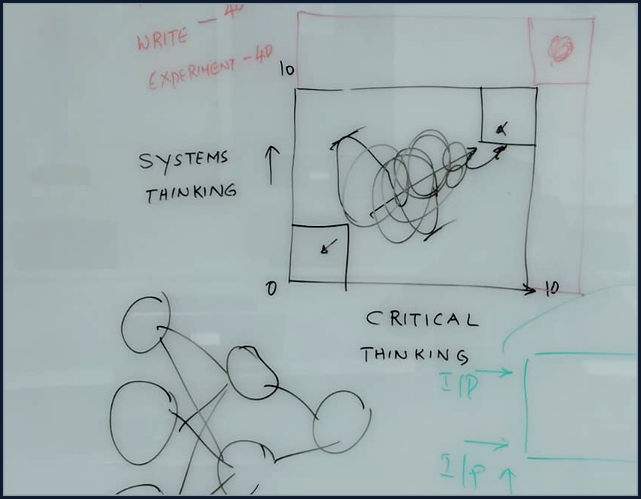
Figure 2A. Instructor Whiteboard: Systems Thinking (Y-axis) vs. Critical Thinking (X-axis) 2x2 matrix (0 to 10 scale) showing the non-linear learning trajectory toward top-right mastery. Hand-drawn during Session 1.

📌 TEACHER'S NOTE
"If you are believing what I am telling, you are not thinking. Critical thinking will not be taught in schools, colleges, or universities. If you get only one skill from this entire program, let it be critical thinking — that gets you everything else."
— Dr. JB Simha

KEY TERMS
• CRITICAL THINKING — The disciplined practice of actively analyzing, synthesizing, and evaluating information through rigorous questioning, empirical testing, and bias detection.
• EMPIRICAL VALIDATION — The objective process of verifying whether a system output, analytical conclusion, or model prediction accurately corresponds to ground truth.
• COGNITIVE BLIND SPOT — A subconscious perceptual deficit within a practitioner's intellectual framework that obscures systemic errors or knowledge limitations.

Topic 3: Systems Thinking, Feedback Mechanisms, and Operational Architecture
Systems thinking provides the conceptual framework required to comprehend complex enterprise architectures and analytical workflows. By deconstructing real-world operations into inputs, functional transformations, outputs, and feedback loops, analysts gain the capacity to predict systemic behavior and diagnose failure. In enterprise analytics, distinguishing between open and closed systems is essential for engineering resilient architectures that adapt to real-world operational environments.
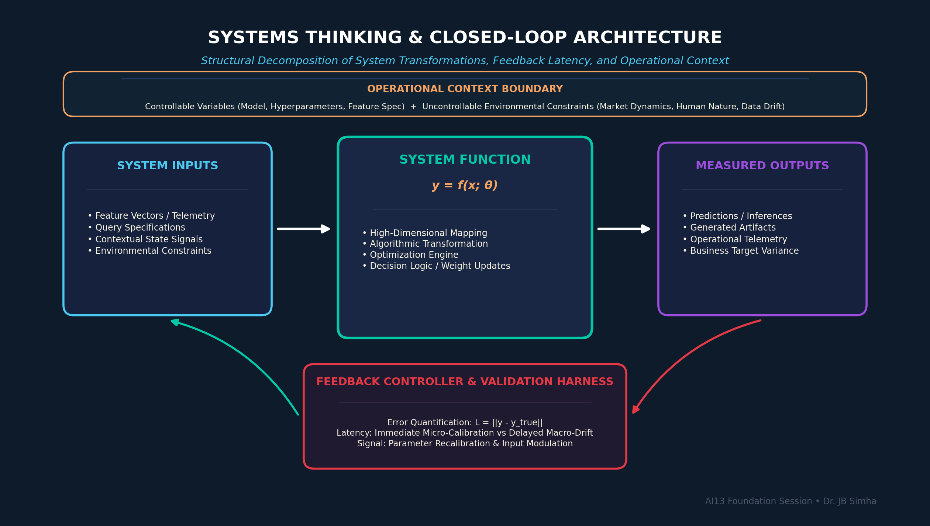
Figure 3. Systems Thinking & Closed-Loop Architecture: Structural decomposition of system transformations, feedback latency, and controllable vs. uncontrollable operational parameters. [Generated companion infographic.]

Core Analytical Principles (20 Key Points)
1. A system is formally defined as an interconnected entity that ingests inputs, performs functional transformations, and produces measurable outputs.
2. In software engineering and mathematical modeling, a system operates analogously to a pure function: mapping domain inputs to codomain outputs via explicit logic.
3. The core engineering challenge is never the mere generation of output, but the independent verification that produced output conforms to expected ground truth.
4. An open system is characterized by unidirectional throughput where inputs produce outputs without any corrective feedback influencing upstream operations.
5. The vast majority of traditional corporate workflows and uncalibrated models operate as open systems, highly vulnerable to compounding operational drift.
6. A closed system incorporates formal feedback mechanisms that continuously measure output variance against ground truth and dynamically adjust input parameters.
7. Effective feedback mechanisms require decomposing vague subjective observations into discrete, quantifiable operational or sensory metrics.
8. In enterprise analytics, every operational system functions within a broader context defined by both controllable parameters and uncontrollable constraints.
9. Controllable variables represent specific analytical and operational levers where direct intervention can optimize system performance.
10. Uncontrollable variables constitute the environmental context; systems must be engineered for structural resilience against them rather than futile attempts at control.
11. Analytical problem solving requires mapping all relevant stakeholder perceptions, recognizing that the decision-maker's evaluation criteria define success.
12. Systems thinking demonstrates that optimizing individual subsystem components in isolation frequently degrades global macro-system performance.
13. Every analytical system must possess an explicit validation harness that assesses whether operational results satisfy strategic business objectives.
14. A business process lacking closed-loop feedback operates blindly, mistaking motion for progress and computational activity for analytical impact.
15. Feedback loops must be engineered with minimal latency; high feedback latency induces systemic overcorrection, oscillation, and operational instability.
16. In predictive enterprise modeling, the analytical goal is to uncover the underlying mathematical mapping connecting input feature spaces to target business outcomes.
17. Dimensional modeling in enterprise data warehouses embodies systems thinking by systematically decoupling contextual dimensions from numerical fact measurements.
18. Systemic analysis requires identifying hidden dependencies, circular causal loops, and second-order consequences that linear thinking fails to perceive.
19. A system's failure modes provide substantially more diagnostic insight into its true operational architecture than its routine operational successes.
20. Mastery of systems thinking empowers the analyst to deconstruct arbitrary organizational complexity into manageable, quantifiable, and governable components.

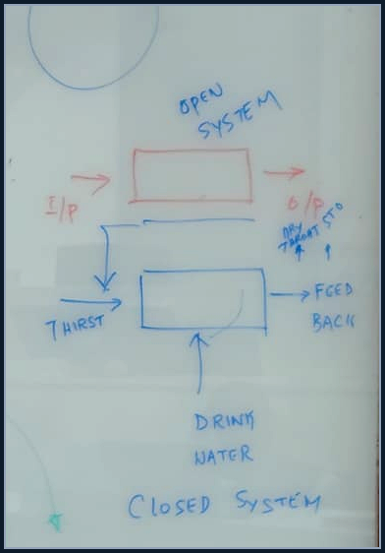
Figure 3A. Instructor Whiteboard: Open System (I/P -> O/P) contrasted with Closed System incorporating feedback loop (Thirst -> Drink Water -> Feedback -> Dry Throat Subsided). Hand-drawn during Session 1.

📌 TEACHER'S NOTE
"A system is anything that takes an input, does a computation, and gives an output. But if you cannot validate what it produces, you are not running a system — you are running a superstition."
— Dr. JB Simha

KEY TERMS
• OPEN SYSTEM — A process structure where inputs generate outputs with no feedback mechanism to calibrate future operations.
• CLOSED SYSTEM — A self-regulating process that measures output variance and routes corrective signals upstream to modulate inputs.
• FEEDBACK LATENCY — The time elapsed between an operational error occurring and the corrective feedback signal reaching the system controller.
• CONTROLLABLE VARIABLE — An internal operational parameter within a system that can be directly modified by analytical or managerial intervention.

Topic 4: The Nature of Intelligence: Natural Adaptation vs. Artificial Computation
Developing true mastery over artificial intelligence requires first demystifying the biological principles of natural intelligence. Real intelligence is fundamentally grounded in survival capability, sample efficiency, and environmental adaptation under conditions of novel uncertainty. By contrasting how living organisms solve survival problems with how computational models optimize loss functions, engineers can rigorously assess the genuine capabilities and structural boundaries of machine learning.
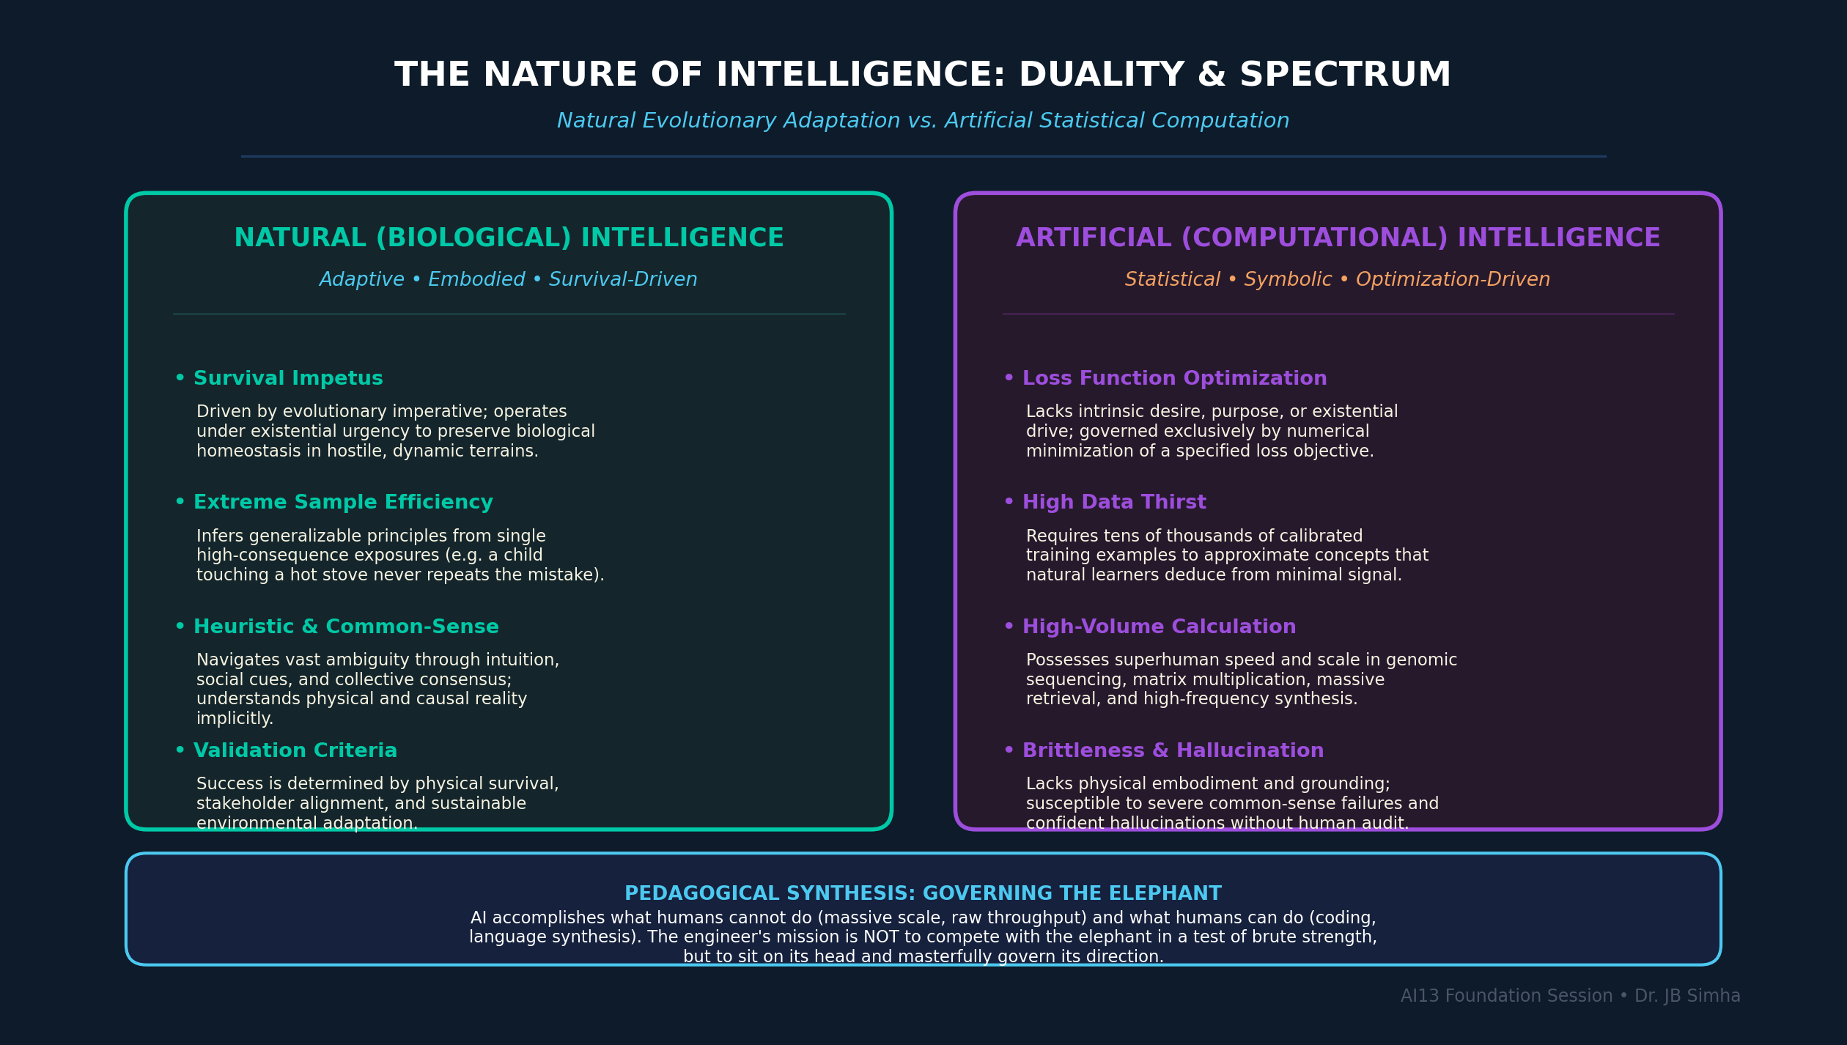
Figure 4. The Nature of Intelligence — Biological Adaptation vs. Computational Optimization: Comparing the high sample-efficiency and survival imperatives of natural cognition with high-volume statistical computation. [Generated infographic — AI13 Foundations Series.]

Core Analytical Principles (20 Key Points)
1. Intelligence is operationally defined as the capacity of an organism or system to execute effective survival actions when confronted with novel, ambiguous environments.
2. Natural intelligence does not rely on exhaustive symbolic rules or massive datasets; living organisms infer universal principles from single exposures.
3. The biological imperative of survival drives cognitive evolution, prioritizing rapid heuristic classification over computationally exhaustive exact optimization.
4. Human sensory perception and social coordination operate through universal non-verbal cues that transcend spoken languages and formal cultural conventions.
5. Observation and environmental mimicry constitute the evolutionary substrate upon which formal learning and cognitive abstraction are constructed.
6. Artificial intelligence, in its current statistical paradigm, lacks intrinsic survival imperatives, emotional embodiment, and authentic intentionality.
7. Machine learning operates essentially as computational mimicry: observing input-output pairs and extracting mathematical representations that replicate behavior.
8. Natural human cognition leverages frontal cortex architecture to categorize novel objects through collective consensus, semantic associations, and functional context.
9. A fundamental demarcation must be maintained between authentic cognitive reasoning and high-dimensional statistical pattern interpolation.
10. Artificial systems possess superhuman capability in high-volume, repetitive computational tasks, such as genomic sequencing and matrix multiplication.
11. Conversely, artificial systems remain exceptionally brittle when confronted with basic common-sense reasoning that human children execute effortlessly.
12. Human beings evaluate problem validity based on domain understanding, whereas computational models evaluate validity solely against mathematical loss functions.
13. The objective in enterprise AI is neither to fear machine capability nor to worship it, but to achieve complete operational governance over its deployment.
14. Adversarial learning mirrors natural predatory dynamics, testing system robustness by actively generating inputs designed to induce catastrophic failure.
15. Natural intelligence exhibits remarkable sample efficiency, frequently establishing lifelong behavioral adaptations from a single high-consequence failure.
16. Machine learning models require tens of thousands of calibrated examples to approximate conceptual mappings that human learners deduce from minimal feedback.
17. The true frontier of AI engineering lies in architecting validation environments that bridge computational processing speed with human critical judgment.
18. Intelligence in an analytical system is measured not by the complexity of its internal architecture, but by its operational reliability under distributional shift.
19. Deploying AI without deep awareness of its computational assumptions inevitably transforms high-dimensional optimization into high-dimensional organizational risk.
20. Governing artificial intelligence requires the practitioner to master the mathematical principles underlying the machine's representation of reality.

📌 TEACHER'S NOTE
"Intelligence is an ability of any organism, any system, to do something to survive when it does not know what to do. If I drop you in an unknown city where you know nobody and speak nothing, your survival is your intelligence. AI is our attempt to replicate that behavior in machines."
— Dr. JB Simha

KEY TERMS
• OPERATIONAL INTELLIGENCE — The demonstrable capacity of an agent or system to navigate unfamiliar conditions and achieve defined objectives without predefined rules.
• SAMPLE EFFICIENCY — The rate at which a learning system acquires generalizable proficiency relative to the volume of training data required.
• DISTRIBUTIONAL SHIFT — The divergence between the statistical distribution of training data and the operational environment encountered in production.

Topic 5: Machine Learning Foundations, Representation, and Agentic Systems
Machine learning represents a profound paradigm inversion from classical deterministic programming. Rather than human engineers handcrafting algorithmic rules to process data into outputs, machine learning systems ingest data and desired outputs to infer the underlying mathematical function. Understanding this transition from rule-based logic to statistical pattern extraction and generative agentic architectures is essential for modern technical leadership.
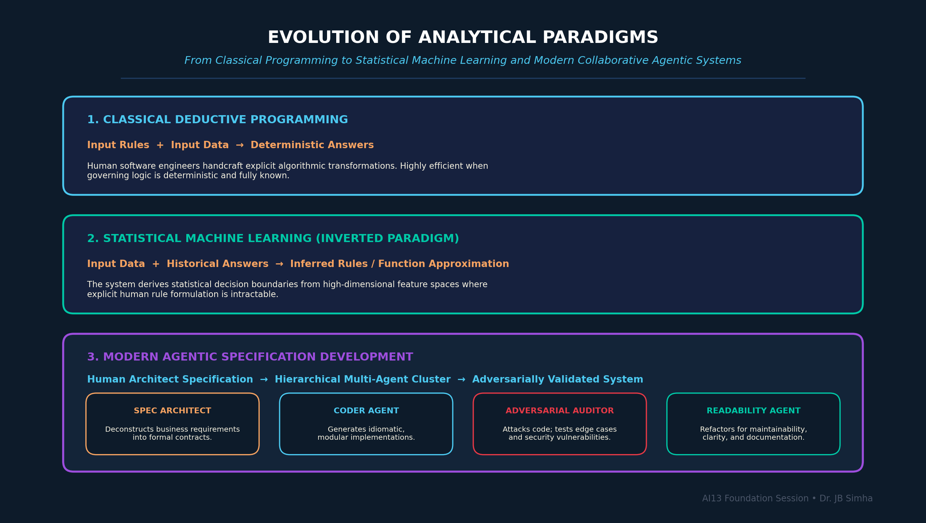
Figure 5. Evolution of Analytical Paradigms: Transition from classical deductive programming to statistical machine learning and collaborative multi-agent specification development. [Generated companion infographic.]

Core Analytical Principles (20 Key Points)
1. Classical computing requires the programmer to specify both the input data and explicit deductive algorithms to generate deterministic outputs.
2. Machine learning inverts the classical computing paradigm by ingesting inputs and historical outputs to infer the underlying transformation function.
3. At its mathematical core, machine learning is high-dimensional function approximation: mapping feature vectors to target spaces through iterative parameter optimization.
4. When an explicit deductive algorithm is available, writing deterministic code is vastly superior to training an approximate statistical model.
5. Machine learning becomes indispensable precisely when the true governing function is too complex, non-linear, or high-dimensional for human formal specification.
6. Supervised learning constructs decision boundaries or regression surfaces from labeled historical examples, serving as the foundational workhorse of enterprise predictive modeling.
7. The phenomenon of memorization represents a critical failure mode where a model reproduces training instances without learning the underlying generative structure.
8. Generative artificial intelligence transcends retrieval and memorization by synthesizing novel artifacts conditioned on latent probability distributions.
9. Uncritical acceptance and deployment of generative model outputs without rigorous verification constitutes severe technical negligence.
10. The modern frontier of software engineering is transitioning toward specification-driven development, where engineers define architectures and constraints while AI agents generate code.
11. Agentic architectures deploy specialized, collaborative AI agents organized into functional hierarchies: architects, designers, coders, and adversarial testers.
12. In multi-agent systems, adversarial validation agents actively probe generated code for vulnerabilities, readability flaws, and edge-case execution failures.
13. A single well-architected agentic cluster can compress multi-month enterprise development cycles into days of automated, verified synthesis.
14. Technical professionals must master the mathematical formulation of loss functions, optimization surfaces, and gradient updates from foundational first principles.
15. Relying on high-level libraries and automated generative tools without the ability to derive foundational algorithms from scratch breeds intellectual fragility.
16. The distinction between training loss and generalization error defines the boundary between true predictive utility and deceptive statistical overfitting.
17. Feature engineering and representation design represent the highest-leverage analytical interventions in traditional machine learning workflows.
18. Small Language Models (SLMs) fine-tuned on curated enterprise telemetry and industrial documentation frequently outperform massive general-purpose models on domain tasks.
19. Building resilient AI systems requires continuous monitoring for data drift, concept drift, and performance degradation across production lifecycles.
20. The ultimate measure of machine learning engineering is not theoretical model elegance, but demonstrable, auditable business value delivered under real-world constraints.


Figure 5A. Instructor Whiteboard: Multi-layer neural network architecture hand-drawn across interconnected input, hidden, and output nodes. Hand-drawn during Session 2.

📌 TEACHER'S NOTE
"If the algorithm is known, write the code. If only inputs and outputs are available, let the machine derive the pattern — that is machine learning. But remember: whoever can build it from scratch without ChatGPT is the only one who truly has the right to use ChatGPT."
— Dr. JB Simha

KEY TERMS
• FUNCTION APPROXIMATION — The mathematical process of identifying an approximate function that closely matches an unknown target mapping across a defined domain.
• AGENTIC ARCHITECTURE — A multi-agent software framework where autonomous AI components collaborate, execute specialized roles, and adversarially validate outputs.
• SPECIFICATION DEVELOPMENT — A development methodology where human engineers define formal behavioral specifications and architectural constraints, while automated systems generate implementation code.
• CONCEPT DRIFT — The phenomenon where the statistical properties of the target variable and its relationship to input features change over operational time.

Topic 6: The Rigorous Learning Framework: Deliberate Practice and Micro-Calibration
Mastering the rigorous domain of artificial intelligence cannot be achieved through passive consumption of video lectures or superficial blog skimming. It demands a deliberate, disciplined pedagogical framework centered on rapid feedback loops, mathematical derivation from first principles, and daily hands-on implementation. Establishing this learning architecture is the primary objective of Day 1, providing students with the operational habits necessary to achieve elite global competence.
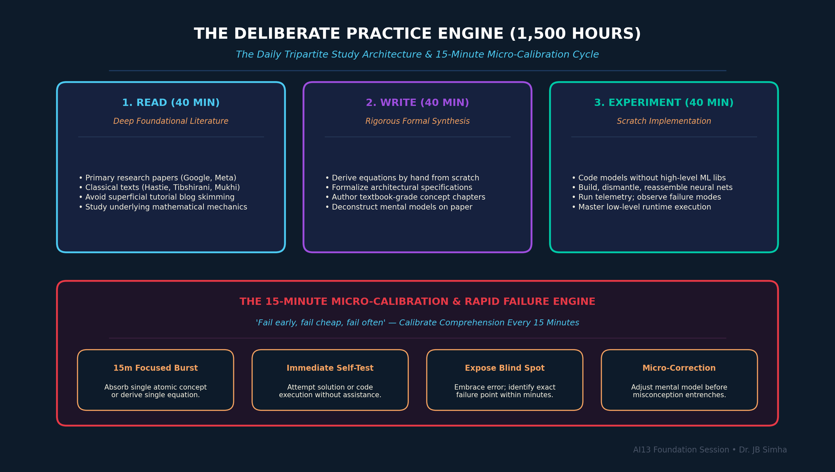
Figure 6. The Deliberate Practice Engine (1,500 Hours): The daily Read-Write-Experiment tripartite architecture combined with the 15-minute micro-calibration rapid failure loop. [Generated companion infographic.]

Core Analytical Principles (20 Key Points)
1. Achieving world-class technical competence in artificial intelligence requires an uncompromising commitment of approximately 1,500 hours of deliberate practice across two years.
2. Superficial study habits, such as reading repetitive tutorial blogs and watching disconnected videos, produce an illusion of competence without functional capability.
3. The daily study architecture must be structured around the rigorous Read-Write-Experiment triad, allocating dedicated time to each cognitive modality.
4. The reading phase demands engaging with foundational texts, peer-reviewed literature, and primary technical documentation from premier industrial research laboratories.
5. The writing phase requires formal synthesis: converting raw concepts into structured academic prose, mathematical derivations, and architecture specifications.
6. The experimental phase requires building, dismantling, and testing implementations from scratch in software and computational environments.
7. Micro-learning sessions must be capped at 15 to 40 minutes, followed immediately by objective self-assessment to prevent cognitive fatigue and illusion of mastery.
8. The learning practitioner must adopt an aggressive calibration strategy: fail early, fail cheaply, and fail frequently within 15-minute diagnostic loops.
9. Embracing rapid micro-failures within practice environments immunizes the engineer against catastrophic failure in production and professional assessments.
10. The cognitive journey toward technical mastery is non-linear, characterized by recurring cycles of apparent mastery followed by the humbling discovery of deeper ignorance.
11. True professional maturity is evidenced by intellectual humility: recognizing that expanding knowledge reveals an ever-widening perimeter of unknown unknowns.
12. Practitioners must systematically eliminate the temptation to use automated coding assistants until they have demonstrated the capability to build implementations from scratch.
13. Every core machine learning algorithm — from simple linear regression to deep multi-layer neural networks — must be derived mathematically and coded without external dependencies.
14. The triad of professional excellence consists of Competence (technical capability), Commitment (disciplined execution), and Communication (articulation of complex insights).
15. Tracking personal academic metrics, such as study duration, problem completion rates, and error frequencies, provides empirical feedback for learning optimization.
16. Adult students must dismantle the psychological fear of public academic failure, treating mistakes as indispensable calibration signals.
17. Accountability for learning outcomes rests entirely upon the individual student; instructors provide diagnostic pressure, but the student constructs competence.
18. Consistent, daily execution across thirty-day cycles produces compound intellectual growth that vastly exceeds sporadic cramming.
19. Elite performance in analytics mirrors elite athletic performance: rigorous adherence to foundational mechanics under pressure separates champions from amateurs.
20. The ultimate objective of this educational journey is not the accumulation of academic credentials, but the autonomous capacity to conceive, build, and deploy transformative systems.

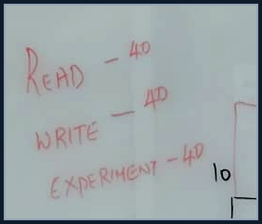
Figure 6A. Instructor Whiteboard: The foundational 40-40-40 daily deliberate practice allocation ('READ - 40, WRITE - 40, EXPERIMENT - 40'). Hand-drawn during Session 1.

📌 TEACHER'S NOTE
"Give me 1,500 hours over two years — 40 minutes reading, 40 minutes writing, 40 minutes experimenting every day. Fail early, fail cheap, fail often. If you can do it without ChatGPT, you are allowed to use ChatGPT. If you can only do it with ChatGPT, you are already obsolete."
— Dr. JB Simha

KEY TERMS
• DELIBERATE PRACTICE — A highly structured, purposeful practice routine focused specifically on improving performance and overcoming weaknesses through continuous feedback.
• MICRO-CALIBRATION — The discipline of testing comprehension within short, 15-minute intervals to detect cognitive errors before they become entrenched.
• READ-WRITE-EXPERIMENT TRIAD — The daily tripartite study routine allocating equal focus to conceptual literature, structured written synthesis, and hands-on computational testing.
• DELIBERATE FAILURE — The pedagogical practice of engineering challenging learning scenarios where failure occurs safely, rapidly, and informatively.

Section C — Student Activities & Socratic Workshop

Workshop / Socratic Classroom Dialogue & Case Analyses
Throughout the Day 1 Foundation Session, Dr. JB Simha conducted multiple interactive Socratic dialogues and diagnostic thought experiments designed to test student assumptions, expose perceptual conditioning, and demonstrate systems modeling in real time. The table below records the key structured student interactions, student responses, instructor evaluations, and the core pedagogical lessons derived from each exchange.
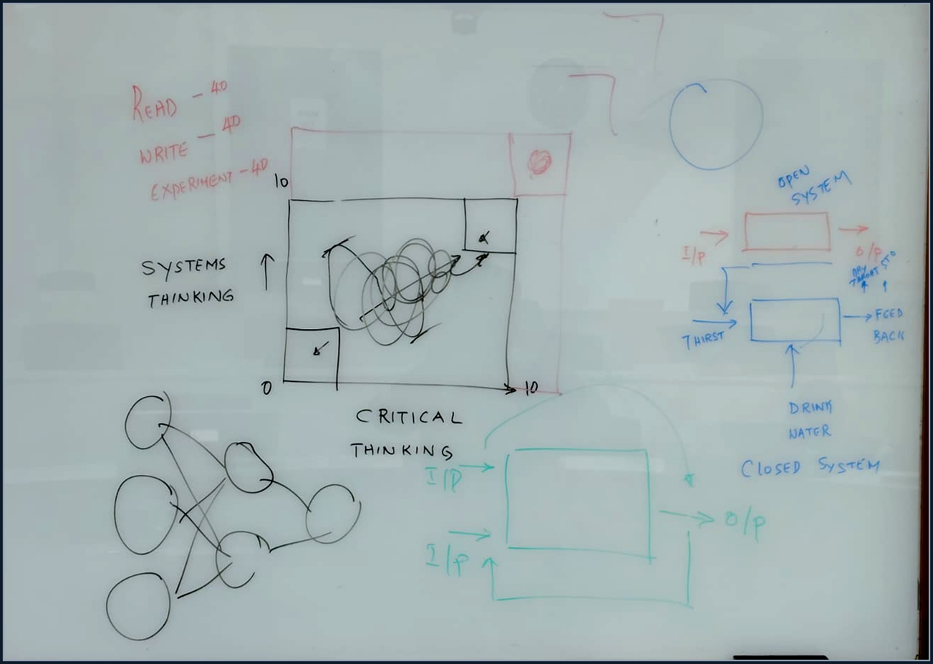
Figure 7. Complete Classroom Whiteboard: Comprehensive overview of Dr. JB Simha's live boardwork for Day 1, showing the 40-40-40 rule, 2x2 thinking matrix, open/closed feedback systems, and neural network topology.

Student / Participant | Analytical Prompt / Challenge | Student Proposal / Initial Answer | Instructor's Diagnostic Critique & Response | Key Analytical Lesson
Cohort Participants | Definition of Intelligence:  'What is intelligence? Offer your opinion.' | Students suggested:  1. 'Ability to solve problems.'  2. 'Capacity to think.'  3. 'Intuition and emotion.' | Instructor analyzed each proposal:  1. 'Solving problems is an output, but not all problems.'  2. 'Capacity to think is vague.'  3. 'Intuition is dangerous in systems; we do not want emotional machines that compete with humans.'  Instructor offered operational definition: 'Intelligence is an ability of any organism to survive when it does not know what to do.' | Operational definitions must be rooted in observable survival and functional adaptation, not anthropomorphic or romantic projections.
Cohort Participants | Perception vs. Reality Test:  'What is this object in my hand?' (Instructor holds a whiteboard marker and performs various physical actions). | Students unanimously answered:  'A marker.'  When used to scratch, a student suggested:  'A scratching tool / hammer.' | Instructor challenged consensus:  'Why do you call it a marker? Because all of you agree it is a marker! Visual perception is collective identification. Aristotelian logic conditions us: A is A, not non-A. But in real systems, tools become whatever function they serve.' | Feature representation in AI is shaped by perceptual consensus and contextual affordance, rather than immutable intrinsic identity.
Harshini | Challenging Authority & Independence:  Student pushed back on a provocative pedagogical claim made by the instructor. | Harshini vocalized disagreement and challenged the instructor's assertion directly in the open forum. | Instructor celebrated the challenge:  'Harshini says she is challenging me. I will teach you a lesson: I will tell you, you are wrong, but I would love to be proved wrong! When the next generation grows and proves me wrong, I am happy. That is the culture of questioning.' | Science and critical thinking advance exclusively through fearless intellectual challenge, never through subservience to academic hierarchy.
Cohort Participants | Systems Modeling & Self-Assessment:  'Design an AI tutoring system for a neurodivergent / autistic / ADHD child. Rate your capability from 0 to 10.' | Students offered hesitant scores between 0 and 5, acknowledging difficulty in modeling non-standard cognitive responses. | Instructor evaluated the responses:  'A score of 0 is honest and acceptable. The first step in problem solving is recognizing that a problem exists. If you claim 10 today, you are either lying or hallucinating. To model this, you must map sensory feedback loops, non-verbal cues, and emotional latency.' | Accurate self-calibration and honest recognition of ignorance are prerequisites for modeling complex, sensitive human systems.
Abhishek | Student Support & Operational Governance:  Role of teaching assistant and peer mentor. | Abhishek actively supported cohort participants, facilitating dialogue and clarifying assignment guidelines. | Instructor noted:  'The best guide is Abhishek. Speak to him; he is the eyes and ears of all participants. If you have any problem, let us know and we will resolve it.' | Collaborative peer feedback and low-latency operational support channels are vital components of rigorous academic cohorts.

Core Pedagogical Takeaways from Workshop Activities
1. Operational definitions must be grounded in empirical observation and testable survival criteria rather than abstract, untestable labels.
2. Consensus reality is often a conditioned cognitive shortcut; an AI practitioner must deconstruct how features are perceived and categorized by observers.
3. Intellectual challenge must be directed upward toward authority; progress requires disproving legacy frameworks with superior empirical evidence.
4. Accurate self-calibration is the beginning of technical competence; pretending to know what one does not know guarantees catastrophic failure in production.
5. Designing AI systems for human stakeholders requires mapping feedback loops, psychological context, and emotional latency rather than writing raw code in isolation.

Glossary of Key Terms
Alphabetical reference of foundational terminology defined across all lecture modules:
• ABT (ANALYTICAL BASE TABLE) — A denormalized, flattened tabular data structure consolidating dimension attributes and fact measurements into a single wide format optimized for machine learning feature ingestion.
• ADVERSARIAL VALIDATION — An evaluation methodology where an adversarial model or agent actively crafts edge cases and perturbed inputs to detect failure modes in a target system.
• AGENTIC SYSTEM — An autonomous software architecture composed of multiple interacting AI agents assigned specialized functional roles that collaborate to execute complex workflows.
• CLOSED SYSTEM — A self-regulating operational system that continuously monitors output variance and feeds corrective signals upstream to modulate input parameters.
• COGNITIVE BLIND SPOT — A subconscious perceptual deficit within an analyst's mental model that prevents objective recognition of errors, biases, or knowledge gaps.
• CONCEPT DRIFT — The temporal divergence in statistical relationships between input features and target variables in production machine learning environments.
• CONTROLLABLE VARIABLE — An internal operational parameter within an enterprise system that can be directly modified by managerial or analytical intervention.
• CRITICAL THINKING — The disciplined cognitive practice of evaluating claims, deconstructing assumptions, and validating evidence through rigorous, skeptical inquiry.
• DELIBERATE PRACTICE — A systematic, effortful learning methodology focused on targeting specific performance deficits through structured repetition and immediate feedback.
• DISTRIBUTIONAL SHIFT — The divergence between the probability distribution of training data and the actual data distribution encountered during operational deployment.
• FEEDBACK LATENCY — The duration of time elapsed between the occurrence of an operational error and the arrival of a corrective signal at the system controller.
• FUNCTION APPROXIMATION — The computational process of deriving an explicit or parametric mathematical mapping that closely matches an unknown target transformation.
• GENERATIVE MODELING — A machine learning paradigm focused on modeling the joint probability distribution of data to synthesize novel, statistically consistent instances.
• GRAIN — The precise, unambiguous operational definition of what a single row represents within a dimensional fact table or analytical base table.
• MICRO-CALIBRATION — The rapid evaluation of personal comprehension within short intervals (15 to 40 minutes) to verify learning before compounding errors.
• OPEN SYSTEM — A linear process architecture where inputs are transformed into outputs without any internal feedback loop to calibrate future performance.
• OPERATIONAL CONTEXT — The composite set of environmental, organizational, and uncontrollable variables that define the operational boundary conditions of a system.
• READ-WRITE-EXPERIMENT TRIAD — A daily pedagogical framework dividing study into conceptual reading, written synthesis, and empirical computational experimentation.
• SAMPLE EFFICIENCY — A measure of the quantity of training data required by a learning algorithm to achieve a predefined benchmark of generalization accuracy.
• SPECIFICATION-DRIVEN DEVELOPMENT — A software engineering paradigm where human practitioners define behavioral constraints and architecture, while automated agents generate implementation code.
• STAR SCHEMA — A relational dimensional modeling architecture featuring a centralized numerical fact table surrounded by descriptive, denormalized dimension tables.
• SYSTEMS THINKING — A holistic analytical framework focused on understanding complex phenomena through the interaction of inputs, transformations, outputs, and feedback loops.
• UNCONTROLLABLE VARIABLE — An external environmental condition that influences system performance but cannot be directly manipulated by internal system controls.
• VALIDATION — The formal empirical procedure of verifying that a computational model's outputs conform to ground truth and satisfy operational requirements.

Key Takeaways from This Session
If you remember nothing else from this foundation session, remember these core principles:
1. Artificial intelligence is an engineering discipline governed by rigorous mathematical principles, not an autonomous magic that substitutes for human critical thought.
2. Critical thinking operates as the primary defense against deploying flawed analytical models, requiring practitioners to interrogate assumptions and validate evidence relentlessly.
3. Systems thinking provides the architectural foundation for enterprise analytics, demanding the clear delineation of inputs, outputs, feedback mechanisms, and contextual constraints.
4. Every operational process must be engineered as a closed-loop system; processes lacking empirical feedback inevitably experience performance drift and operational failure.
5. True intelligence is demonstrated through survival capability and environmental adaptation under conditions of novel uncertainty, rather than rote memorization.
6. Machine learning fundamentally inverts classical programming by inferring transformation functions from historical input-output pairs rather than executing handwritten deductive logic.
7. Relying on automated tools and AI coding assistants without foundational first-principles mastery produces intellectual fragility and catastrophic vulnerability in production.
8. The modern software engineering paradigm is rapidly shifting toward specification-driven multi-agent systems where human architects govern collaborative automated developers.
9. World-class competence requires a non-negotiable pedagogical contract of 1,500 hours across two years, structured around the daily Read-Write-Experiment routine.
10. Accelerating learning velocity requires embracing rapid, low-cost micro-failures within 15-minute diagnostic loops to calibrate comprehension continuously.
11. Enterprise analytics is fundamentally a thinking discipline rather than a tooling challenge; analysts who understand the system always outperform those who only know the software.
12. Professional conviction and intellectual humility must coexist: unwavering resolve to master the discipline balanced with constant awareness of one's expanding ignorance.

Suggested References
The following foundational texts were explicitly cited or directly drawn upon by the instructor during the session. Additional references are suggested for advanced study:
• Hastie, T., Tibshirani, R., & Friedman, J. (2009). The Elements of Statistical Learning: Data Mining, Inference, and Prediction. Springer. *Relevance: Mentioned as the foundational, indispensable mathematical text for statistical machine learning that every serious practitioner must master inside and out.*
• Mukhi, V. (1992). The Odyssey of C. BPB Publications. *Relevance: Cited by the instructor as the seminal text that taught him foundational systems architecture, memory registers, and low-level CPU operations through hands-on implementation.*
• Lewis, M. (2003). Moneyball: The Art of Winning an Unfair Game. W. W. Norton & Company. *Relevance: Cited to demonstrate how objective statistical modeling and linear regression transform legacy domain intuitions into predictable, winning operational strategies.*
• Patanjali. (c. 400 CE). Yoga Sutras. *Relevance: Mentioned regarding the core discipline of Satya (truthfulness) and rigorous internal self-mastery as foundational principles for genuine intellectual practice.*
• R.K. Narayan. (1935). Swami and Friends / Malgudi Days. *Relevance: Cited as exemplifying the power of culturally grounded, authentic communication over pretentious imitation of external orthodoxies.*

Closing Summary
The foundational session of the AI13 program establishes a profound truth that will govern every subsequent lecture, laboratory, and project: artificial intelligence is fundamentally a discipline of thinking rather than tooling. In an era where technological frameworks, libraries, and generative capabilities evolve at breathtaking speed, the practitioner who anchors their identity to specific tools is perpetually vulnerable to obsolescence. True professional resilience, intellectual sovereignty, and technical leadership derive from mastery of foundational cognitive mechanics — the twin pillars of Critical Thinking and Systems Thinking.

By deconstructing complex real-world phenomena into inputs, transformations, outputs, and feedback loops, the systems thinker cuts through superficial noise to reveal the true operational architecture of an enterprise. By subjecting every assertion, metric, and model output to relentless empirical interrogation, the critical thinker erects an unbreachable defense against self-delusion, statistical bias, and the seductive hallucinations of automated systems. When these two disciplines are fused, the practitioner ceases to be a passive consumer of software and transforms into an architect capable of governing intelligent systems with precision and authority.

The path ahead demands extraordinary dedication. The pedagogical contract articulated in this session — 1,500 hours of deliberate practice, structured around the daily Read-Write-Experiment triad and rapid micro-failure calibration — is intentionally demanding. It rejects the comforting myths of effortless mastery and credentialism in favor of visible, earned competence forged through hands-on derivation from mathematical first principles. The journey will be non-linear, marked by moments of breakthrough followed by humbling encounters with new frontiers of ignorance.

Embrace that discomfort, for it is the authentic physical sensation of cognitive growth. You have embarked upon a transformative intellectual voyage designed to turn you into one of the top practitioners in the world. Approach each session not with the passivity of an employee seeking instructions, but with the curiosity, courage, and relentless conviction of an autonomous problem solver. Welcome to the discipline of Artificial Intelligence.

