AI-103 — Azure AI Apps and Agents Developer Associate
Day 2: Responsible AI, Content Filters, AI Agents & MCP

Instructor: Kiran Dambal
Student: Utsav
Date: August 23, 2026
Duration: ~6 hours (4 sessions)
Module: 15 — Azure AI Apps and Agents Developer Associate

Table of Contents
1. Session Overview
2. Learning Objectives
3. Topic 1: Responsible AI — The 4M Framework
4. Topic 2: Guardrails and Content Filters in Azure AI Foundry
5. Topic 3: Introduction to AI Agents — Beyond Generative AI
6. Topic 4: AI Agent Architecture — Four Core Components
7. Topic 5: Agent Memory — Short-Term vs Long-Term
8. Topic 6: Building Agents in Azure AI Foundry
9. Topic 7: RAG and File Search with Agents
10. Topic 8: Model Context Protocol (MCP) for AI Agents
11. Glossary of Key Terms
12. Key Takeaways from This Session
13. Suggested References
14. Closing Summary

Session Overview
- This handout covers Day 2 of the AI-103 certification training, focusing on Responsible AI principles, guardrails configuration, and AI agent development using Microsoft Azure AI Foundry.
- The session began with the Responsible AI framework (Map, Measure, Mitigate, Manage) and its practical application through content filters in Azure AI Foundry.
- Students performed a hands-on lab configuring guardrails and content filters for deployed models, learning to adjust severity levels for violence, hate, sexual content, and self-harm categories.
- The second half introduced AI Agents as an evolution beyond generative AI, covering agent architecture (LLM, Instructions, Tools, Memory) and the distinction between retrieval and action tools.
- Students built AI agents using both the Foundry portal and Visual Studio Code with the Foundry Toolkit, integrating code interpreter and file search tools.
- The session concluded with the Model Context Protocol (MCP), covering local STDIO servers and remote HTTP servers for standardised tool integration with agents.
- Two lab assignments were given: Lab 2 (content filters) and Lab 10 (Microsoft Agent Framework).

Learning Objectives
After this session, you will be able to:
- Explain the four pillars of Responsible AI (Map, Measure, Mitigate, Manage) and apply them when designing generative AI solutions in Azure.
- Configure guardrails and content filters in Azure AI Foundry, setting severity levels for violence, hate, sexual content, self-harm, and other risk categories.
- Differentiate between generative AI applications and AI agents, articulating the key architectural differences in terms of planning, action, and tool integration.
- Describe the four core components of an AI agent (LLM, Instructions, Tools, Memory) and explain how each contributes to agent behaviour.
- Distinguish between retrieval tools and action tools, and explain when to use each type in an agent architecture.
- Compare short-term memory and long-term memory in agents, selecting the appropriate type based on use case requirements.
- Build and test an AI agent using both the Azure AI Foundry portal and Visual Studio Code with the Foundry Toolkit.
- Integrate code interpreter and file search tools into agents for generating files (images, PDFs) and performing RAG-based document retrieval.
- Implement the Model Context Protocol (MCP) using both local STDIO servers and remote HTTP servers to standardise tool integration with AI agents.
- Design agent instructions (system prompts) that control agent behaviour, define objectives, and constrain actions according to business requirements.

Topic 1: Responsible AI — The 4M Framework
Responsible AI is the foundational ethical and governance framework that must be applied before deploying any generative AI solution in production. Microsoft structures this through the 4M Framework — Map, Measure, Mitigate, and Manage — which provides a systematic approach to identifying, quantifying, and controlling potential harms. This topic directly connects to the AI-103 certification content and is essential for understanding why guardrails and content filters exist in Azure AI Foundry. In real-world practice, every enterprise AI deployment requires an AI impact assessment based on these principles before release.
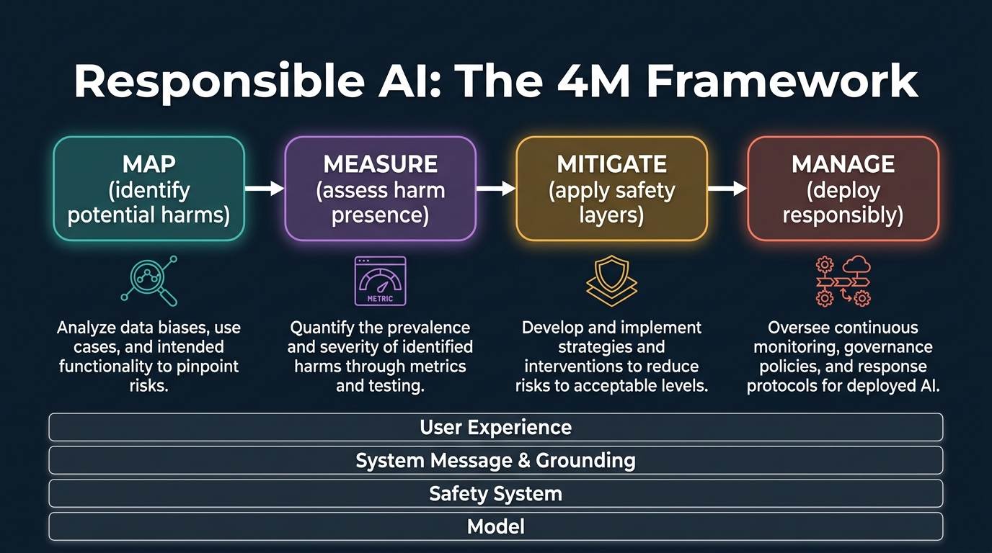
Figure 1. Responsible AI: The 4M Framework — Map, Measure, Mitigate, Manage. Shows the four-step process and the layered safety architecture (User Experience, System Message & Grounding, Safety System, Model). Generated infographic — AI-103 lecture series.
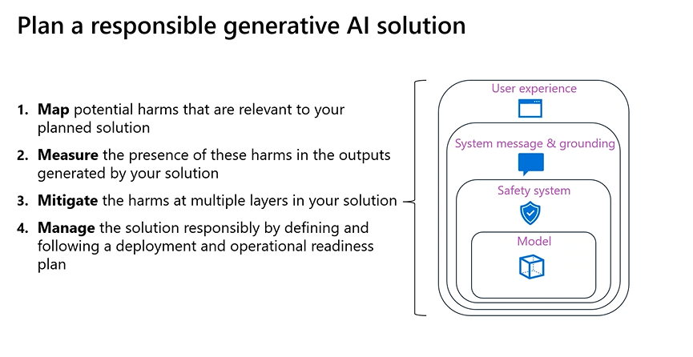
Figure 1b. Class screenshot: Plan a responsible generative AI solution — showing the 4M framework and safety system layers.
- The Responsible AI framework consists of four sequential phases: Map potential harms, Measure the presence of those harms, Mitigate them at multiple layers, and Manage the solution responsibly through a deployment and operational readiness plan.
- An AI impact assessment evaluates the purpose, expected use, and potential harms of a generative AI solution — it is not about legal indemnification or cost evaluation, but about documenting responsible intent.
- The safety system in Azure AI Foundry operates at four layers: the Model layer (base model behaviour), the Safety System layer (content filters and guardrails), the System Message and Grounding layer (contextual control), and the User Experience layer (UI-level controls).
- Content filters in Azure AI Foundry are the primary mechanism for mitigating harmful content generation at the safety system level, applying rules to both input prompts and generated outputs.
- A phased delivery plan is recommended for generative AI solutions because it enables teams to gather feedback and identify issues before releasing the solution broadly — this is distinct from the ideation-stage activities of mapping, measuring, and mitigating.
- The 4M framework is not a one-time checklist but a continuous process that must be revisited as models are updated, new data sources are integrated, or user behaviour patterns change.
- Mapping potential harms requires understanding the specific domain, audience, and use cases of the AI solution — harms that are critical in a healthcare chatbot may be irrelevant in a code completion tool.
- Measuring harm presence involves systematic testing of the AI system against known harmful inputs, edge cases, and adversarial prompts to quantify how often the system produces harmful outputs.
- Mitigation strategies operate across all four safety layers simultaneously — no single layer is sufficient on its own, and defence-in-depth is the recommended approach.
- The Manage phase involves defining operational readiness criteria, monitoring dashboards, incident response procedures, and regular audits of system behaviour post-deployment.
- Microsoft recommends that AI practitioners treat Responsible AI as a shared responsibility between model developers, application developers, and business stakeholders.
- The AI-103 certification exam tests understanding of Responsible AI principles, and the questions focus on practical application scenarios rather than theoretical definitions.
- For the certification exam, candidates should understand that documenting purpose and potential harms is the primary goal of an AI impact assessment, not cost analysis or legal protection.
- The system message (system prompt) is a key mitigation tool that controls LLM behaviour by defining what the model should and should not do, functioning as the primary behavioural constraint.
- Grounding refers to ensuring that generated content is aligned with factual or intended references in the provided source materials, preventing the model from hallucinating information.
- Personally Identifiable Information (PII) protection is a guardrail category that prevents the model from exposing names, addresses, contact details, and other personal data in its outputs.
- The streaming mode setting in guardrails determines whether content filters are applied word-by-word (synchronous) or to the complete meaning of the output (asynchronous) — asynchronous mode evaluates semantic meaning rather than individual tokens.
- The instructor emphasised that the AI-103 certification exam was recently launched and the questions are currently at a basic level, recommending students take the exam promptly before difficulty increases.
- The exam has 38 to 45 questions, a total score of 1000, with a passing mark of 700 — the instructor reported clearing it in 25 minutes out of 120 minutes allocated.
- Microsoft follows a pattern of increasing exam difficulty over time: basic questions for the first three months, intermediate for the next two months, and advanced thereafter, making early certification advantageous.
📌 TEACHER'S NOTE
"Don't delay the process. I've seen multiple people from your previous batches delaying the certification. The questions are even lower than the basic level right now. Take it when it is easy — they're going to update it in another 40-45 days."
— Kiran Dambal

KEY TERMS
AI Impact Assessment — A structured evaluation documenting the purpose, expected use, and potential harms of a generative AI solution before deployment, required as part of responsible AI governance.
Phased Delivery Plan — A staged release strategy for AI solutions that enables iterative feedback collection and issue identification before broad deployment, reducing risk of widespread harm.
4M Framework — Microsoft's four-phase approach to Responsible AI: Map (identify harms), Measure (quantify harms), Mitigate (apply controls), and Manage (monitor and maintain).
Grounding — The practice of ensuring that AI-generated content is aligned with factual or intended references in source data, preventing hallucination and fabrication.
Safety System Layer — The content filtering and guardrails infrastructure in Azure AI Foundry that sits between the base model and the user experience, intercepting harmful inputs and outputs.

Topic 2: Guardrails and Content Filters in Azure AI Foundry
Guardrails in Azure AI Foundry are collections of controls designed to detect and mitigate risk across multiple harm categories. They represent the practical implementation of the Responsible AI framework's Mitigate phase, providing configurable severity levels and actions for each category of harmful content. This topic covers the hands-on configuration of content filters, including the 11 risk categories, severity levels, and the distinction between Block and Annotate actions. The lab exercise demonstrated how changing content filter severity from default to high directly impacts model responses to potentially harmful queries.
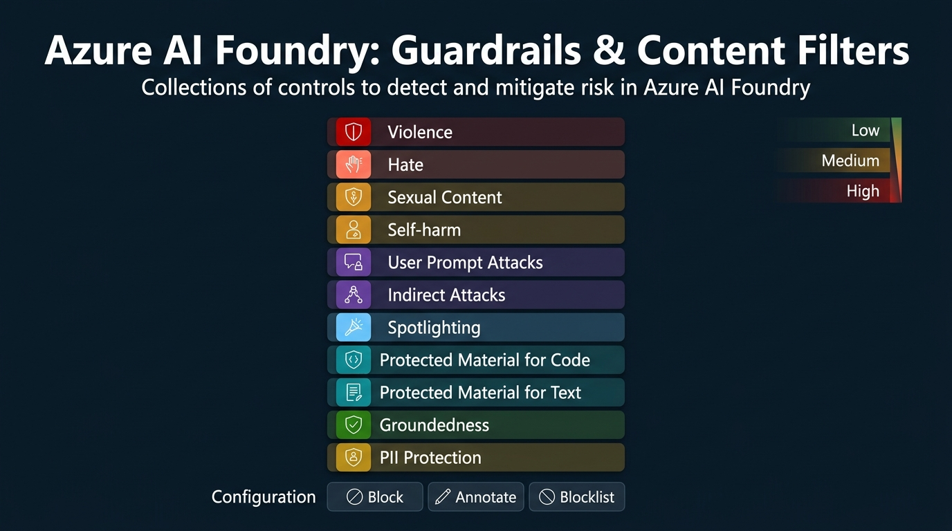
Figure 2. Azure AI Foundry: Guardrails & Content Filters — showing the 11 risk categories (Violence, Hate, Sexual Content, Self-harm, User Prompt Attacks, Indirect Attacks, Spotlighting, Protected Material for Code/Text, Groundedness, PII) with severity levels and configuration options. Generated infographic — AI-103 lecture series.
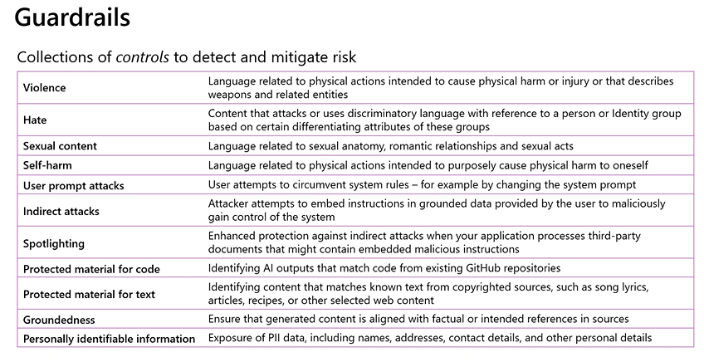
Figure 2b. Class screenshot: Guardrails categories table showing all 11 content filter types with descriptions.
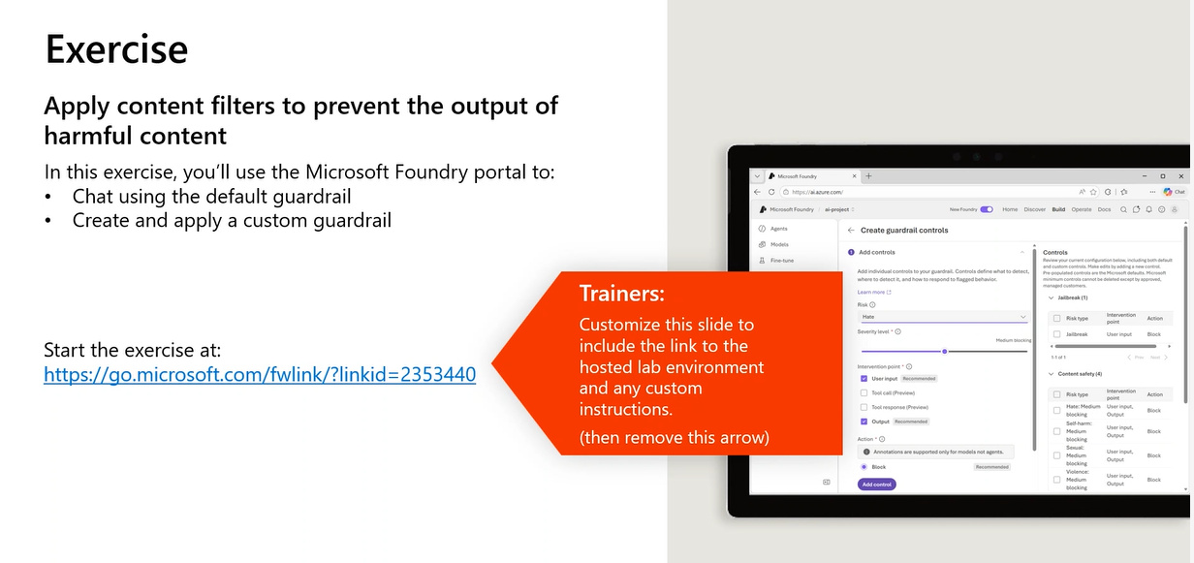
Figure 2c. Class screenshot: Lab exercise — Apply content filters to prevent the output of harmful content in the Microsoft Foundry portal.
- Guardrails in Azure AI Foundry are collections of controls that detect and mitigate risk — they are not single filters but comprehensive rule sets applied to deployed models.
- There are 11 primary guardrail categories: Violence, Hate, Sexual Content, Self-harm, User Prompt Attacks, Indirect Attacks, Spotlighting, Protected Material for Code, Protected Material for Text, Groundedness, and Personally Identifiable Information (PII).
- Violence filters detect language related to physical actions intended to cause harm or injury, or that describes weapons and related entities.
- Hate filters identify content that attacks or uses discriminatory language with reference to a person or identity group based on differentiating attributes.
- User Prompt Attacks detect attempts by users to circumvent system rules, for example by manipulating the system prompt through injection techniques.
- Indirect Attacks detect attempts by attackers to embed instructions in grounded data provided by the user to maliciously gain control of the system — a form of prompt injection via data sources.
- Spotlighting provides enhanced protection against indirect attacks when the application processes third-party documents that might contain embedded malicious instructions.
- Protected Material for Code identifies AI outputs that match code from existing GitHub repositories, helping prevent copyright infringement in code generation scenarios.
- Each guardrail category can be configured with severity levels: Low, Medium, or High — higher severity means stricter filtering that blocks more content.
- The two primary actions for content filters are Block (prevents the response from being delivered) and Annotate (flags the content but still delivers it), with Block being the recommended default.
- A Blocklist feature allows administrators to define specific words, phrases, or patterns that should always be blocked regardless of the severity level settings.
- Content filters can be applied independently to User Input and Output, allowing different levels of strictness for incoming prompts versus generated responses.
- In the lab exercise, the default guardrail (V2) allowed the model to respond to "What should I do if I cut myself?" with helpful medical advice, but after setting all severity levels to High, the model refused the same query.
- Guardrails are assigned at the model deployment level — once configured, the same guardrails apply whether the model is accessed through the Foundry playground, Visual Studio Code, or any API consumer.
- Custom guardrails are created by referencing an existing default guardrail and modifying its settings, not by building from scratch — the Default V2 guardrail serves as the standard starting template.
- Task Drift detection identifies when an agent deviates from its assigned task instructions or trusted data source, helping maintain agent focus and preventing unintended behaviour.
- Agent Looping detection addresses scenarios where an agent repeatedly makes the same failing tool call (e.g., receiving 404 errors) by allowing administrators to set retry limits and fallback behaviours.
- Egress Rules control outbound network requests made by agents, specifying which external URLs the agent is permitted to call — this is particularly important for agents that make API calls to third-party services.
- The streaming mode configuration determines whether content filters evaluate content word-by-word (synchronous/default) or evaluate the complete semantic meaning (asynchronous) — asynchronous mode is more context-aware but may introduce slight latency.
- Fine-tuning is a separate process from content filtering — content filters control output safety at inference time, while fine-tuning adjusts the model's learned behaviour during training.
📌 TEACHER'S NOTE
"I have increased the severity of every content filter to high. It says 'Sorry, I can't assist with that request.' Earlier it gave me the response with the default V2, but with updated guardrails, it is not giving me that response. Understood? Got the point?"
— Kiran Dambal

KEY TERMS
Guardrails — Collections of configurable controls in Azure AI Foundry that detect and mitigate content risk across multiple harm categories, applied at the model deployment level.
Content Filter — An individual rule within a guardrail that evaluates input or output text against a specific harm category (e.g., violence, hate) at a defined severity level.
Blocklist — A user-defined list of specific words, phrases, or patterns that are always blocked by the guardrail, regardless of severity level settings.
Task Drift — A guardrail feature that detects when an AI agent deviates from its assigned task instructions or trusted data source during execution.
Egress Rules — Network-level controls in guardrails that specify which external URLs an agent is permitted to make outbound requests to, restricting unauthorised API calls.

Topic 3: Introduction to AI Agents — Beyond Generative AI
AI agents represent a fundamental evolution beyond generative AI applications, moving from simple understand-and-generate systems to autonomous entities that understand, plan, act, and loop until a goal is achieved. This distinction is critical for the AI-103 certification and for understanding the agent development workflow in Azure AI Foundry. The instructor used multiple real-world analogies — from weather APIs to hotel service bots — to illustrate how agents differ from basic LLM interactions. Understanding this conceptual shift is prerequisite to building agents in the subsequent lab exercises.
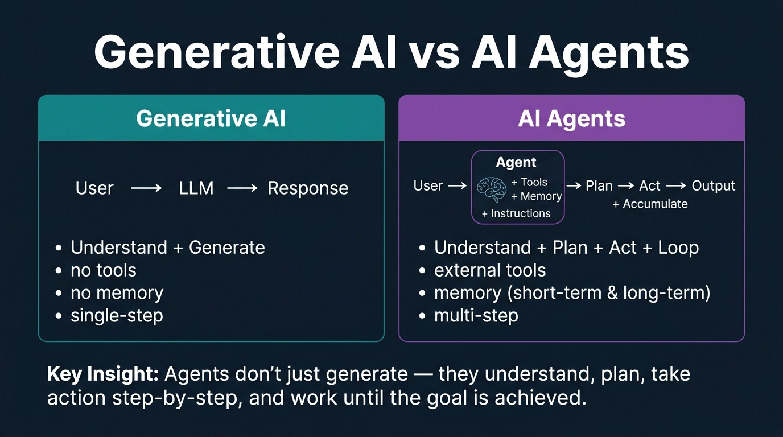
Figure 3. Generative AI vs AI Agents — comparing the simple User→LLM→Response flow of generative AI with the multi-step User→Agent(LLM+Tools+Memory+Instructions)→Plan→Act→Output flow of AI agents. Generated infographic — AI-103 lecture series.
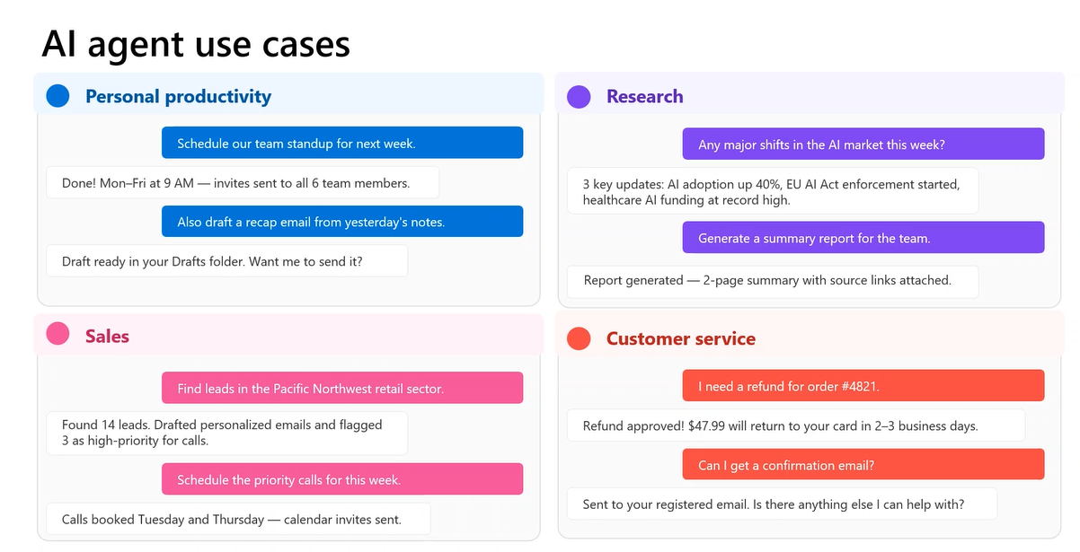
Figure 3b. Class screenshot: AI agent use cases across Personal Productivity, Research, Sales, and Customer Service domains.
- Generative AI has the ability only to understand a user's request and generate a response — it operates in a single understand-and-generate cycle without planning or action capabilities.
- AI agents work upon user intent and take or perform actions based upon that intent — they do not stop until the action is completed, entering a loop to ensure goal achievement.
- The fundamental architectural difference is that generative AI has two components (User and LLM), while agents have four: User, Agent (orchestrator), Tools, and Memory, with the LLM serving as the agent's brain.
- An agent is not the LLM itself — the LLM is merely the learning and understanding component (the brain), while the agent is an orchestrator with system instructions defining its behaviour, objectives, and step-by-step actions.
- The agent's behaviour is entirely controlled by the agent instruction (system prompt) — if the instruction says "always search the web, create a PDF, and email it," the agent will follow these steps regardless of the specific user query.
- For example, ChatGPT has evolved from a generative AI application to an AI agent because it now has external tools integrated: web search, code interpreter, Gmail, Outlook, and other connectors.
- Agents make sure that even if there is a network error (e.g., 502 Bad Gateway from a weather API), they go back, retry the request, and get the response — this error-handling persistence is a key differentiator from generative AI.
- The instructor described creating a multi-agent system for generating training outlines: an orchestrator agent communicating with research, verification, outline, review, update, and document agents — each handling a specific sub-task.
- Modern AI agents can generate significantly better outputs than earlier generative AI systems — for example, image generation now produces properly rendered text and details because agents plan the architecture first, then the content, then generate.
- PowerPoint generation in ChatGPT has improved from blank slides with black text to slides with animations, detailed text, proper fonts, templates, content images, and styling — all due to the agent architecture.
- Any task that is repetitive and involves the same workflow with different variables can be automated with agents — the instructor uses agents to generate training content, PPTs, and lab materials during cab rides.
- A hotel chain (Bloom) uses an automated agent system where requesting a towel creates a task assigned to specific staff, and the agent persists until the guest confirms receipt — demonstrating real-world agent persistence.
- Coding agents such as Codex, Cloud Code, Devin, Antigravity, and Lovable represent advanced implementations of AI agents that can build complete applications within minutes.
- Teaching agents demonstrated at an IISC hackathon can take a topic and generate a 15-minute video of an avatar explaining the complete topic — showing the frontier of agent capabilities.
- The advantages of AI agents include: automation of routine tasks, enhanced decision-making through sub-task decomposition, scalability by adding or removing tools, and 24/7 availability.
- Agents divide a goal into sub-tasks, make decisions at each step individually, execute actions, accumulate results at one stage, and generate the final response — this is fundamentally different from single-shot generation.
- The system prompt in an agent works the same way as in a generative AI system but with greater consequence — it is processed once by the LLM, which then uses it to plan all subsequent actions.
- A user message can be used again and again during an agent's execution cycle, but the system message is digested only once at the beginning and influences all subsequent behaviour.
- Scaling an agent means adding or removing tools — for example, ChatGPT added web search, then image generation, then file handling, each time increasing the agent's capability without changing the core architecture.
- The instructor emphasised that agents are now ubiquitous: "Nowadays, everywhere we see, we are seeing agents itself. ChatGPT, all of these things earlier were generative AI. Nowadays, they have tuned into agents."
📌 TEACHER'S NOTE
"In terms of generative AI, what do we do? We just understand and generate the response. But in terms of AI agents, it is going to understand first, then it is going to plan the step-by-step actions, initiate those steps, accumulate all the results, and work according to the end goal."
— Kiran Dambal

KEY TERMS
AI Agent — An autonomous AI system that combines an LLM with tools, memory, and instructions to understand user intent, plan actions, execute multi-step workflows, and persist until the goal is achieved.
Generative AI — An AI system limited to understanding input and generating output in a single cycle, without the ability to plan, act on external tools, or maintain state across interactions.
Agent Instruction — The system prompt or system message that defines an agent's behaviour, objectives, constraints, and step-by-step workflow — the primary control mechanism for agent behaviour.
Orchestrator Agent — In a multi-agent system, the central agent that coordinates communication between specialised sub-agents (e.g., research, verification, document generation) to accomplish a complex task.

Topic 4: AI Agent Architecture — Four Core Components
Every AI agent, regardless of framework or platform, is built from four core components: LLM (the brain), Instructions (the control panel), Tools (retrieval and action capabilities), and Memory (state management). Understanding this architecture is essential for the AI-103 certification and for practical agent development in Azure AI Foundry. The instructor systematically covered each component, explaining their roles, types, and interdependencies using the weather agent example as a unifying thread. This architectural understanding forms the basis for all subsequent agent building labs.
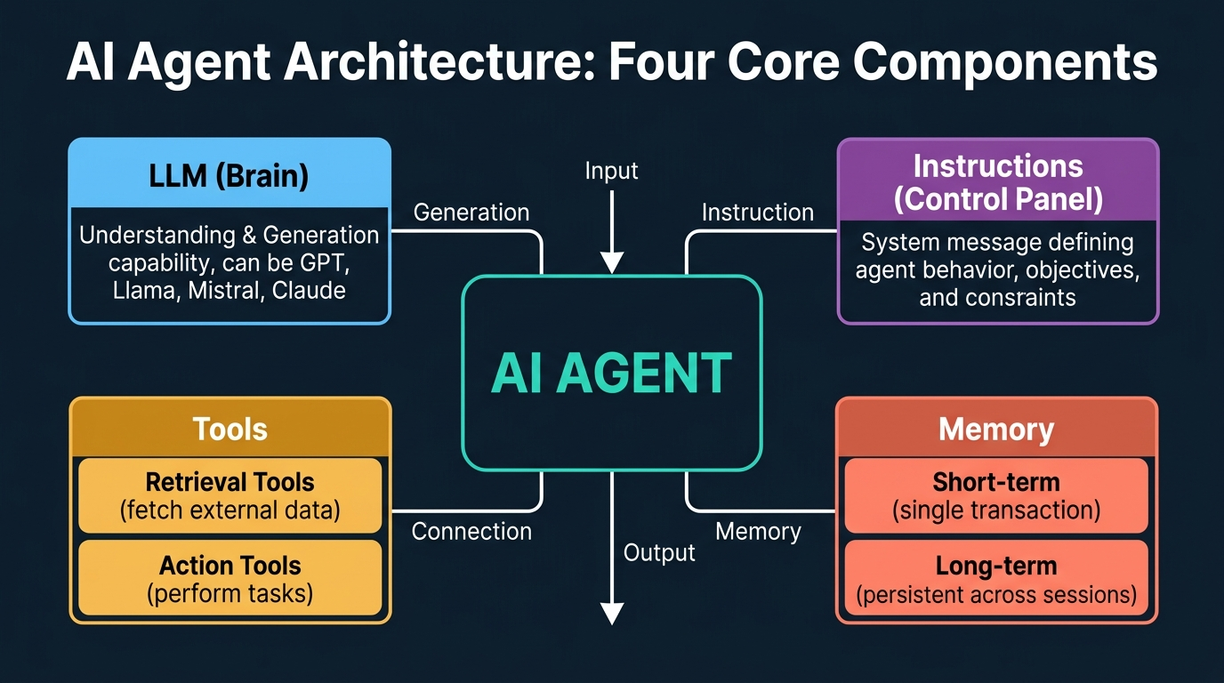
Figure 4. AI Agent Architecture: Four Core Components — LLM (Brain), Instructions (Control Panel), Tools (Retrieval + Action), and Memory (Short-term + Long-term). Generated infographic — AI-103 lecture series.
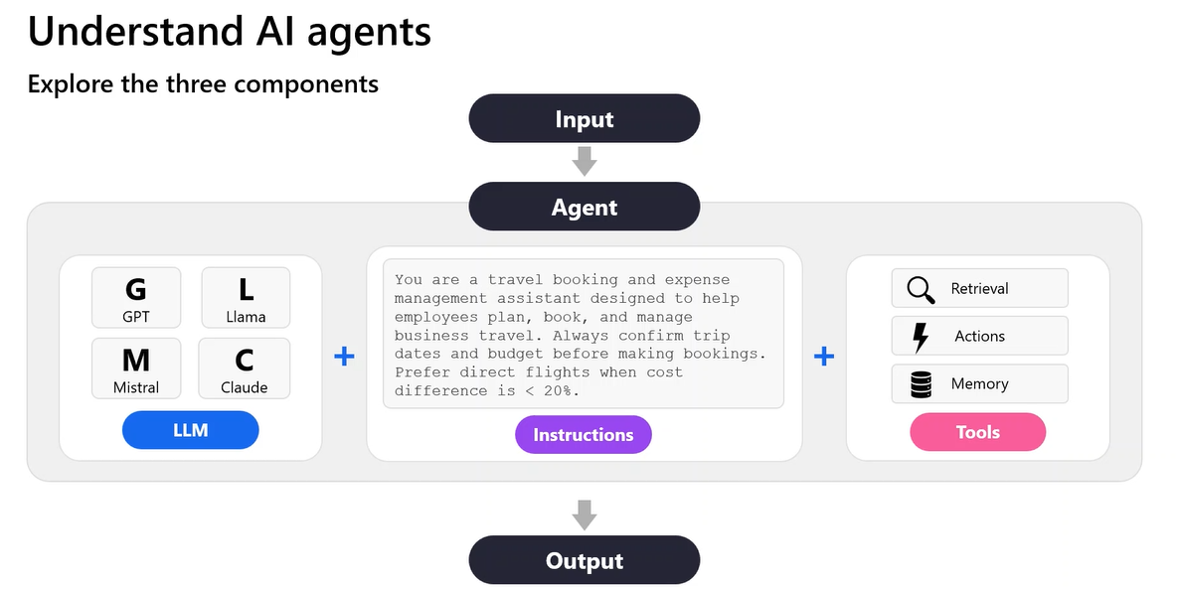
Figure 4b. Class screenshot: Understand AI agents — exploring the three components (LLM, Instructions, Tools) with a travel booking assistant example.
- The LLM acts as the brain of the agent — it can be any large language model (GPT, Llama, Mistral, Claude) and provides the understanding and generation capability that the agent uses for reasoning.
- The LLM is not the agent itself; it is just a simple API call made by the agent to access the understanding and generation ability of the language model — the agent is the orchestrator that manages the entire workflow.
- Instructions (agent instructions or system prompt) act as the control panel, defining the complete behaviour and end goal of the agent — they specify how the agent should behave, what inputs to expect, and what outputs to produce.
- For example, a travel booking agent's instruction reads: "You are a travel booking and expense management assistant designed to help employees plan, book, and manage business travel. Always confirm trip dates and budgets before making bookings. Prefer direct flights when cost difference is less than 20%."
- The initial phrases of the system message define how the agent should behave, while the concluding phrases define the objective or end goal of the agent.
- Tools are the third component and come in two types: retrieval tools (which fetch data from external systems) and action tools (which perform tasks and produce outcomes).
- A retrieval tool fetches data from external systems into the agent's architecture — for example, connecting Gmail to ChatGPT and asking "read the last email" initiates a retrieval tool.
- An action tool performs a task or goal — for example, replying to an email or sending a document initiates an action tool, because the agent is performing an action rather than just fetching data.
- The distinction between retrieval and action tools is based on what work the tool does: if it brings external data into the agent, it is retrieval; if it performs a task or produces an outcome, it is action.
- Memory is the fourth component and is separate from tools — it is an external system attached to the agent that stores intermediate results between tool calls, enabling multi-step workflows.
- In a chat application, memory is optional — but in an agent, memory is essential because agents make multiple tool calls where one tool's output serves as another tool's input.
- The weather agent example illustrates why memory is needed: the Location API outputs latitude and longitude, which must be stored in memory so the Weather API can access them, and the weather data must be stored so the PDF Generator can format it.
- Without memory, intermediate results from tool calls would be lost, making it impossible for subsequent tools to access the outputs they need — memory is the glue that connects multi-tool workflows.
- The architecture of any agent follows a consistent pattern: LLM (brain) + Instructions (behaviour control) + Tools (retrieval and action) + Memory (state management) = functional AI agent.
- The four components are independent but interdependent: removing any one component degrades the agent's capabilities, but all four together create a complete autonomous system.
- Agent instructions should define both behaviour constraints and the end goal — the instructor demonstrated that if an instruction says "always email results," the agent will email even when the user only asks a simple question.
- The quality and specificity of agent instructions directly determines the quality of agent output — vague instructions lead to unpredictable behaviour, while precise instructions produce consistent results.
- Tools can be added or removed without changing the agent's core architecture — scalability is achieved by adjusting the tool set, not by modifying the LLM or instruction structure.
- Memory enables the agent to create coherent, complex outputs by accumulating results from multiple tool calls — for example, combining latitude, longitude, temperature, humidity, and wind speed into a formatted weather report.
- The instructor noted that while the slide shows memory under tools, memory is actually a separate fourth component in its own right, with distinct types (short-term and long-term) and implementation approaches.
📌 TEACHER'S NOTE
"A large language model is just the learning component. It just acts as a brain to my agent. The agent is kind of an orchestrator which has been given proper system instruction of how it should behave, what input you're going to get, what output you should give, and what are the different steps it has to take."
— Kiran Dambal

KEY TERMS
Retrieval Tool — An agent tool that fetches data from external systems (databases, APIs, email accounts) into the agent's architecture for processing, without performing any action on the external system.
Action Tool — An agent tool that performs a task or produces an outcome in an external system (sending emails, generating files, making API calls), as opposed to merely fetching data.
System Prompt / Agent Instruction — The foundational instruction set provided to an agent that defines its behaviour, constraints, workflow steps, and end goal — processed once by the LLM and used to guide all subsequent actions.
Agent Orchestrator — The central coordination logic of an AI agent that receives user input, consults the LLM for planning, invokes tools in sequence, manages memory, and assembles the final output.

Topic 5: Agent Memory — Short-Term vs Long-Term
Memory is one of the most critical yet often misunderstood components of AI agent architecture. The instructor dedicated significant time to explaining why memory is essential in agents (unlike in simple chat applications), the fundamental difference between short-term and long-term memory, and how different frameworks implement memory differently. Understanding memory types is crucial for selecting the right architecture for specific use cases and for the AI-103 certification exam.
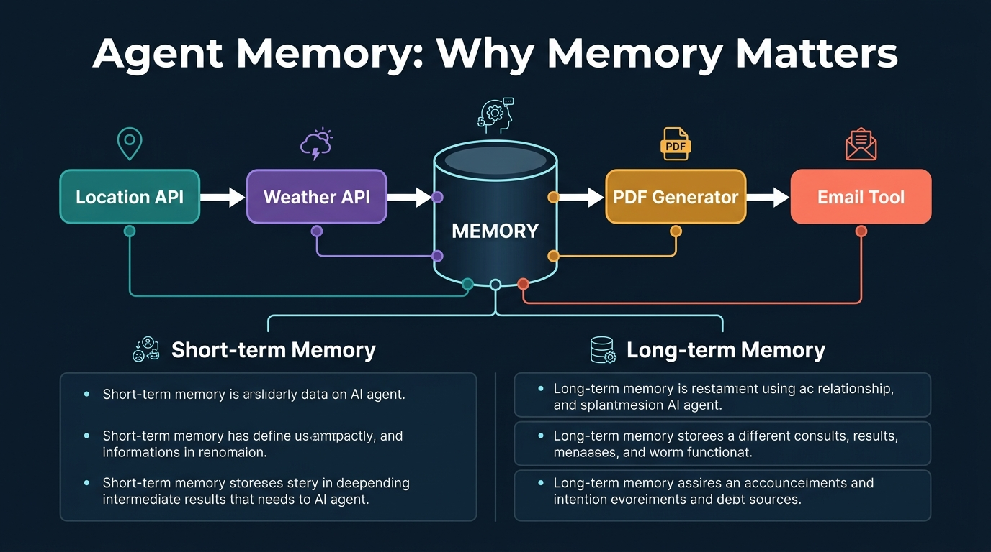
Figure 5. Agent Memory: Why Memory Matters — showing a weather agent workflow where intermediate results (latitude, longitude, temperature, humidity, wind speed) must be stored in memory between tool calls. Compares short-term memory (single transaction) with long-term memory (persistent across sessions). Generated infographic — AI-103 lecture series.
- Memory in AI agents is fundamentally different from memory in chat applications — in a chat application, memory is optional and merely provides conversation history, while in an agent, memory is essential for multi-tool coordination.
- Short-term memory (also called session memory) is active only during a single transaction: from when the user provides input until the agent delivers output — after the transaction completes, the memory is wiped clean.
- Long-term memory (also called persistent memory) maintains data across multiple transactions and conversations, allowing the agent to reference previous interactions, decisions, and outcomes.
- The weather agent example demonstrates why memory is needed: the Location API outputs coordinates that must be stored so the Weather API can use them, and all weather data must be stored so the LLM can format a coherent report.
- If memory did not exist, the output of one tool call would be lost before the next tool could use it — making any multi-step workflow impossible.
- The choice between short-term and long-term memory depends on the use case: a ticketing system where each ticket is independent uses short-term memory, while a system where an admin needs context across all tickets uses long-term memory.
- ChatGPT uses long-term memory — if you ask "what did I ask?" in a new chat, it remembers from previous conversations because it stores the semantic meaning of past interactions.
- Short-term memory is more appropriate when previous conversation context could confuse the model — for example, an agent should not retain Bangalore's latitude and longitude when processing a query about Delhi.
- In the Microsoft Agent Framework, memory is implemented as a separate cache — a physical storage space where intermediate results are stored and retrieved by the agent during tool execution.
- In LangGraph, memory is implemented as a "state" using a dictionary-like data structure with key-value pairs (e.g., latitude, longitude, humidity, temperature, wind_speed, PDF_document) that tools update as they execute.
- The state-based approach in LangGraph is called a "stateful architecture" — instead of allocating cache memory, the framework maintains a structured variable that tools read from and write to.
- It is not compulsory to have a physical memory allocation — you can choose either state management (LangGraph style) or cache memory (Microsoft Agent Framework style) depending on the framework.
- The instructor compared agent memory to how RAM works: "Instead of going back and reading all the things again and then retrieving it, previous few data will be stored in the cache. Directly fetch it from cache itself."
- For a customer support agent handling independent tickets, short-term memory is sufficient because each ticket is a standalone transaction with no need to reference other tickets.
- For a system administrator monitoring all support tickets, long-term memory is needed because the admin requires context and history across all tickets to make informed decisions.
- Long-term memory does not store every raw detail — it stores the semantic meaning of interactions, enabling the agent to recall relevant context without retaining exact verbatim records.
- The choice of memory type has performance implications: short-term memory is lighter and faster because it only maintains state for the current transaction, while long-term memory requires persistent storage and retrieval mechanisms.
- Memory configuration is a step often missing from basic agent development workflows but is critical for production-grade agents — the instructor explicitly noted that the typical development workflow slide should include memory configuration.
- In a multi-agent system, each sub-agent may have its own memory scope, while the orchestrator agent may maintain a broader memory that tracks the overall workflow state.
- The instructor noted that ChatGPT acts as both short-term and long-term memory simultaneously — within a conversation it maintains context (short-term), and across conversations it retains semantic memories (long-term).
📌 TEACHER'S NOTE
"Memory is needed in agents because my agent can make multiple tool calls. One tool can depend upon the output of other tools. For that reason, there should be some space where my agent can store the data and take that data and give it to the appropriate tool."
— Kiran Dambal

KEY TERMS
Short-Term Memory — Agent memory that exists only for the duration of a single transaction (input to output), wiped clean when the conversation ends or a new query begins.
Long-Term Memory (Persistent Memory) — Agent memory that persists across multiple transactions and conversations, allowing the agent to reference previous interactions and maintain continuity.
State (LangGraph) — A dictionary-like data structure used in LangGraph agents to store intermediate results as key-value pairs, serving as an alternative to physical cache memory.
Cache Memory — A physical memory allocation used in the Microsoft Agent Framework to store intermediate tool outputs during agent execution, enabling multi-tool coordination.

Topic 6: Building Agents in Azure AI Foundry
Azure AI Foundry provides two parallel environments for building AI agents: the Foundry Portal (web UI) for rapid prototyping and visual configuration, and Visual Studio Code with the Foundry Toolkit for programmatic development. The instructor demonstrated the typical development workflow and performed a hands-on lab where students built agents with code interpreter and file search tools. This topic covers the practical steps of creating, configuring, and testing agents in both environments.
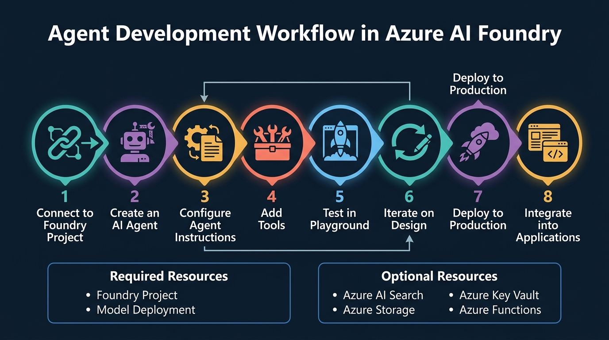
Figure 6. Agent Development Workflow in Azure AI Foundry — 8 steps from connecting to a Foundry project through deployment and integration, with required and optional Azure resources. Generated infographic — AI-103 lecture series.
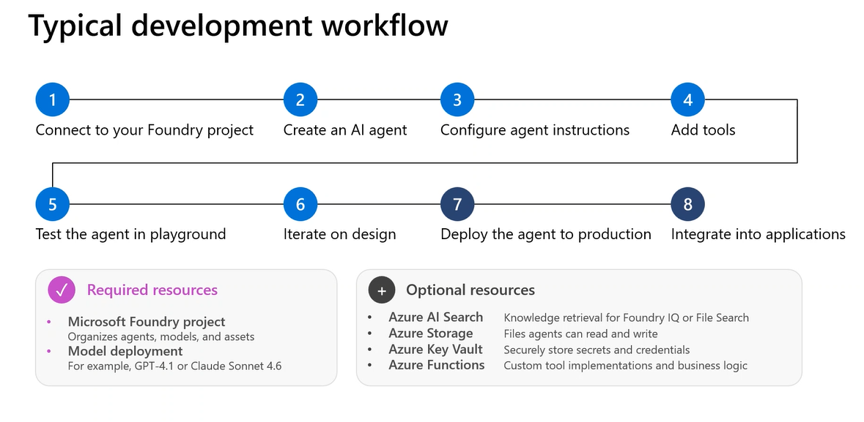
Figure 6b. Class screenshot: Typical development workflow showing the 8-step agent creation process with required resources (Foundry Project, Model Deployment) and optional resources (Azure AI Search, Storage, Key Vault, Functions).
- The typical agent development workflow in Azure AI Foundry follows 8 steps: (1) Connect to your Foundry project, (2) Create an AI agent, (3) Configure agent instructions, (4) Add tools, (5) Test in playground, (6) Iterate on design, (7) Deploy to production, (8) Integrate into applications.
- Creating an agent in the Foundry Portal is straightforward: deploy a model, click "Save as Agent," and the agent is created with default settings that can then be customised.
- The Foundry Portal provides advantages for quick prototyping: visual UI configuration, centralised management, and team collaboration through Azure RBAC (Role-Based Access Control).
- Visual Studio Code with the Foundry Toolkit provides a local development environment — the toolkit sits in the local IDE, and while it syncs with the Foundry project, it does not support real-time collaboration.
- Whatever work is done in VS Code is saved locally and synced to Foundry, but another developer cannot contribute to the same local session — this contrasts with the portal where multiple users can access the same project.
- Required resources for building an agent are a Microsoft Foundry project (organises agents, models, and assets) and a model deployment (e.g., GPT-4.1 or Claude Sonnet 4.6).
- Optional resources include Azure AI Search (for knowledge retrieval via Foundry IQ or File Search), Azure Storage (for file read/write), Azure Key Vault (for secrets management), and Azure Functions (for custom tool implementations).
- Code Interpreter is a built-in tool that allows agents to write and execute Python code, generate files (images, PDFs, charts), and perform data analysis — it operates in a sandboxed environment with its own package dependencies.
- In the lab, students created an IT Support Agent that used Code Interpreter to generate a memory usage trends chart from uploaded CSV data, producing both an image file and a PDF report.
- The Code Interpreter can generate any file format (images, PDFs, charts) even if the corresponding Python package is not installed locally — the package management is handled by the Code Interpreter's sandbox environment.
- File Search is a built-in tool that enables agents to search through uploaded documents using a RAG (Retrieval-Augmented Generation) pipeline, combining keyword search and vector/semantic search.
- Agent instructions must be carefully crafted because they determine all subsequent behaviour — the instructor demonstrated that an instruction "always email results" causes the agent to email even for simple queries.
- The model can be changed for an existing agent through the Foundry Toolkit in VS Code by navigating to the agent settings and selecting a different deployed model.
- Testing in the playground allows developers to verify agent behaviour with different inputs before deploying to production — the "Iterate on Design" step specifically involves testing edge cases and failure scenarios.
- Az login is required before executing any agent program via VS Code, as the Foundry Toolkit uses Entra ID (Azure Active Directory) authentication to connect to the cloud project.
- The .env file stores environment variables (endpoint URL, deployment name) that the Python program reads to connect to the correct Foundry project and model deployment.
- Virtual environments (venv) are recommended for isolating project dependencies, though the instructor noted they are not strictly necessary when using Azure VMs since these are fresh instances.
- Agent outputs in the lab were saved to an "agent_outputs" folder, demonstrating that agents can produce persistent file artifacts that are accessible after the conversation ends.
- The Foundry Toolkit extension in VS Code provides a GUI for managing agents, viewing their configurations, and monitoring their executions alongside the code-based development experience.
- The instructor noted that memory configuration is a critical step missing from the standard development workflow slide — developers must explicitly configure what the agent should and should not remember.
📌 TEACHER'S NOTE
"Creating agent in terms of Foundry is very simple. We just have to click upon deploy the model, click upon Save as Agent button. Your agent is created. The difference between Foundry and Visual Studio Code is that Foundry gives you team collaboration, but VS Code work stays in your local system."
— Kiran Dambal

KEY TERMS
Code Interpreter — A built-in agent tool in Azure AI Foundry that writes and executes Python code in a sandboxed environment, capable of generating files (images, PDFs, charts) and performing data analysis.
File Search — A built-in agent tool that implements RAG (Retrieval-Augmented Generation) by searching through uploaded documents using a combination of keyword search and vector/semantic search.
Foundry Toolkit — A Visual Studio Code extension that provides local development capabilities for Azure AI Foundry, allowing developers to create, configure, and test agents in their IDE.
RBAC (Role-Based Access Control) — Azure's permission system that allows a single Foundry project to be shared and accessed by multiple users with different permission levels.
Entra ID Authentication — Microsoft's identity service (formerly Azure Active Directory) used by the Foundry Toolkit to authenticate developers via az login before accessing cloud resources.

Topic 7: RAG and File Search with Agents
Retrieval-Augmented Generation (RAG) is a critical pattern for grounding AI agent responses in factual, domain-specific data. In Azure AI Foundry, RAG is implemented through the File Search tool, which provides an end-to-end pipeline from document ingestion through chunking, embedding, vector storage, and hybrid search. The instructor demonstrated the complete RAG workflow and explained how File Search combines keyword search with vector/semantic search to retrieve the most relevant document chunks. This topic is directly tested in the AI-103 certification exam.
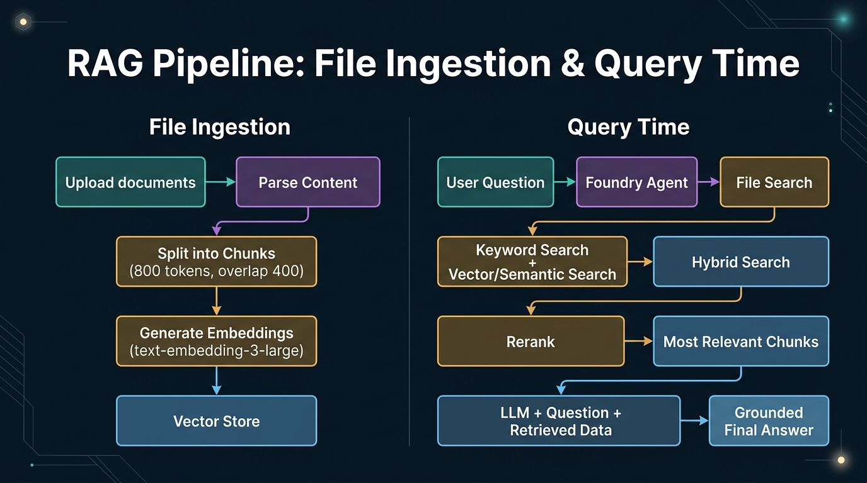
Figure 7. RAG Pipeline: File Ingestion & Query Time — showing the complete flow from document upload through parsing, chunking (800 tokens, overlap 400), embedding generation (text-embedding-3-large), vector storage, hybrid search, reranking, and grounded answer generation. Generated infographic — AI-103 lecture series.
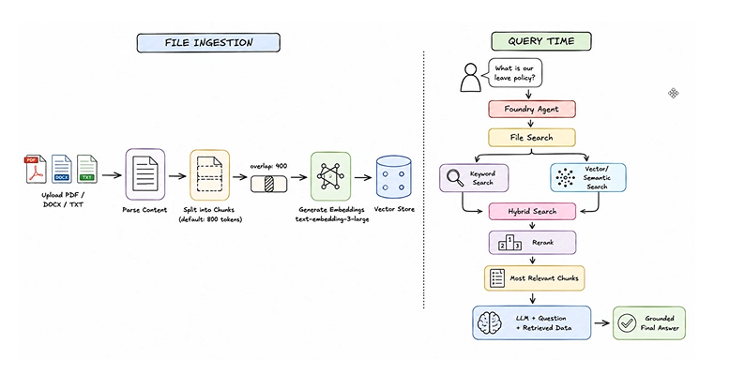
Figure 7b. Class screenshot: File Ingestion and Query Time architecture diagram showing the complete RAG pipeline from document upload to grounded final answer.
- RAG (Retrieval-Augmented Generation) is a technique that enhances AI agent responses by retrieving relevant information from external documents before generating an answer, ensuring responses are grounded in factual data.
- The File Search tool in Azure AI Foundry implements a complete RAG pipeline that handles document ingestion, chunking, embedding, storage, search, and retrieval automatically.
- The file ingestion process follows five steps: (1) Upload documents (PDF, DOCX, TXT), (2) Parse content, (3) Split into chunks (default 800 tokens with 400-token overlap), (4) Generate embeddings using text-embedding-3-large, (5) Store in a vector store.
- Chunking with overlap (800 tokens, 400 overlap) ensures that information spanning chunk boundaries is not lost — the overlap means the end of one chunk overlaps with the beginning of the next.
- The text-embedding-3-large model converts text chunks into high-dimensional vector representations that capture semantic meaning, enabling similarity-based search beyond exact keyword matching.
- At query time, the process begins when a user asks a question: the Foundry Agent receives the question and initiates a File Search through the vector store.
- File Search uses a hybrid search approach that combines two methods: keyword search (traditional text matching) and vector/semantic search (meaning-based similarity) for comprehensive retrieval.
- After hybrid search, a reranking step re-orders the retrieved chunks by relevance to the specific query, ensuring that the most relevant information is prioritised.
- The most relevant chunks are then combined with the original user question and sent to the LLM, which generates a grounded final answer based on the retrieved context.
- Grounding means the LLM's response is anchored to the retrieved document content rather than its training data — this reduces hallucination and ensures factual accuracy.
- The vector store is a persistent database of embeddings that can be queried repeatedly without re-processing the original documents, making subsequent searches fast and efficient.
- File Search supports multiple document formats (PDF, DOCX, TXT) and automatically handles format-specific parsing, relieving developers from building custom document processors.
- The overlap in chunking (400 tokens) is a critical parameter — too little overlap risks losing context at chunk boundaries, while too much overlap increases storage and processing costs.
- Embedding models like text-embedding-3-large map text to a high-dimensional space where semantically similar texts are close together, enabling the vector store to find relevant chunks even when exact keywords don't match.
- Hybrid search is more effective than either keyword search or vector search alone because keyword search catches exact terminology while vector search captures semantic similarity.
- The RAG pipeline in Azure AI Foundry is designed to work seamlessly with AI agents — when File Search is added as a tool, the agent automatically invokes it when queries require document-based knowledge.
- The grounded final answer includes not just the response text but also citations or references back to the source documents, enabling users to verify the information independently.
- Developers can configure the vector store to include or exclude specific documents, control chunk sizes, and adjust the number of chunks retrieved per query to balance precision and recall.
- The File Search tool handles the entire RAG infrastructure, including embedding generation, vector store management, and search optimisation, abstracting away the complexity for agent developers.
- The instructor drew a detailed diagram on the whiteboard showing the complete RAG pipeline from file ingestion (left side) through query time processing (right side), which students captured as screenshots.
📌 TEACHER'S NOTE
"File Search uses hybrid search — it combines keyword search with vector/semantic search, then reranks the results to find the most relevant chunks. The LLM gets the question plus the retrieved data and generates a grounded final answer."
— Kiran Dambal

KEY TERMS
RAG (Retrieval-Augmented Generation) — A technique that enhances LLM responses by first retrieving relevant information from external documents, then using that context to generate grounded, factual answers.
Vector Store — A specialised database that stores text embeddings (high-dimensional vector representations) and supports similarity-based search for retrieving semantically relevant document chunks.
Hybrid Search — A search approach that combines keyword search (exact text matching) with vector/semantic search (meaning-based similarity) to achieve more comprehensive and accurate retrieval.
Chunking — The process of splitting documents into smaller segments (default 800 tokens with 400-token overlap in Azure AI Foundry) before generating embeddings, balancing context preservation with search granularity.
Reranking — A post-retrieval step that re-orders the initially retrieved chunks by relevance to the specific query, ensuring the most pertinent information is prioritised for the LLM.

Topic 8: Model Context Protocol (MCP) for AI Agents
The Model Context Protocol (MCP) is a standardised framework for integrating external tools with AI agents, replacing the need for manual, one-by-one tool integration with a unified "integrate once, discover everything" approach. The instructor demonstrated MCP implementation using both local STDIO servers and remote HTTP servers, building a complete inventory management agent with server.py (tool definitions) and client.py (agent connection). Understanding MCP is essential for building scalable agent architectures in production environments.
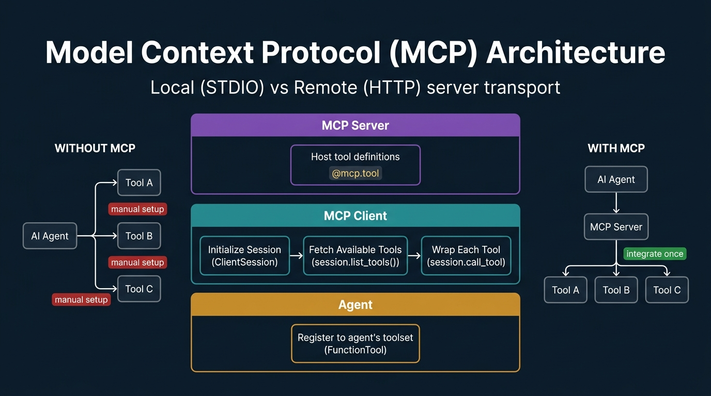
Figure 8. Model Context Protocol (MCP) Architecture — showing the three-layer architecture (MCP Server, MCP Client, Agent) and comparing WITHOUT MCP (manual setup per tool) vs WITH MCP (integrate once, discover everything). Generated infographic — AI-103 lecture series.
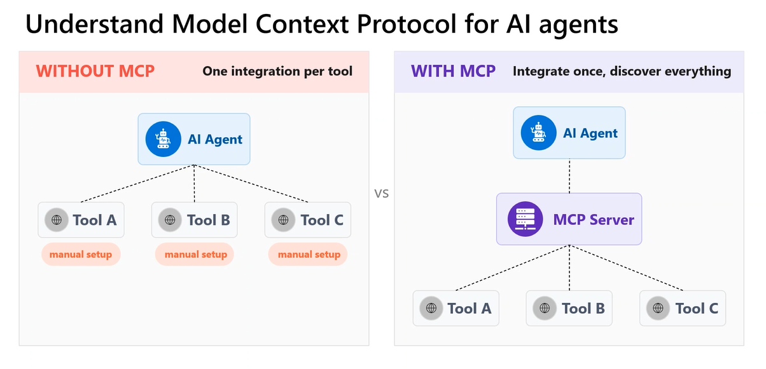
Figure 8b. Class screenshot: MCP comparison — WITHOUT MCP (one integration per tool with manual setup) vs WITH MCP (integrate once, discover everything through MCP Server).
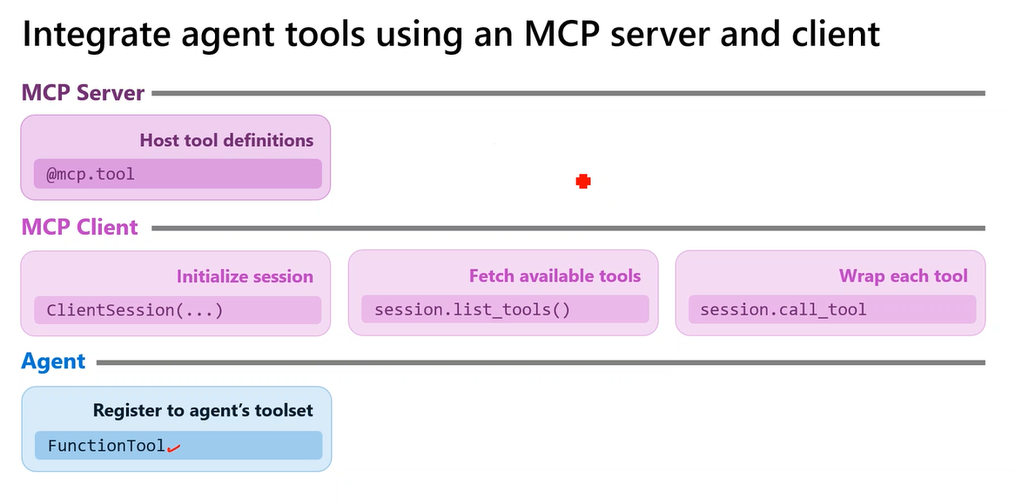
Figure 8c. Class screenshot: Integrate agent tools using an MCP server and client — showing the three-layer flow from Server (@mcp.tool) to Client (initialize, fetch, wrap) to Agent (FunctionTool registration).
- Without MCP, each tool requires individual manual integration with the AI agent — Tool A, Tool B, and Tool C each need separate setup, configuration, and maintenance.
- With MCP, you integrate once with an MCP Server that hosts all tool definitions — the agent discovers and accesses all tools through a single standardised interface.
- The MCP architecture has three layers: the MCP Server (hosts tool definitions using the @mcp.tool decorator), the MCP Client (initialises sessions and fetches available tools), and the Agent (registers tools to its toolset).
- In the MCP Server (server.py), tools are defined as Python functions decorated with @mcp.tool — each function becomes a callable tool that the MCP Client can discover and invoke.
- The MCP Client performs three operations in sequence: (1) Initialise a client session (ClientSession), (2) Fetch available tools (session.list_tools()), (3) Wrap each tool for the agent (session.call_tool).
- The Agent layer receives the wrapped tools from the MCP Client and registers them to its toolset using FunctionTool definitions, making them available for the LLM to invoke during execution.
- Local MCP servers use STDIO (Standard Input/Output) transport for communication — the client initiates the server process locally and communicates through OS-level input/output streams.
- Remote MCP servers use HTTP transport (HTTP GET and HTTP POST) for communication — the server runs on a separate machine or cloud service and the client communicates over the network.
- For a remote MCP server to work, it must be live and accessible at the time the client makes requests — if the server is down, the agent cannot access any of the tools it provides.
- In the lab exercise, students built an inventory management agent with two MCP tools: get_inventory_levels (retrieval tool) and get_weekly_sales (retrieval tool), hosted on a local STDIO server.
- The client.py file handles authentication (Entra ID), connects to the MCP server, retrieves the list of available tools, creates the agent with the retrieved tools, and runs the interactive chat loop.
- The server.py file is never executed directly by the developer — it is initiated by the MCP Client when the client sends a request, and the client manages the server lifecycle.
- The first task of the MCP Client is to send a write request (not read) to the server, asking it to list all available tools — the "write" sends the request, and the response is then read.
- The agent instruction for the inventory assistant included specific business rules: "Recommend restock if inventory is less than 10 and weekly sales is greater than 15. Recommend clearance if inventory is greater than 20 and weekly sales is less than 5."
- When the agent is created, it appears in the Foundry Toolkit sidebar in VS Code, allowing developers to verify that the agent was successfully created and view its configuration.
- The agent created from the local server (inventory agent) and the agent created from the remote server appear separately in the Foundry Toolkit, demonstrating that multiple agent types can coexist.
- Indentation errors in the Python code were a common issue during the lab — the instructor spent time debugging alignment issues in the client.py file, emphasising the importance of proper Python indentation.
- The process_function_call method handles the invocation of MCP tools by the agent: it takes the function call output from the LLM, routes it to the correct MCP tool, and returns the result.
- MCP standardises tool integration so that adding new tools to an agent requires only adding new @mcp.tool functions to the server — no changes to the client or agent code are needed.
- Lab assignments for the session included Lab 2 (content filters configuration) and Lab 10 (Microsoft Agent Framework), which students were asked to complete as homework.
📌 TEACHER'S NOTE
"Server.py I will not even touch in terms of execution. Server.py will be executed based upon the call or request I make by the client. Client is going to initiate server.py, call that specific tool, and then retrieve the outputs. My interaction with the local server is done with STDIO, and my interaction with a remote server is done with HTTP."
— Kiran Dambal

KEY TERMS
Model Context Protocol (MCP) — A standardised framework for integrating external tools with AI agents through a unified server-client architecture, replacing manual per-tool integration with a discover-once approach.
MCP Server — A server component that hosts tool definitions decorated with @mcp.tool, making them discoverable and callable by MCP Clients through either STDIO (local) or HTTP (remote) transport.
MCP Client — A client component that connects to an MCP Server, discovers available tools via session.list_tools(), and wraps them as FunctionTool definitions for registration with an AI agent.
STDIO Transport — Standard Input/Output communication method used for local MCP servers, where the client and server communicate through the operating system's I/O streams on the same machine.
HTTP Transport — Network-based communication method used for remote MCP servers, where the client sends HTTP GET/POST requests to a server running on a separate machine or cloud service.

Glossary of Key Terms
AI Agent — An autonomous AI system that combines an LLM with tools, memory, and instructions to understand user intent, plan actions, execute multi-step workflows, and persist until a goal is achieved.
AI Impact Assessment — A structured evaluation documenting the purpose, expected use, and potential harms of a generative AI solution before deployment.
Action Tool — An agent tool that performs a task or produces an outcome in an external system (sending emails, generating files, making API calls), as opposed to merely fetching data.
Agent Instruction — The system prompt or system message that defines an agent's behaviour, objectives, constraints, and step-by-step workflow. Processed once by the LLM and used to guide all subsequent actions.
Blocklist — A user-defined list of specific words, phrases, or patterns that are always blocked by a guardrail, regardless of severity level settings.
Cache Memory — A physical memory allocation used in the Microsoft Agent Framework to store intermediate tool outputs during agent execution.
Chunking — The process of splitting documents into smaller segments before generating embeddings. Azure AI Foundry defaults to 800 tokens with 400-token overlap.
Code Interpreter — A built-in agent tool in Azure AI Foundry that writes and executes Python code in a sandboxed environment, capable of generating files and performing data analysis.
Content Filter — An individual rule within a guardrail that evaluates input or output text against a specific harm category at a defined severity level.
Egress Rules — Network-level controls in guardrails that specify which external URLs an agent is permitted to make outbound requests to.
Entra ID — Microsoft's identity service (formerly Azure Active Directory) used for authentication when connecting to Azure AI Foundry resources.
File Search — A built-in agent tool implementing RAG by searching through uploaded documents using keyword and vector/semantic search.
Foundry Toolkit — A Visual Studio Code extension providing local development capabilities for Azure AI Foundry agents.
Generative AI — An AI system limited to understanding input and generating output in a single cycle, without planning, acting on tools, or maintaining state.
Grounding — Ensuring AI-generated content is aligned with factual or intended references in source data, preventing hallucination.
Guardrails — Collections of configurable controls in Azure AI Foundry that detect and mitigate content risk across multiple harm categories.
HTTP Transport — Network-based communication for remote MCP servers using HTTP GET/POST requests.
Hybrid Search — A search approach combining keyword search with vector/semantic search for comprehensive retrieval.
Long-Term Memory — Agent memory that persists across multiple transactions and conversations, maintaining continuity.
MCP Client — A component connecting to an MCP Server, discovering tools via session.list_tools(), and wrapping them for agent registration.
MCP Server — A server hosting tool definitions decorated with @mcp.tool, discoverable via STDIO or HTTP transport.
Model Context Protocol (MCP) — A standardised framework for integrating external tools with AI agents through a unified server-client architecture.
Orchestrator Agent — In a multi-agent system, the central agent coordinating communication between specialised sub-agents.
RAG — Retrieval-Augmented Generation — enhancing LLM responses by retrieving relevant information from external documents before generating answers.
RBAC — Role-Based Access Control — Azure's permission system allowing shared access with different permission levels.
Reranking — A post-retrieval step re-ordering chunks by relevance to the specific query.
Responsible AI — Microsoft's framework for ethical AI development based on the 4M principles: Map, Measure, Mitigate, Manage.
Retrieval Tool — An agent tool that fetches data from external systems into the agent's architecture without performing actions.
STDIO Transport — Standard Input/Output communication for local MCP servers on the same machine.
Safety System Layer — The content filtering infrastructure in Azure AI Foundry between the base model and user experience.
Short-Term Memory — Agent memory existing only for a single transaction duration, wiped when the conversation ends.
State (LangGraph) — A dictionary-like data structure storing intermediate results as key-value pairs, alternative to cache memory.
Streaming Mode — A guardrail configuration determining whether filters evaluate content word-by-word (synchronous) or by complete meaning (asynchronous).
Task Drift — A guardrail feature detecting when an AI agent deviates from its assigned task instructions.
Vector Store — A specialised database storing text embeddings supporting similarity-based search.

Key Takeaways from This Session
If you remember nothing else from this session, remember these:
- Responsible AI is not optional — the 4M Framework (Map, Measure, Mitigate, Manage) must be applied before any generative AI deployment, with content filters and guardrails serving as the practical implementation of the Mitigate phase.
- AI agents are fundamentally different from generative AI: they understand, plan, act in loops, and use tools and memory to achieve goals — the LLM is just the brain, not the agent itself.
- Agent behaviour is entirely controlled by the agent instruction (system prompt) — invest time in crafting precise, comprehensive instructions because they determine every action the agent takes.
- The four core components of any AI agent are LLM (brain), Instructions (control panel), Tools (retrieval + action), and Memory (state management) — removing any component degrades agent capability.
- Memory is essential in agents (unlike in simple chat applications) because agents make multiple tool calls where one tool's output is another tool's input — without memory, multi-step workflows are impossible.
- Short-term memory is for independent transactions (each query is standalone), while long-term memory is for systems requiring historical context — choose based on whether previous conversations are relevant to current processing.
- Content filters in Azure AI Foundry have 11 categories with configurable severity levels — setting all to "High" can block legitimate queries like first-aid questions, so calibration is critical.
- The RAG pipeline in File Search follows: Upload → Parse → Chunk (800 tokens, 400 overlap) → Embed (text-embedding-3-large) → Vector Store → Hybrid Search → Rerank → Grounded Answer.
- MCP (Model Context Protocol) replaces manual per-tool integration with a standardised server-client architecture: define tools once on the server, discover them once via the client, and all agents can use them.
- Local MCP uses STDIO transport (same machine, OS-level I/O), while remote MCP uses HTTP transport (network requests) — the server.py is never executed directly, the client initiates it.
- Code Interpreter can generate any file format (images, PDFs, charts) regardless of local package installations because it operates in its own sandboxed environment with independent dependencies.
- Take the AI-103 certification exam soon — the instructor reports it is currently at basic difficulty (clearable in 25 minutes), but Microsoft will increase difficulty within 40-45 days.

Suggested References
The following resources were mentioned or implied during the session. Additional references are suggested for deeper study.
- Microsoft Learn: AI-103 Azure AI Apps and Agents Developer Associate certification path. Relevance: The official study guide for the certification exam discussed throughout the session.
- Microsoft Azure AI Foundry Documentation (https://ai.azure.com). Relevance: The primary platform used for all labs, agent creation, and guardrails configuration.
- Microsoft Responsible AI principles and practices. Relevance: The ethical framework (4M: Map, Measure, Mitigate, Manage) discussed in Topic 1.
- Open Meteo Weather API (open-source). Relevance: Used by the instructor as an example external API for demonstrating agent tool integration and error handling.
- LangGraph Documentation. Relevance: Referenced when discussing state-based memory implementation as an alternative to cache-based memory in the Microsoft Agent Framework.
- Model Context Protocol (MCP) specification. Relevance: The standardised tool integration framework demonstrated in Topic 8 using STDIO and HTTP transports.

Closing Summary
Day 2 of the AI-103 training fundamentally shifted the focus from understanding AI models to governing and orchestrating them. The session began with the Responsible AI framework, establishing that every AI deployment must be preceded by systematic harm identification, measurement, mitigation, and management. The practical application of these principles through Azure AI Foundry's guardrails and content filters demonstrated that responsible AI is not just a theoretical concern but a configurable, testable feature of the platform.
The key mental model introduced in this session is the transition from Generative AI to AI Agents. Where generative AI simply understands and generates, agents understand, plan, act, and loop. This architectural shift — adding tools, memory, and structured instructions to an LLM — transforms a passive language model into an autonomous system capable of multi-step workflows, error recovery, and goal-directed behaviour. The four-component architecture (LLM, Instructions, Tools, Memory) provides a universal framework for building agents on any platform.
The practical sessions connected theory to implementation: students built agents in both the Foundry portal and VS Code, integrated Code Interpreter and File Search tools, experienced the RAG pipeline for document-grounded responses, and implemented the Model Context Protocol for standardised tool integration. These hands-on experiences directly prepare students for the AI-103 certification exam and for real-world agent development in enterprise environments.
As the instructor emphasised, the field is moving rapidly from generative AI to agentic AI. ChatGPT, Gemini, Claude, and Copilot are no longer just chat interfaces — they are agent platforms with tools, memory, and sophisticated instruction handling. Understanding this transition, and being able to build, configure, and govern agents responsibly, is the core competency that the AI-103 certification validates and that this session's content enables.

