AI-103
Azure AI Apps and Agents Developer Associate
Day 1: Student Handout
Generative AI Foundations & Microsoft Foundry Platform

Instructor | Kiran Dambal — Microsoft Certified Trainer
Date | 22 August 2026

Table of Contents
1. Session Overview
2. Learning Objectives
3. Topic 1: Evolution of AI — From Algorithms to Large Language Models
4. Topic 2: AI vs Generative AI — The Fundamental Distinction
5. Topic 3: Microsoft Foundry — Platform Architecture and Services
6. Topic 4: Model Selection, Deployment, and Evaluation
7. Topic 5: Developing Generative AI Applications — APIs and SDKs
8. Topic 6: Tools in Generative AI Applications
9. Topic 7: Responsible AI Principles
10. Lab Activities Summary
11. Glossary of Key Terms
12. Key Takeaways from This Session
13. Suggested References
14. Closing Summary

Session Overview
- This session introduced the foundational concepts of the AI-103 certification course, covering generative AI, Microsoft Foundry platform, model deployment, API consumption, and responsible AI principles.
- The course was formerly known as AI-102 and has been restructured into four modules focused entirely on the Microsoft Foundry platform as a one-stop solution for AI, Generative AI, and Agentic AI.
- Students explored the Microsoft Foundry portal hands-on, creating projects, deploying GPT 5.2 models, and building chat applications using both Chat Completions API and Responses API.
- The session included an introduction to tools integration (code interpreter, web search, file search, custom functions) for extending generative AI capabilities beyond base model responses.
- Key frameworks introduced include the distinction between Foundry Resource (infrastructure) and Foundry Project (platform), three SDK types, two endpoint types, and two authentication methods.
- The six Responsible AI principles were covered as an exam-critical topic, with emphasis on fairness, reliability, privacy, inclusiveness, transparency, and accountability.
- Four labs were conducted: Lab 1 (Foundry exploration), Lab 3 (Chat application), Lab 4 (Tools integration), with Lab 2 assigned as student homework.

Learning Objectives
After this session, you will be able to:
1. Trace the evolution of AI from basic algorithms through machine learning, neural networks, transformer models, to large language models, explaining the key breakthroughs at each stage.
2. Articulate the fundamental difference between traditional AI (retrieval of existing data) and generative AI (generation of new, unique data) with practical demonstrations.
3. Navigate the Microsoft Foundry portal, create projects, deploy models, and understand the relationship between Foundry Resources (infrastructure) and Foundry Projects (platform).
4. Compare and select large language models from the Foundry Model Catalog using four evaluation parameters: quality, safety, throughput, and cost.
5. Configure model deployment types (Global Standard, Provisioned, Batch, Developer) and select appropriate regions based on model availability and quota limits.
6. Develop a generative AI chat application using the Open AI SDK, distinguishing between Chat Completions API and Responses API based on use case requirements.
7. Integrate tools (code interpreter, web search, file search, custom functions) into generative AI applications to extend model capabilities beyond pre-trained knowledge.
8. Select the appropriate endpoint (Azure Open AI vs. Project), SDK (Open AI, Microsoft Agent Framework, Foundry Tools), and authentication method (Intra ID vs. API Key) for a given application scenario.
9. Apply the six Responsible AI principles (Fairness, Reliability & Safety, Privacy & Security, Inclusiveness, Transparency, Accountability) to evaluate AI deployment scenarios.
10. Execute hands-on labs in the Skillable LODS environment, including project creation, model deployment, playground testing, and application development within virtual machines.

══════════════════════════════════════════════════════════════════════

TOPIC 1: Evolution of AI — From Algorithms to Large Language Models
The evolution of artificial intelligence represents a systematic progression from simple rule-based systems to sophisticated generative models capable of producing entirely new content. Understanding this evolutionary trajectory is essential for grasping why modern generative AI applications function the way they do and where the field is headed.
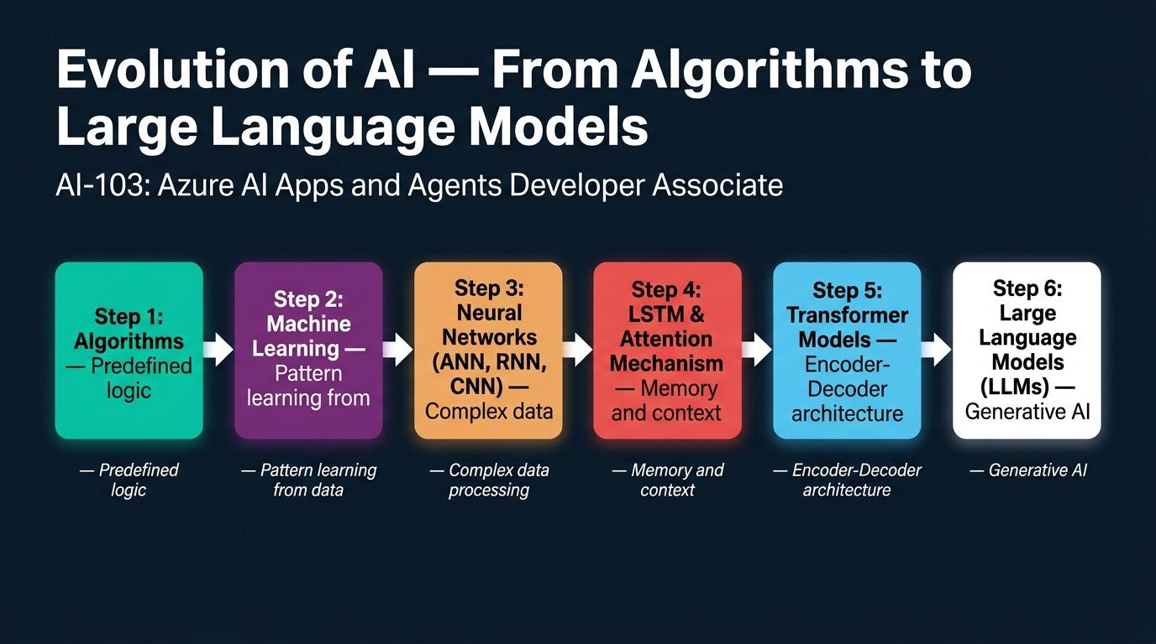
Figure 1. Evolution of AI — From Algorithms to Large Language Models: A six-stage progression showing how AI evolved from predefined algorithms through machine learning, neural networks, LSTM and attention mechanisms, transformer models, to modern large language models.
1. Artificial intelligence began with simple algorithms — predefined sets of procedures or steps that a user could follow to generate outputs such as complex calculations; the key limitation was that the user could always predict the output of the algorithm in advance.
2. Machine learning algorithms represented the first major leap beyond rule-based systems by learning patterns from historically gathered data rather than following predefined logic, enabling prediction and decision-making capabilities that algorithms alone could not achieve.
3. The critical difference between algorithms and machine learning algorithms is that algorithms operate on explicit inputs with predictable outputs, whereas machine learning algorithms observe data, learn its underlying patterns, and then use those patterns for future prediction or decision-making.
4. Neural networks were developed to overcome two key limitations of machine learning: the inability to process very complex and high-dimensional data efficiently, and the extensive feature engineering required to convert all data into numerical format arranged in CSV-like structures before processing.
5. There are three fundamental categories of neural networks: Artificial Neural Networks (ANN) for simple workloads like prediction and decision-making, Recurrent Neural Networks (RNN) for processing sequential data such as time series, text, and speech, and Convolutional Neural Networks (CNN) for processing digital data like images and videos.
6. RNNs suffered from the Vanishing Gradient Descent (VGD) problem, meaning that as they processed longer sequences of data, they progressively lost the semantic meaning learned from earlier portions of the sequence — for example, in a long paragraph where "Ahmed went to a shopping mall" and later "he bought an apple," the network would fail to associate "he" with "Ahmed" over long distances.
7. Long Short-Term Memory (LSTM) networks addressed the VGD problem by adding a cache memory component to RNNs, controlled by three gates — input, output, and forget gates — which managed what information to store, retrieve, and discard during sequential processing.
8. Despite LSTM's improvements, a critical problem remained unsolved: sequence-to-sequence processing, where the semantic alignment between input and output was not accurately maintained — for example, in translating "I sat on chair" to Hindi, word-to-word translation produced incorrect meaning because word order differs fundamentally between languages.
9. The attention mechanism was the breakthrough that addressed both the VGD problem and the semantic alignment issue by assigning an importance score (on a scale of 0 to 1) to every token in the input, ensuring that the model knew which words mattered most in relation to every other word.
10. Tokenization is the process of reducing text dimensionality by breaking paragraphs into sentences and sentences into individual words (tokens), which the model then processes one by one — this technique predates transformers but became crucial for the attention mechanism to function effectively.
11. Transformer models are the architectural patterns upon which large language models are trained; they combine the memory capabilities of LSTM with the attention mechanism, creating a two-component architecture consisting of an encoder (for understanding) and a decoder (for generation).
12. In NLP terminology, the encoder performs Natural Language Understanding (NLU) — digesting and learning the meaning of input data — while the decoder performs Natural Language Generation (NLG) — producing a response based on the understood meaning, analogous to how humans understand speech before formulating a reply.
13. Three distinct transformer architectures exist: encoder-only (used by Google's BERT), decoder-only (used by OpenAI's GPT series including GPT 5.6, 5.5, and 5.2), and encoder-decoder (used by Meta's T5), each optimised for different use cases based on the organisation's requirements.
14. Large language models (LLMs) are the products built upon transformer model architectures, representing the current state of the art in AI — they are distinguished from earlier AI by their ability to generate entirely new data rather than merely retrieving or classifying existing information.
15. The five primary workloads of traditional AI are machine learning (pattern-based prediction and decision-making), text and language processing (NLP analysis and feature extraction), computer speech services (speech recognition and synthesis), computer vision (image and video processing through pixels), and information extraction or data mining.
16. Information extraction, also known as data mining, involves converting raw data from any source into specific, structured information — a practical example is OCR (Optical Character Recognition) in payment apps, which reads card numbers, dates, and CVV from photographs and maps them to the correct fields automatically.
17. The AI workload categories remain foundational even in the age of generative AI — text processing, speech services, computer vision, and information extraction are all consumed as pre-built services within the Microsoft Foundry platform, now extended by generative capabilities.
18. Deep learning models, built upon neural networks, powered applications like Google Lens and enabled processing of higher-dimensional data with significantly less computational time compared to traditional machine learning algorithms.
19. The concept of "processing data one by one" in sequential models is fundamental to understanding why context preservation was so challenging — unlike humans with trillions of neurons who can easily track pronouns across paragraphs, neural networks with hundreds of neurons have inherent capacity limitations.
20. The complete evolutionary chain — Algorithms → Machine Learning → Neural Networks → LSTM + Attention → Transformer Models → Large Language Models — represents not just a technological progression but a philosophical shift from deterministic computing to probabilistic generation, where each stage solved a specific limitation of its predecessor.
📌 TEACHER'S NOTE
"Ahmed went to a shopping mall, he bought an apple. Who is 'he'? We are human beings — we have trillions of neurons, we can easily identify. But neural networks have hundreds of neurons. How much can they hold?"
— Kiran Dambal

KEY TERMS
Vanishing Gradient Descent (VGD) — A problem in RNNs where the model progressively loses the semantic meaning it learned from earlier portions of a sequence as it processes longer data.
Attention Mechanism — A technique that assigns importance scores (0 to 1) to every token in a sequence, enabling the model to focus on the most semantically relevant words regardless of their position.
Transformer Model — An architectural pattern combining LSTM memory capabilities with attention mechanisms, consisting of encoder (understanding) and decoder (generation) components.
Tokenization — The process of breaking down text into smaller processing units (tokens) — typically splitting paragraphs into sentences and sentences into individual words.
Large Language Model (LLM) — A model trained upon transformer architectures that can generate entirely new data in response to prompts, producing semantically consistent but representationally unique outputs.

══════════════════════════════════════════════════════════════════════

TOPIC 2: AI vs Generative AI — The Fundamental Distinction
Understanding the distinction between traditional AI and generative AI is not merely an academic exercise — it is the conceptual foundation upon which every technical decision in this course is built. The instructor demonstrated this difference live using Google Search versus ChatGPT, making the abstract concept immediately tangible.
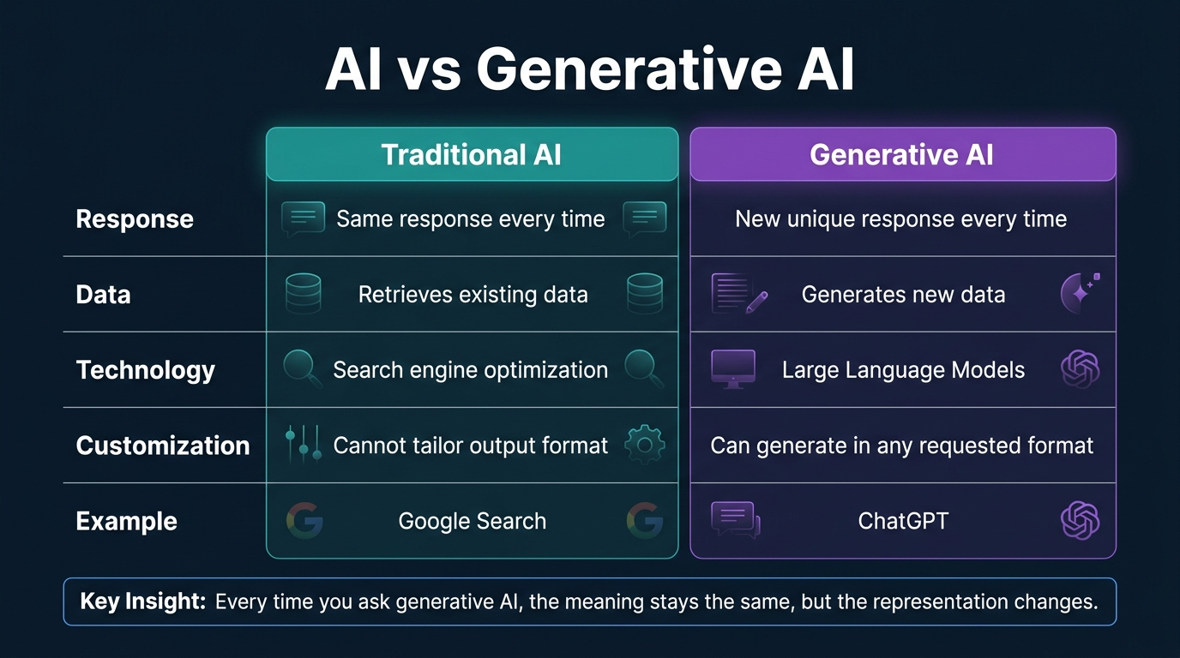
Figure 2. AI vs Generative AI: A side-by-side comparison across five dimensions — response consistency, data handling, underlying technology, customisation capability, and real-world examples.
1. Traditional AI systems, such as search engines built upon Search Engine Optimisation (SEO), function as information retrieval tools — they find and present existing data from indexed sources rather than creating new content, which means asking the same query twice produces identical results.
2. Generative AI, built upon large language models, produces entirely new data every time a question is asked — the semantic meaning of the response remains consistent across multiple queries, but the representation (structure, vocabulary, formatting, and examples used) changes with each generation.
3. The instructor demonstrated this distinction live by searching "What is AI?" on Google twice — the results were word-for-word identical, including the same emojis, videos, and suggested questions, proving that traditional AI merely retrieves and ranks existing content.
4. When the same question was asked to ChatGPT twice, the first response used two columns (Aspect and Explanation) while the second used three columns (Topic, Explanation, and Example) — the underlying meaning was equivalent, but the generative model produced a structurally distinct response each time.
5. Traditional AI cannot tailor its output format to user preferences — when the instructor modified the Google search to "What is AI? Explain in tabular format," the search engine ignored the format request entirely and returned the same list of websites.
6. Generative AI natively supports format customisation because it constructs responses token by token rather than retrieving pre-existing pages — asking ChatGPT to explain in tabular format produces a properly formatted table.
7. The core technical distinction is that AI retrieves data that already exists somewhere, while generative AI produces data that has never existed before in that exact form — the LLM generates content probabilistically, selecting each next token based on learned statistical patterns.
8. Generative AI is a subset of AI, not a replacement for it — it inherits all the foundational workloads of traditional AI while adding the ability to generate novel content across text, image, audio, and video modalities.
9. Every time a user interacts with generative AI, the model generates output token by token, based on the statistical weightage of previous tokens — this autoregressive generation process is what makes each output unique.
10. The practical implication for developers is that generative AI applications require different evaluation approaches than traditional AI — since outputs are non-deterministic, testing must focus on semantic accuracy rather than exact output matching.
11. Generative AI was born from the combination of LSTM memory capabilities and the attention mechanism within transformer architectures, enabling models to understand input at scale and produce coherent, contextually appropriate new content.
12. The non-deterministic nature of generative AI introduces challenges around hallucination (generating plausible but factually incorrect information) and consistency, which must be addressed through guardrails and grounding techniques.
13. Traditional AI excels in scenarios where deterministic, reproducible results are required — database lookups, classification tasks, and search indexing — while generative AI is superior for creative, conversational, and adaptive tasks.
14. The evolution from AI to generative AI represents a shift from "finding the right answer" to "constructing a right answer," fundamentally changing how applications are designed, tested, deployed, and maintained.
15. Cost is a critical practical distinction: traditional AI queries are computationally inexpensive, while generative AI queries consume tokens that are priced per input and output token, making every interaction a billable event.
16. The instructor emphasised that generative AI "is not a technology problem — it is a thinking problem," noting that enterprise customers ask for demonstrations but fail to articulate the specific business value or architecture.
17. In the context of the AI-103 certification, generative AI is the primary focus because Microsoft Foundry has been redesigned as a platform specifically for building, deploying, and managing generative AI and agentic AI applications.
18. The simplicity of the demo (Google Search vs. ChatGPT) belies the profound architectural difference: search engines use inverted indexes and ranking algorithms on static data, while LLMs use billions of parameters for forward passes of transformer networks.
19. Understanding this distinction is exam-critical because AI-103 questions frequently present scenarios where candidates must determine whether a traditional AI service or a generative AI approach is appropriate for a given business requirement.
20. The instructor's observation that "companies are asking for demos but not moving to production" highlights the gap between understanding generative AI conceptually and deploying it successfully at enterprise scale.
📌 TEACHER'S NOTE
"Every time you ask a question to AI, it gives you the same response. Every time you ask a question to generative AI, it gives you a similar response, not the same response."
— Kiran Dambal

KEY TERMS
Generative AI — A subset of AI built upon large language models that generates entirely new, previously non-existent data in response to prompts, producing semantically consistent but representationally unique outputs each time.
Search Engine Optimisation (SEO) — The traditional AI technique used by search engines to index, rank, and retrieve existing web content based on relevance to user queries.
Token-by-Token Generation — The autoregressive process by which LLMs produce output one token at a time, with each subsequent token's probability conditioned on all previously generated tokens.
Non-Deterministic Output — The characteristic of generative AI where identical inputs produce different (though semantically similar) outputs across multiple executions.

══════════════════════════════════════════════════════════════════════

TOPIC 3: Microsoft Foundry — Platform Architecture and Services
Microsoft Foundry is the centrepiece of the AI-103 certification and represents Azure's consolidated approach to AI, generative AI, and agentic AI development. Understanding its architecture — the distinction between resources and projects, the five categories of foundry tools, and the integration of models, agents, knowledge, and developer tools — is essential for every subsequent lab and exam scenario.
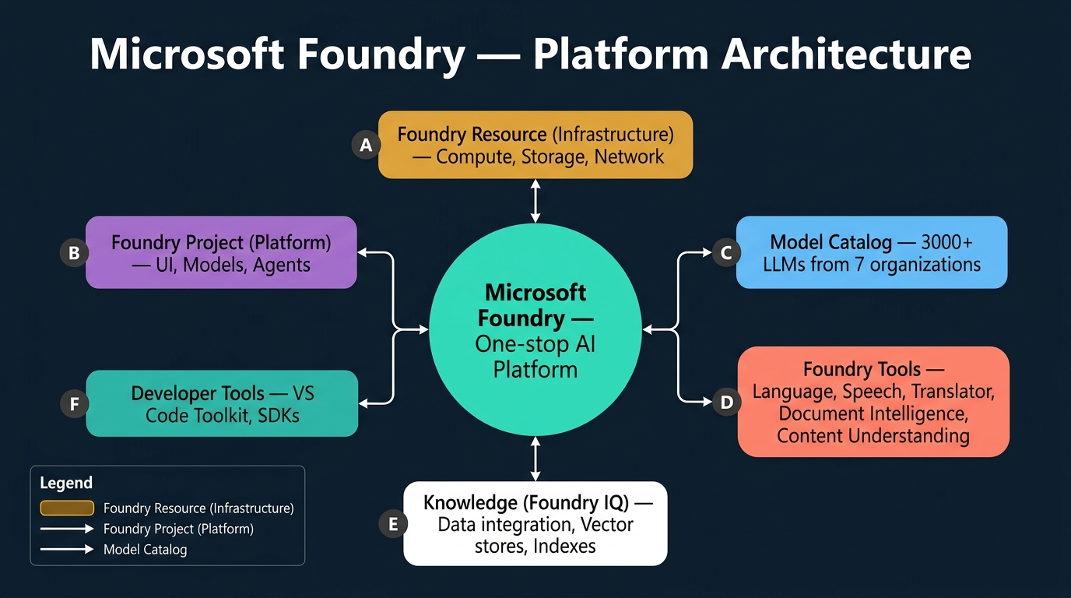
Figure 3. Microsoft Foundry — Platform Architecture: A system diagram showing the central Foundry platform connected to six key components — Foundry Resource, Foundry Project, Model Catalog, Foundry Tools, Knowledge (Foundry IQ), and Developer Tools.
1. Microsoft Foundry (formerly Azure OpenAI Platform) is a platform-as-a-service that serves as a one-stop solution for all AI, generative AI, and agentic AI requirements — it consolidates model hosting, agent building, tool integration, and knowledge management into a single unified environment.
2. The Foundry architecture has two mandatory layers: the Foundry Resource (infrastructure-as-a-service) which provides dedicated compute, storage, and network connectivity, and the Foundry Project (platform-as-a-service) which provides the UI, model access, agent management, and all user-facing services.
3. A single Foundry Resource can host multiple Foundry Projects — different users or workloads can share the same underlying infrastructure, analogous to having one laptop (resource) running multiple applications (projects).
4. When creating a project in Foundry, the resource is automatically created with default configurations — users do not need to manually configure infrastructure unless they require scaling.
5. Foundry's Model Catalog contains approximately 3,000 to 3,500 models from seven major organisations: Azure OpenAI, Anthropic (Claude), Meta (Llama), DeepSeek, Mistral, Microsoft (Phi models), and others.
6. Three Azure regions offer the best model availability and highest quota limits: West US 3, East US 2, and Central US — other regions like Central India may have limited model availability and reduced quotas.
7. The Foundry portal is organised into two primary sections: "Discover" (for exploring pre-built resources) and "Build" (for creating custom resources — agents, models, tools, and knowledge bases).
8. Five Foundry Tools (pre-built AI services) are available: Azure Language, Azure Speech, Azure Translator, Azure Document Intelligence, and Azure Content Understanding.
9. Azure Document Intelligence requires training with sample templates for custom formats; Azure Content Understanding handles images, videos, PowerPoints, and complex documents with just a single sample document, though it processes one template at a time.
10. Foundry Tools are pre-built AI models, not generative AI — they function as standalone services that can be integrated into generative applications or agents as external tools.
11. The model comparison dashboard evaluates up to three models across four parameters: quality index, safety, throughput, and cost.
12. Agent templates (48 pre-built) are available in the Discover section — starting frameworks that developers can customise, with support for MCP servers and A2A communication protocols.
13. The Tools section supports four categories: custom tools, remote MCP tools, local MCP tools, and skills tools — enabling connections to MongoDB, Outlook, OneDrive, and other enterprise connectors.
14. MCP tools are appropriate when many external tools must be managed; individual tool connectors are sufficient for one or two simple integrations.
15. Authentication uses two methods: API Key (endpoint as username, key as password) and Microsoft Intra ID (bearer token from Microsoft credentials) — the Foundry Toolkit uses Intra ID by default.
16. Two endpoints are available: the Azure OpenAI Endpoint (for OpenAI/GPT models only) and the Project Endpoint (universal endpoint for all services). The Project Endpoint is a superset that works for everything.
17. Three SDKs are available: Microsoft Agent Framework SDK (for agent building), OpenAI SDK (for consuming LLMs), and Microsoft Foundry Tools SDK (for consuming pre-built AI services).
18. The Foundry Toolkit is a VS Code extension providing direct, bidirectional connectivity to the Foundry platform — changes in the portal reflect in VS Code and vice versa.
19. Knowledge management uses Foundry IQ, supporting graph-based storage for agent knowledge with connections to Azure Blob, AWS S3, Cosmos DB, PostgreSQL, and other storage mediums.
20. Projects within the same subscription are completely isolated — communication between agents across projects requires explicit A2A protocol calls or external MCP integration.
📌 TEACHER'S NOTE
"Foundry is kind of a one-stop solution — either you want to build, train, or deploy AI models, agents, or generative applications, everything is at one place. If you build outside and try to integrate, that will be a very big headache."
— Kiran Dambal

KEY TERMS
Foundry Resource — The infrastructure-as-a-service layer providing dedicated compute, storage, and network connectivity; can host multiple projects.
Foundry Project — The platform-as-a-service layer providing UI and access to models, agents, tools, and knowledge; each project is isolated.
Foundry IQ — Foundry's knowledge management system integrating external data using graph-based storage.
Foundry Toolkit — A VS Code extension providing bidirectional connectivity to the Foundry platform.
MCP (Model Context Protocol) — A protocol for connecting agents to external tools and data sources; supports local and remote servers.

══════════════════════════════════════════════════════════════════════

TOPIC 4: Model Selection, Deployment, and Evaluation
Selecting the right model, deploying it with appropriate configurations, and evaluating its performance are the practical decision points that determine the success and cost-effectiveness of any generative AI application.
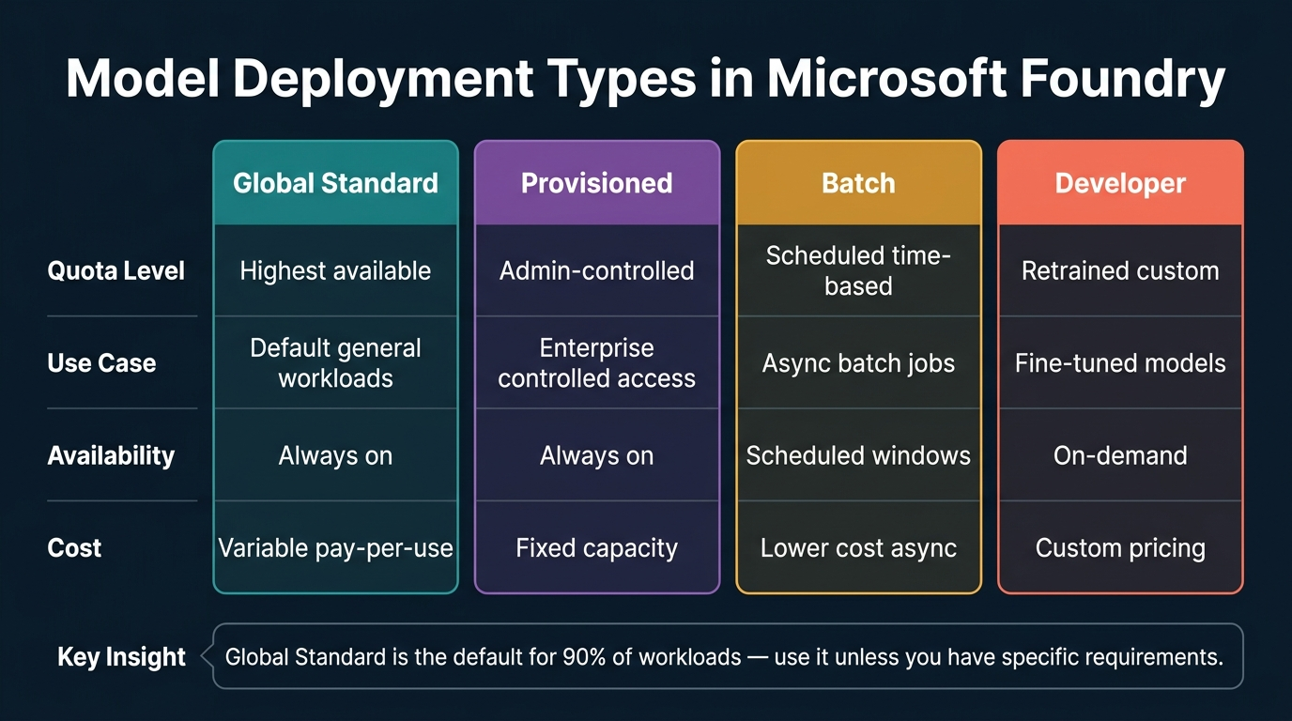
Figure 4. Model Deployment Types in Microsoft Foundry: A comparison matrix showing four deployment types — Global Standard, Provisioned, Batch, and Developer — evaluated across quota level, use case, availability, and cost.
1. The Microsoft Foundry Model Catalog provides access to approximately 3,000 models from seven organisations, each deployable with configurable parameters for quota, region, and deployment type.
2. Four parameters compare models: Quality Index (accuracy from user feedback), Safety (content filter effectiveness), Throughput (output token efficiency), and Cost (pricing based on tier and capabilities).
3. GPT 5.2 is costlier than GPT 4.1 because it is trained on a larger dataset, offers enhanced multilingual support, processes text/images/audio, and includes reasoning capabilities.
4. Four deployment types exist: Global Standard (highest quota, default), Provisioned (admin-controlled quota), Batch (scheduled time-window), and Developer (fine-tuned/retrained models).
5. Global Standard deployment should be the default choice for approximately 90% of use cases — it provides the highest available quota with variable pay-per-use pricing and always-on availability.
6. When deploying a model in the lab, students must reduce Tokens Per Minute (TPM) to 10K to stay within subscription quota limits — in production, this value is configured based on expected traffic.
7. Three evaluation methods are available: Manual Testing (subjective user checking), Automated Testing (synthetic data with BLEU/ROUGE metrics), and LLM-as-a-Judge (using a proven model to evaluate another).
8. Manual testing remains the most reliable evaluation method because automated testing depends on synthetic data (which may contain errors) and LLM-as-a-judge introduces hallucination risk.
9. Three manual evaluation criteria: Relevance (response addresses the topic), Groundedness (response references provided data), and Fluency (linguistic correctness and natural language quality).
10. These three evaluation criteria are general descriptive terms rather than formal metrics — they guide human evaluators in assessing acceptable model performance.
11. LLM-as-a-judge works by giving an input question and the model's response to a separate, trusted LLM for quality evaluation.
12. Model evaluation reports for base foundation models are pre-computed — fetched from previously run automated tests rather than regenerated each time.
13. The playground is a testing sandbox where changes to system messages affect only the playground session — they do not modify the deployed model's behaviour when consumed via API.
14. The "Code" button in the playground reveals the backend request code, showing the JSON payload structure for custom client applications.
15. Deployment regions matter significantly: West US 3, East US 2, and Central US have nearly all model versions available; other regions may have gaps.
16. Labs are the most important exam preparation because questions are scenario-based — remembering specific steps, configurations, and parameter choices is more valuable than theory alone.
17. Lab 2 (Explore Models and Evaluate Performance) was assigned as homework worth 5 marks — capture 5-6 screenshots and compile into a Word document.
18. The model monitoring dashboard provides: total request count, total token count, estimated cost, input token breakdown, and output token count.
19. The evaluation process in Lab 2 includes both manual evaluation (playground interaction) and automated evaluation (creating an evaluation run).
20. Understanding the four evaluation parameters (quality, safety, throughput, cost) is exam-critical for deployment scenario recommendations.
📌 TEACHER'S NOTE
"The labs are more important to clear your exam. Questions will be scenario-based and towards practical implementation. The more labs you do, the more effective your answering will be. Before the exam, execute all labs at least two times."
— Kiran Dambal

KEY TERMS
Global Standard Deployment — The default deployment type providing highest available quota with variable pay-per-use pricing; recommended for ~90% of use cases.
Tokens Per Minute (TPM) — A quota-limiting parameter controlling how many tokens a deployed model can process per minute.
Groundedness — A manual evaluation criterion assessing whether a model's response is anchored to the specific data source provided.
LLM-as-a-Judge — An evaluation method where a trusted LLM assesses the quality of another model's responses.

══════════════════════════════════════════════════════════════════════

TOPIC 5: Developing Generative AI Applications — APIs and SDKs
Building a functional generative AI application requires understanding how to consume a deployed model programmatically — selecting the right API, configuring authentication, and managing conversation context.
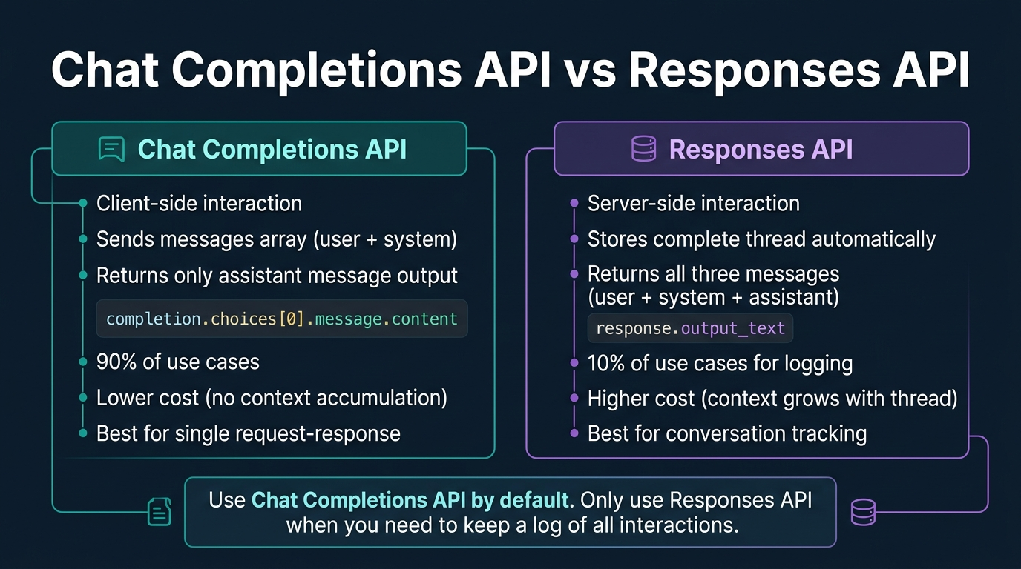
Figure 5. Chat Completions API vs Responses API: The two primary methods for consuming deployed models — Chat Completions API (client-side, 90% of use cases) vs Responses API (server-side, for logging).
1. Two APIs exist for consuming deployed models: Chat Completions API (client-side, sends messages array, returns only assistant's response) and Responses API (server-side, stores complete conversation thread).
2. Chat Completions API is used approximately 90% of the time — the developer already knows the input and system message they sent, so retrieving only the assistant's response minimises token consumption and cost.
3. Responses API is used when conversation logging or thread tracking is required — it returns all three message types as a complete thread, enabling applications that need full conversation history.
4. In Chat Completions API, the response is accessed via completion.choices[0].message.content; in Responses API, via response.output_text.
5. Cost implications are significant: with Responses API, previous context is appended for each new interaction, causing token count to grow — first conversation may consume 400 tokens, the second 800, the third 1,200.
6. Context growth management strategies include: replacing (overwriting) previous context, using a double-ended queue (deque) limited to three recent conversations, or creating a separate index for conversation history.
7. The messages array contains two components: the system message (defining model behaviour and format) and the user message (the actual question) — both sent as a JSON object from the client side.
8. Authentication pattern: OpenAI SDK works with either API Key or Intra ID; Microsoft Foundry SDK requires Intra ID; the Foundry Toolkit uses Intra ID by default.
9. The .env file stores credentials (endpoint URL and model deployment name) as environment variables, avoiding hardcoded sensitive information.
10. Azure CLI login (az login) is required for Intra ID authentication — generating a bearer token stored in token_provider for the OpenAI client.
11. Endpoint selection rule: Azure OpenAI Endpoint for GPT/OpenAI models only; Project Endpoint for non-OpenAI models or any other Foundry service.
12. SDK selection rule: OpenAI SDK for LLMs; Microsoft Agent Framework SDK for building agents; Microsoft Foundry Tools SDK for consuming pre-built AI services.
13. The Project Endpoint is a universal endpoint (superset of Azure OpenAI Endpoint) — it works for everything including OpenAI models.
14. The chat application in Lab 3 followed: load env variables → authenticate with Intra ID → initialise OpenAI client → send messages array → receive completion → print assistant message.
15. The VM lab environment provides pre-installed Python, VS Code, and internet connectivity — cloning the course repository from GitHub provides boilerplate code.
16. Requirements.txt contains three essential packages: python-dotenv, azure-identity, and openai — must be installed via pip install -r requirements.txt in each new VM session.
17. Playground testing and programmatic consumption via SDK are independent — system message changes in the playground do not affect external API consumption.
18. The "Call Model" button provides ready-to-use code snippets in Python, JavaScript, C#, Go, Java, and cURL — already configured with the correct endpoint and authentication.
19. Foundry also offers a cloud-based VS Code instance launched from the playground, pre-connected to the deployed model for rapid prototyping.
20. Cost-optimised recommendation: use Chat Completions API with context replacement (not accumulation), Global Standard mode with lowest acceptable TPM, and Intra ID authentication.
📌 TEACHER'S NOTE
"Chat Completions API — 90% of the time that is what you will use. I don't want to know what I asked, I know what I asked. I just want the output from my model. Responses API is only for when you need logs."
— Kiran Dambal

KEY TERMS
Chat Completions API — A client-side API sending a messages array and returning only the assistant's response; used in ~90% of applications.
Responses API — A server-side API storing complete conversation threads; used when logging or full context access is required.
Intra ID — Microsoft's identity service (formerly Azure AD) generating bearer tokens for authentication without exposing API keys.
.env File — An environment variable configuration file storing credentials outside application code for centralised management.

══════════════════════════════════════════════════════════════════════

TOPIC 6: Tools in Generative AI Applications
Tools are the components that transform a basic generative AI chat application into an intelligent, capable solution by connecting it to external data sources and action capabilities. Without tools, an LLM can only respond from its training data — with tools, it can access real-time information, execute code, search uploaded documents, and perform custom actions.
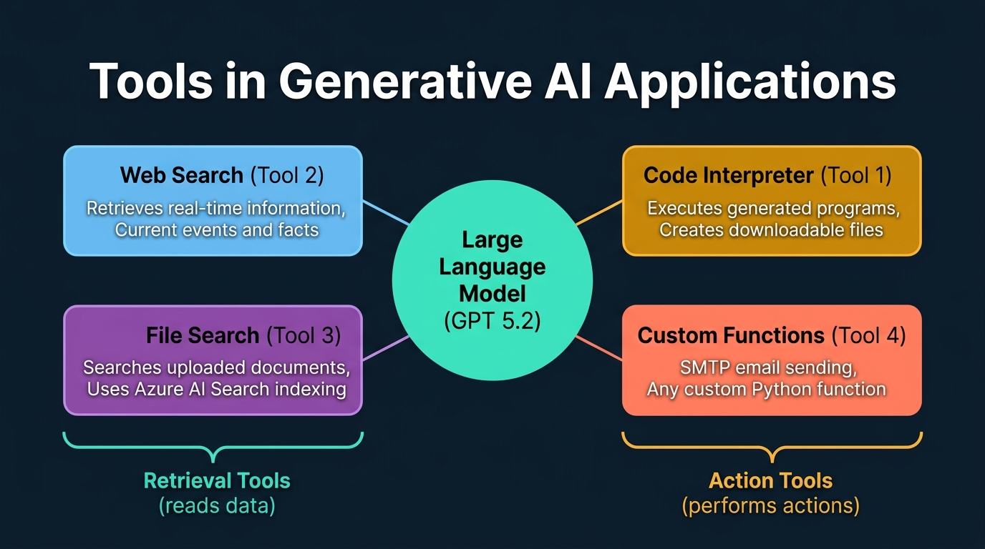
Figure 6. Tools in Generative AI Applications: A central LLM connected to Code Interpreter, Web Search, File Search, and Custom Functions — categorised as Retrieval Tools and Action Tools.
1. Tools are external connections that extend a model's capabilities beyond pre-trained knowledge — enabling real-time information access, action execution, grounded responses, and intelligent workflows.
2. Two categories of tools: Retrieval Tools (read data from external sources — web search, file search) and Action Tools (perform actions — code interpreter, custom functions).
3. Code Interpreter executes programs generated by the model — the LLM writes Python code, and code interpreter runs it to produce output files; it does not validate program correctness.
4. Without code interpreter enabled, asking ChatGPT to generate a file only produces text content with instructions to manually save it; with code interpreter, the same prompt produces a downloadable file.
5. Web Search retrieves real-time information — GPT 5.6 is trained only through October 2025, so without web search, it cannot answer questions about 2026 events.
6. File Search operates on user-uploaded documents using Azure AI Search as the backend — creating an index (not embeddings) for document search.
7. Critical distinction: File Search uses page-based indexing (not vector embeddings) — documents are stored as direct text in a JSON-based index, not numerical vector representations.
8. In the lab, File Search processed six travel brochure PDFs by converting all documents into a single index named "travel_brochure" using Azure AI Search.
9. Custom Functions allow any Python function to be registered as a tool — for example, an SMTP email function enabling the agent to send emails when instructed.
10. Lab 4 used Responses API because the application needed conversation tracking — sequential questions about the same topic can reuse previously retrieved data.
11. The last_response_id variable maintained previous conversation context by overwriting (not appending) — a deliberate cost-optimisation choice.
12. The system message specified both domain constraint ("answer from travel brochures") and web search fallback ("search web for general information"), creating a two-tier retrieval strategy.
13. Responses API was chosen because both file search and web search tools require context about previously retrieved data to avoid redundant index lookups.
14. Vector store creation: authenticate → create vector store → stream and upload PDF files → poll until conversion completes → receive vector store ID for tool configuration.
15. File search supports up to 200 MB of uploads (~10,000 files) — all consolidated into a single searchable index document.
16. Tool configuration in Responses API uses a tools parameter accepting a list of tool definitions with type and resource specifications.
17. File search provided citation information with responses, showing which document and section was referenced — enabling transparency and auditability.
18. Knowledge storage has two modes: Index-based (temporary, for lab file search) and Knowledge Base (permanent, using Foundry IQ with persistent storage connections).
19. For enterprise deployment, the Knowledge Base approach via Foundry IQ is recommended over local file search — providing permanent, scalable data connections.
20. The model decides autonomously when to invoke a tool based on the user's query — if training data suffices, no tool is called; if real-time data is needed, web search triggers automatically.
📌 TEACHER'S NOTE
"The model writes the program. Code interpreter just executes it. Code interpreter's job is not to check what the program is or whether it matches the user's request — its job is only to execute whatever program is given to it."
— Kiran Dambal

KEY TERMS
Code Interpreter — An action tool executing LLM-generated programs to produce outputs; does not validate correctness, only executes.
File Search — A retrieval tool using Azure AI Search to create text-based indexes from uploaded documents; uses page-based indexing.
Vector Store — In Foundry, a text-based index (not a vector database) consolidating multiple files into a single searchable format.
Retrieval Augmented Generation (RAG) — A pattern where model responses are grounded in retrieved external data rather than relying solely on training data.

══════════════════════════════════════════════════════════════════════

TOPIC 7: Responsible AI Principles
The six Responsible AI principles are not just ethical guidelines — they are a guaranteed source of exam questions and a critical framework for every AI deployment decision. The instructor explicitly stated that minimum two to three questions (maximum four) in the AI-103 exam will test these principles through detailed scenario-based questions.
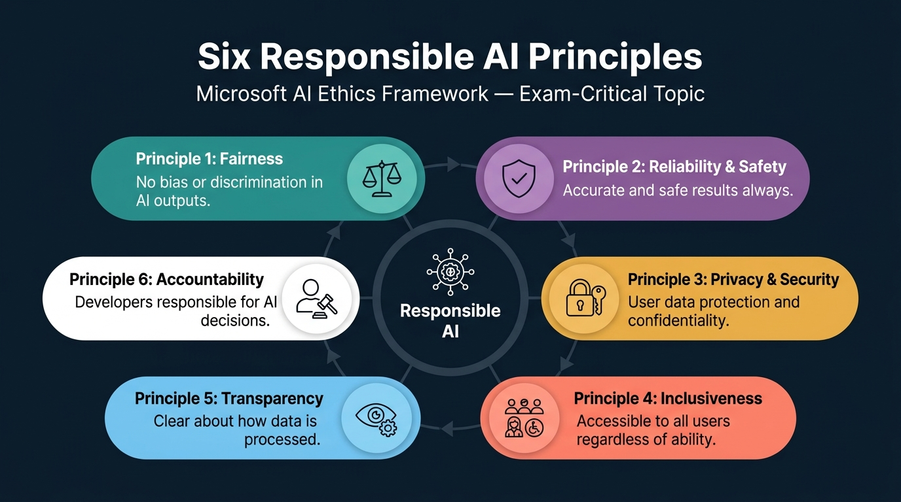
Figure 7. Six Responsible AI Principles: Microsoft AI Ethics Framework — Fairness, Reliability & Safety, Privacy & Security, Inclusiveness, Transparency, and Accountability. Exam-critical topic with 2-4 guaranteed questions.
1. The six Responsible AI principles — Fairness, Reliability & Safety, Privacy & Security, Inclusiveness, Transparency, and Accountability — have been a consistent exam topic across both AI-102 and AI-103 for the past four years.
2. Fairness addresses bias and discrimination — root causes include unrepresentative training data, wrong prompts with insufficient context, and lack of data diversity.
3. Reliability and Safety concerns output accuracy and safety — inaccurate outputs in safety-critical applications (like autonomous vehicles) can lead to physical harm.
4. Privacy and Security addresses data protection — most users do not trust generative AI with personal data because data processing in the backend is opaque.
5. Inclusiveness means providing AI access to all users regardless of ability — text input for mute users, speech for blind users, multilingual support for diverse populations.
6. Transparency requires being explicit about how user data is processed, stored, and consumed — communicated through terms and conditions and privacy policies.
7. Accountability assigns responsibility for AI decisions to developers and organisations — whether AI produces good or bad results, the builder is responsible.
8. Exam questions on these principles are scenario-based, not definitional — presenting detailed scenarios and asking which principle addresses the described issue.
9. Fairness vs Reliability distinction: Fairness addresses systematic bias against particular groups; Reliability addresses overall accuracy across all users and scenarios.
10. Privacy and Security has two dimensions: user-facing (informed consent and data control) and developer-facing (encryption, access controls, data isolation).
11. Inclusiveness extends beyond disability access to encompass multilingual support, multiple input modalities, and cultural sensitivity.
12. Transparency vs Accountability: Transparency is about informing users; Accountability is about accepting responsibility for consequences.
13. Despite sounding simple, these principles are deeply tested — multiple principles may seem to apply, and candidates must identify the most directly relevant one.
14. Fairness violations commonly appear in scenarios involving biased hiring algorithms, discriminatory loan models, or facial recognition systems with demographic performance gaps.
15. Reliability and Safety scenarios typically involve autonomous systems where incorrect outputs could cause physical harm, financial loss, or life-threatening consequences.
16. Privacy scenarios focus on data handling — chatbots storing conversations accessibly, or models memorising and reproducing personal information from training data.
17. Inclusiveness scenarios test whether applications support users with disabilities, multiple languages, or alternative input/output modalities.
18. Transparency scenarios involve situations where users are unaware of AI decision-making factors — loan rejections without explanation, undisclosed use of browsing history.
19. Accountability scenarios present situations where AI has caused harm and ask who is responsible — the developer and deploying organisation bear accountability.
20. Exam preparation recommendation: study each principle through multiple real-world examples, practice scenario mapping, and learn the nuanced differences between overlapping principles.
📌 TEACHER'S NOTE
"These six principles might sound very simple to you. Definitely, out of 37 or 38 questions in the exam, two to three questions will be from these principles. And the questions will not be easy — they will give you detailed scenarios."
— Kiran Dambal

KEY TERMS
Fairness — Ensuring AI systems do not produce biased or discriminatory outputs; root causes include unrepresentative training data and insufficient prompts.
Reliability & Safety — Ensuring AI outputs are consistently accurate and do not cause harm; critical in autonomous vehicles and medical diagnosis.
Inclusiveness — Ensuring AI is accessible to the widest user range through multiple modalities, multilingual support, and disability accommodations.
Accountability — Assigning responsibility for AI decisions to developers and organisations, requiring remediation processes for AI-caused harm.

Lab Activities Summary

Labs Completed in Class
Lab # | Lab Name | Key Activities | Status
Lab 1 | Prepare for AI Development Project | Created Foundry project, deployed GPT 5.2, explored Foundry portal, configured Foundry Toolkit in VS Code | ✅ Completed
Lab 3 | Create a Generative AI Chat App | Cloned GitHub repo, configured .env file, installed requirements, built chat app using Chat Completions API | ✅ Completed
Lab 4 | Generative AI App with Tools | Created vector store from 6 travel PDFs, built tools-integrated app using Responses API with file/web search | ✅ Completed

Labs Assigned as Homework
Lab # | Lab Name | Assignment Details | Marks
Lab 2 | Explore Models and Evaluate Performance | Complete independently; capture 5-6 screenshots; compile as 'Assignment 1, Lab 2' | 5 marks

Lab Environment Details
- Platform: Skillable LODS (labs.skillable.com)
- Access Duration: 180 days (until ~October 31, 2026)
- Attempts per Lab: 10 maximum launches per lab
- VM Extensions: Timer-based with 15-minute extensions (max 3 extensions = 45 additional minutes)
- Authentication: Username + Temporary Access Pass (TAP), not password
- Common Issues: Keyboard disconnection (fix: reconnect/reboot VM), internet dropout (fix: reconnect)
- RBAC Restrictions: VMs allow creation of only lab-specific resources
- Key Reminder: Redeem training key by signing in first (not 'Register with Training Key') for full 180-day access

Glossary of Key Terms
Accountability — The Responsible AI principle assigning responsibility for AI system decisions to developers and organisations.
Agent-to-Agent (A2A) Protocol — A communication protocol between agents in multi-agent systems, enabling inter-agent communication.
Attention Mechanism — A technique assigning importance scores (0-1) to every token, enabling focus on semantically relevant words regardless of position.
Azure AI Search — Microsoft's search service used as the backend for file search tools, creating text-based indexes without vector embeddings.
Azure Content Understanding — A Foundry tool for intelligent extraction from any data type using a single sample document, without training.
Azure Document Intelligence — A Foundry tool for extracting structured information from documents, requiring training with sample templates.
Chat Completions API — A client-side API sending a messages array and returning only the assistant's generated response.
Code Interpreter — An action tool executing LLM-generated programs to produce output files.
CNN (Convolutional Neural Network) — A neural network category for processing digital data like images and videos.
Encoder/Decoder — The two components of a transformer: encoder performs NLU (understanding), decoder performs NLG (generation).
Fairness — Ensuring AI systems produce unbiased, non-discriminatory outputs.
File Search — A retrieval tool creating text-based indexes from uploaded documents using Azure AI Search.
Foundry IQ — Foundry's knowledge management system integrating external data via graph-based storage.
Foundry Project — The PaaS layer providing UI and access to models, agents, tools, and knowledge.
Foundry Resource — The IaaS layer providing dedicated compute, storage, and network connectivity.
Foundry Toolkit — A VS Code extension for bidirectional connectivity to the Foundry platform.
Generative AI — A subset of AI generating new data in response to prompts using large language models.
Global Standard Deployment — The default deployment type with highest quota and variable pay-per-use pricing.
Groundedness — An evaluation criterion assessing whether responses are anchored to provided data sources.
Inclusiveness — Ensuring AI is accessible to all users through multiple modalities and languages.
Intra ID — Microsoft's identity service (formerly Azure AD) for token-based authentication.
Large Language Model (LLM) — A model trained on transformer architectures capable of generating new content.
LSTM (Long Short-Term Memory) — An RNN enhancement adding cache memory with input/output/forget gates.
MCP (Model Context Protocol) — A protocol for connecting agents to external tools and data sources.
Microsoft Agent Framework SDK — An SDK combining Semantic Kernel and AutoGen for building multi-agent systems.
OCR (Optical Character Recognition) — A technique for reading text from images in information extraction applications.
Responses API — A server-side API storing complete conversation threads for logging and history.
Responsible AI — Microsoft's ethical framework comprising six principles governing AI development and deployment.
RNN (Recurrent Neural Network) — A neural network for sequential data processing, suffering from VGD for long sequences.
Tokenization — Breaking text into smaller processing units (tokens) for sequential model processing.
Transformer Model — An architecture combining LSTM memory with attention, forming the foundation of LLMs.
Transparency — Requiring organisations to be explicit about how AI processes user data.
VGD (Vanishing Gradient Descent) — A problem where RNNs lose semantic meaning from earlier portions of long sequences.
Vector Store — In Foundry, a text-based index consolidating files into a single searchable format.

Key Takeaways from This Session
If you remember nothing else from this session, remember these:
1. Microsoft Foundry is the single platform that consolidates AI, generative AI, and agentic AI — understanding the distinction between Foundry Resource (infrastructure) and Foundry Project (platform) is fundamental.
2. The evolution from algorithms to LLMs follows a problem-solution chain where each innovation solved a specific limitation — understanding why each breakthrough occurred matters more than memorising dates.
3. Generative AI produces new data; traditional AI retrieves existing data — this distinction determines architecture, cost structure, evaluation methods, and deployment patterns.
4. Chat Completions API should be your default choice (90% of use cases) — use Responses API only when you need conversation thread logging or cross-turn retrieval.
5. Three endpoint and SDK choices must be matched correctly: OpenAI SDK + Azure OpenAI Endpoint for LLM consumption; Agent Framework SDK + Project Endpoint for agents; Foundry Tools SDK + Project Endpoint for pre-built services.
6. Tools transform a basic chat into an intelligent application — code interpreter for file generation, web search for real-time info, file search for document-grounded responses, custom functions for actions.
7. File search uses page-based indexing, not vector embeddings — faster, no embedding model needed, all documents consolidated into a single Azure AI Search index.
8. The six Responsible AI principles are exam-critical (guaranteed 2-4 questions) — pay special attention to Fairness/Reliability and Transparency/Accountability distinctions.
9. Labs are more important than theory for passing the exam — execute all 22 labs at least twice before the exam.
10. West US 3, East US 2, and Central US are the three best regions for model availability and highest quotas.
11. Context management is the hidden cost driver — use replacement strategies, deques, or separate indexes instead of appending previous conversations.
12. The Foundry Toolkit in VS Code provides bidirectional connectivity — exam questions will test knowledge of this extension and its Intra ID authentication.
13. Enterprise AI success requires more than technology — understanding data architecture, ROI assessment, and deployment challenges is equally important.

Suggested References
Microsoft AI-103 Official Certification Page (Microsoft Learn). The definitive resource for exam objectives, practice questions, and study guides for the Azure AI Apps and Agents Developer Associate certification.
Microsoft Foundry Documentation (Microsoft Learn — ai.azure.com). Official documentation for all Foundry services, APIs, SDKs, and tools covered in this course.
OpenAI API Documentation (platform.openai.com). Reference for Chat Completions API and Responses API specifications, authentication methods, and SDK usage patterns.
GitHub Repository: MS Learn AI Studio (github.com/Microsoft-Learning/ms-learn-ai-studio). The course repository containing boilerplate code for chat applications and tools-integrated applications.

Closing Summary
Day 1 of the AI-103 certification course established the foundational understanding upon which the entire programme is built. The session traced the evolution of artificial intelligence from simple algorithms through machine learning, neural networks, and transformer models to the large language models that power today's generative AI revolution.
The core technical framework introduced today centres on Microsoft Foundry as a unified platform-as-a-service. The critical distinction between Foundry Resource (infrastructure) and Foundry Project (platform) is the organising principle for every subsequent topic. With approximately 3,000 models from seven organisations, five Foundry tools, three SDKs, two endpoint types, and two authentication methods, the decision matrix for building generative AI applications is complex — but systematic and learnable.
The hands-on labs demonstrated the complete development lifecycle: from creating a Foundry project and deploying a GPT 5.2 model, through building a basic chat application using the Chat Completions API, to extending that application with tools (file search, web search) using the Responses API.
Looking ahead, tomorrow's session will cover guardrails and content filters, followed by the agentic AI module including the Microsoft Agent Framework, agent building, MCP integration, and agent-to-agent communication. Between now and the next session, complete Lab 2, review the six Responsible AI principles with scenario-based practice, and ensure your Azure access and LODS environment are fully operational.
══════════════════════════════════════════════════════════════════════
HANDOUT ASSEMBLY COMPLETE.
AI-103 — Azure AI Apps and Agents Developer Associate — Day 1 Student Handout
Instructor: Kiran Dambal, Microsoft Certified Trainer
Compiled from lecture transcripts — 22 August 2026

