AI-103 — Azure AI Apps and Agents Developer Associate
Day 4: Speech Voice Live, Computer Vision & Content Understanding

Instructor: Kiran Dambal
Student: Utsav
Date: 30 August 2026
Duration: ~4 hours (3 sessions)
Module: Module 3 (completion) & Module 4

Table of Contents
1. Session Overview
2. Learning Objectives
3. Topic 1: LLM Classification Framework
4. Topic 2: Azure Speech Voice Live Agent
5. Topic 3: Voice Live Client Application Development
6. Topic 4: Computer Vision & CNN Fundamentals
7. Topic 5: Vision-Enabled Generative AI Applications
8. Topic 6: Document Intelligence & Content Understanding
9. Topic 7: Content Understanding Studio — Image Analysis
10. Topic 8: Content Understanding Studio — Multi-Modal Analysis
11. Topic 9: AI-103 Exam Preparation Guide
12. Glossary of Key Terms
13. Key Takeaways
14. Suggested References
15. Closing Summary

Session Overview
- This handout covers the final day of AI-103 (Module 15), completing Module 3 (Language & Speech Services) and the entirety of Module 4 (Extracting Insights from Visual Data).
- The session began with a comprehensive recap of agents, multi-agent orchestration frameworks (concurrent, sequential, group chat, handoff), and NLP services covered on previous days.
- A deep-dive into LLM classification was provided, covering three categorisation axes: data type (unimodality vs multimodality), training data size (LLM vs SLM), and training process (pre-trained, matured, fine-tuned).
- Azure Speech Voice Live was introduced as a real-time, event-based conversational framework using PCM16 encoding and G.711 decoding for speech-to-speech interactions with Foundry agents.
- Computer Vision fundamentals were reviewed, including CNN architecture (convolutional, max pooling, flatten layers) and vision-enabled generative AI applications using GPT-5 multimodal models.
- Content Understanding Studio was explored as an evolution of Document Intelligence, supporting image, document, audio, and video analysis through custom analyzers and few-shot learning.
- Detailed AI-103 exam preparation guidance was shared, including exam structure, difficulty tips, and practice assessment strategies.

Learning Objectives
After this session, you will be able to:
- Classify any large language model along three axes: data modality (unimodal vs multimodal), training data scope (LLM vs SLM), and training process (pre-trained, matured, fine-tuned).
- Configure and deploy an Azure Speech Voice Live agent by enabling audio mode in Microsoft Foundry and connecting it to a GPT-5 model for real-time speech interactions.
- Explain the role of PCM16 (16-bit Pulse Code Modulation) for speech recognition and G.711 for speech synthesis in the Voice Live pipeline.
- Build a Voice Live client application using the Azure AI SDK, integrating authentication, audio processing, session management, and event handling components.
- Describe the CNN architecture layers (convolutional, max pooling, flatten) and their roles in computer vision feature extraction.
- Develop a vision-enabled generative AI application that submits both image and text inputs to a multimodal LLM using either the Chat Completion API or the Response API.
- Distinguish between Document Intelligence (legacy, PDF/image-only) and Content Understanding (current, supports images, documents, audio, and video) services in Azure.
- Create custom analyzers in Azure Content Understanding Studio for images, documents, audio, and video data, defining extraction fields and building reusable analyzer models.
- Apply few-shot learning techniques to train Content Understanding analyzers for handling diverse document templates and formats.
- Prepare effectively for the AI-103 certification exam using the exam guide, sandbox environment, and practice assessments.

Topic 1: LLM Classification Framework
Understanding how large language models are categorised is essential for selecting the right model for any enterprise AI application. The instructor introduced three distinct classification axes that collectively define any language model’s capabilities, scope, and readiness for deployment. This framework provides a structured lens through which students can evaluate models such as GPT-3.5, GPT-5, DALL·E, and domain-specific SLMs like Finance GPT. Mastering this taxonomy is foundational for every subsequent topic in the AI-103 curriculum.
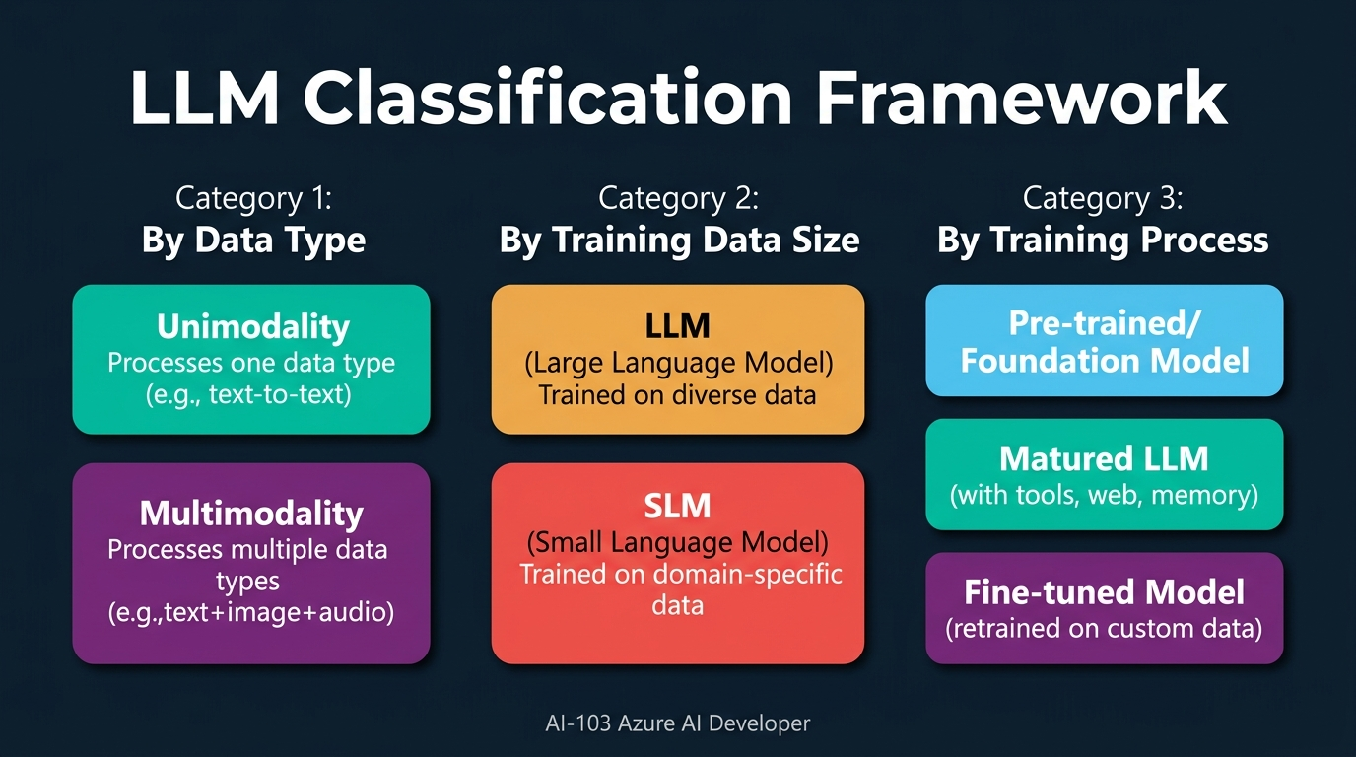
Figure 1. LLM Classification Framework: Three axes of model categorisation — by data type, training data size, and training process. [Generated infographic — AI-103 lecture series.]
- The first classification axis is based on the type of data a model can process, dividing models into unimodality and multimodality categories.
- A unimodality LLM processes only one type of data as input and generates only one type of data as output — for example, GPT-3 and GPT-3.5 could only process text and generate text.
- A multimodality LLM can process or generate more than one type of data, either at input or output; GPT-4.1 processes text, speech, and images as input but generates only text output, yet still qualifies as multimodal.
- DALL·E, despite converting text to images, is classified as a unimodal model because it processes only one input type (text) and produces only one output type (images) — the key criterion is whether more than one type is handled on either side.
- Models from GPT-5 onwards can process multiple data types simultaneously (text, image, and audio together in a single request), representing a significant advancement over earlier multimodal models that handled one type at a time.
- The second classification axis is based on the size and scope of training data, distinguishing Large Language Models (LLMs) from Small Language Models (SLMs).
- LLMs are trained on diverse, cross-domain data — they can answer questions about AI, finance, environment, education, and virtually any topic, making them general-purpose knowledge systems.
- SLMs are trained on limited, domain-specific data for a particular use case; Finance GPT, for example, is an official OpenAI SLM trained exclusively on financial information and cannot answer questions about unrelated topics like global warming.
- When an organisation needs a generative AI application that answers only about its own company data and policies, building or using an SLM is more appropriate and efficient than deploying a full LLM.
- The third classification axis is based on the model training process, producing three categories: pre-trained (foundation) models, matured LLMs, and fine-tuned models.
- Pre-trained models (also called foundation models) answer only based on the data they were originally trained upon — they have no awareness of information outside their training corpus, such as a specific individual’s identity.
- Matured LLMs are enterprise-ready models augmented with additional context beyond the pre-training data, including web search capabilities, code interpreters, file search tools, memory of previous conversations, and custom data integrations.
- ChatGPT exemplifies a matured LLM because it can access web search results and retain conversation context, enabling it to answer questions about topics and individuals not in its original training data.
- Fine-tuned models are created by re-initiating the training process on an already-trained model with additional domain-specific data, permanently embedding that new knowledge into the model’s parameters.
- Fine-tuning differs from matured LLMs in that the additional knowledge becomes a permanent part of the model’s weights, whereas matured LLMs access external information at runtime through tools and retrieval systems.
- The instructor emphasised that these three axes are not mutually exclusive: a single model can be classified along all three dimensions simultaneously — for example, GPT-5 is multimodal, an LLM by data scope, and available as both a pre-trained and a matured variant.
- Understanding the distinction between LLM and SLM is critical for industry applications: banks typically use SLMs for chatbots because they need domain-specific accuracy without the overhead and risk of general-purpose knowledge.
- The classification framework has direct exam relevance — while questions will not directly test these categories, the terminology (unimodal, multimodal, SLM, foundation model, fine-tuned) appears throughout AI-103 exam questions.
- Stable Diffusion was cited as another example of a unimodal model (text-to-image only), reinforcing that the modality classification is about the number of distinct data types, not the direction of conversion.
- The practical implication of this framework is that model selection in enterprise projects should begin by answering three questions: what data types must it handle, how broad must its knowledge be, and how permanently must it learn new domain knowledge.
📌 TEACHER'S NOTE
"It does not matter what type of conversion it does — if either in input or output, it handles more than one type of data, it is multimodal. DALL·E is unimodal because text-in, image-out is still one type each side."
— Kiran Dambal

KEY TERMS
UNIMODALITY — A model classification where the LLM processes only one data type as input and generates only one data type as output, regardless of whether the input and output types differ.
MULTIMODALITY — A model classification where the LLM can process or generate more than one data type on either the input side, the output side, or both — examples include processing text plus images simultaneously.
SLM (Small Language Model) — A language model trained on limited, domain-specific data for a particular use case or industry, offering focused accuracy at the cost of general-purpose knowledge.
FINE-TUNING — The process of re-initiating model training on an already pre-trained model with additional domain-specific data, permanently embedding the new knowledge into the model’s parameters.
FOUNDATION MODEL — A pre-trained model that serves as the base version of an LLM, answering only from its original training data without access to external tools, web search, or additional context.

Topic 2: Azure Speech Voice Live Agent
Azure Speech Voice Live represents the evolution of speech-enabled AI from the manual pipeline of speech recognition → text → LLM → text → speech synthesis to a native, real-time conversational framework. Before multimodality, developers had to chain separate Azure Speech Recognition and Speech Synthesis services around a text-only LLM. With Voice Live, multimodal models like GPT-5 natively understand audio input and generate audio output, enabling seamless voice conversations similar to ChatGPT’s voice mode, Google Assistant, or Siri. This topic covers the architecture, key audio codecs, and configuration of Voice Live agents in Microsoft Foundry.
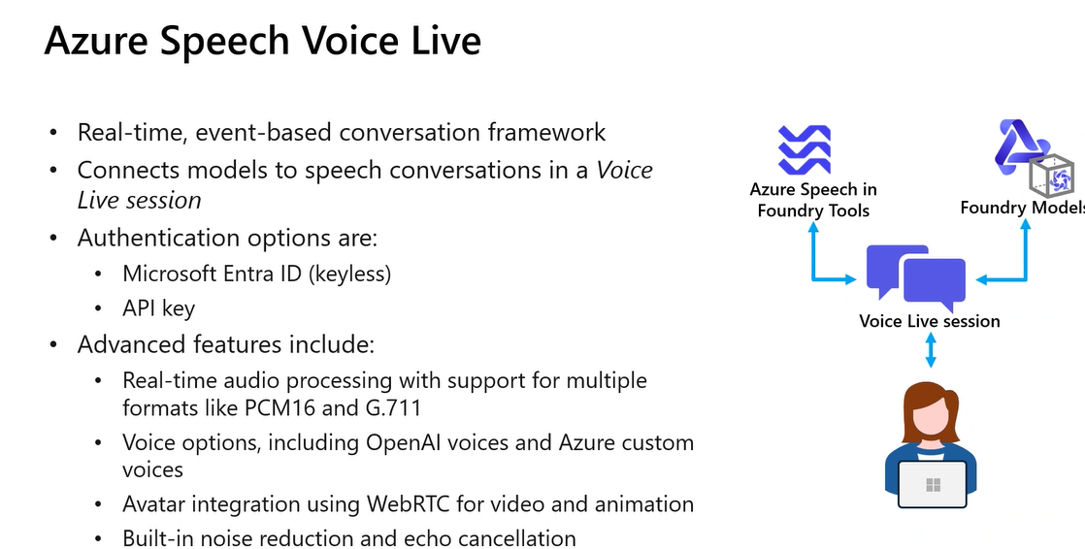
Figure 2. Azure Speech Voice Live architecture: Real-time event-based conversation framework connecting Azure Speech in Foundry Tools, Foundry Models, and Voice Live sessions. [Source: Instructor slide — Session 4.]
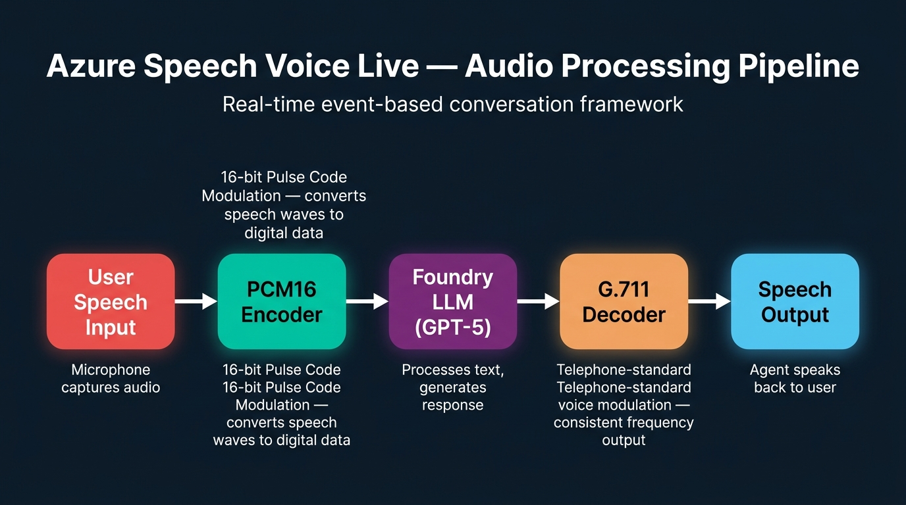
Figure 3. Voice Live Audio Processing Pipeline: PCM16 encoding for speech input and G.711 decoding for speech output. [Generated infographic — AI-103 lecture series.]
- Before multimodal models existed, voice-enabling a generative AI application required a three-step pipeline: Speech Recognition converted spoken words to text, the text was submitted to a text-only LLM, and the LLM’s text output was passed to Speech Synthesis to generate spoken audio back to the user.
- Azure Speech Voice Live eliminates this manual pipeline by leveraging multimodal LLMs (GPT-5 and above) that natively understand audio input and generate audio output, creating a direct speech-to-speech interaction.
- Voice Live is a real-time, event-based conversation framework — it does not process audio in batch but maintains a continuous bidirectional audio stream between the user and the agent.
- Two critical audio codecs power the Voice Live pipeline: PCM16 (16-bit Pulse Code Modulation) for recognising speech input, and G.711 for generating speech output.
- PCM16 works by converting human speech (represented as sine waves) into digital data by sampling the audio signal at regular intervals, measuring the amplitude with 16-bit precision, and encoding it into a processable format.
- G.711 is a telephone-standard voice modulation codec that generates audio output with consistent frequency characteristics — the pitch and voice modulation vary naturally, but the underlying sound quality remains uniform throughout.
- To enable Voice Live on a Foundry agent, the developer toggles the “Voice mode” switch in the agent’s configuration panel, selects the GPT-5 model, and saves — no additional service deployment is required.
- The Voice Live configuration panel exposes Speech Input settings including recognition model selection, language auto-detection (supporting multilingual conversations), end-of-utterance detection, audio enhancement, and phrase lists.
- End-of-utterance detection, when enabled, causes the system to wait until the speaker pauses for a few seconds before processing the input, rather than attempting real-time mid-sentence processing.
- Speech Output settings include voice selection from the Azure voice gallery (e.g., Ava Multilingual, Andrew Multilingual), playback speed control (default 1x, adjustable slower or faster), and advanced settings for interim responses and avatar integration.
- The Voice Live system supports avatar integration using WebRTC for video and animation, enabling visual representations of the AI agent during conversations.
- Built-in noise reduction and echo cancellation are integrated into the Voice Live pipeline, automatically cleaning audio during both input recognition and output generation.
- Authentication for Voice Live uses the same Azure CLI credential and barrier token mechanism as other Foundry services, with the endpoint specified only to the Azure.com level (not the full project endpoint).
- The Voice Live agent functions as a tool within the agent framework — when the agent is initiated with audio data, it uses the Voice Live tool for processing audio input and generating speech responses.
- A Voice Live session follows a specific lifecycle: connection initiation → audio process setup → conversation start → playback initiation → event processing → event handling → session shutdown.
- The system supports queuing multiple speech inputs, processing them sequentially as request one, request two, etc., with the queue being cleared after each question is answered.
- The Azure Semantic VAD (Voice Activity Detection) Multilingual library is used to detect which language the user is speaking, enabling the agent to respond appropriately in any supported language.
- Server event types (session_updated) are used to communicate between the client application and the Azure Speech tool, enabling real-time status updates and response coordination.
- Voice Live requires the GPT-5 model or later variants; earlier models like GPT-4.1 do not support native audio input/output and would require the legacy speech recognition/synthesis pipeline.
- The instructor demonstrated that VM-based lab environments sometimes have microphone connectivity issues that prevent Voice Live from working, but the same code functions correctly on local machines with proper audio hardware.
📌 TEACHER'S NOTE
"Earlier, what we used to do to give a voice enablement for unimodality LLMs — we used speech recognition, submitted text to the LLM, and then speech synthesis spoke back. Nowadays, multimodality is in the picture. No need to do that. The model itself understands what you are speaking and generates back the audio output."
— Kiran Dambal

KEY TERMS
PCM16 (16-bit Pulse Code Modulation) — An audio encoding standard that converts analogue speech waves into digital data by sampling at 16-bit precision, used in Voice Live for speech recognition and input processing.
G.711 — A telephone-standard audio codec used in Voice Live for speech output generation, producing consistent-frequency audio with natural pitch variation but uniform sound quality.
VOICE LIVE SESSION — A real-time, bidirectional audio conversation between a user and a Foundry agent, managed through event-based processing and server event types.
UTTERANCE — The speech input provided by a user — in Voice Live configuration, end-of-utterance detection determines when the system considers the user has finished speaking.
VAD (Voice Activity Detection) — A component that detects when a user is actively speaking versus silent, used in multilingual mode to identify the language being spoken.

Topic 3: Voice Live Client Application Development
After configuring a Voice Live agent in the Foundry playground, the next step is building a client application that consumes the agent programmatically. This topic covers the Python SDK architecture for Voice Live, including the libraries, authentication flow, audio processing classes, and event handling patterns required to build a production-ready voice assistant. The client application demonstrates how to connect to Azure’s Voice Live service, capture microphone input, process it through the LLM, and play back synthesised responses.
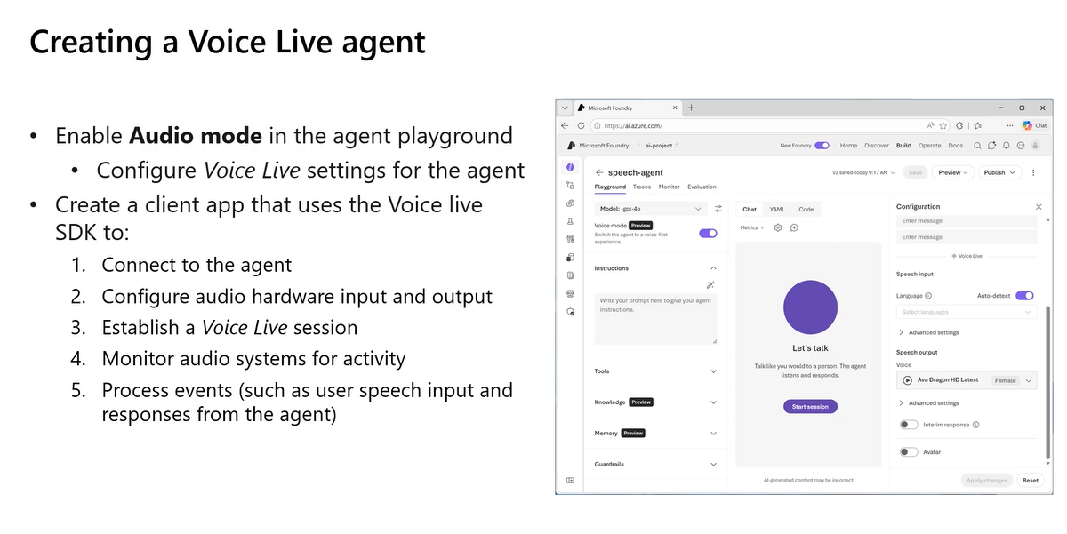
Figure 4. Creating a Voice Live Agent: Enabling Audio mode in the agent playground and configuring Voice Live settings including speech input/output and voice selection. [Source: Instructor slide — Session 4.]
- The Voice Live client application requires three core Python packages: dotenv for environment credential loading, PyAudio for microphone recording and speaker playback, and aiohttp for asynchronous HTTP communication with the Foundry Speech tool.
- Authentication follows the Azure CLI credential pattern: executing “az login” generates a barrier token in the terminal, which is picked up by the DefaultAzureCredential class and stored in a credential variable.
- The .env configuration file contains three values: the endpoint (specified only to Azure.com level), the project name, and the Voice Live agent ID (the agent’s name, e.g., “chat-agent”).
- The endpoint is truncated to Azure.com (rather than the full project URL) because the Voice Live application connects to both the project and the Azure AI Speech service, requiring the broader endpoint scope.
- The agent configuration (AgentConfig) combines the agent name and project name, enabling the SDK to locate and authenticate against the correct Foundry project and agent.
- From the Voice Live SDK models, several pre-built AI model classes are imported: audio input format (pitch, hertz, frequency analysis), modularity (data type representation), output audio format (voice-matched synthesis), and request session management.
- The AudioNoiseReduction class reduces background noise during speech generation, while EchoCancellation prevents audio feedback loops during simultaneous input and output processing.
- The AzureSemanticVADMultilingual class enables the system to detect and respond in multiple languages, supporting conversations where the user may switch between English, Hindi, Kannada, or any other supported language.
- The main VoiceAssistant class coordinates the entire conversation flow through five sequential steps: connecting to Azure, setting up audio processing, initiating the conversation, starting playback, and processing events.
- Connection initiation uses the connect() method with the endpoint, credential, API version, and agent configuration, establishing a persistent bidirectional channel for audio data.
- Audio processing is managed by a dedicated AudioProcess class that handles microphone configuration, speaker setup, audio input capture, and output playback coordination.
- The setup_conversation method initialises a new conversation session, while start_playback enables the response playback pipeline — ensuring the agent’s spoken response can be heard through the user’s speakers.
- Event processing follows a producer-consumer pattern: process_event() delegates to handle_event() for each individual conversation turn (e.g., user says “hi”, agent responds “hello, how can I assist you?”).
- The AudioProcess class includes a queue mechanism for managing multiple concurrent speech inputs, processing them in order and clearing the queue after each response is delivered.
- The clear_playback_queue method removes completed conversation turns from the processing queue, preventing duplicate or stale responses.
- The shutdown method terminates the entire Voice Live session, closing the audio streams, disconnecting from Azure, and releasing system resources.
- Base64 encoding is used for audio data transmission between the client and the Azure service, ensuring binary audio data can be safely transmitted over HTTP connections.
- The server event type “session_updated” is used in the process_event handler to track the state of the conversation and coordinate between the client’s audio input and the server’s processing pipeline.
- Error handling must account for VM-specific issues such as microphone access permissions, audio driver compatibility, and network latency that can prevent the Voice Live connection from functioning correctly.
- The complete client application code pattern can be reused for any Voice Live agent by simply changing the agent name, project name, and endpoint in the .env file — the SDK architecture remains constant.
📌 TEACHER'S NOTE
"Why am I using my endpoint only till Azure.com? Because I am using the Azure AI Speech also for my speech recognition. It’s not only the project — inside a project, I’m using the Azure AI Speech tool as well. For that reason, I initialise the endpoint only till Azure.com."
— Kiran Dambal

KEY TERMS
PYAUDIO — A Python library for audio I/O that provides bindings to PortAudio, used in Voice Live client applications for capturing microphone input and playing synthesised speech output.
AIOHTTP — An asynchronous HTTP client/server framework for Python, used in Voice Live for making real-time API calls to the Azure Speech tool during audio conversations.
BARRIER TOKEN — An authentication token generated by Azure CLI login that grants temporary access to Azure services; picked up automatically by the DefaultAzureCredential class in the SDK.
AGENT CONFIG — A configuration object combining the agent name and project name, used to authenticate and connect to a specific Foundry agent for Voice Live sessions.

Topic 4: Computer Vision & CNN Fundamentals
Module 4 of AI-103 transitions from language and speech services to visual data processing. Computer vision is a category of AI that processes digital data represented in pixels — including images, videos, live streams, and document formats like PDFs and PowerPoint presentations. The instructor reviewed the foundational CNN (Convolutional Neural Network) architecture that underpins all computer vision models in Azure Foundry, connecting the theoretical understanding of neural network layers to the practical tools available in the Microsoft ecosystem.
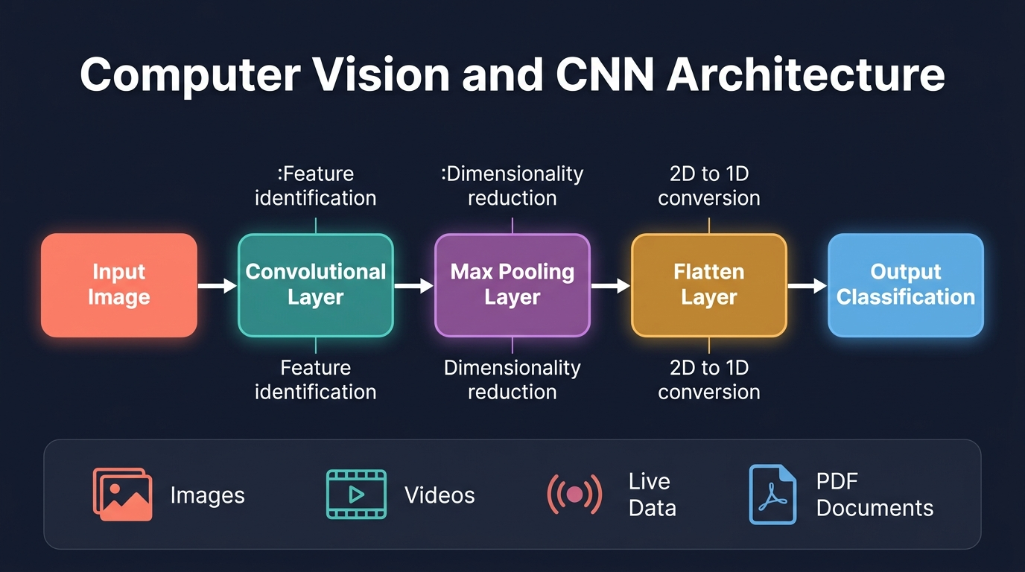
Figure 5. Computer Vision and CNN Architecture: The convolutional neural network pipeline from input image through feature extraction layers to output classification. [Generated infographic — AI-103 lecture series.]
- Computer vision is defined as the category of AI where features are processed and extracted from digital data represented in the format of pixels, encompassing images, videos, live data streams, and digital documents.
- Digital content in computer vision is represented as an RGB grid — each pixel contains three colour channel values (Red, Green, Blue), and the entire image is a two-dimensional matrix of these pixel values.
- Convolutional Neural Networks (CNNs) are the primary neural network architecture used for computer vision tasks, consisting of three types of layers within the hidden layer structure.
- The Convolutional Layer (Conv2D) is responsible for identifying features in the input image by applying learnable filters (kernels) that detect patterns such as edges, textures, and shapes.
- The Max Pooling Layer (MaxPool2D) reduces the dimensionality of the feature maps produced by the convolutional layer, retaining the most important features while decreasing computational requirements.
- The CNN architecture typically alternates convolutional and max pooling layers in a repeating pattern: Conv2D → MaxPool2D → Conv2D → MaxPool2D → Conv2D → MaxPool2D, progressively extracting higher-level features.
- The Flatten Layer is applied once, at the end of the hidden layer stack, converting the two-dimensional feature maps into a one-dimensional vector suitable for input into fully connected classification layers.
- PyTorch is the primary deep learning library used for building CNN-based computer vision models, both in general practice and within Microsoft Foundry’s pre-trained model ecosystem.
- Microsoft Foundry provides pre-trained computer vision models built with CNN architectures and PyTorch, ready for deployment without requiring students to train models from scratch.
- Module 4 covers three Foundry tools for visual data processing: the Computer Vision tool, Document Intelligence tools, and the Content Understanding tool.
- The computer vision tool in Foundry handles standard image analysis tasks including object detection, image classification, description generation, and tag extraction using pre-trained AI models.
- All models from GPT-5 onwards have native multimodal capabilities for processing images alongside text, enabling developers to submit images directly to the LLM without requiring a separate computer vision service.
- GPT-5 variants can process multiple data types simultaneously in a single request (text + image + audio together), whereas GPT-4.1 could handle multiple input types but only one at a time.
- The distinction between processing multiple types “one at a time” versus “simultaneously” is significant: GPT-5 can correlate information across modalities in a single inference, producing richer and more contextually aware outputs.
- Vision-enabled generative AI applications use the same API patterns (Chat Completion and Response APIs) as text-only applications, with the addition of image URLs or base64-encoded image data in the input payload.
- The instructor uses multimodal capabilities practically: uploading complex architecture diagrams to ChatGPT with the prompt “make it simple and explain it to me in simple words” for rapid comprehension.
- When submitting both image and text input to a multimodal LLM, the request body includes a role:user content array with two elements: one of type “text” containing the query, and one of type “image_url” containing the image reference.
- Audio input can also be added as a third element in the content array, enabling truly tri-modal requests that combine text instructions, image context, and voice annotations in a single API call.
- The practical lab (Lab 18) demonstrated deploying GPT-5.2, cloning a repository, configuring the .env file with the Open AI endpoint and model deployment name, and submitting an orange image with text prompts to generate recipe suggestions.
- Computer vision’s role in the AI-103 exam is weighted at approximately 25–30% of questions within the “Extracting Insights from Visual Data” module, making it a critical area for exam preparation.
📌 TEACHER'S NOTE
"Computer vision is not a technology — it is a whole category of AI where we process and extract features from digital data represented in the format of pixels. This particular digital data can be an image, a video, live data, or PDF documents, PowerPoint presentations — anything represented in the format of an RGB grid."
— Kiran Dambal

KEY TERMS
CNN (Convolutional Neural Network) — A deep learning architecture designed for processing grid-like data (images), using convolutional layers for feature extraction, pooling layers for dimensionality reduction, and flatten layers for classification preparation.
CONV2D (Convolutional Layer) — The feature identification layer in a CNN that applies learnable filters across the input image to detect patterns such as edges, textures, shapes, and objects.
MAX POOLING — A dimensionality reduction technique that downsamples feature maps by taking the maximum value in each local region, retaining the most prominent features while reducing computational cost.
FLATTEN — The layer that converts multi-dimensional feature maps (2D) into a single one-dimensional vector, bridging the convolutional layers and the fully connected classification layers.

Topic 5: Vision-Enabled Generative AI Applications
With multimodal LLMs now capable of processing images alongside text, developers can build powerful vision-enabled applications that analyse, describe, and reason about visual content. This topic covers the two API approaches for building these applications — the Chat Completion API and the Response API — and their respective use cases for stateless versus contextual image processing workflows. The practical implications for maintaining image context across conversation turns make this a critical architectural decision for any production application.
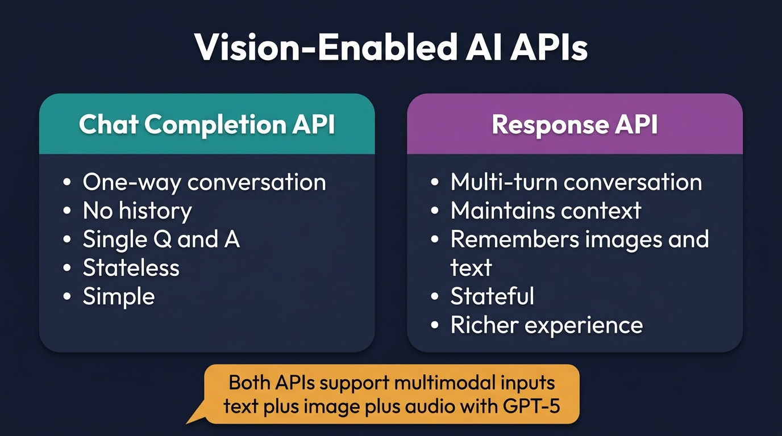
Figure 6. Vision-Enabled AI APIs: Comparison between Chat Completion API (stateless) and Response API (stateful, context-maintaining) for multimodal applications. [Generated infographic — AI-103 lecture series.]
- Vision-enabled generative AI applications use multimodal models that can accept image data as input alongside text, enabling the LLM to analyse, describe, and reason about visual content.
- Two API approaches are available for building vision-enabled applications: the Chat Completion API (stateless, one-turn) and the Response API (stateful, multi-turn with context retention).
- The Chat Completion API treats each request as an independent interaction — the model has no memory of previous images or text submitted in earlier turns, making it suitable for simple one-off analysis tasks.
- The Response API maintains context across multiple conversation turns, remembering previously submitted images, text, and the model’s prior responses, enabling iterative analysis workflows.
- The instructor demonstrated Response API context retention by first requesting a doodle image generation, then asking “what is undis?” (a typo in the generated image) without re-uploading the image — the model successfully referenced the previous image from context.
- In a follow-up turn, the instructor simply typed “now this” with a new text block, and the model correctly applied the same image generation style from the previous context, demonstrating seamless multi-turn understanding.
- For applications requiring image context retention (e.g., iterative design reviews, multi-step document analysis, or progressive image refinement), the Response API is the appropriate choice.
- For simple, standalone image analysis tasks (e.g., “describe this photo” or “what ingredients are in this image?”), the Chat Completion API is simpler to implement and more resource-efficient.
- The practical lab used the Response API (client.response.create) rather than the Completion API, even though both were viable options, demonstrating the instructor’s preference for context-aware interactions.
- The input payload structure for vision-enabled requests includes a developer role with the system message, followed by a user role with a content array containing both text and image_url type elements.
- Image data can be provided either as a direct URL (pointing to a hosted image) or as base64-encoded binary data embedded directly in the request payload.
- The system message for the lab was configured as a grocery store AI assistant that provides detailed answers about produce, demonstrating how system prompts can focus multimodal analysis on specific domains.
- The GPT-5.2 model was deployed specifically for this lab, though any GPT-5 variant (5.0, 5.1, 5.2, 5.2-mini, 5.2-nano) supports the same multimodal image processing capabilities.
- When using the Open AI endpoint (rather than the project endpoint), the application connects directly to the deployed model without needing the full Foundry project infrastructure, since no agents or tools are involved.
- The Azure Identity library provides the DefaultAzureCredential class, while the get_bearer_token_provider function generates the authentication token needed for the Open AI client connection.
- A key code difference between text-only and vision-enabled applications is the addition of the image_url content element in the user message — the rest of the application architecture remains identical.
- Audio input can also be added as an additional content element alongside text and image, enabling tri-modal requests for applications that need to process voice commands about visual content.
- The lab demonstrated that the model correctly identified a mango in the input image and generated relevant dessert recipes (mango pudding, mango chai pudding, mango mousse, mango sorbet), validating its visual understanding capabilities.
- Lab 19 (assigned as homework) reverses the flow: instead of giving an image as input, the student provides text prompts to generate images as output using GPT-5.2’s image generation capabilities.
- The practical architecture pattern for vision-enabled apps follows: deploy model → configure .env with endpoint and model name → install requirements (dotenv, azure-identity, openai) → authenticate → submit multimodal request → process response.
📌 TEACHER'S NOTE
"Without providing that image, without providing any of the previous context, I just asked what is undis — and it was able to map to the previous conversation, load that image which was in the previous context, and said it is a typo. That is the power of the Response API."
— Kiran Dambal

KEY TERMS
CHAT COMPLETION API — A stateless API for single-turn interactions where each request is independent, with no memory of previous conversations or submitted images — the conversation is “completed” after each exchange.
RESPONSE API — A stateful API that maintains context across multiple conversation turns, remembering previously submitted text, images, and model responses for iterative, multi-turn workflows.
MULTIMODAL REQUEST — An API request that includes more than one type of input data (e.g., text + image, or text + image + audio) in the content array, leveraging the model’s ability to process multiple modalities simultaneously.
OPEN AI ENDPOINT — The Azure-hosted endpoint URL for direct model access without Foundry project infrastructure, used when the application only needs LLM inference without agent tools or services.

Topic 6: Document Intelligence & Content Understanding
Content Understanding represents the evolution of Azure’s document processing capabilities, expanding from the legacy Document Intelligence service (limited to PDFs and images) to a comprehensive multimodal content extraction platform. This topic covers the architectural differences between the two services, the concept of analyzers, the role of few-shot learning in handling diverse document templates, and the four types of content that Content Understanding can process: images, documents, audio, and video.
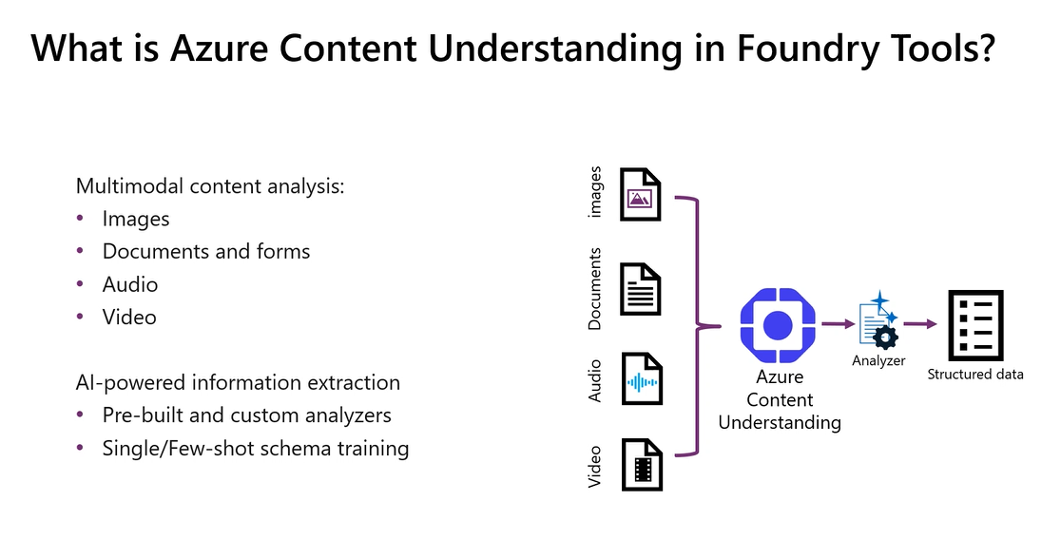
Figure 7. Azure Content Understanding in Foundry Tools: Multimodal content analysis pipeline processing images, documents, audio, and video through analyzers to produce structured data. [Source: Instructor slide — Session 4.]
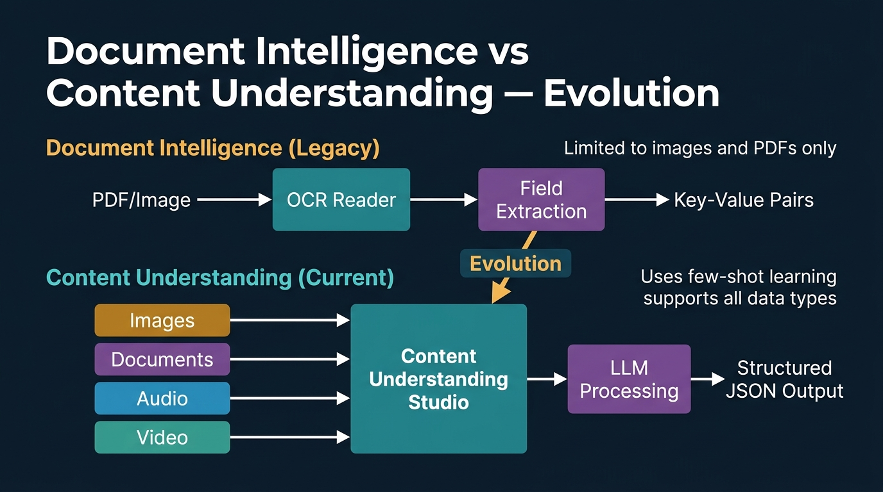
Figure 8. Document Intelligence vs Content Understanding — Evolution: The transition from PDF/image-only OCR-based extraction to multimodal LLM-powered content understanding. [Generated infographic — AI-103 lecture series.]
- Document Intelligence is an Azure service that reads entire documents using OCR (Optical Character Recognition) and extracts only the specific information needed, storing it as key-value pairs in predefined field placeholders.
- Unlike raw OCR, which extracts all text indiscriminately from top-left to bottom-right, Document Intelligence selectively extracts only the relevant data points (e.g., card number, holder name, expiry date) from a larger document.
- The practical example of Document Intelligence is mobile credit card scanning: when you photograph a card, the system reads everything but extracts only the card number, cardholder name, expiry date, and CVV into their respective fields.
- Document Intelligence was limited to only two data types: PDF documents and images — it could not process audio, video, or non-standard document formats.
- Content Understanding Studio is the evolution of Document Intelligence, performing the same extraction tasks but extending support to four data types: images, documents (any format), audio, and video.
- Content Understanding leverages LLMs (GPT-5 variants) in the backend rather than relying solely on traditional OCR and CNN models, enabling more intelligent and context-aware extraction.
- For document processing, Content Understanding uses a combination approach: pre-built AI models read the document content (similar to OCR), and then the LLM processes and structures the extracted information.
- Even advanced models like GPT-5.6 cannot read PDF documents directly — they require pre-built tools to extract text and images from the document, which are then processed as separate text and image inputs in JSON format.
- Few-shot learning is the key technique for handling diverse document templates in Content Understanding: developers provide example documents as references, and the LLM learns the extraction pattern from these examples.
- Unlike Document Intelligence, which required retraining for different document formats, Content Understanding with LLMs needs only example references through few-shot learning to handle new templates.
- The instructor drew an analogy to ChatGPT’s context retention: just as providing one detailed example prompt enables the model to replicate the pattern in subsequent requests, few-shot learning enables Content Understanding to generalise extraction patterns.
- For images, Content Understanding extracts descriptions, tags, object detection results, and classification labels — if no specific fields are defined, it extracts all features the pre-built models are trained to identify.
- For audio data, Content Understanding performs transcription, caller identification, summary generation, callback number extraction, and sentiment analysis — functioning as an intelligent meeting transcription tool.
- Microsoft Teams’ Facilitator feature was cited as a real-world example of audio content understanding: it processes meeting recordings, generates minutes of meetings (MOM), and assigns specific action items to participants.
- For video data, Content Understanding combines audio transcription with frame-by-frame visual analysis, extracting participant identification, discussion summaries, shared slide descriptions, and assigned action items.
- Video analysis includes segment detection: the system identifies distinct topical sections within a video (e.g., “introduction”, “agent configuration”, “Q&A”) with their timestamp boundaries.
- The backend video processing uses Azure Video Indexer (Video Analyzer), which is automatically selected when video data type is chosen in Content Understanding — developers cannot configure the backend video indexer directly.
- Content Understanding extracts data as dictionary/JSON format (key-value pairs) rather than list format, because multiple predefined fields (keys) must each receive their extracted values.
- The pricing model for Content Understanding follows Azure’s pay-as-you-go structure: if you process only images, you pay only for image analysis; video processing costs apply only when video data is submitted.
- Content Understanding Studio was recently separated from the main Foundry portal into its own dedicated platform (contentunderstandingstudio.ai.azure.com), reflecting its distinct role as a knowledge mining and data mining service.
📌 TEACHER'S NOTE
"Content Understanding is a wrapper on top of all the services combined, based upon the type of data which we use. It is going to use pre-built AI models wherever required to read the data, and then use the LLM to generate the output according to your request."
— Kiran Dambal

KEY TERMS
DOCUMENT INTELLIGENCE — An Azure service (legacy) that performs selective data extraction from PDF documents and images using OCR and field mapping, limited to two data types.
CONTENT UNDERSTANDING — The evolution of Document Intelligence, supporting extraction from images, documents, audio, and video using LLMs and pre-built AI models through a dedicated studio platform.
ANALYZER — A project-level component in Content Understanding Studio that defines what fields to extract and how to extract them from a specific type of input data (image, document, audio, or video).
FEW-SHOT LEARNING — A prompt engineering technique where example documents or data samples are provided as references, enabling the LLM to learn extraction patterns without full model retraining.
OCR (Optical Character Recognition) — A technology that reads all text characters in a document or image from top-left to bottom-right, extracting raw text without understanding context or relevance.

Topic 7: Content Understanding Studio — Image Analysis
The Content Understanding Studio provides a dedicated web platform for building, testing, and deploying custom analyzers. This topic covers the practical workflow for creating an image analyzer: setting up the required infrastructure (Foundry project, Azure Storage Account), configuring the studio, defining extraction fields, running analysis, and building the analyzer for programmatic consumption. The lab demonstrates how custom fields can be defined to extract specific information from any image type.
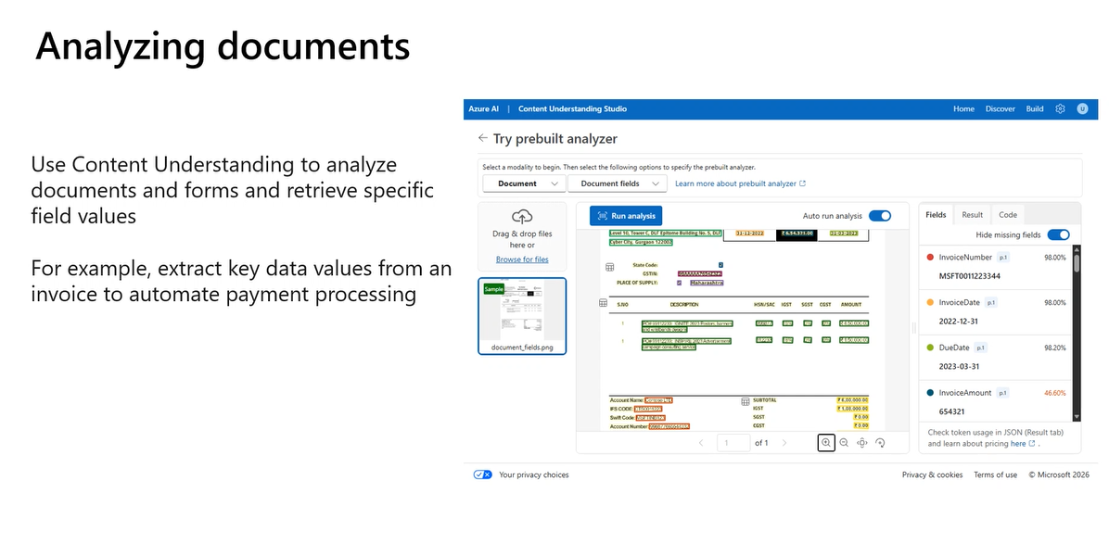
Figure 9. Analyzing Documents in Content Understanding Studio: Prebuilt analyzer extracting invoice fields (InvoiceNumber, InvoiceDate, DueDate, InvoiceAmount) with confidence scores. [Source: Instructor slide — Session 4.]
- Content Understanding Studio requires three infrastructure components: a Microsoft Foundry project (for LLM deployment), an Azure Storage Account (for data upload and result storage), and the Content Understanding Studio platform itself.
- The Azure Storage Account must be created in the Azure Portal (portal.azure.com), not in Foundry, as it is an infrastructure-level service — configured with Azure Blob Storage, Standard performance, and LRS (Locally Redundant Storage) redundancy.
- The Storage Account region must match the region of the Foundry project to ensure data locality and minimize latency between the storage and the AI processing services.
- Content Understanding Studio automatically deploys GPT-5, GPT-5-mini, and text-embedding-3-large models when a resource is connected, providing the base LLM infrastructure for all analysis tasks.
- The studio homepage displays pre-built analyzers on the left panel: Layout, Document Fields, Invoice, Identity, US Tax, and Call Center — these are pre-trained and ready to use without any additional configuration.
- Custom analyzers are created through the Build section of the studio, where developers define a project name, select the workflow kind (extract content with custom schema vs classify with custom categories), and configure storage.
- When creating a custom project, the BLOB container setting determines where analysis results are stored — if no container exists, the studio creates a new one with a random string identifier.
- After uploading an image, the studio suggests templates based on the data type: image analysis templates for images, call center templates for audio, video analysis templates for video — demonstrating intelligent data type detection.
- Fields define what information to extract: each field has a name, description, value type (string, integer, list of strings, list of objects), and method (generate — using the LLM, or auto — using pre-built extraction).
- The instructor added four custom fields for the lion image analyzer: Animal (which animal is displayed), Description (image description), Tags (image tags as a list), and Color of Animal’s Skin.
- Running analysis executes the field extraction on the uploaded image, using the deployed LLM to generate descriptions and the pre-built models to extract features, producing results for each defined field.
- Building an analyzer creates a reusable model that can be consumed programmatically through the SDK, with the analyzer ID serving as the unique identifier for API calls.
- The studio provides a code example section that generates the Python boilerplate for consuming the built analyzer, including authentication, input submission, and result parsing.
- For the lion image, the analyzer correctly extracted: Animal = “male lion with a full mane sitting in tall grass on open savanna”, Description = detailed scene description, Tags = relevant keywords, Color = “golden brown fur with darker brown mane”.
- Fields can be added for any extraction purpose: vehicle number plates, building types, text overlay on images, product identification — the LLM’s general knowledge enables flexible field definitions.
- If a defined field does not apply to a specific image (e.g., “vehicle number” on a lion image), the analyzer simply reports that no relevant data was found rather than generating incorrect information.
- The Python client application for image analysis uses the Azure Content Understanding SDK (azure-ai-content-understanding), authenticating with the project endpoint and consuming the analyzer by ID.
- The analysis result is returned in dictionary format, where keys are the defined field names and values are the LLM-generated or model-extracted content for each field.
- Value types matter: selecting “string” for a tags field that should return multiple values causes errors — the correct type for multi-value fields is “list of strings”.
- The same analyzer pattern applies across all data types — once students understand the image analyzer workflow, they can apply identical steps for document, audio, and video analyzers.
📌 TEACHER'S NOTE
"Whatever fields you define, whatever tags you define, even if you define something like text on the image — if you upload a vehicle image, it will extract the vehicle number. If you upload a lion image, it will just say there is no vehicle number. It extracts according to what is actually in the image."
— Kiran Dambal

KEY TERMS
AZURE STORAGE ACCOUNT — An Azure infrastructure service providing cloud-based blob storage for uploading data and storing Content Understanding analysis results, configured with a region matching the Foundry project.
LRS (Locally Redundant Storage) — An Azure Storage redundancy option that maintains three copies of data within a single data center, providing basic protection against hardware failures at the lowest cost.
ANALYZER — A reusable model built in Content Understanding Studio that defines extraction fields, processes input data through AI models and LLMs, and produces structured JSON results consumable via SDK.
FIELD — A named extraction target in a Content Understanding analyzer, defined by a name, description, value type, and extraction method, determining what specific information to extract from input data.

Topic 8: Content Understanding Studio — Multi-Modal Analysis
Building on the image analysis foundation, this topic extends Content Understanding to document (PDF/invoice), audio (voicemail), and video (conference recording) analysis. Each data type requires its own analyzer project with type-specific fields, but the underlying workflow remains consistent: upload data, select template, define fields, run analysis, and build the analyzer. The instructor walked through creating analyzers for all four data types in a single lab, demonstrating the unified architecture of Content Understanding Studio.
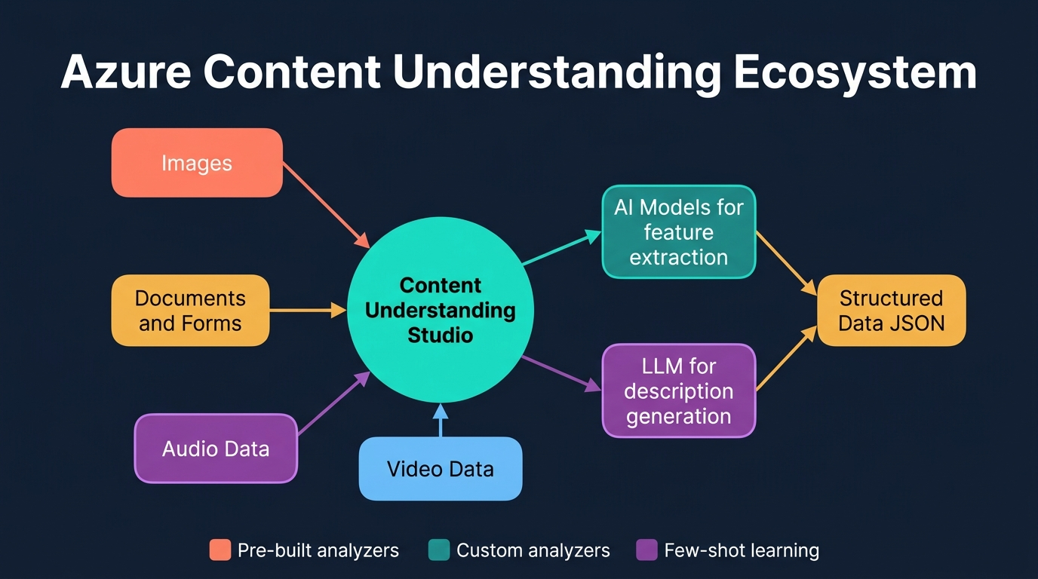
Figure 10. Azure Content Understanding Ecosystem: Central hub processing images, documents, audio, and video through AI models and LLMs to produce structured JSON output. [Generated infographic — AI-103 lecture series.]
- Lab 21 demonstrated creating four separate analyzers within Content Understanding Studio: an image analyzer, a PDF document analyzer, an audio (voicemail) analyzer, and a video (conference recording) analyzer.
- For PDF/invoice analysis, the studio offers a pre-built Invoice template that automatically defines common fields: invoice number, invoice date, due date, invoice amount, vendor name, and line items.
- The schema tab provides a “Suggest” button that analyses the uploaded document and recommends additional fields that could be extracted, leveraging the LLM’s understanding of the document structure.
- Invoice analysis fields can be customised: the instructor deleted the billing address field, kept recipient address, and added a custom “Total Acquire Quantity” field to demonstrate field flexibility.
- For audio/voicemail analysis, the template “Audio Analysis” is automatically suggested when an MP3 file is uploaded, and fields are defined for: Caller (string), Summary (string), Callback Number (string), and Alternative Context (list of strings).
- The voicemail analyzer successfully extracted: Caller = “Ava from Contoso”, Summary = “Ava is calling about last week’s meeting, has run the numbers and can meet”, and the callback number and alternative context.
- For video/conference analysis, the “Video Analysis” template is selected, with fields defined for: Summary (string), Participants Count (integer), Participant Names (list of strings), Shared Slides (list of strings), and Assigned Actions (list of objects).
- The “list of objects” value type supports sub-fields: the Assigned Actions field contains two sub-fields — Task (description of the action item) and Assigned To (the person responsible for the task).
- Video analysis combines multiple AI capabilities: audio transcription for spoken content, frame-by-frame visual analysis for displayed content (slides, participants), and LLM processing for summarisation and action extraction.
- The Video Analyzer requires specific Azure regions that support the Video Indexer backend service — not all Azure regions provide this capability, limiting deployment options.
- Video analysis is significantly slower than image or audio analysis due to the computational requirements of processing both the audio track and individual video frames simultaneously.
- Each analyzer type (image, document, audio, video) is created as a separate project within Content Understanding Studio, maintaining clean separation between different analysis workflows.
- The “Test” functionality allows developers to upload new, unseen data to a built analyzer and verify extraction accuracy before deploying the analyzer to production applications.
- Pre-built analyzers (Layout, Invoice, Identity, US Tax, Call Center) are trained on standard document formats and require no configuration; custom analyzers are needed only for organisation-specific templates.
- The content understanding client SDK uses the begin_analyze() method, providing the analyzer ID and analysis input, and returning results in dictionary format with field names as keys.
- When the analyze method encounters a field defined with the wrong value type (e.g., string instead of list of strings for tags), it raises an error — field type accuracy is critical during analyzer configuration.
- The AI services deployment section in Foundry Build shows the pre-deployed content understanding models: Layout Analyzer, Document Layout Analyzer, Invoice Analyzer, Call Center Analyzer, Tax Analyzer, and OCR Read Analyzer.
- Content Understanding was recently moved out of the Foundry portal into its own dedicated studio because it combines AI and generative AI capabilities in a knowledge mining context that differs from Foundry’s core agentic AI focus.
- Lab 22 (homework assignment) replicates the same analyzer consumption pattern in a local Visual Studio Code application, connecting to the built analyzers via SDK and processing data programmatically.
- The unified Content Understanding workflow across all data types follows: Create Project → Upload Data → Select Template → Define Fields → Run Analysis → Build Analyzer → Test → Consume via SDK.
📌 TEACHER'S NOTE
"Previous lab and this lab are the same. Here, what we are doing is specifying what has to be extracted from our content — either it is an image, document, audio, or video. We specifically explain what has to be extracted and we extract those contents. This is what we call Content Understanding."
— Kiran Dambal

KEY TERMS
VIDEO INDEXER — An Azure backend service automatically selected for video analysis in Content Understanding, responsible for extracting visual and audio features from video data.
LIST OF OBJECTS — A Content Understanding field value type that supports nested sub-fields, used for complex extractions like action items that have both a task description and an assignee.
SCHEMA — The collection of defined fields in a Content Understanding analyzer project, specifying what information to extract, the data type of each field, and the extraction method.
PRE-BUILT ANALYZER — A ready-to-use analyzer in Content Understanding Studio trained on standard document types (invoices, identity documents, tax forms), requiring no additional configuration.

Topic 9: AI-103 Exam Preparation Guide
The instructor dedicated significant time to sharing practical exam preparation strategies for the AI-103 certification, drawing from personal experience with 16 Azure certification exams. This topic consolidates all exam-related guidance including format, timing, question types, scoring, preparation resources, and critical tactical tips that can significantly impact exam performance.
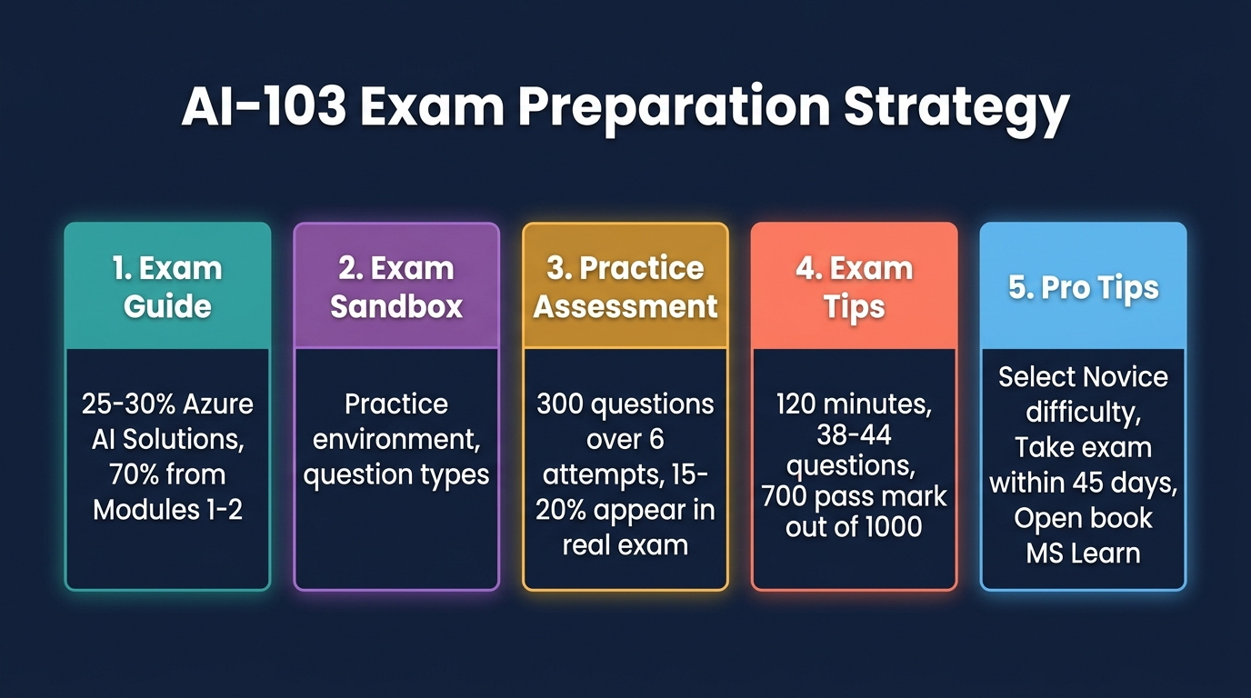
Figure 11. AI-103 Exam Preparation Strategy: Five key preparation areas covering exam guide, sandbox, practice assessment, exam format, and pro tips. [Generated infographic — AI-103 lecture series.]
- The AI-103 exam duration is 120 minutes with approximately 38 to 44 questions — the exact number varies by exam instance and is determined by the testing system.
- Total marks are 1000, with a passing score of 700; even a score of 699 is considered a failure, making every question critical.
- Individual question marks are hidden and vary: one question may be worth 50 marks, another 100, and another 150 — there is no way to know the weight distribution, so every question must be answered correctly.
- The exam is open-book with full access to Microsoft Learn during the test — students can search and browse any MS Learn documentation, including the AI-103 course materials.
- Despite being open-book, questions are significantly more difficult than the practice MCQs found after each chapter in the course materials — the instructor characterised those practice questions as “not even 0.1% as complex”.
- Question types include: single-answer MCQ, multi-answer MCQ (with the number of correct answers specified), match-the-following, fill-in-the-blanks, drag-and-drop ordering, and drop-down selection.
- For multi-answer MCQs, the last line of the question explicitly states how many correct answers to select (e.g., “Select 2 right answers from the four options”).
- Use case sections contain 2–3 pages of detailed scenario descriptions with 5–6 attached questions — these must be answered in one pass and CANNOT be revisited after closing the section.
- All other (non-use-case) questions can be marked for review and revisited later — the instructor strongly recommends answering all questions first before opening MS Learn for research.
- Approximately 70% of questions come from Modules 1 and 2 (Azure AI solutions, agents, generative AI), while 30% come from Modules 3 and 4 (language, speech, vision, content understanding).
- Three critical preparation resources are available: (1) the Exam Guide showing topic percentages, (2) the Exam Sandbox providing the actual exam interface experience, and (3) the Practice Assessment with live questions.
- The Practice Assessment can be taken six times, each time generating a different set of questions — completing all six attempts provides practice with approximately 300 distinct questions.
- The instructor reported that approximately 15–20% of practice assessment questions appear in the actual exam (with minor sentence modifications), making thorough practice assessment completion essential.
- AI-103 is a new certification (approximately 2.5 months old), and the current question set is relatively moderate in difficulty — the instructor completed the exam in 25 minutes and scored 920.
- The instructor strongly recommends taking the exam within 30–45 days: if a new question version is released, the difficulty increases significantly.
- CRITICAL TIP: When the exam presents 6–7 initial self-assessment questions asking about experience level (Novice/Intermediate/Expert), always select “Novice” (Beginner) for ALL questions regardless of actual knowledge.
- Selecting “Intermediate” or “Expert” on the self-assessment dramatically increases question difficulty — the instructor scored only 400/1000 on DP-203 after selecting Intermediate despite having taught the course multiple times.
- For online exam takers: start 30 minutes early, prepare Aadhaar card / ID for verification, photograph the room from all four directions, ensure no phones or other people are present, and minimise ambient noise.
- Any suspicious activity detected by the proctor (phone vibrations, sounds, movements) results in exam pause and a full security re-check, consuming valuable exam time.
- The internal assessment for the course includes: 20-mark MCQ assessment (20 questions) to be taken next Saturday, 20-mark assignment (Labs 2, 10, 16, and 19), totalling 40 of the 50 internal marks.
📌 TEACHER'S NOTE
"Without even reading the questions, select Novice for all of those things. Even by mistake if you select Intermediate, your questions will be in such a difficulty stage, you will sweat while writing your exam. I am telling it with my experience."
— Kiran Dambal

KEY TERMS
EXAM GUIDE — The official Microsoft document detailing AI-103 exam structure, topic percentages, and question distribution across the four modules.
EXAM SANDBOX — A Microsoft-provided practice environment that simulates the actual exam interface, showing question types, navigation, review marking, and MS Learn integration.
PRACTICE ASSESSMENT — A Microsoft Learn feature providing real exam-style questions that can be taken six times for approximately 300 unique practice questions, with 15-20% appearing in the actual exam.
USE CASE SECTION — A non-revisitable exam section containing a multi-page scenario with 5-6 attached questions that must be answered in a single pass.

Glossary of Key Terms
AIOHTTP — An asynchronous HTTP client/server framework for Python, used for real-time API communication with Azure services in Voice Live applications.
ANALYZER — A reusable component in Content Understanding Studio that defines extraction fields and processes input data (image, document, audio, video) to produce structured JSON output.
BARRIER TOKEN — An authentication token generated by Azure CLI login that grants temporary, scoped access to Azure AI services.
CHAT COMPLETION API — A stateless OpenAI API for single-turn model interactions, where each request is independent with no memory of prior exchanges.
CNN (Convolutional Neural Network) — A deep learning architecture optimised for grid-like data (images), using convolutional, pooling, and flatten layers for hierarchical feature extraction.
CONTENT UNDERSTANDING — An Azure service that extracts structured information from images, documents, audio, and video using a combination of pre-built AI models and LLMs.
CONV2D — A two-dimensional convolutional layer that applies learnable filters across input images to detect features such as edges, textures, and shapes.
DOCUMENT INTELLIGENCE — A legacy Azure service for selective data extraction from PDFs and images using OCR and field mapping; superseded by Content Understanding for broader data type support.
ECHO CANCELLATION — An audio processing feature in Voice Live that prevents feedback loops when the system simultaneously captures input audio and plays output audio.
FEW-SHOT LEARNING — A technique where a small number of example inputs are provided to an LLM, enabling it to learn extraction patterns or response formats without full retraining.
FINE-TUNED MODEL — A pre-trained LLM that has undergone additional training on domain-specific data, permanently embedding new knowledge into its model parameters.
FLATTEN LAYER — The CNN layer that converts multi-dimensional feature maps into a one-dimensional vector for input to fully connected classification layers.
FOUNDATION MODEL — A pre-trained base LLM that responds only from its original training data, without access to external tools, web search, or real-time information.
G.711 — A telephone-standard audio codec used for Voice Live speech output, producing consistent-frequency audio with uniform sound quality.
LLM (Large Language Model) — A language model trained on diverse, cross-domain data capable of answering questions about virtually any topic.
LRS (Locally Redundant Storage) — An Azure Storage option maintaining three data copies within a single data centre for basic hardware failure protection.
MATURED LLM — An enterprise-ready LLM augmented with external tools (web search, code interpreter, file search, memory) beyond its pre-training data.
MAX POOLING — A CNN dimensionality reduction operation that retains the maximum value in each local region of a feature map.
MULTIMODALITY — The ability of a model to process or generate more than one data type (text, image, audio) on either the input or output side.
NOISE REDUCTION — An audio processing feature in Voice Live that removes background noise from generated speech output.
OCR (Optical Character Recognition) — Technology that reads all characters in a document or image sequentially, extracting raw text without semantic understanding.
OPEN AI ENDPOINT — The Azure endpoint URL for direct model access without Foundry project overhead, used for standalone LLM inference.
PCM16 (16-bit Pulse Code Modulation) — An audio encoding standard that digitises speech by sampling at 16-bit precision, used for Voice Live speech recognition.
PRE-BUILT ANALYZER — A ready-to-use Content Understanding analyzer for standard document types (invoices, IDs, tax forms) requiring no configuration.
PYAUDIO — A Python library for audio input/output, providing microphone capture and speaker playback capabilities for Voice Live clients.
RESPONSE API — A stateful OpenAI API maintaining conversation context across turns, remembering previous text, images, and model responses.
SLM (Small Language Model) — A language model trained on domain-specific data for a particular industry or use case, offering focused accuracy within a narrow scope.
UNIMODALITY — A model classification where only one data type is processed as input and one type generated as output.
UTTERANCE — The speech input from a user; end-of-utterance detection determines when the Voice Live system considers the speaker has finished.
VAD (Voice Activity Detection) — A technology that identifies when a user is actively speaking, supporting multilingual language identification in Voice Live.
VIDEO INDEXER — An Azure backend service for video analysis in Content Understanding, extracting visual and audio features from video data.
VOICE LIVE SESSION — A real-time, bidirectional audio conversation between a user and a Foundry agent managed through event-based processing.

Key Takeaways from This Session
If you remember nothing else from this session, remember these:
- LLMs are classified along three independent axes — data modality, training scope, and training process — and every model can be positioned on all three simultaneously; this framework is essential for model selection in any enterprise project.
- Voice Live replaces the legacy three-step speech pipeline (recognize → LLM → synthesize) with a native multimodal conversation, but understanding PCM16 and G.711 codecs remains exam-critical.
- The endpoint scope matters architecturally: Voice Live requires the broad Azure.com endpoint because it accesses both the project and the Speech service, while vision-enabled apps can use the narrower Open AI endpoint.
- Multimodality is not just about what a model can do — it’s about how many data types it handles on each side (input vs output); DALL·E converting text to images is still unimodal because each side handles only one type.
- The Response API’s context retention across turns — including image memory — is a game-changing capability for iterative visual analysis workflows that the simpler Chat Completion API cannot support.
- Content Understanding is not just an upgrade to Document Intelligence — it’s an architectural paradigm shift from OCR-based extraction to LLM-powered understanding, supporting four data types instead of two.
- Few-shot learning is the bridge between pre-built and custom analyzers: instead of retraining models for every new document format, a few example references enable the LLM to generalise extraction patterns.
- Custom analyzers in Content Understanding follow a universal workflow regardless of data type: create project → upload data → select template → define fields → run analysis → build → test → consume via SDK.
- CNN architecture fundamentals (Conv2D for features, MaxPool for reduction, Flatten for dimensionality conversion) underpin all computer vision services in Foundry, even when accessed through high-level APIs.
- The AI-103 exam difficulty self-assessment is arguably the most impactful 30 seconds of the entire exam — always selecting “Novice” regardless of experience level can mean the difference between passing and failing.
- Practice assessment completion across all six attempts (~300 questions) is the single most effective exam preparation strategy, as 15–20% of questions appear directly in the actual exam.
- Model deployment in Foundry creates a copy of the model per project within the specified region, consuming quota from the subscription — this explains both regional model availability limitations and token rate limits.
- Even GPT-5.6 cannot read PDF documents directly; all models rely on pre-built tools to extract text and images from documents before processing them as separate modalities in JSON format.
- The separation of Content Understanding Studio from the main Foundry portal reflects Microsoft’s architectural distinction between agentic AI (Foundry) and knowledge mining/data extraction (Content Understanding).
- Take the AI-103 exam within 30–45 days while the current question set remains moderate; a new version release will significantly increase difficulty levels.

Suggested References
The following texts and resources were mentioned or implied during the session. Additional references are suggested for deeper study.
- Microsoft Learn — AI-103: Azure AI Apps and Agents Developer Associate. (Official course documentation.) Relevance: The primary study resource and open-book reference available during the exam.
- AI-103 Exam Guide. (Microsoft.) Relevance: Provides topic percentages and question distribution across the four modules.
- AI-103 Exam Sandbox. (Microsoft.) Relevance: Simulates the actual exam interface for familiarity with navigation, question types, and MS Learn integration.
- AI-103 Practice Assessment. (Microsoft Learn — Skill Navigator.) Relevance: Provides ~300 practice questions across six attempts, with 15–20% appearing in the actual exam.
- Azure Speech Voice Live Documentation. (Microsoft.) Relevance: Technical reference for PCM16, G.711, and Voice Live SDK integration patterns.
- Azure Content Understanding Studio Documentation. (Microsoft.) Relevance: Reference for creating analyzers, defining fields, and consuming analysis results via SDK.

Closing Summary
This session completed the AI-103 curriculum by finishing Module 3 (Language & Speech Services) with the Voice Live agent framework and covering the entirety of Module 4 (Extracting Insights from Visual Data). The overarching theme was the transition from unimodal, tool-chained AI architectures to natively multimodal, LLM-powered services that unify text, image, audio, and video processing under cohesive platforms.
The key conceptual framework introduced was the three-axis LLM classification system (data modality, training scope, training process), which provides a structured vocabulary for evaluating any language model’s capabilities and deployment readiness. This taxonomy connects directly to practical decisions: choosing between Voice Live (multimodal native) versus the legacy speech pipeline (unimodal chaining), selecting Chat Completion versus Response APIs, and understanding why Content Understanding supersedes Document Intelligence.
From a practical skills perspective, students are now equipped to configure Voice Live agents, build vision-enabled applications with multimodal APIs, create custom Content Understanding analyzers for any data type, and consume these services programmatically through Python SDKs. These skills directly map to the AI-103 exam objectives and to real-world enterprise scenarios where multimodal content processing is increasingly required.
The instructor’s emphasis on immediate exam preparation reflects a time-sensitive opportunity: the AI-103 certification is new, the current question set is moderate, and the practice assessments closely mirror the actual exam. Students who complete the four homework labs, review the MS Learn documentation, and systematically work through all six practice assessment attempts within the next 30–45 days are well-positioned to achieve certification. As the instructor demonstrated with a personal score of 920 in 25 minutes — thorough preparation with the right strategy makes this achievable for every student in this cohort.

