AI-103 — Azure AI Apps and Agents Developer Associate
Module 15 — Day 3: Foundry IQ, Multi-Agent Orchestration & NLP Services

Instructor: Kiran Dambal
Student: Utsav
Date: 29 August 2026 (Saturday)
Duration: ~5 hours 30 minutes (4 sessions)

Table of Contents
- 1. Session Overview
- 2. Learning Objectives
- 3. Topic 1: Recap — AI Agents, MCP & Foundry Fundamentals
- 4. Topic 2: Retrieval Augmented Generation (RAG)
- 5. Topic 3: Microsoft Foundry IQ — Enterprise Knowledge Management
- 6. Topic 4: Multi-Agent Orchestration Patterns
- 7. Topic 5: Natural Language Processing (NLP) — Language Services
- 8. Topic 6: Text Analysis Agent with MCP Server
- 9. Topic 7: Azure Speech Services
- 10. Student Activities & Lab Work
- 11. Glossary of Key Terms
- 12. Key Takeaways
- 13. Suggested References
- 14. Closing Summary

Session Overview
- This session covered the final two chapters of AI-103 Module 2 (Agent Development Kit): Microsoft Foundry IQ and Multi-Agent Orchestration with Microsoft Agent Framework.
- The session began with a comprehensive recap of previous concepts including AI agents, MCP (Model Context Protocol), and the four built-in Foundry tools.
- Microsoft Foundry IQ was explored as an enterprise-grade knowledge management platform that extends RAG capabilities by connecting multiple organizational data sources through a unified index.
- Four multi-agent orchestration patterns were introduced: Concurrent, Sequential, Group Chat, and Handoff orchestration — each suited to different complexity levels and use cases.
- The session transitioned to Module 3 (Natural Language Solutions), covering NLP fundamentals, Azure language services (language detection, entity recognition, PII detection), and their integration with AI agents via MCP servers.
- Azure Speech Services were explored, including text-to-speech (synthesis) and speech-to-text (transcription) capabilities using both LLMs and pre-trained AI models.
- Hands-on labs included configuring Foundry IQ with Azure Blob Storage (Lab 9), building multi-agent pipelines with Microsoft Agent Framework (Lab 11), consuming text analytics services (Labs 12–13), and working with speech models (Labs 14–15).

Learning Objectives
After this session, you will be able to:
- Explain the architecture and three key components of Microsoft Foundry IQ: knowledge source, knowledge base, and retriever.
- Configure Foundry IQ to connect enterprise data sources (SharePoint, OneDrive, Azure Blob Storage, SQL databases) and create a unified knowledge index.
- Differentiate between Foundry IQ and file search in terms of data source connectivity, authentication, and enterprise integration capabilities.
- Describe the four multi-agent orchestration patterns (Concurrent, Sequential, Group Chat, Handoff) and select the appropriate pattern for a given use case.
- Build a sequential multi-agent pipeline using the Microsoft Agent Framework library in Python, including agent creation, workflow definition, and result aggregation.
- Consume Azure AI Language services (language detection, named entity recognition, PII detection) through both SDK and API methods.
- Integrate Azure Language tools into an AI agent using MCP (Model Context Protocol) servers for automated text analysis.
- Differentiate between NLU (Natural Language Understanding) and NLG (Natural Language Generation) and identify real-world applications of each.
- Implement Azure Speech Services for text-to-speech synthesis and speech-to-text transcription using the correct SDK methods (speech_synthesizer vs. speak_text_async).
- Apply hybrid search (keyword + semantic search with Euclidean distance and cosine similarity) concepts in the context of Foundry IQ retrieval operations.

Topic 1: Recap — AI Agents, MCP & Foundry Fundamentals
The session opened with a structured recap of the concepts covered in previous classes, establishing the foundation upon which the day’s new material would be built. This review served as both a refresher and a diagnostic check to ensure all students had internalised the core agent architecture before advancing to enterprise-grade knowledge management and multi-agent orchestration. Understanding these fundamentals is essential because every subsequent topic in this session — from Foundry IQ to MCP-based language tool integration — builds directly upon the agent-tool-memory-knowledge paradigm established here.
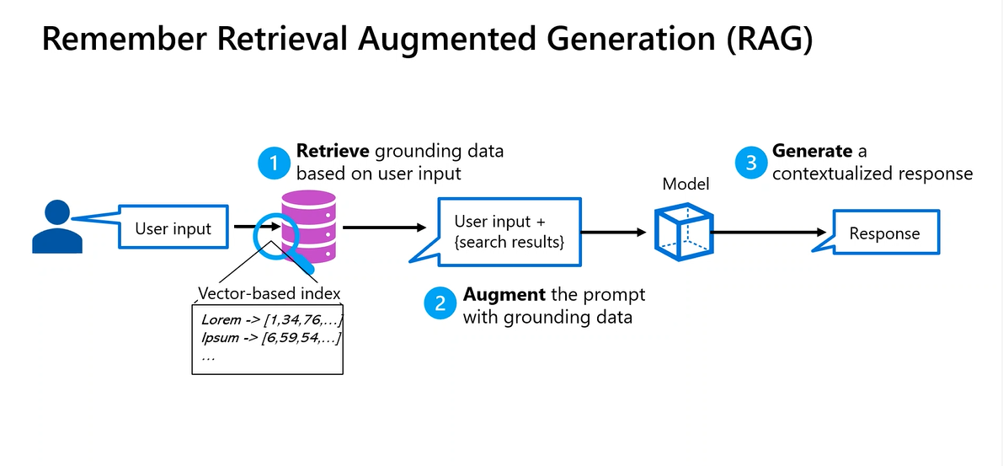
Figure 1. RAG (Retrieval Augmented Generation) architecture: User input is searched against a vector-based index, augmented with grounding data, and fed to the model for contextualized response generation. (Source: Instructor slide, Session 3.)
- AI agents extend beyond simple LLM applications by incorporating four core components: the LLM (brain/orchestrator), tools (hands for retrieval and action), knowledge (external context), and memory (conversation persistence).
- The LLM serves as the brain of the agent application, responsible for orchestrating task decomposition, tool selection, and response generation based on the combined context of user input, retrieved knowledge, and conversation history.
- Tools in the agent architecture are categorised into two functional types: retrieval tools that fetch external knowledge from databases, documents, or APIs, and action tools that perform operations such as sending emails, executing code, or triggering workflows.
- Memory in agent systems operates at two temporal scales: short-term memory persists only for the duration of the active conversation session, while long-term memory retains context across multiple conversations to enable personalisation and continuity.
- The Foundry platform provides four built-in tools for agent development: file search (document-based RAG), web search (live internet retrieval), code interpreter (Python execution sandbox), and functionality (custom external integrations).
- The functionality tool category encompasses four sub-types for external integration: custom Python functions (local scripts), Azure Functions (cloud-hosted serverless code), Azure Logic Apps (trigger-based automation workflows), and OpenAPI Specification (third-party API connections).
- Azure Logic Apps, one of the functionality sub-types, is primarily used for trigger-based or time-based automation and is commonly employed in Power Apps and Power Automate workflows within the Microsoft ecosystem.
- Model Context Protocol (MCP) was introduced as a unified communication standard that reduces the complexity of agent-tool interactions by eliminating the need for separate networking channels for each service integration.
- MCP architecture consists of two components: the MCP client (attached to the agent side) and the MCP server (attached to the tool side), whether the tool is knowledge-based for retrieval or action-based for task execution.
- MCP servers come in two deployment variants: remote servers hosted by external organisations and accessed via HTTP protocol, and local servers running in the same application environment as the agent and communicating via STDIO (Standard Input/Output).
- The distinction between remote and local MCP servers is architecturally significant: remote servers enable integration with third-party services through API calls, while local servers provide low-latency access to tools co-located with the agent runtime.
- Agent instruction (also called system message or system instruction) defines the behavioural boundaries, personality, and task scope of an agent — all three terms are interchangeable and may appear in exam questions to test comprehension.
- RAG (Retrieval Augmented Generation) was established as the foundational pattern for grounding LLM responses in external data, using a pipeline of chunking, embedding, vector storage, semantic search, and context augmentation before generation.
- In RAG implementations, the retrieval stage uses two search methods: keyword search (lexical matching) and semantic search (embedding-based matching using Euclidean distance and cosine similarity formulas).
- The top-K retrieval parameter controls how many of the most semantically relevant chunks are selected from the vector index and augmented with the user’s question before being sent to the LLM for response generation.
- Euclidean distance and cosine similarity are the two mathematical formulas used in semantic search to measure embedding proximity — these appear frequently in AI-103 exam questions, particularly in Foundry IQ contexts.
- The hybrid search approach combines both keyword search and semantic search to maximise retrieval accuracy, and is the default search strategy used by Azure AI Search in both file search and Foundry IQ implementations.
- Token generation occurs at the LLM stage (after retrieval and augmentation), not during the retrieval process itself — a distinction that is important for understanding the computational flow and cost implications of RAG pipelines.
- The agent configuration workflow in Foundry involves creating a project, deploying a model (e.g., GPT-5), creating an agent with a system instruction, connecting tools (built-in or MCP-based), and optionally adding knowledge sources and memory.
- Guard rails in the Foundry agent configuration control content filtering and block lists, ensuring that agent responses comply with organisational policies and safety standards before being delivered to end users.
📌 TEACHER'S NOTE
"MCP is like having one universal adapter instead of carrying ten different chargers. Without MCP, every tool needs its own communication channel. With MCP, one unified protocol handles everything — that is the major reason we use it."
— Kiran Dambal

KEY TERMS
RAG (Retrieval Augmented Generation) — A pattern that enhances LLM responses by retrieving relevant external context from a vector database and augmenting the user’s query with that context before generation, ensuring responses are grounded in specific, verifiable data.
MCP (Model Context Protocol) — A unified communication standard that provides a single, standardised channel for AI agents to interact with diverse tools and services, eliminating the need for custom integration code for each external system.
Top-K Retrieval — A parameter that specifies the number of most semantically relevant chunks to retrieve from the vector index during the search phase of a RAG pipeline; for example, top-3 returns the three most relevant results.
Hybrid Search — A search strategy that combines keyword-based lexical matching with semantic embedding-based matching to maximise retrieval accuracy; it is the default approach used by Azure AI Search.
Guard Rails — Configuration controls in the Foundry agent framework that enforce content filtering policies and block lists to ensure agent outputs comply with safety, compliance, and organisational standards.

Topic 2: Microsoft Foundry IQ — Enterprise Knowledge Management
Microsoft Foundry IQ represents a significant evolution of the RAG paradigm, transforming it from a developer-managed vector database pattern into an enterprise-grade, fully managed knowledge platform. While traditional RAG requires developers to manually configure chunking, embedding, and vector storage for individual document collections, Foundry IQ abstracts this complexity by providing a unified knowledge management layer that connects to diverse enterprise data sources with built-in authentication, authorization, and automatic index maintenance. This topic is critical for the AI-103 certification exam because Foundry IQ questions frequently test understanding of its architecture, its relationship to Azure AI Search, and its advantages over manual RAG implementations.
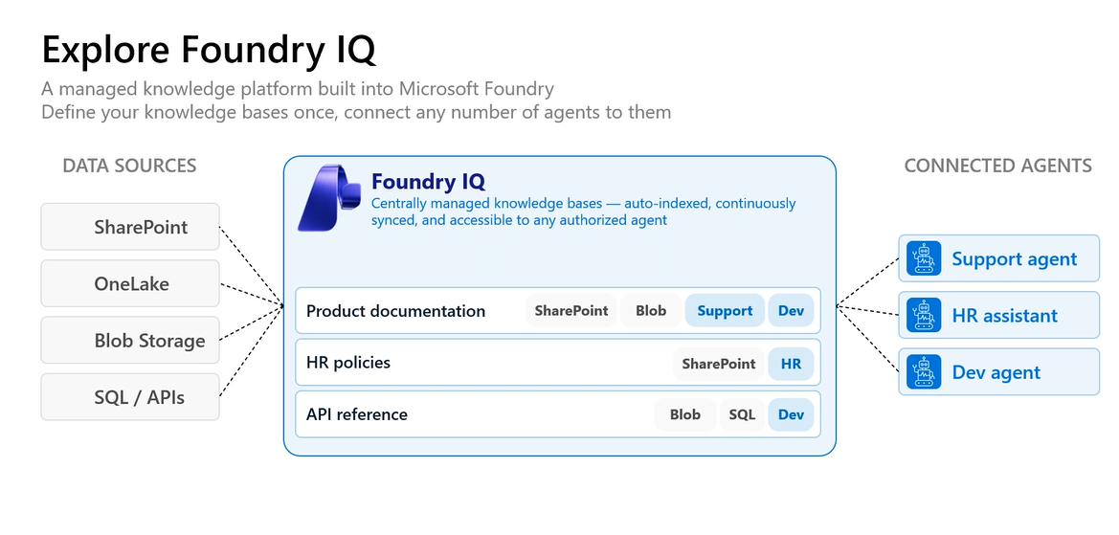
Figure 2. Foundry IQ Architecture: Data sources (SharePoint, OneLake, Blob Storage, SQL/APIs) connect to Foundry IQ, which manages centrally indexed knowledge bases accessible to any authorized agent (Support, HR, Dev). (Source: Instructor slide, Session 3.)

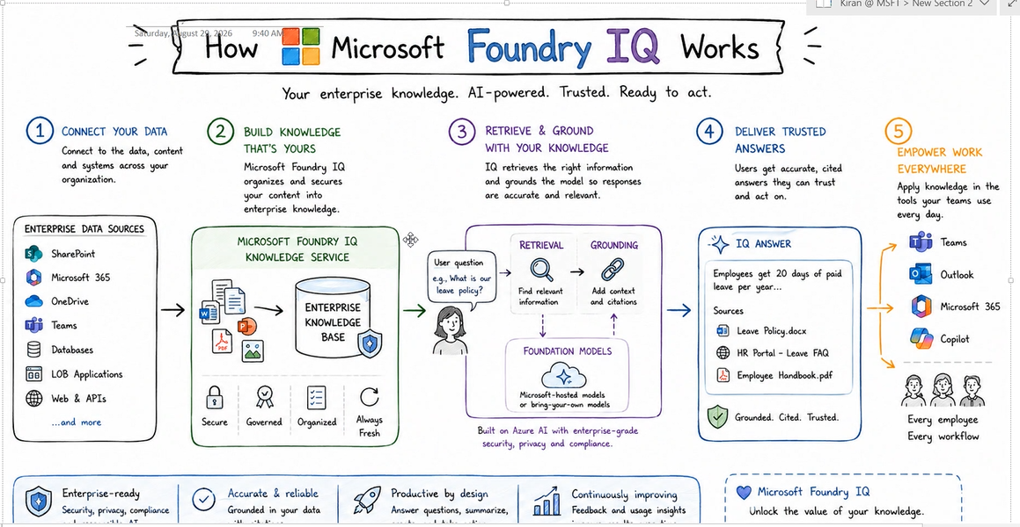
Figure 3. How Microsoft Foundry IQ Works: A 5-step process from connecting data sources, building knowledge, retrieving and grounding with your knowledge, delivering trusted answers, to empowering work everywhere. Shows enterprise data sources, the knowledge service with security properties, retrieval with foundation models, and delivery to Teams, Outlook, Microsoft 365, and Copilot. (Source: Instructor’s OneNote diagram, Session 3.)
- Microsoft Foundry IQ is an enterprise-grade knowledge management platform that extends the RAG paradigm by providing a fully managed service for connecting, indexing, and retrieving data from multiple organisational data sources through a single unified interface.
- The architecture of Foundry IQ is built upon three key components that students must memorise: the knowledge source (diverse enterprise data inputs), the knowledge base (unified vector index), and the retriever (Azure AI Search engine).
- Knowledge sources in Foundry IQ encompass any enterprise data repository accessible through organisational credentials, including SharePoint, OneDrive, Azure Blob Storage, Microsoft Teams files, Microsoft 365 data, SQL databases, line-of-business applications (SAP, Jira, Salesforce), and external API connections.
- The knowledge base is a unified embedding index created by Foundry IQ that aggregates data from all connected knowledge sources into a single searchable repository, eliminating the need for developers to manage separate vector databases for each data source.
- Foundry IQ automatically handles the entire data processing pipeline: chunking documents into segments, generating overlapping embeddings, storing them in the internal vector database, and managing deduplication across sources — processes that developers had to manually configure in traditional RAG implementations.
- The retriever component in Foundry IQ is always Azure AI Search, which performs hybrid search combining both keyword matching and semantic search using Euclidean distance and cosine similarity to find the most relevant chunks from the unified index.
- When multiple data sources contain duplicate information (e.g., the same leave policy document exists in both SharePoint and OneDrive), Foundry IQ automatically detects and removes duplicate content during indexing, ensuring the knowledge base remains clean and non-redundant.
- The unified index in Foundry IQ follows a parent-child or master-slave architecture: one main index is created that contains references to sub-indexes for each connected knowledge source, enabling efficient cross-source retrieval through a single search operation.
- Data retrieval in Foundry IQ is content-based rather than file-based or source-based, meaning the search engine retrieves results based on the semantic meaning of the data regardless of which original source or file format it came from.
- For structured databases (SQL, PostgreSQL), Foundry IQ does not perform traditional chunking; instead, it works with schema retrieval by converting structured data into JSON objects as chunks, preserving the relational structure while making it searchable.
- Foundry IQ provides built-in authentication and authorisation management through Microsoft Entra ID, ensuring that only authorised users and agents can access specific knowledge bases, with comprehensive logging of all retrieval operations for audit purposes.
- The critical difference between Foundry IQ and file search is scope: file search only accepts locally uploaded documents (PDFs, Word files, PPTs), while Foundry IQ connects to live enterprise data sources with dynamic re-indexing capabilities.
- Foundry IQ supports automatic re-indexing: when new documents or data are added to connected sources, administrators can initiate a re-index operation that automatically processes new content without rebuilding the entire knowledge base from scratch.
- Developers have no direct control over embedding size, chunk size, or overlap parameters in Foundry IQ — these are determined internally by Azure AI Search and depend on the model provider (e.g., OpenAI uses 556-byte chunks; DeepSeek uses different sizes).
- The embedding model used by Foundry IQ can be selected during knowledge base creation (e.g., text-embedding-model-large or text-embedding-model-small), along with the chat completion model (e.g., GPT-5.2) for processing retrieval results.
- Retrieval instructions can be specified during knowledge base configuration to control search priority — for example, "Prioritise HR policies for benefits questions" directs the retriever to weight certain knowledge sources more heavily for specific query types.
- Foundry IQ supports multiple knowledge source types beyond Azure Blob Storage: Microsoft Fabric (for intelligent data processing), web sources, pre-existing Azure AI Search indexes, MCP servers, Azure SQL, and Microsoft SharePoint direct connections.
- The lab exercise (Lab 9) demonstrated the end-to-end Foundry IQ configuration: creating an Azure AI Search service, setting up a storage account, uploading documents, creating a knowledge base, configuring API key authentication, and testing the agent with knowledge-grounded queries.
- A critical lab step that students commonly miss is changing the API Access Control setting on the Azure AI Search resource from "Role-based access control (RBAC)" to "Both" — without this change, the Foundry IQ connection will fail with authentication errors.
- Foundry IQ responses include verifiable citations with URLs pointing to the specific source documents, enabling users to trace any answer back to its original data source — a critical advantage for enterprise compliance and trust requirements.
📌 TEACHER'S NOTE
"Foundry IQ is just RAG with enterprise superpowers. The working is exactly the same — chunking, embedding, indexing, retrieving. The only difference is instead of uploading local files, you connect to live enterprise data sources with proper authentication. To understand Foundry IQ, just remember three terms: knowledge source, knowledge base, and retriever."
— Kiran Dambal

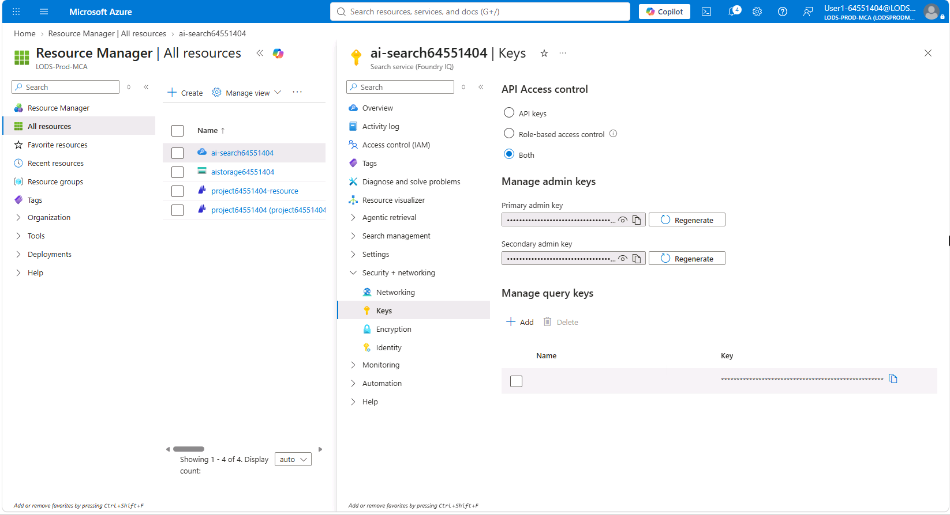
Figure 4. Azure AI Search — Keys Configuration: The Azure portal showing the AI Search service with API Access Control set to "Both" (API keys + Role-based access control). This step is critical for Foundry IQ integration. (Source: Lab 9 screenshot, Session 3.)

KEY TERMS
Foundry IQ — Microsoft’s enterprise knowledge management platform that provides a fully managed RAG implementation, connecting multiple organisational data sources into a unified, searchable knowledge base with built-in authentication, deduplication, and automatic indexing.
Knowledge Source — Any enterprise data repository (SharePoint, OneDrive, Azure Blob, SQL, APIs, LOB applications) connected to Foundry IQ as an input for building the unified knowledge index.
Knowledge Base — The unified vector index created by Foundry IQ that aggregates and deduplicates embedded data from all connected knowledge sources into a single searchable repository managed by Azure AI Search.
Azure AI Search — Microsoft’s cloud search service that serves as both the indexer and retriever in Foundry IQ, performing hybrid search (keyword + semantic) across the unified knowledge base to find relevant content for agent queries.
Unified Index — A parent-child index architecture in Foundry IQ where one main index references sub-indexes for each connected knowledge source, enabling cross-source retrieval through a single search operation.

Topic 3: Multi-Agent Orchestration Patterns
As AI agent applications scale from simple single-task assistants to complex, enterprise-grade systems handling multi-faceted problems, the limitations of single-agent architectures become apparent. A single agent attempting to manage an overly complex system instruction, numerous tools, and diverse task domains risks hallucination, confusion, and degraded performance. Multi-agent orchestration addresses this by decomposing complex workflows into specialised sub-agents, each with a focused instruction set and dedicated tools. This topic introduces four orchestration patterns that form the foundation of enterprise multi-agent design — understanding these patterns is critical for the AI-103 exam, where at least one question on orchestration types is virtually guaranteed.
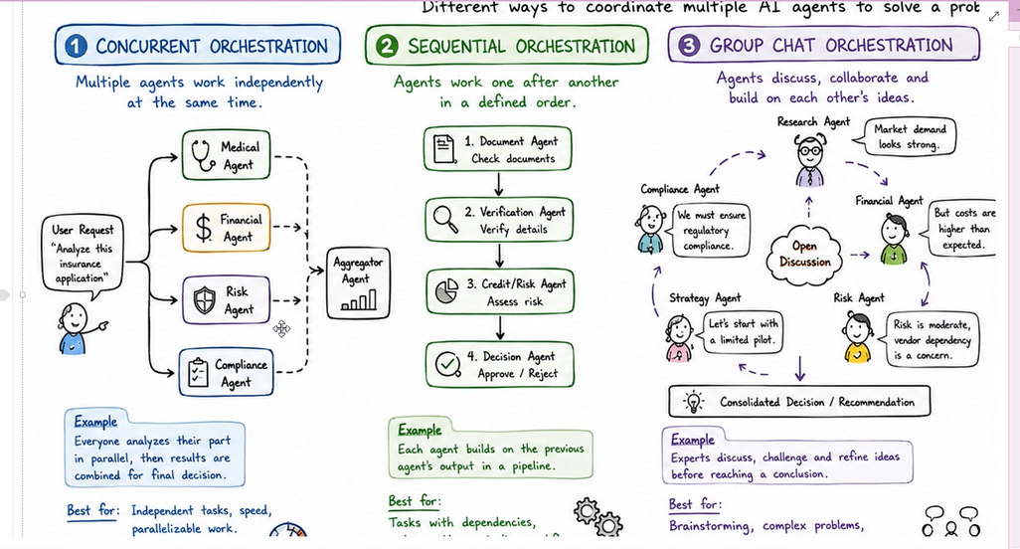
Figure 5. Multi-Agent Orchestration Patterns: (1) Concurrent Orchestration — multiple agents work independently in parallel; (2) Sequential Orchestration — agents work one after another in a defined order; (3) Group Chat Orchestration — agents discuss, collaborate and build on each other’s ideas through a shared log directory. (Source: Instructor’s OneNote diagram, Session 3.)
- Multi-agent orchestration is the practice of decomposing a complex task into subtasks and assigning each subtask to a specialised agent with its own focused system instruction, tools, and capabilities, rather than burdening a single agent with the entire workload.
- The fundamental motivation for multi-agent orchestration is reducing cognitive overload on individual agents: when a single agent’s system instruction becomes too long or its tool set too diverse, it becomes prone to hallucination, confusion, and inconsistent behaviour.
- In single-agent architectures, tasks are divided into subtasks and assigned to tools; in multi-agent architectures, tasks are divided into subtasks and assigned to specialised agents, each of which may further decompose its subtask and use its own tools.
- There are four orchestration patterns for multi-agent systems in Microsoft Foundry: Concurrent (parallel), Sequential (pipeline), Group Chat (collaborative), and Handoff (intent-based routing) — each optimised for different workflow characteristics.
- Concurrent orchestration (also called parallel orchestration) follows a master-slave architecture where all sub-agents work simultaneously on the user’s input, producing independent results that are merged by an aggregator agent into a unified response.
- Concurrent orchestration is optimal when no agent depends on the output of another agent — for example, analysing an insurance application where medical, financial, risk, and compliance assessments can all proceed independently on the same input document.
- Sequential orchestration operates as a pipeline where each agent’s output becomes the input for the next agent in a defined order, similar to the workflow pattern used by LangGraph — the execution is strictly linear with no parallel branches.
- In sequential orchestration, even conditional branching (if-else logic) does not create parallel execution: the workflow evaluates the condition and follows one path at a time, making it fundamentally sequential despite appearing to have branches.
- Group Chat orchestration gives all agents equal authority (no master-slave hierarchy) and allows them to collaboratively discuss, divide, and execute tasks through a shared log directory that maintains transparency across all agent interactions.
- In Group Chat orchestration, a common log repository ensures that every agent can observe what other agents are doing, what tasks have been completed, and what remains — enabling collaborative decision-making similar to a team project.
- The primary advantage of Group Chat orchestration is error resilience: if one agent encounters an error or enters a loop, other agents can observe the failure through the shared log and intervene or adjust their own behaviour accordingly.
- The primary disadvantage of Group Chat orchestration is high token consumption: since all agents maintain awareness of the entire conversation through the shared log, every agent consumes tokens even when not actively performing a task.
- Group Chat orchestration is best suited for brainstorming, complex problem-solving, debate reviews, and collaborative decisions where the interplay between multiple specialist perspectives produces better outcomes than isolated individual analysis.
- Handoff orchestration operates on an intent-based routing model: a triage (orchestrator) agent analyses the user’s intent and hands off the entire task to the most appropriate specialist agent, which then handles the complete interaction.
- Handoff orchestration is ideal for generalised chatbot applications (like ChatGPT) where users may ask about diverse topics — financial advice, email composition, document analysis — and each intent requires a different specialised agent.
- In Handoff orchestration, agents use Agent-to-Agent (A2A) communication protocol for one-directional task delegation, whereas Group Chat orchestration requires all agents to be co-located on a common platform with bidirectional communication.
- The Microsoft Agent Framework is the open-source Python library used to implement multi-agent orchestration, providing three packages: agent-framework-core (agent creation), agent-framework-foundry (model connectivity), and agent-framework-orchestration (workflow patterns).
- The Agent Framework merges capabilities from two previous Microsoft libraries — Semantic Kernel and AutoGen — into a unified open-source framework, though Foundry-specific features require an Azure subscription for model deployment.
- Lab 11 demonstrated sequential orchestration using three agents (summariser, classifier, action recommender) processing customer feedback through a pipeline: the summariser condensed the feedback, the classifier categorised the sentiment, and the action agent recommended next steps.
- In the lab implementation, agents were created using the chat_client.as_agent() method (temporary cache) rather than chat_client.agent.create() (persistent storage in Foundry), an important distinction for understanding agent lifecycle management.
📌 TEACHER'S NOTE
"Think of multi-agent orchestration like this: if I give one person a 500-word system instruction, they will get confused. But if I divide that instruction into four 125-word instructions and give each to a specialist, every task gets done properly. The system message division is the real trick."
— Kiran Dambal

KEY TERMS
Concurrent Orchestration — A multi-agent pattern where all sub-agents execute simultaneously on the same input, producing independent results that are merged by an aggregator; best for tasks with no inter-agent dependencies.
Sequential Orchestration — A pipeline-based multi-agent pattern where each agent’s output feeds into the next agent in a defined order; equivalent to LangGraph-style workflows.
Group Chat Orchestration — A collaborative multi-agent pattern with no master-slave hierarchy, where all agents discuss and coordinate through a shared log directory; best for brainstorming and complex problem-solving, but expensive in token consumption.
Handoff Orchestration — An intent-based routing pattern where a triage agent analyses user intent and delegates the entire task to the most appropriate specialist agent; ideal for generalised chatbots serving diverse user needs.
Microsoft Agent Framework — An open-source Python library (merging Semantic Kernel and AutoGen capabilities) that provides core agent creation, Foundry model connectivity, and multi-agent orchestration pattern implementations.

Topic 4: Natural Language Processing (NLP) — Language Services
With the completion of Modules 1 (Generative AI) and 2 (Agent Development Kit), the session transitioned to Module 3: Developing Natural Language Solutions in Azure. This module covers the pre-generative-AI world of NLP services — specialised, cost-efficient AI models trained for specific text and speech processing tasks. While LLMs can technically perform language detection, entity recognition, and PII extraction, these pre-built AI models remain essential in production because they consume far fewer tokens and cost a fraction of LLM-based alternatives. Understanding when to use pre-built AI services versus LLMs is a key practical skill and a common exam topic in AI-103.
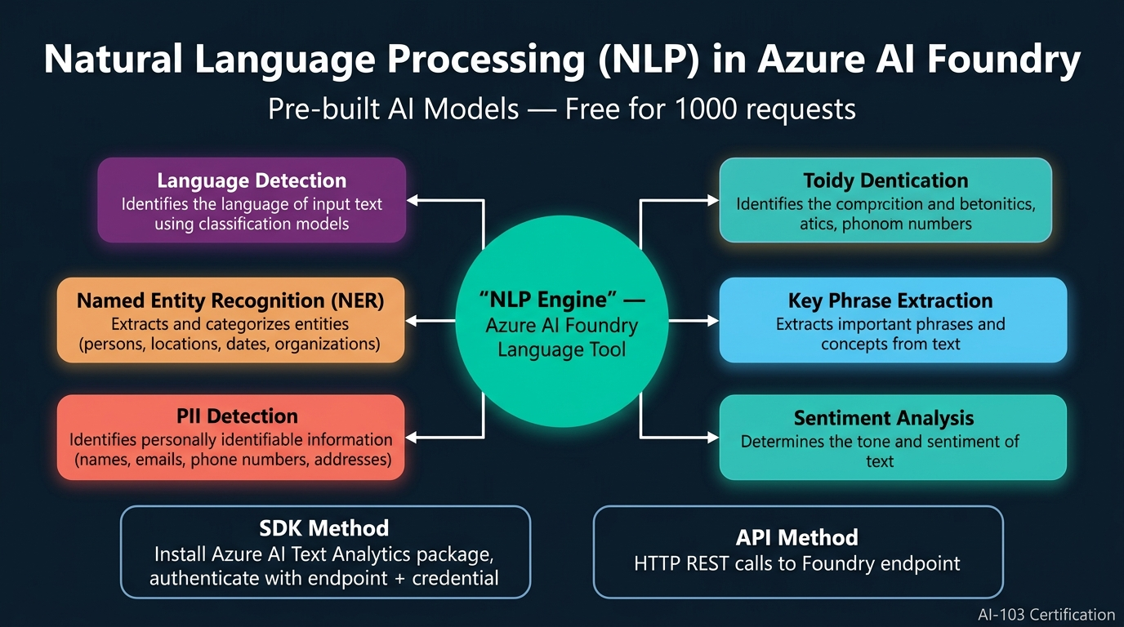
Figure 6. Natural Language Processing (NLP) in Azure AI Foundry: Architecture showing the NLP Engine (Language Tool) connected to five pre-built capabilities — Language Detection, Named Entity Recognition, PII Detection, Key Phrase Extraction, and Sentiment Analysis — consumable via SDK or API methods. (Generated infographic.)
- Natural Language Processing (NLP) is a category of artificial intelligence that gives software the ability to process, understand, and generate human language in both text and speech modalities.
- NLP is divided into two fundamental workloads: Natural Language Understanding (NLU), where the model extracts features and meaning from input text or speech, and Natural Language Generation (NLG), where the model produces text or speech as output.
- NLU tasks include language detection, keyword extraction, text summarisation, sentiment analysis, speech recognition, speech synthesis, entity extraction, and translation — all of which involve learning the meaning or structure of given input data.
- NLG tasks include translation (generating text in a target language), summarisation (generating condensed versions), and conversational response generation — chatbots represent the quintessential combination of both NLU and NLG capabilities.
- Module 3 and Module 4 of AI-103 collectively represent approximately 30% of exam questions, with the remaining 70% coming from Modules 1 and 2 (Generative AI and Agent Development Kit), making agent-related content the primary study priority.
- Within that 30%, approximately 15% focuses on content understanding and knowledge mining (Module 4), and the remaining 15% covers text, speech, and image services (Module 3), indicating relatively equal distribution across the two modules.
- Azure AI Foundry provides five built-in tool categories for AI services: Language, Speech, Vision, Document Intelligence, and Content Understanding — each containing pre-trained AI models that can be consumed via SDK or API methods.
- The Language tool in Azure AI Foundry contains pre-built models for language detection, named entity recognition (NER), PII detection, key phrase extraction, sentiment analysis, text redaction, and healthcare entity extraction.
- Language detection is a classification model that identifies which language a given text is written in, returning both the detected language name and a confidence percentage — for example, identifying Kannada script with 100% confidence.
- Named Entity Recognition (NER) processes text token by token to identify and categorise real-world entities such as persons, locations, organisations, dates, addresses, and other proper nouns, assigning each a category label.
- PII (Personally Identifiable Information) detection extracts sensitive personal data from text including names, email addresses, phone numbers, Aadhaar card numbers, credit card details, and physical addresses — essential for compliance with data protection regulations.
- The primary reason pre-built AI services remain relevant despite LLM capabilities is cost efficiency: these models consume minimal tokens (often zero cost for the first 1,000 requests) compared to the substantial token consumption of equivalent LLM-based processing.
- For example, asking an LLM to detect the language of a text paragraph would consume hundreds of tokens for the full input and response, whereas the pre-built language detection model returns a single-word result consuming effectively one token.
- Each NLP capability (language detection, NER, PII detection) uses a separate pre-trained deep learning model — one model per task — because AI models are trained for specific workload types and specific data formats, unlike generalised LLMs.
- The Text Analysis Client (from the Azure AI Text Analytics package) is the primary SDK interface for consuming language services, authenticated using the Foundry endpoint (trimmed to azure.com) and Entra ID barrier token credentials.
- The three critical SDK method names for the AI-103 exam are: detect_language() for language detection, recognize_entities() for named entity recognition, and recognize_pii_entities() for PII detection — exact method names matter in exam questions.
- Language detection returns a single result (one language), while entity recognition and PII detection return lists of results requiring iteration — this is why the lab code uses a for loop for entities and PII but not for language detection.
- The Foundry endpoint used for AI services differs from the project endpoint used for agents: AI services require only the base URL (truncated to azure.com), while agent consumption requires the full project endpoint including the /api suffix.
- Lab 12 demonstrated SDK-based consumption of language services against five hotel review text files, successfully detecting languages (including French), extracting entities (hotel names, locations, dates), and identifying PII (addresses, emails, country names).
- These pre-trained AI models are RNN-based (Recurrent Neural Network) deep learning models deployed and maintained by Microsoft — developers simply authenticate and call them without managing training, deployment, or model infrastructure.
📌 TEACHER'S NOTE
"For everything, no need for using LLMs. If I ask the LLM to detect the language of this text, it would consume a lot of tokens. Instead, I pass it to the AI model and get one word back — one token instead of hundreds. That is why we still have these AI services."
— Kiran Dambal

KEY TERMS
NLU (Natural Language Understanding) — The branch of NLP concerned with extracting meaning, features, and structure from input text or speech — including language detection, entity recognition, sentiment analysis, and PII detection.
NLG (Natural Language Generation) — The branch of NLP concerned with producing human-readable text or speech as output — including translation, summarisation, and conversational response generation.
Named Entity Recognition (NER) — An NLP task that identifies and categorises real-world entities (persons, locations, organisations, dates) within text by processing tokens individually and assigning category labels.
PII Detection — The process of identifying Personally Identifiable Information (names, emails, phone numbers, addresses, national ID numbers) within text, essential for regulatory compliance and data protection.
Text Analysis Client — The Azure SDK class (from Azure AI Text Analytics package) that provides methods for consuming pre-built language models: detect_language(), recognize_entities(), and recognize_pii_entities().

Topic 5: Text Analysis Agent with MCP Server Integration
Building upon the direct SDK consumption of language services explored in Topic 4, this topic demonstrates how to integrate those same capabilities into an AI agent through the Model Context Protocol (MCP). Instead of a developer writing code to call each language API individually, an agent can be equipped with an MCP server that provides access to the entire Azure Language tool catalogue, enabling the agent to autonomously select and invoke the appropriate language analysis capability based on user intent. This pattern — agent + MCP server + Foundry tool — represents the production-grade approach for building intelligent text analysis applications in the Microsoft ecosystem.
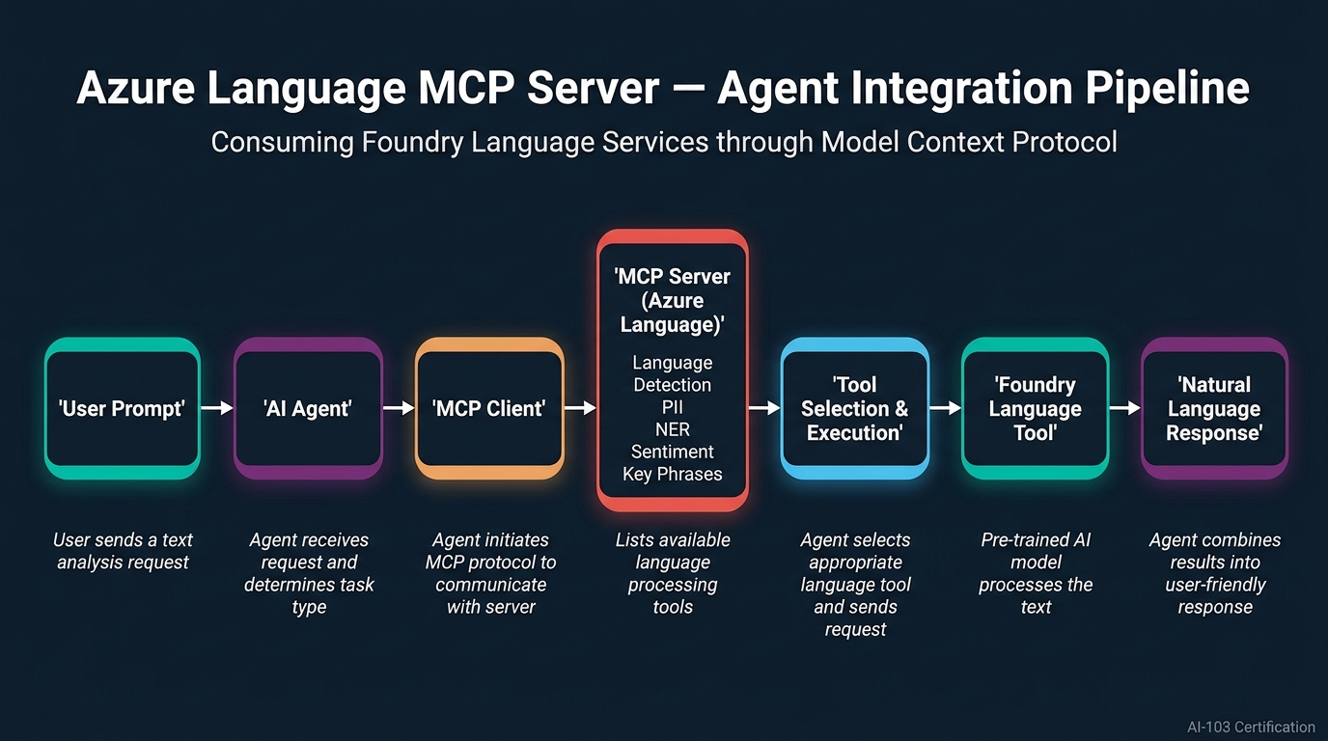
Figure 7. Azure Language MCP Server — Agent Integration Pipeline: User prompt flows through the AI Agent to the MCP Client, which queries the MCP Server for available language tools, selects the appropriate tool, executes it against the Foundry Language Tool, and returns a natural language response. (Generated infographic.)
- The Azure Language MCP Server is a remote MCP server hosted within the Microsoft Foundry ecosystem that provides agent access to all pre-built language analysis capabilities through a standardised Model Context Protocol interface.
- The MCP server integration workflow follows a defined sequence: user sends a prompt → agent determines the task type → MCP client requests the tool list from the server → server returns available tools → agent selects the appropriate tool → tool processes the input → agent formats the response.
- The Azure Language in Foundry Tools MCP server contains multiple sub-tools including language detection, PII redaction, named entity extraction, key phrase extraction, sentiment analysis, healthcare entity extraction, and text redaction.
- To configure the MCP server, developers navigate to the Tools section (not Toolbox or Skills) in the Foundry agent interface, click "Connect a Tool," search for "Azure Language in Foundry Tools," and create the connection with a unique name.
- The MCP server configuration requires two critical inputs: the Foundry resource name (not the project name — a common mistake) and the API key from the project homepage, using key-based authentication.
- After creating the MCP server tool, it must be linked to a specific agent by clicking the "Use in Agent" button on the tool’s configuration page, which navigates to the agent playground with the MCP server pre-connected.
- The agent instruction must be updated to explicitly reference the language tool: "You are an AI assistant that assists users by helping them analyse text. Use the Azure Language tool to perform text analysis tasks."
- When the agent first attempts to use the MCP server, it requests approval from the user through a consent dialog — this is a security governance feature controlled by the AI Gateway in Foundry.
- The approval can be granted at three levels: approve once (single use), approve for this tool (persistent access for this specific tool), or deny — the governance settings can be modified in the tool’s configuration under the AI Gateway section.
- A critical architectural insight is that the MCP server is not always guaranteed to be invoked: if the agent’s LLM determines it can handle the task directly (e.g., PII detection using its own knowledge), it may bypass the MCP server entirely.
- The Python program for consuming an MCP-integrated agent is identical to a standard agent consumption program — no MCP-specific code is needed in the client application because the MCP server is pre-configured within the Foundry agent itself.
- When the agent runs, the first visible output is the MCP tool listing: the agent queries the server for all available tools (redact_pii, document_extracted_named_entities, get_answers_from_text, etc.) before selecting the appropriate one.
- The agent installation requirements differ between direct SDK consumption and MCP-based consumption: direct SDK requires the Azure AI Text Analytics package, while MCP-based consumption requires the Azure AI Projects package (since the agent handles the tool interaction).
- The Foundry endpoint configuration also differs: direct AI model consumption uses a truncated endpoint (up to azure.com), while agent consumption uses the full project endpoint (including /api paths) because the client communicates with the agent, not the model directly.
- The HTTPX package must be installed as an additional dependency for MCP-based agent consumption programs, as it is used for HTTP communication between the Python client and the Foundry-hosted agent.
- The response from an MCP-integrated agent includes confidence scores for each detected entity, reflecting the underlying AI model’s classification accuracy — a reminder that pre-built models produce probabilistic outputs, not deterministic ones.
- The same MCP server integration pattern used for language tools can be replicated for speech tools, document intelligence tools, computer vision tools, and content understanding tools — the architecture is consistent across all five Foundry tool categories.
- Lab 13 demonstrated the complete end-to-end flow: creating a Text Analysis Agent, deploying GPT-5, configuring the Azure Language MCP server, updating agent instructions, granting tool approval, and consuming the agent from Python code.
- A practical deployment consideration: the MCP server name must be unique across the subscription since all participants share the same subscription in lab environments — adding a personal identifier to the name avoids naming conflicts.
- The distinction between the Tools section and the Toolbox/Skills sections in Foundry is important: Tools is where MCP servers and external service connections are configured, while Toolbox contains built-in tools and Skills contains pre-built agent capabilities.
📌 TEACHER'S NOTE
"The tool means servers are also connected to the agent via the tools option. When you connect the Azure Language in Foundry Tools, that IS the MCP server. Inside that server, we have sub-tools — language detection, PII detection, entity recognition. The program on the client side is exactly the same as any other agent; only the tool is extra."
— Kiran Dambal

KEY TERMS
Azure Language MCP Server — A remote MCP server within Microsoft Foundry that provides agent access to pre-built language analysis capabilities (detection, NER, PII, sentiment) through the Model Context Protocol.
AI Gateway — The governance layer in Microsoft Foundry that controls tool approval policies, determining whether agents require user consent before invoking MCP server tools.
Foundry Resource Name — The unique identifier for the Azure AI Foundry resource (distinct from the project name) required when configuring MCP server connections — commonly confused with the project name in lab exercises.
HTTPX — A Python HTTP client library required as an additional dependency for MCP-based agent consumption programs, handling the HTTP communication between the client application and the Foundry-hosted agent.

Topic 6: Azure Speech Services — Synthesis and Transcription
The final major topic of the session explored Azure Speech Services, completing the NLP domain by covering the audio modality of human-computer communication. Speech services operate in two directions: text-to-speech (synthesis), where AI models generate spoken audio from text input, and speech-to-text (transcription), where AI models convert spoken audio into written text. This topic is particularly important for the AI-103 exam because Microsoft uses deliberately confusing method names and terminology that can trick students into selecting wrong answers — the instructor shared personal exam experience highlighting this trap.
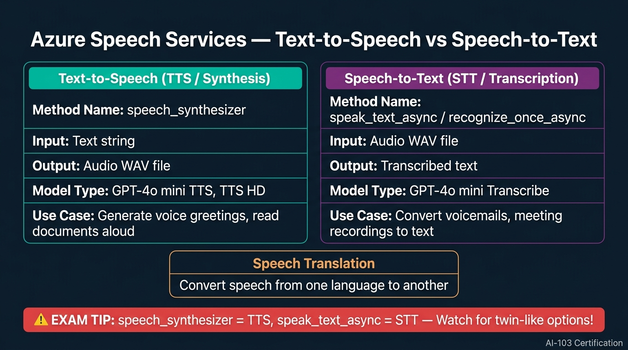
Figure 8. Azure Speech Services Comparison: Text-to-Speech (speech_synthesizer) vs Speech-to-Text (speak_text_async / recognize_once_async), including model types, input/output formats, and the critical exam tip about twin-like method name options. (Generated infographic.)
- Azure Speech Services encompass three core capabilities: Text-to-Speech (TTS/synthesis) which generates audio from text, Speech-to-Text (STT/transcription) which converts audio to text, and Speech Translation which translates speech from one language to another.
- Speech services can be consumed through two approaches: using Large Language Models with built-in speech capabilities (e.g., GPT-4o mini TTS, GPT-4o mini Transcribe), or using specialised pre-trained AI models accessed through the Azure Cognitive Services Speech SDK.
- In the Foundry model catalog, models with "TTS" in their name (e.g., GPT-4o mini TTS, TTS HD) are designed for text-to-speech synthesis, while models with "Transcribe" in their name are designed for speech-to-text transcription.
- The Azure Cognitive Services Speech SDK provides two primary method families for speech processing: speech_synthesizer for text-to-speech operations and speech recognition methods (speak_text_async, recognize_once_async) for speech-to-text operations.
- For the AI-103 exam, the most critical memorisation point is: speech_synthesizer = Text-to-Speech (synthesis), and speak_text_async = Speech-to-Text (transcription) — the instructor personally encountered this as a trick question in a recent exam.
- The exam deliberately presents twin-like options to confuse candidates: "speech_text_async" vs "speak_text_async" (note: "speech" vs "speak") — only speak_text_async is the correct method name for speech-to-text transcription.
- Speech synthesis (TTS) in the SDK works by creating an AudioOutputConfig specifying the output filename (e.g., "output.wav"), then using the speech_synthesizer method to convert a text message into the audio file format.
- Speech recognition (STT) in the SDK works by using the recognize_once_async method to process an audio WAV file input and return the transcribed text — "once" indicates it processes a single utterance or audio segment.
- Azure Speech Services support multiple voice types for each language: lesser-known languages typically have two voice options, while widely-spoken languages offer 10-15 voice variations, each identified by a unique voice code.
- Voice codes can be changed programmatically to switch between different speech personas for the same language — for example, switching from an English male voice to a Kannada female voice by updating the voice code in the configuration.
- When using a non-English voice code, the input text must be provided in the corresponding script — for example, using a Kannada voice code requires Kannada script input; providing English text with a Kannada code will result in English pronunciation.
- The lab exercise (Lab 15) used the Azure Cognitive Services Speech SDK to implement a voicemail application with two options: recording a greeting (TTS — text to WAV file) and transcribing a message (STT — WAV file to text).
- For speech services, the Foundry endpoint must be truncated to azure.com (same as language services) because the client is consuming AI models directly, not communicating through an agent — the full project endpoint is only needed for agent-based consumption.
- The play_sound3 Python package was included in the requirements for playing back generated audio files, though VM-based lab environments sometimes have microphone and speaker configuration issues that prevent audio playback.
- Before the era of generative AI, training a model to synthesise human speech was considered a significant AI achievement — technologies like Google Assistant’s pronunciation features and Google Translate’s speech output were built on these same pre-trained speech models.
- Modern voice cloning and deepfake audio (e.g., mimicking public figures’ voices on social media) are built upon base speech AI models that learn to replicate specific frequency patterns, demonstrating both the capability and ethical considerations of speech synthesis technology.
- The Azure Speech MCP server ("Azure Speech in Foundry Tools") can be configured for agent integration using the same pattern as the Language MCP server, enabling agents to autonomously perform speech synthesis and transcription as part of multi-step workflows.
- Lab 16 (assigned as homework worth 5 marks) requires students to independently configure the Azure Speech MCP server and integrate it with an agent — applying the same configuration pattern learned in Lab 13 for language services.
- Region selection matters for speech services: Lab 14 specifically required East US 2 deployment because GPT-4o mini TTS models were not available in West US 3, while Lab 15 (pre-trained AI models) had no region restriction since AI models are available across most regions.
- The speech_synthesizer method is a sub-component of the SpeechSynthesizer class, while recognize_once_async is a sub-method of the SpeechRecognizer class — understanding this class hierarchy helps disambiguate the twin-like method names in exam questions.
📌 TEACHER'S NOTE
"I personally faced this question in my AI-103 exam. The question was one line about speech recognition methods. The options were twins: speech_text_async and speak_text_async. Speech and speak — that is the difference. Be very particular about memorising these method names. Questions will be hard, answers will be very easy — if you read carefully."
— Kiran Dambal

KEY TERMS
Speech Synthesis (TTS) — The process of converting text input into spoken audio output using AI models; implemented in Azure using the speech_synthesizer method of the SpeechSynthesizer class.
Speech Transcription (STT) — The process of converting spoken audio input into written text output using AI models; implemented in Azure using speak_text_async or recognize_once_async methods of the SpeechRecognizer class.
Speech Translation — A speech service that converts spoken input in one language into spoken or written output in a different target language, combining transcription and translation in a single operation.
Voice Code — A unique identifier string that specifies a particular voice persona (language, gender, style) for speech synthesis; changing the voice code switches the generated speech to a different voice.
Azure Cognitive Services Speech SDK — The Python package (azure-cognitiveservices-speech) that provides classes and methods for consuming pre-trained speech AI models for synthesis, transcription, and translation.

Student Activities & Lab Work
This session included extensive hands-on lab work across multiple Azure AI services. Students completed labs using Microsoft Foundry portal and Visual Studio Code, covering Foundry IQ configuration, multi-agent orchestration, text analytics, and speech services. The following table summarises the lab activities and key outcomes.
Lab # | Title | Key Activity | Status
Lab 9 | Integrate AI Agent with Foundry IQ | Created Azure AI Search, storage account, knowledge base; connected Foundry IQ to agent; tested with product queries and verified citations | Completed in class
Lab 10 | Microsoft Agent Framework (Basics) | Exploring Agent Framework fundamentals | Home assignment
Lab 11 | Multi-Agent Orchestration | Built sequential pipeline with 3 agents (summariser, classifier, action) using Microsoft Agent Framework in VS Code | Completed in class
Lab 12 | Analyse Text (SDK Method) | Consumed language detection, entity recognition, and PII detection using Text Analysis Client against 5 hotel review files | Completed in class
Lab 13 | Text Analysis Agent (MCP Server) | Created Text Analysis Agent, configured Azure Language MCP server, consumed agent from Python client | Completed in class
Lab 14 | Speech-Capable Generative AI Apps | Deployed GPT-4o mini TTS and Transcribe models; tested in playground | Self-guided lab
Lab 15 | Recognise and Synthesise Speech | Implemented voicemail app with TTS and STT using Azure Cognitive Services Speech SDK | Completed in class
Lab 16 | Speech Agent with MCP Server | Configure Azure Speech MCP server and integrate with agent | Homework (5 marks)

Key Q&A Highlights
- Q: Is Foundry IQ’s knowledge base an embedding database or just a connector? A: It is an embedding database itself — it performs chunking, overlapping, and embedding storage just like file search, but for multiple enterprise data sources managed by one service.
- Q: How does chunking work for structured databases (SQL)? A: It does not perform traditional chunking on structured data; instead, it converts database content into JSON objects as chunks, preserving the relational structure while making it searchable.
- Q: Is the vector database configurable in Foundry IQ? A: No — Foundry IQ exclusively uses Azure AI Search as its vector database, indexer, and retriever. Developers have no control over the database choice, embedding size, or chunk parameters.
- Q: Can we control retrieval ranking across multiple data sources? A: Yes — retrieval instructions can be specified during knowledge base configuration to prioritise certain sources for specific query types.
- Q: In Group Chat orchestration, how do agents know what others are doing? A: All agents share a common log directory that maintains transparency — every communication, task assignment, and result is logged and visible to all participating agents.

Glossary of Key Terms
A2A (Agent-to-Agent) Communication — A communication protocol used in Handoff orchestration where a triage agent directly delegates tasks to specialist agents through one-directional message passing.
Agent Instruction — The system-level prompt that defines an agent’s role, capabilities, behavioural boundaries, and task scope; interchangeable with "system message" and "system instruction" in Microsoft documentation.
Aggregator Agent — In Concurrent orchestration, the agent that collects outputs from all parallel sub-agents and merges them into a unified response for the user.
Azure AI Search — Microsoft’s cloud search service that functions as both the indexer and retriever in Foundry IQ and file search implementations, performing hybrid search (keyword + semantic) across vector indexes.
Azure Cognitive Services Speech SDK — The Python package (azure-cognitiveservices-speech) providing classes for speech synthesis (SpeechSynthesizer) and speech recognition (SpeechRecognizer) operations.
Concurrent Orchestration — A multi-agent pattern where all sub-agents execute simultaneously on the same input, with results merged by an aggregator; optimal for independent, parallelisable tasks.
Cosine Similarity — A mathematical formula measuring the angle between two embedding vectors to determine semantic similarity; one of the two primary metrics used in semantic search alongside Euclidean distance.
Euclidean Distance — A mathematical formula measuring the straight-line distance between two embedding vectors in multi-dimensional space; used alongside cosine similarity in semantic search operations.
Foundry IQ — Microsoft’s enterprise knowledge management platform providing fully managed RAG with multi-source connectivity, unified indexing, authentication management, and automatic deduplication.
Group Chat Orchestration — A collaborative multi-agent pattern where agents discuss and coordinate through a shared log directory without a master-slave hierarchy; best for complex, interconnected problem-solving.
Handoff Orchestration — An intent-based routing pattern where a triage agent analyses user intent and delegates entire tasks to specialist agents; ideal for multi-purpose chatbot applications.
Hybrid Search — A search strategy combining keyword-based lexical matching with semantic embedding-based matching; the default retrieval method used by Azure AI Search in both Foundry IQ and file search.
Knowledge Base (Foundry IQ) — The unified vector index aggregating embedded data from all connected knowledge sources; managed by Foundry IQ with automatic deduplication and parent-child index architecture.
Knowledge Source — Any enterprise data repository (SharePoint, OneDrive, Blob Storage, SQL, APIs, LOB apps) connected to Foundry IQ as input for building the knowledge base.
MCP (Model Context Protocol) — A unified communication standard for agent-tool interaction, providing a single protocol for connecting agents to diverse services without custom integration code.
MCP Client — The MCP component attached to the agent side, responsible for initiating communication with MCP servers and routing tool requests on behalf of the agent.
MCP Server — The MCP component attached to the tool side (remote or local), exposing available tools and processing requests from MCP clients; remote servers use HTTP, local servers use STDIO.
Microsoft Agent Framework — An open-source Python library (combining Semantic Kernel and AutoGen) providing core agent creation, Foundry connectivity, and orchestration pattern implementations.
NLG (Natural Language Generation) — The NLP branch producing human-readable text or speech as output, including translation, summarisation, and conversational response generation.
NLU (Natural Language Understanding) — The NLP branch extracting meaning, features, and structure from input text or speech, including detection, recognition, classification, and sentiment analysis.
Named Entity Recognition (NER) — An NLP task identifying and categorising real-world entities (persons, locations, organisations, dates) within text by processing tokens individually.
PII Detection — Identification of Personally Identifiable Information (names, emails, phones, IDs, addresses) within text; critical for regulatory compliance and data protection.
RAG (Retrieval Augmented Generation) — A pattern enhancing LLM responses by retrieving external context from vector databases and augmenting queries with relevant data before generation.
Sequential Orchestration — A pipeline-based multi-agent pattern where each agent’s output feeds the next agent in sequence; equivalent to LangGraph-style workflows.
Speech Synthesis (TTS) — Converting text to spoken audio using the speech_synthesizer method; models include GPT-4o mini TTS and Azure pre-trained speech models.
Speech Transcription (STT) — Converting spoken audio to text using speak_text_async or recognize_once_async methods; models include GPT-4o mini Transcribe.
Text Analysis Client — The Azure SDK class providing methods (detect_language, recognize_entities, recognize_pii_entities) for consuming pre-built language AI models.
Top-K Retrieval — A parameter specifying the number of most relevant chunks to retrieve from a vector index during RAG search; e.g., top-3 returns the three best matches.
Triage Agent — In Handoff orchestration, the orchestrator agent that analyses user intent and routes the task to the most appropriate specialist agent.
Unified Index — The parent-child index structure in Foundry IQ where a main index references sub-indexes for each connected source, enabling cross-source retrieval.

Key Takeaways from This Session
If you remember nothing else from this session, remember these:
- Foundry IQ is RAG with enterprise superpowers — the working is identical (chunk, embed, index, retrieve), but Foundry IQ adds multi-source connectivity, automatic deduplication, Entra ID authentication, and managed re-indexing; remember the three components: knowledge source, knowledge base, retriever.
- Azure AI Search is the universal backbone of Microsoft’s retrieval infrastructure — it serves as the retriever in Foundry IQ, the indexer in file search, and the search engine in hybrid search, always using both keyword and semantic matching.
- Multi-agent orchestration exists because single agents fail at scale — dividing a 500-word system instruction among four specialised agents produces better results than overloading one agent; choose Concurrent for independent tasks, Sequential for pipelines, Group Chat for collaboration, Handoff for intent routing.
- Group Chat orchestration trades cost for quality — all agents consume tokens by monitoring the shared log, making it expensive, but the collaborative error-checking and brainstorming capabilities produce superior results for complex, interconnected problems.
- Pre-built AI services remain essential despite LLM capabilities — language detection, NER, and PII extraction cost nearly zero tokens with pre-trained models versus hundreds of tokens with LLM-based processing; always evaluate whether a specialised AI model can replace an LLM call.
- 70% of AI-103 exam questions come from Modules 1 and 2 (Generative AI and Agent Development Kit), with the agent module carrying the highest weight; the remaining 30% is split between language/speech services (15%) and computer vision/content understanding (15%).
- MCP servers transform tools into agent-accessible services — once an Azure Language or Speech MCP server is configured in Foundry, the client-side Python code remains identical to any standard agent consumption program; the MCP abstraction handles all tool interaction complexity.
- Method names are deliberate exam traps in speech services — speech_synthesizer = TTS (text-to-speech), speak_text_async = STT (speech-to-text); the difference between "speech" and "speak" is a documented trick question that has appeared in live AI-103 exams.
- Endpoint format depends on what you’re consuming — AI model consumption (language, speech services) uses the truncated endpoint (up to azure.com), while agent consumption uses the full project endpoint (including /api paths); mixing these up causes authentication failures.
- The Microsoft Agent Framework is an open-source library that merges Semantic Kernel and AutoGen capabilities — it provides three packages (core, foundry, orchestration) and does not require an Azure subscription for basic agent creation, only for Foundry model deployment.
- Foundry IQ retrieval is content-based, not file-based — the search engine finds relevant information based on semantic meaning regardless of which original source or file format it came from, and automatically removes duplicate content across sources.
- Always change the Azure AI Search API Access Control to "Both" (API keys + RBAC) when configuring Foundry IQ — this is the most commonly missed lab step that causes connection failures and has been flagged by the instructor as a frequent source of student errors.

Suggested References
The following resources were mentioned or implied during the session. Additional references are suggested for deeper study.
- Microsoft Learn — AI-103: Azure AI Apps and Agents Developer Associate. (Official certification learning path.) Relevance: Primary study material for all four modules covered in this course.
- Microsoft Foundry Documentation — Foundry IQ Overview. (Microsoft official documentation.) Relevance: Detailed configuration guides for knowledge base creation, data source connectivity, and retrieval instruction customisation.
- Microsoft Agent Framework GitHub Repository. (Open-source library.) Relevance: Source code, examples, and API documentation for building multi-agent orchestration pipelines using the three framework packages.
- Azure AI Search Documentation. (Microsoft official documentation.) Relevance: Understanding hybrid search, indexing strategies, and the role of Azure AI Search as the retriever in both Foundry IQ and file search.
- Azure Cognitive Services Speech SDK Documentation. (Microsoft official documentation.) Relevance: Complete API reference for speech synthesis (SpeechSynthesizer) and speech recognition (SpeechRecognizer) classes and methods.

Closing Summary
This session completed the study of Modules 1 and 2 of the AI-103 certification — the two most heavily weighted modules representing 70% of exam content — and initiated Module 3 on Natural Language Solutions. The day’s progression followed a deliberate pedagogical arc: from consolidating foundational agent concepts (recap), through enterprise-grade knowledge management (Foundry IQ), to distributed agent architectures (multi-agent orchestration), and finally to specialised NLP services (language and speech). Each topic built upon the previous one, demonstrating how individual components — agents, tools, MCP servers, knowledge bases — compose into increasingly sophisticated AI systems.
The central analytical framework introduced in this session is the distinction between using generalist LLMs and specialist AI models. Foundry IQ demonstrated that enterprise knowledge management requires more than a simple vector database — it demands authentication, multi-source connectivity, deduplication, and managed indexing. Multi-agent orchestration showed that complex workflows benefit from task decomposition across specialised agents rather than burdening a single agent with an unwieldy instruction set. And the NLP services topic reinforced that pre-built AI models, despite being eclipsed by LLM capabilities in popular perception, remain essential for cost-efficient, high-throughput text and speech processing in production systems.
Looking ahead, the remaining Module 3 content (speech-based MCP server integration) and Module 4 (computer vision and content understanding) will complete the AI-103 curriculum in the final session. These modules, while representing only 30% of exam weight, cover critical Azure AI services that are frequently deployed in real-world applications. Students should prioritise revision of agent architecture, Foundry IQ, and multi-agent orchestration patterns for exam preparation, while ensuring familiarity with the method names and endpoint conventions for language and speech services.
As Kiran Dambal emphasised throughout the session: the questions will be hard, but the answers will be easy — if you read carefully. The exam tests precision of terminology (speech vs. speak, system message vs. agent instruction), understanding of architectural decisions (when to use Foundry IQ vs. file search, concurrent vs. sequential orchestration), and practical knowledge of SDK methods and endpoint configurations. Mastery of these specifics, combined with hands-on lab experience, provides the strongest foundation for both the certification exam and real-world Azure AI development.

