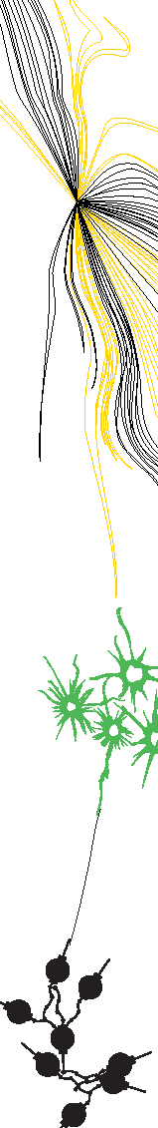CC Final Project Report

By:

Luuk Verkleij (s1362801)

Yağmure Eyrice

Contents

Summary 3

Problems and Solutions 4

Detailed Language Description 5

Description of the Software 6

Test plan and Results 7

Conclusion 8

Appendices 9

Appendix A: Grammar 9

Appendix B: Tree Walkers 10

Appendix C: Extended Test PRogram 11

# Summary

# Problems and Solutions

# Detailed Language Description

# Description of the Software

# Test plan and Results

# Conclusion

# Appendices

## Appendix A: Grammar

## Appendix B: Tree Walkers

## Appendix C: Extended Test PRogram