TABLE OF CONTENT
1. Abstract……………........................................................................................................ .7
2. Project Milestones, Timeline, and Status………........................................................ 8
2.1 Project Timeline and Milestones Overview ................................................................... 8
3. Architecture & Host Inventory ......................................................................................... 9
4. Deployment Activities Completed ..................................................................................10
5. Requirement Understanding & Honeypot Research ………………………………………11
5.1 Requirement Analysis...................................................................................................12
5.2 Honeypot Research......................................................................................................12
5.3 Authentication-Focused Honeypots .............................................................................12
5.4 Design Implications from Research .............................................................................13
5.5 Outcome of the Research Phase ………………………………………………………………. 13
6. VirtualBox Installation, Python & HTML/CSS Setup ..................................................... 13
6.1 Installation of VM Instances .........................................................................................13
6.2 Installation Process.......................................................................................................14
6.3 Python Environment Setup ..........................................................................................14
6.4 HTML/CSS Setup for Login Interface ......................................................................... 15
6.5 Verification and Initial Testing .....................................................................................15
7. Week 2: Study of Authentication Attacks & Logging Mechanisms …………..................16
7.1 Activities Performed......................................................................................................16
7.2 Logging Mechanism Design ........................................................................................16
8. Week 3: Design of Login Interface & Backend Architecture ..........................................18
8.1 Activities Performed .................................................................................................... 18
8.2 Backend Architecture Planning ....................................................................................18
8.3 System Flow Design ................................................................................................... 19
9. Week 4: Python Environment Setup & Module Testing ................................................ 20
9.1 Activities Performed .................................................................................................... 20
9.2 Testing & Validation .....................................................................................................20
10. Week 5: Implement Basic Web Server & Login Form Handling ...................................21
10.1 Activities Performed................................................................................................... 21
10.2 Testing & Validation................................................................................................... 21
11. Week 6: Implement Credential Logging Module ......................................................... 22
11.1 Activities Performed .................................................................................................. 22
11.2 Testing & Validation .................................................................................................. 22
12. Week 7: Add IP Tracking & Timestamp Functionality ..................................................23
12.1 Activities Performed .................................................................................................. 23
12.2 Testing & Validation .................................................................................................. 23
13. Week 8: Data Analysis & Pattern Recognition Module (Planned) ……….................... 24
13.1 Planned Tasks ……....................................................................................................24
14. Week 9: Final Documentation, Demonstration & Report Writing …………...................24
14.1 Planned Tasks ...........................................................................................................24

LIST OF FIGURES

1 Table 1. Project timeline , description and status ………………………………………………8
Figure 1. Traffic Flow 9
Figure 2 Research on working 12
Figure 3.Oracle virtual box 13
Figure 4 Python Isntall 14
Figure 5 sample html login page 15
Figure 6 Html Login Page VM 17
Figure 7 User submissioon credentials 19
Figure 8 Backend Server capture credes. 19
Figure 9 Detecttion Engine 20
Figure10 CMD shoeing flask startup 21
Figure 11 creds capture and the meta data 22
Figure 12 Log file details 22

ABSTRACT

The Mini Honeypot Login System – Trace the Attacker Path is a cybersecurity research project designed to simulate a realistic login interface, attracting and monitoring unauthorized access attempts. The primary purpose of the system is to understand attacker behavior, identify common attack patterns, and provide insights for improving authentication security. Honeypots are decoy systems that serve as a trap for malicious actors by mimicking real applications or services. This project focuses on a web-based honeypot, implemented as a login page, which captures information about every authentication attempt, including usernames, passwords, timestamps, IP addresses, and user-agent strings. The project is implemented using Python for backend logic, with HTML/CSS for the frontend interface. The system runs locally on Windows OS, creating a safe environment for testing and analysis. Key components include a logging module to record all activities, a detection engine to identify suspicious patterns, and optional data visualization tools to interpret attack trends

Project Milestones, Timeline, and Status
The project follows a phased implementation roadmap to ensure systematic development and controlled deployment, continuous assessment, and progressive enhancement of the honeypot-based login monitoring system. Each milestone represents a key activity contributing to the overall project objective, beginning from infrastructure provisioning to security validation and final documentation. The table below summarizes the planned timeline and current execution status. The table below summarizes the planned timeline, key activities, and current execution status of the project.

Milestone Description |  | Description | Status
Week 1 | Requirement Analysis & Honeypot Research | Studied honeypot concepts, types, and real-world use cases; identified project scope and objectives | Completed
Week 2 | Study of Authentication Attacks | Researched brute-force attacks, password spraying, and credential stuffing techniques. | Completed
Week 3 | System Architecture & Interface Design | Designed login interface using  HTML/CSS and backend architecture using Python. | Completed
Week 4 | Environment Setup & Module Testing | Installed Python environment, tested Flask framework and logging modules | Completed
Week 5 | Web Server & Login Handling | Implemented Python-based web server and integrated login form submission | Completed
Week 6 | Credential Logging Module | Developed logging mechanism to capture credentials and metadata | Completed
Week 7 | IP Tracking &  Timestamp Integration | Implemented IP address tracking and timestamp logging for all attempts | Completed
Week 8 | Data Analysis & Pattern Recognition | Analysis of collected login data to identify attack patterns and behavior. | Completed
Week 9 | Data Visualization | Visualization of attack and studying the pattern | Completed
Week 10 | Documentation & Final Reporting | Final project report preparation, demonstration, and evaluation | Completed

Table 1. Project timeline , description and status

Architecture & Host Inventory Web Login Honeypot:
A Python-based web application deployed on Windows OS that hosts a fake login interface (HTML/CSS) to attract and capture unauthorized authentication attempts.
Backend & Detection Engine:
Handles incoming login requests, records credentials and metadata (IP, timestamp, user-agent), and applies rule-based logic to detect suspicious behavior.
SSH Honeypot:
A Python-based SSH emulation service used to capture unauthorized SSH login attempts for additional attack surface monitoring.
Logging & Analysis Module:
Stores all captured data securely and performs analysis to identify attack patterns, frequency, and commonly used credentials.
Kali Linux: Deployed in VirtualBox used for validation, manual testing.
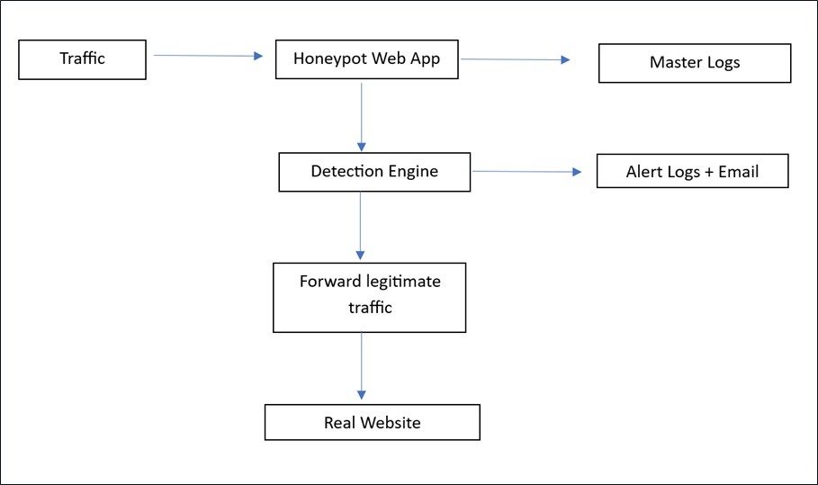

Fig
.

Traffic

Workflow

Deployment Activities Completed
Web Login Honeypot Deployment
- Built and deployed a Python-based web login honeypot on the designated Windows host system. Developed and integrated a fake authentication interface using HTML and CSS to simulate a legitimate login portal. Backend Server & Logging Configuration
- Configured a master logging mechanism to capture attempted usernames, passwords, timestamps, source IP addresses, ports, user-agent strings, and session identifiers. Storage of log files for later analysis and reporting.
Detection Engine Deployment
- Implemented a rule-based detection engine to monitor authentication behavior. Configured detection rules for brute-force attempts, password spraying, and repeated login failures from the same IP address..
SSH Honeypot Deployment
- Deployed a lightweight SSH honeypot module (ssh.py) on the same Windows host. Configured the service to emulate an SSH login prompt and capture unauthorized SSH credential attempts. System Validation & Testing
- Performed manual testing of the web login honeypot using browser-based and scripted login attempts. Verified accurate logging and detection of suspicious authentication behavior and the log files data collection Data Collection Readiness
- Verified that captured data is correctly formatted and ready for analysis and visualization.
- Ensured logs can be processed by analysis modules to generate attack statistics and behavioral insights.

Week1:- Requirement Understanding & Honeypot Research
1.1 Requirement Analysis
The primary requirement of the project is to design and implement a honeypot-based login system capable of capturing and analyzing unauthorized authentication attempts. Unlike traditional security systems that aim to block attackers, the honeypot intentionally attracts malicious users to observe their behavior.
Based on the project objectives, the following functional and non-functional requirements were identified:
Functional Requirements: A realistic web-based login interface to simulate a genuine authentication system ability to capture all login attempts, regardless of success or failure.
Logging of critical metadata including:
O Username and password combinations
O Timestamp of each attempt
O Source IP address and port
O User-agent and browser information
O Session identifiers

Detection of suspicious authentication patterns such as brute-force attacks and password spraying.
1.2 Honeypot Research
A honeypot is defined as a decoy system designed to attract attackers by mimicking legitimate services or applications. Any interaction with a honeypot is considered suspicious or malicious, making it an effective tool for studying attacker techniques without risking production systems.
Research was conducted on different types of honeypots:
  - Low-Interaction Honeypots: \
Simulate basic services with limited functionality. They are easy to deploy and maintain but provide limited behavioral data.

  - Medium-Interaction Honeypots:
Offer more realistic interaction without exposing real operating systems. These honeypots provide richer attack data while maintaining safety.
  - High-Interaction Honeypots:
Involve real systems and services, offering deep insights into attacker behavior but requiring strong isolation and monitoring.

1.3 Authentication-Focused Honeypots

The research emphasized honeypots designed to capture authentication-related attacks, as login interfaces remain one of the most targeted attack surfaces. Common attack techniques studied include:

- Brute-Force Attacks: Repeated attempts to guess credentials for a single account.
- Password Spraying: Attempting a small set of common passwords across multiple usernames.
- Credential Stuffing: Using leaked credentials from data breaches to gain unauthorized access.

Understanding these attack methods influenced the design of the detection engine and logging mechanism implemented in the project.
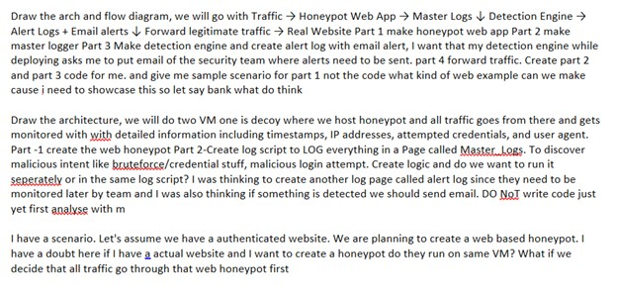

Fig. Re
search

on

Working.

1.4 Design Implications from Research
The research findings directly informed key design decisions:
  - The login interface was designed to overview the real-world applications.
  - All authentication attempts are logged without blocking attackers.
  - Detection logic is rule-based to identify suspicious patterns.
1.5 Outcome of the Research Phase
By the end of this phase, a clear understanding of honeypot concepts, authentication threats, and system requirements was achieved. This foundation enabled the successful design and implementation of the honeypot-based login system in subsequent project phases.
2. VirtualBox Installation, setting up Python , HTML/CSS for the project.
2.1 Installation of VM Instances :-
To begin the project environment setup, Oracle VirtualBox was selected as the virtualization platform to provide an isolated and secure testing environment for future expansion and attack simulation.
The latest version of Oracle VirtualBox was downloaded from the official website: https://www.virtualbox.org/wiki/Downloads
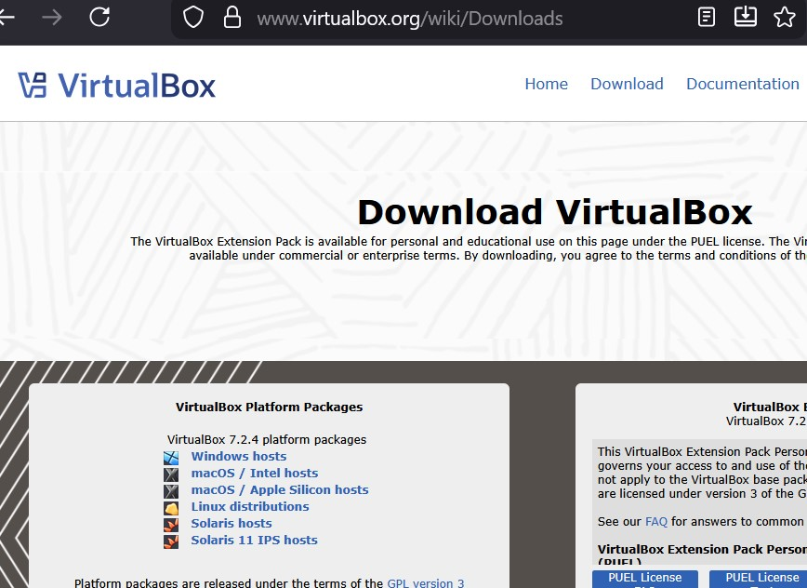
Figure 1: Oracle VirtualBox Official Download Page

Additionally, the following prerequisites were prepared:
Windows OS (Host System)
Python 3.x installer downloaded
A modern web browser (Chrome/Firefox) for frontend testing
Text editor/IDE (VS Code) for Python, HTML, and CSS development
2.2 Installation Process
The VirtualBox installer was executed on the Windows host system. During installation, default configuration options were selected, including networking and USB support. The installer requested administrative privileges and temporarily reset network interfaces during setup.
2.3 Python Environment Setup
The Python 3.x installer was launched, and the option “Add Python to PATH” was enabled to allow command-line execution.
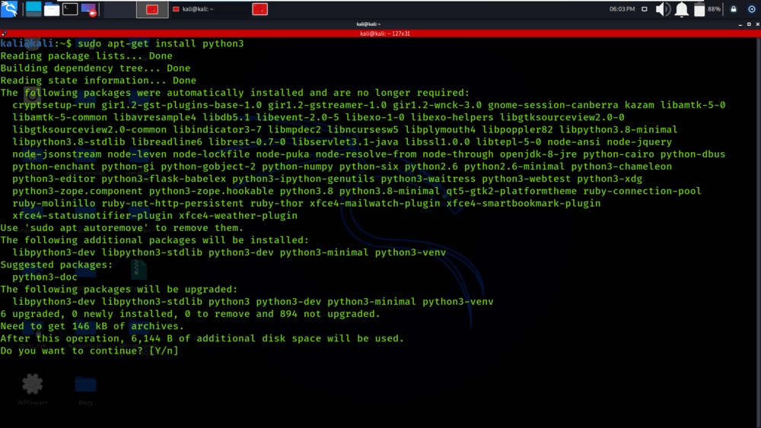
Figure 4: Python Installation Setup Screen python –version

2.4 HTML/CSS Setup for Login Interface
A dedicated project directory was created to organize backend and frontend components. HTML files were used to design the fake login page, while CSS was applied for styling to mimic a real authentication portal.
The login form included:
- Username field
- Password field
- Submit/Login button
These files were later integrated with the Python backend to handle HTTP POST requests.

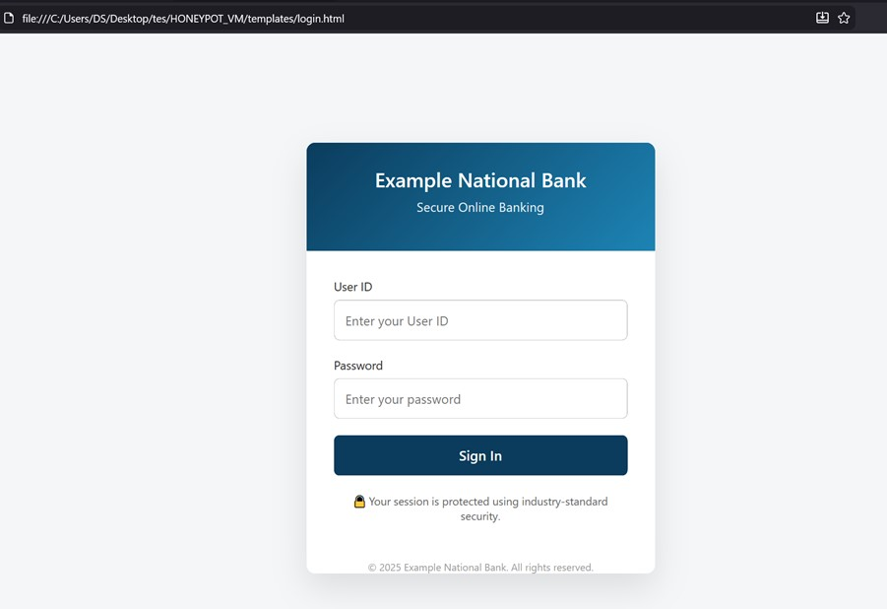

Figure 6: Sample HTML Login Page Design

2.5 Verification and Initial Testing
The login page was accessed through a local browser. Test credentials were entered to verify proper data flow between frontend and backend. Console output and preliminary log entries confirmed successful capture of authentication attempts.
Figure 7: Test Login Attempt and Log Output
Week 2: Study of Authentication Attacks & Logging Mechanisms
During Week 2, the focus was on understanding common authentication-based cyber-attacks and designing a foundational mechanism to log malicious login attempts effectively. This phase helped bridge theoretical security concepts with practical implementation planning.
2.1 Activities Performed
- Studied major authentication attack techniques including:
  - Brute-Force Attacks: Repeated attempts to guess credentials for a single account.
  - Password Spraying: Using one common password across multiple user accounts.
  - Credential Stuffing: Reusing leaked credentials obtained from previous data breaches.
- Analyzed how attackers exploit weak authentication mechanisms and insufficient monitoring systems.
- Designed a preliminary logging mechanism to record all login attempts made to the honeypot system.

Fig. Brute Force Attack
2.2 Logging Mechanism Design
The initial logging framework was planned to capture the following critical parameters for each authentication attempt:
- Attempted username
- Attempted password
- Source IP address
- Timestamp of the attempt
- User-agent and browser details
This design ensures that sufficient metadata is collected to analyze attacker behavior, detect patterns, and support future visualization and reporting modules. Code Snippet :- to log the mentioned elements

Screenshots :-
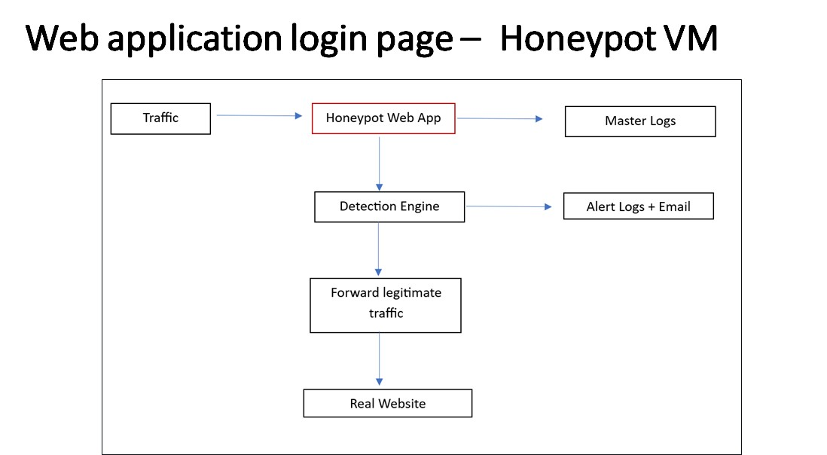

Fig. Architecture diagram attack flow and process

Fig. Sample log structure showing captured fields
Week 3: Design of Login Interface & Backend Architecture
During Week 3, the focus was on designing the UI login interface and planning the backend architecture required to support the honeypot-based authentication system. This phase ensured that the honeypot appeared realistic while maintaining a controlled and secure backend.

3.1 Activities Performed
- Designed a fake login page using HTML and CSS.
- Implemented input fields for username and password along with a login button to attract unauthorized access attempts.
- Applied basic styling (colors, layout, fonts) to enhance realism and usability of the interface.

3.2 Backend Architecture Planning
- Planned a Python-based backend architecture to handle incoming authentication requests.
- Defined request handling logic for HTTP POST submissions from the login form.
- Designed a modular backend structure consisting of:
    - Web server module o Authentication request handler o Central logging module
    - Detection engine (rule-based analysis)
- Ensured that no real authentication was performed and that all login attempts would be treated as suspicious and logged.

3.3 System Flow Design
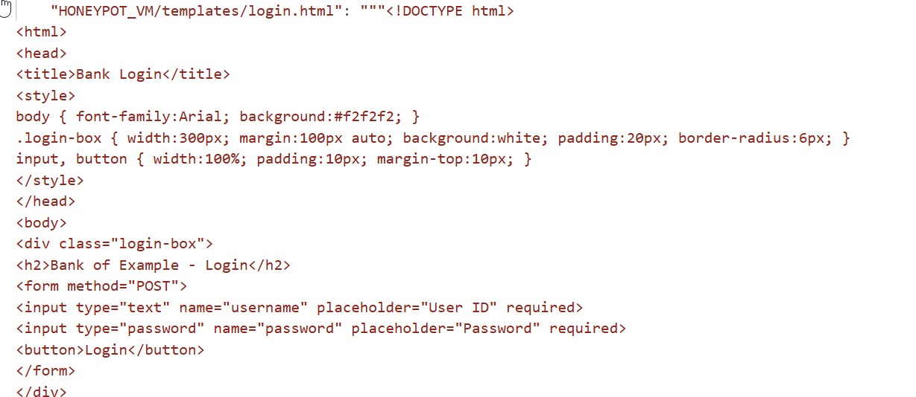

Fig;-Screenshot of HTML/CSS-based login page design

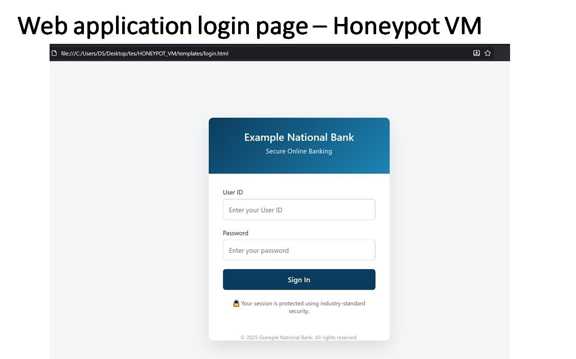
- Fig. User submits credentials through the login page.

Fig. Backend server captures credentials and metadata.
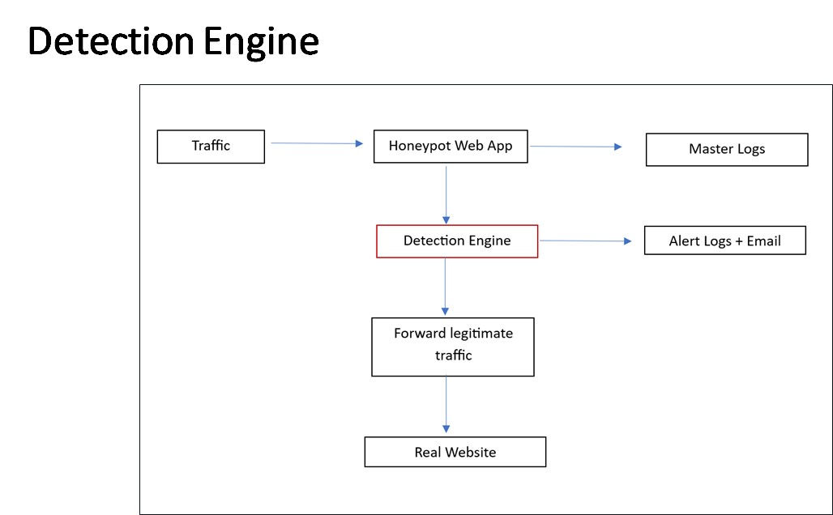
Fig. Detection engine evaluates the attempt for suspicious behavior.

Week 4: Python Environment Setup & Module Testing
In Week 4, the primary objective was to establish a stable Python development environment on VM and validate the core modules required for the honeypot application.
4.1 Activities Performed
- Installed and configured Python 3.x on the VM.
- Verified Python installation and environment variables using command-line execution.
- Installed required Python modules using pip, including:
- Flask (for web server and request handling)
- Logging modules (for capturing authentication data)
4.2 Testing & Validation
- Executed a sample Flask script and accessed it through a web browser to confirm server functionality.
- Verified that HTTP requests were correctly received and responded to by the backend.

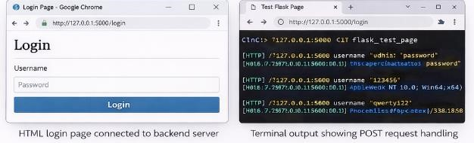

Fig. Screenshot of command prompt showing successful Flask server startup

Week 5: Implement Basic Web Server & Login Form Handling
- Week 5 focused on implementing the core web server logic and integrating the frontend login form with the Python backend.
5.1 Activities Performed
- Implemented a Python-based web server using Flask to serve the login page.
- Configured routing to handle HTTP GET requests for displaying the login page.
- Implemented HTTP POST request handling to capture data submitted through the HTML login form.
- Successfully connected the HTML/CSS login interface with the backend server.
- Ensured that all login attempts are captured regardless of credential correctness.
5.2 Testing & Validation
- Performed multiple test login attempts using different usernames and passwords.
- Verified that submitted data was correctly received by the backend server.

Fig. Screenshot showing successful form submission handling in backend

Week 6: Implement Credential Logging Module
In Week 6, a dedicated credential logging module was implemented to store and manage authentication attempt data for further analysis.
6.1 Activities Performed
- Developed a logging module to record all login attempts in a structured format.
- Configured the module to capture the following details for each attempt:
- o Username o Password o Timestamp o Source IP address, User-agent and browser information
- Ensured that logs were stored persistently in a secure log file.
6.2 Testing & Validation
- Simulated multiple logins attempts to verify correct logging behavior.
- Confirmed that repeated attempts Validated log accuracy and readability for future analysis and reporting. Screenshots / Evidence

Fig. log file showing multiple captured login attempts
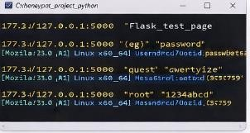

Fig:- Screenshot of terminal output confirming logging success

Week 7: Add IP Tracking & Timestamp Functionality
In Week 7, the honeypot system was enhanced to capture detailed network and time-based metadata for every authentication attempt. This information is critical for identifying attacker behavior, correlating events, and performing later analysis.
7.1 Activities Performed
- Implemented IP address tracking for all incoming login requests.
- Added timestamp functionality to ensure every login attempt is recorded with accurate date and time information.
- Integrated IP and timestamp capture into the master logging module, ensuring consistent storage of all authentication events.
7.2 Testing & Validation
- Performed multiple test login attempts from the local host and simulated external IP addresses.
- Verified that each entry in the log file contained:
- Source IP address o Timestamp o Username and password o User-agent information
Fig. log file showing captured IP address and timestamp for each login attempt Week 8: Data Analysis & Pattern Recognition Module Plan
Week8 :- To analyze the captured honeypot login data in order to identify patterns in attacker behavior and common attack techniques.

8.1 Planned Tasks
Develop a Python-based analysis module to process stored log files.
Perform frequency analysis to identify: o Most commonly used usernames of most frequently attempted passwords

Implement detection for:
- Repeated login attempts from the same IP address
- Password spraying behavior (same password across multiple usernames)

Week 9: Final Documentation, Demonstration Preparation & Report Writing Plan
To compile all development work, analysis results, and screenshots into a structured final project submission.
9.1 Planned Tasks
Prepare the final project report including:
o Introduction of Installation details o Week-wise progress o Analysis results
o Conclusion and future scope
Organize and label all screenshots and diagrams used throughout the report.
Prepare a project demonstration show casing:
- Login honeypot in action.
- Log generation

