Linear search

Definition : refer textbook and write



Algorithm

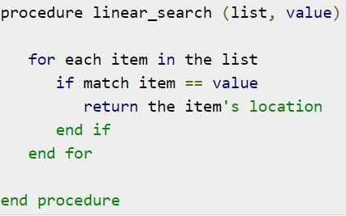

Example : refer your note

---------------------------------------------------------------------------------------------------------

Binary search

Definition:

Algorithm :

binarySearch(arr, size)

loop until left is not equal to end

midIndex = (left + right)/2

if (item == arr[midIndex] )

return midIndex

else if (item > arr[midIndex] )

left = midIndex + 1

else

right = midIndex - 1

Example : refer notebook

---------------------------------------------------------------------------------------------------------

Bubble sort

Definition:

algorithm

begin BubbleSort(list)

for all elements of list

if list[i] > list[i+1]

swap(list[i], list[i+1])

end if

end for

return list

end BubbleSort

example:

---------------------------------------------------------------------------------------------------------

Selection sort

Definition : refer text book

Algorithm

**Step 1** − Set MIN to location 0

**Step 2** − Search the minimum element in the list

**Step 3** − Swap with value at location MIN

**Step 4** − Increment MIN to point to next element

**Step 5** − Repeat until list is sorted

Example : refer your note

---------------------------------------------------------------------------------------------------------

Insertion sort :

Def :

Algo:

**Step 1** − If it is the first element, it is already sorted. return 1;

**Step 2** − Pick next element

**Step 3** − Compare with all elements in the sorted sub-list

**Step 4** − Shift all the elements in the sorted sub-list that is greater than the

value to be sorted

**Step 5** − Insert the value

**Step 6** − Repeat until list is sorted

Example:

---------------------------------------------------------------------------------------------------------

Shell sort

Def: refer textbook

Algo:

**Step 1** − Initialize the value of *h*

**Step 2** − Divide the list into smaller sub-list of equal interval *h*

**Step 3** − Sort these sub-lists using **insertion sort**

**Step 3** − Repeat until complete list is sorted

Eg: refer note

---------------------------------------------------------------------------------------------------------

Radix sort

Def: refer text book

Algo:

radixSort(arr)

max = largest element in the given array

d = number of digits in the largest element (or, max)

Now, create d buckets of size 0 - 9

**for** i -> 0 to d

sort the array elements using counting sort (or any stable sort) according to the  digits at  the ith place

Eg: refer note