**ADS ASSIGNMENT – 2**

**STATISTICS AND TRENDS – REPORT**

**NAME:**

Dhruvkumar Shiroya

Student id :- 21086849

**ABSTRACT:**

The following report show the relationship between three different factors such as forest area, population total and GHG-emissions. The main reason why I select these type of area was to give a meaningful evolution that how the total population affects different other major sectors and to extract meaningful insights from it.

**REPOSITORY LINK:**

<https://github.com/Ds1801/ADS-Assignment2.git>

**CLIMATE CHANGE ANALYSIS BASED ON WORLD BANK DATA**

To commence with, there are total 8 countries that are taken into consideration in different areas which are interrelated and change in any factor also varies the other ones and ultimately leads to climate change. These factors are population, GHG Emission and forest area which are observed in different time series and found meaningful insights.

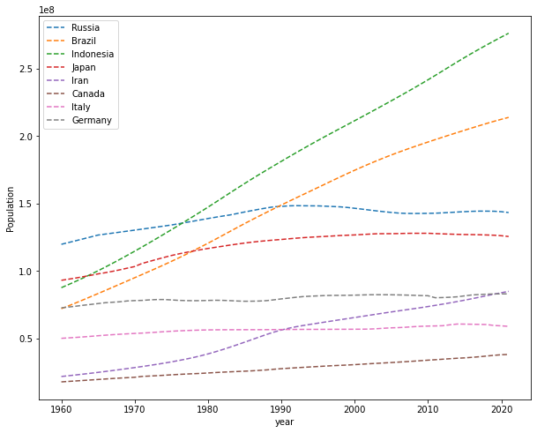

Figure 1: Total Population

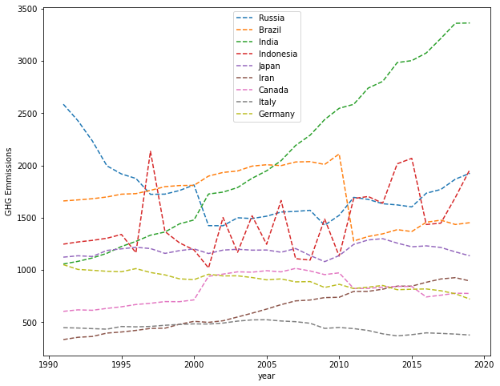

Figure 2: GHG Emission

The “Greenhouse Gas Emission” and “Population” charts also show that Russia and Brazil have similar trends which is significant at the world level. The greenhouse gas is depends on the population of the world. Because of the when the population is increase then its effect on the globally.

The “Greenhouse Gas” charts also show that the Indonesia have up and down trend like Zigzag which is shows that Greenhouse Gas effect on human population. In other Hand Italy and Germany have similar down words trends which is significant at the world level.

The line graph above on Total Population by the countries was constructed with available data from the year 1960 to 2020 in one year increments. Indonesia is the highest increaser of population and display a forward curve with highest rates from the onset of the millennium which is reflected in their “GHG” which stands for “Greenhouse Gas” as seen on the GHG plot on the top right. The gas emission is related to an increase in the World population.

Germany have similar down words trends which is significant at the world level.

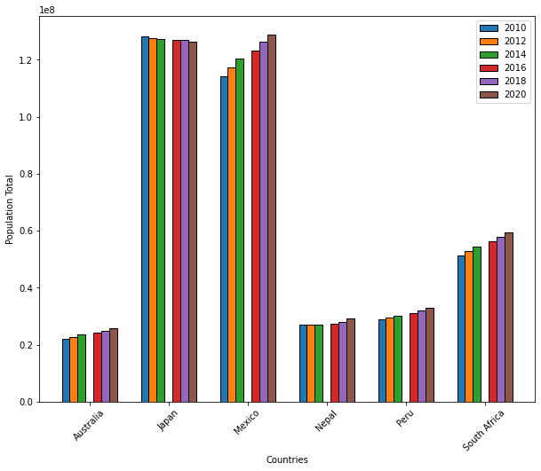

Figure 3: Total Population

The first bar chart shows that the population of the world by the county by county. Which is cover the 6 different years, on two years gap which is 2010, 2012, 2014, 2016, 2018 and 2020. The all data is shows on the billions. So this chart and forest area chart both is related to each other with land availability.

Here japan have the largest population out of 6 country and Australia indicates the lowest population, whereas Nepal and Peru shows the similarity in population. But Mexico increase the population total 2010 to 2020.

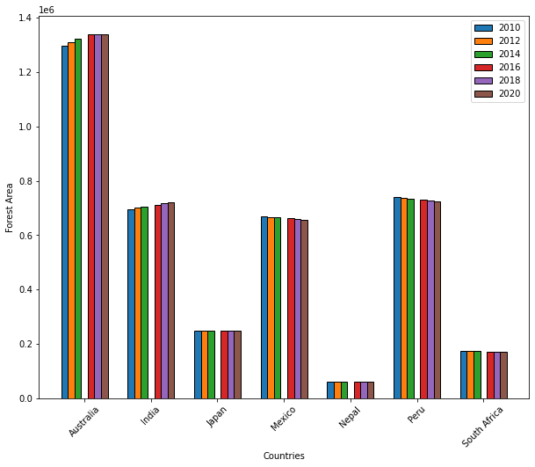

Figure 4: Forest Area

The above given Bar graph indicates the "Forest Area" And "Population Total" from the year 2010 to 2020. It’s clearly seen in the first bar graph "Forest area" indicates the Australia highest forest increase in Australia form 2016 to 2020 whereas the Nepal have lower forest all time. India and Peru have similar area of forest.