ASSIGNMENT-4
EXERCISE 1. Use the data in the table below to generate a scatter plot, calculate Pearson’s correlation, and interpret the relationship between two variables.
X | Y
0 | 88
6 | 52
4 | 64
1 | 60
5 | 54
3 | 78
4 | 40
A scatter plot x and y:
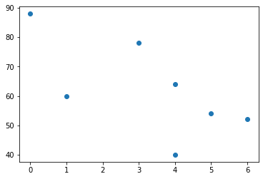
There is a weak, negative association between the two variables.
Pearson’s correlation:
-0.674 indicates a notable correlation between two variables.

EXERCISE 2.In some cases we, data analysts, make calculations using online calculators. Answer the following questions using the online calculator available at this link: Normal Distribution Calculator
- The heights of male students in a particular town are normally distributed with a mean of 65 inches and a standard deviation of 1.7. What percentage of these students is taller than 66.7 inches?
Results:
Area (probability) = 0.1587

- A data set was created by asking 300 students about their weights. The mean is 60 kg. standard deviation is 8 kg. How many students weighed more than 52 kg and less than 68 kg?
Results:
Area (probability) = 0.6827
300x0.6827=204 students are weighted more than 52 kg and less than 68 kg.
EXERCISE 3. The last 10 game results between LA Lakers and LA Clippers are given in the table below. Draw two boxplots for the points scored by these 2 teams and answer the following questions.
Date | LA Lakers | LA Clippers
July 31, 2020 | 103 | 101
March 8, 2020 | 112 | 103
December 26, 2019 | 106 | 111
October 23, 2019 | 102 | 112
July 7, 2019 | 87 | 93
April 6, 2019 | 122 | 117
March 5, 2019 | 105 | 113
February 1, 2019 | 123 | 120
December 29, 2018 | 107 | 118
October 7, 2018 | 87 | 103
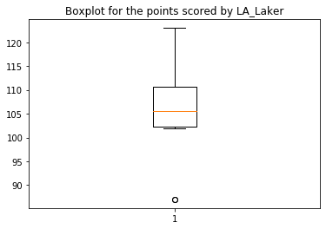

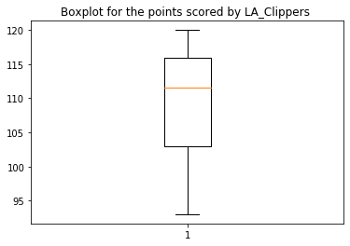

- Which team has a greater median, Lakers or Clippers?
Clippers has a greater median with 111.5.

- Which team has greater IQR, Lakers or Clippers?

Clipper has greater IQR 13.0.

- Which team has a higher percentage of scores above its median?
Lakers has a higher percentage of scores above its median.

