# PL/SQL Mandatory Hands On Exercise 3

QUESTION:

Exercise 3: Stored Procedures

Scenario 1: The bank needs to process monthly interest for all savings accounts.

o Question: Write a stored procedure ProcessMonthlyInterest that calculates and updates the balance of all savings accounts by applying an interest rate of 1% to the current balance.

Scenario 2: The bank wants to implement a bonus scheme for employees based on their performance.

o Question: Write a stored procedure UpdateEmployeeBonus that updates the salary of employees in a given department by adding a bonus percentage passed as a parameter.

Scenario 3: Customers should be able to transfer funds between their accounts.

o Question: Write a stored procedure TransferFunds that transfers a specified amount from one account to another, checking that the source account has sufficient balance before making the transfer.

CODE (Scenario 1):

**CREATE TABLE savings_accounts (**

**account_id NUMBER PRIMARY KEY,**

**customer_id NUMBER,**

**balance NUMBER(12, 2)**

**);**

**INSERT INTO savings_accounts VALUES (101, 1, 10000);**

**INSERT INTO savings_accounts VALUES (102, 2, 15000);**

**INSERT INTO savings_accounts VALUES (103, 3, 12000);**

**INSERT INTO savings_accounts VALUES (104, 4, 8000);**

**INSERT INTO savings_accounts VALUES (105, 5, 9500);**

**CREATE OR REPLACE PROCEDURE ProcessMonthlyInterest IS**

**BEGIN**

**FOR rec IN (SELECT account_id, balance FROM savings_accounts) LOOP**

**UPDATE savings_accounts**

**SET balance = balance + (balance * 0.01)**

**WHERE account_id = rec.account_id;**

**END LOOP;**

**COMMIT;**

**END;**

**/**

**SELECT * FROM savings_accounts;**

**EXEC ProcessMonthlyInterest;**

**SELECT * FROM savings_accounts;**

**commit;**OUTPUT :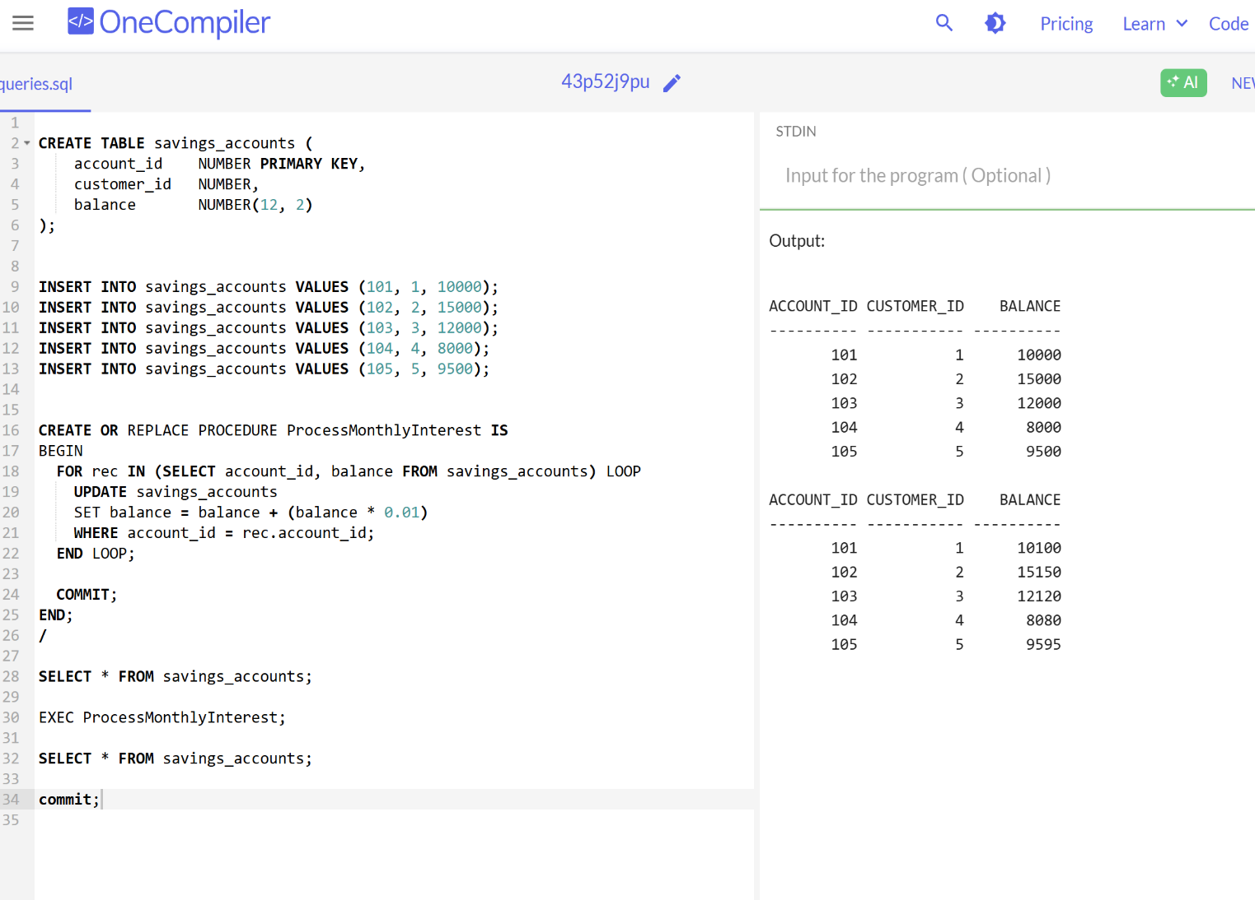

CODE(Scenario 2):

**CREATE TABLE employees (**

**emp_id NUMBER PRIMARY KEY,**

**name VARCHAR2(30),**

**department VARCHAR2(30),**

**salary NUMBER(10, 2)**

**);**

**INSERT INTO employees VALUES (1, 'Alice', 'Sales', 50000);**

**INSERT INTO employees VALUES (2, 'Bob', 'IT', 60000);**

**INSERT INTO employees VALUES (3, 'Charlie', 'HR', 45000);**

**INSERT INTO employees VALUES (4, 'Diana', 'Sales', 55000);**

**INSERT INTO employees VALUES (5, 'Eve', 'IT', 62000);**

**CREATE OR REPLACE PROCEDURE UpdateEmployeeBonus(**

**p_department IN VARCHAR2,**

**p_bonus_percent IN NUMBER**

**) IS**

**BEGIN**

**UPDATE employees**

**SET salary = salary + (salary * p_bonus_percent / 100)**

**WHERE department = p_department;**

**COMMIT;**

**END;**

**/**

**SET LINESIZE 150;**

**SELECT * FROM employees WHERE department = 'Sales';**

**EXEC UpdateEmployeeBonus('Sales', 10);**

**SELECT * FROM employees WHERE department = 'Sales';**

**commit;**

OUTPUT:

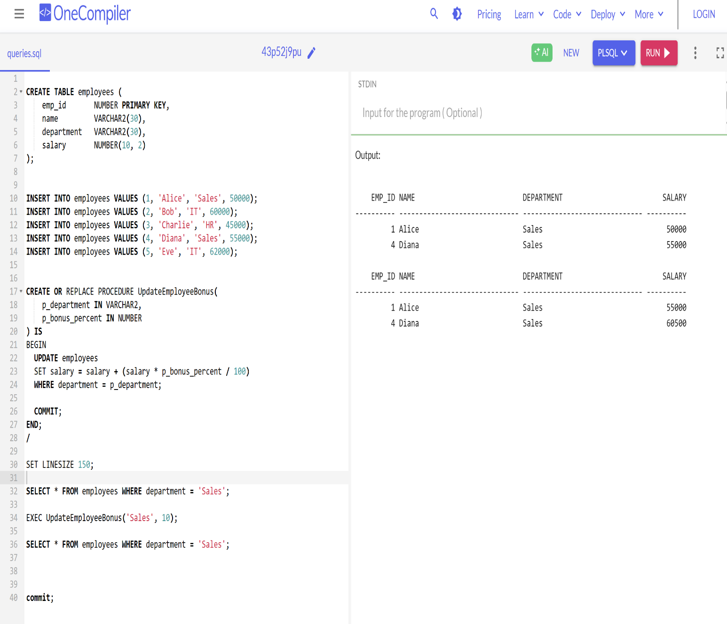

CODE (SCENARIO 3):

**CREATE TABLE accounts (**

**account_id NUMBER PRIMARY KEY,**

**customer_id NUMBER,**

**balance NUMBER(12, 2)**

**);**

**INSERT INTO accounts VALUES (201, 1, 8000);**

**INSERT INTO accounts VALUES (202, 2, 10000);**

**INSERT INTO accounts VALUES (203, 3, 5000);**

**INSERT INTO accounts VALUES (204, 4, 12000);**

**INSERT INTO accounts VALUES (205, 5, 7000);**

**CREATE OR REPLACE PROCEDURE TransferFunds(**

**p_from_account IN NUMBER,**

**p_to_account IN NUMBER,**

**p_amount IN NUMBER**

**) IS**

**v_balance NUMBER;**

**BEGIN**

**SELECT balance INTO v_balance FROM accounts WHERE account_id = p_from_account;**

**IF v_balance < p_amount THEN**

**RAISE_APPLICATION_ERROR(-20001, 'Insufficient balance in source account.');**

**ELSE**

**UPDATE accounts**

**SET balance = balance - p_amount**

**WHERE account_id = p_from_account;**

**UPDATE accounts**

**SET balance = balance + p_amount**

**WHERE account_id = p_to_account;**

**COMMIT;**

**END IF;**

**END;**

**/**

**SELECT * FROM accounts WHERE account_id IN (201, 202);**

**EXEC TransferFunds(201, 202, 2000);**

**SELECT * FROM accounts WHERE account_id IN (201, 202);**

**commit;**

OUTPUT:

