**CS3743 Hwk 3 Data Modeling (30 pts) - due Feb 27th**

**© Copyright 2020 Larry Clark, this document must not be copied to any other website**

You are the data modeler for the County Library System (CLS). You are to provide the data model for their old library system that manages library users, resources, and fees. It is possible when dealing with folks who give you information that they may be weak in their terminology usage.

**Part1 Resource System (18 pts)**

The CLS Resource System will record information about the resources which library users can check-out. Resources can be books, DVDs or Music CDs. All resources have a title, publisher, and a published date. Each resource has been assigned a **unique resource ID**. For books, they also record the ISBN, book category (e.g., mystery, travel, cooking), and number of pages. For DVDs, they record the genre (e.g., romance, comedy) and length in minutes. For CDs, they record the music category (e.g., rock, soul, country, latin, polka, rap, classical) and number of songs. For CDs, CLS also has a list of songs including the sequence (e.g., 1), song titles, and song length (in minutes).

Resource(uniqId, ResourceType, title, publisher, publishedDt) **- SuperClass**

Books(uniqId, ISBN, bookCategory, numOfPgs,) **- SubClass**

DVDs(uniqId, genre, minuteLength) **- SubClass**

MusicCds(uniqId, musicCategory, numOfSongs, SongList) **- SubClass**

Song(uniqId,sequence, songTitle, songLength)

Creator(createdRes,)

physicalCopy(uniqBarCd, resource, checkedStatus, numAvail)

Resources may have many authors/artists, but might not have an author/artist. Authors could write many resources. Note that CLS doesn’t need to distinguish authors and artists. -> Creator?

Resources 1N … 0N Authors

The library may have multiple physical copies of each resource in its inventory. Those physical copies are known as physical resources. Each physical resource has been assigned a unique barcode and a particular resource. Due to recording resources before they are received from the publisher, a resource might not have a physical resource. CLS also wants to know whether a physical resource is checked out.

Show a **UML diagram** using numeric ranges (**not** crow's feet) for this Resource System.

Underline the keys.

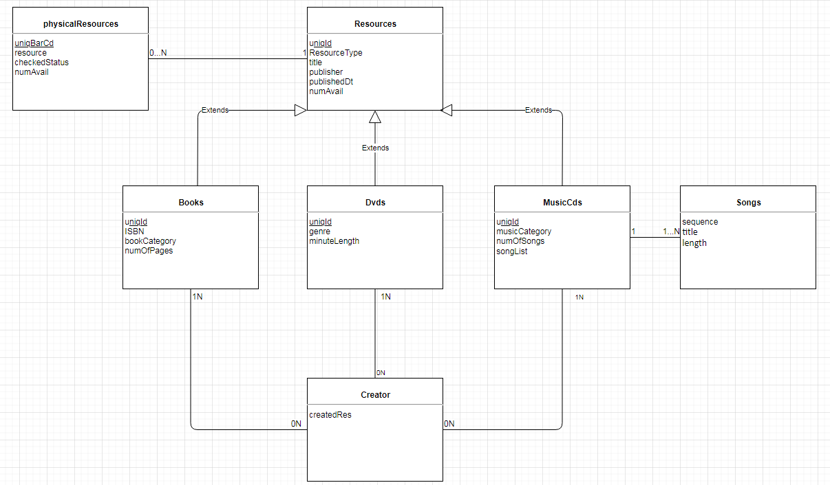

**Part 2 Lending System (12 pts)**

The lending system maintains information about the library users, physical resources, check-outs and fees. For library users, the Lending System records a unique library card number, user name, address, and email.

libraryUsers(uniqCardNm, username, address, email, fees, trueUserCnt, privlegeChk, return)

checkOuts(uniqCardNm, barcode, checkOutDt, resources, userCnt)

fees(UniqCardNm, payDt, payments, totalAmount)

physicalResource(barcode, returnDt, numAvail)

A library user may check-out many resources. When added to the Lending System, a library user will not yet have a check-out. When checking-out a resource, the system must record the library user, resource barcode, and check-out date. A library user might check out the same resource many times, and CLS wants to record each of those. When a resource is returned, CLS wants the lending system to record the return date. A library user cannot check-out any resources if he/she already has 10 resources checked-out.

Once a month, CLS will run a Very Late Resource program that determines current

late charges for each library user (25 cents per day late). The total late charge for each user is

recorded. Anyone having more than $10 in late charges is sent a letter explaining

that their library privileges have been revoked. Privileges cannot be restored

until the late fees are paid and an additional library Abuser Fee (LAF) of $25

is paid. CLS also records each payment made by a library user including its date. If multiple payments are made one day, they are combined into one payment.

Show the data model for the **Lending System** using:

A. Relational Model

B. UML Diagram using numeric ranges (**not** crow's feet)

For both A and B, underline keys. Note that the primary keys from some entities might contain more than two attributes.

In your UML diagram (2B) for the **Lending System,** you **must** also **show one or more relationships** to the **PhysicalResource entity.**

**2A:**

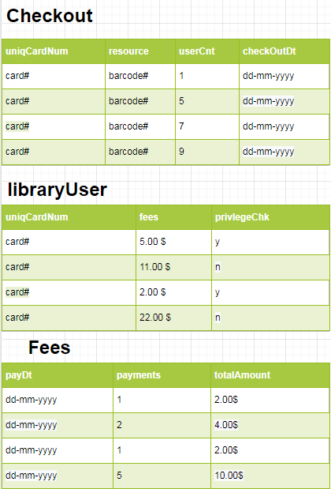

**2B:**