**Multi-LAN Network Configuration with OPNsense**

Setting up a Multi-LAN Network and using a NGFW Firewall OPNsense.

Setting up a Multi-LAN Network infrastructure with the implementation of an OPNsense Next-Generation Firewall (NGFW).

**What is a Multi-LAN Network?**

A Multi-LAN (Local Area Network) Network refers to a network setup that includes multiple distinct local networks within a larger networked environment. In a Multi-LAN configuration, each LAN operates independently but is interconnected, allowing data and information to flow between them.

Download a Windows 10 ISO Image and select a virtualization application; in this illustration, we will utilize the Oracle VM along with the OPNsense image.

**Windows 10 ISO**:

<https://www.microsoft.com/en-us/software-download/windows10>

**Oracle VM**:

<https://www.virtualbox.org/wiki/Downloads>

**OPNsense**:

<https://opnsense.org/download/>

Configure network settings by navigating to File > Tools > Network Manager. Under the NAT Networks tab, click the 'Create' button and employ the settings depicted in the image below. I am labeling my network as WAN with the IP 192.168.10.0/24.

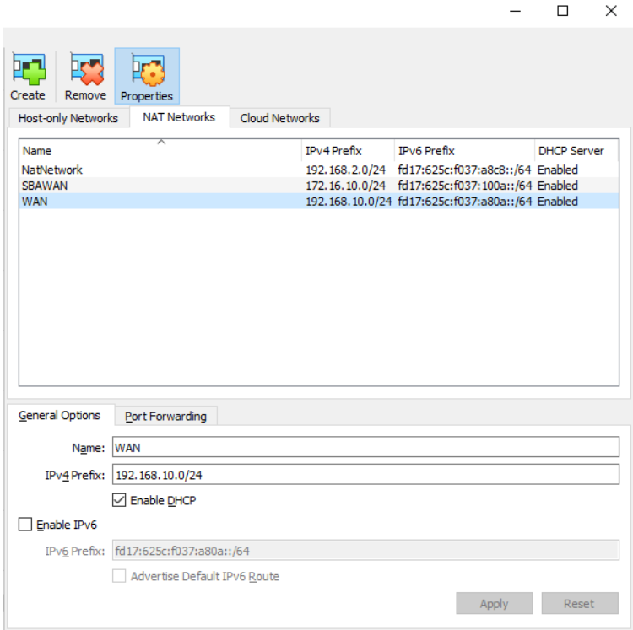

After creating the VM with the OPNsense image, I'm now configuring the VM's network settings. Right-click > Settings > Network. Under Adapter 1, I'm setting it to NAT Network and using the WAN configuration we just established.

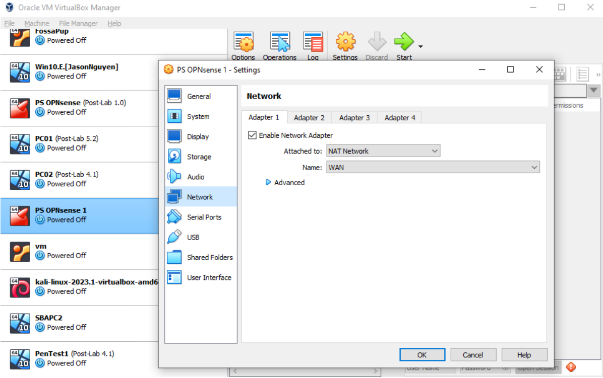

In the network settings, for Adapter 2, I'm configuring it as an Internal Network named LAN. As for Adapter 3, I'm repeating the process, but this time naming it Guest_LAN. Now, our network consists of three networks: WAN for internet access and two Guest Networks, forming our Multi-LAN setup.

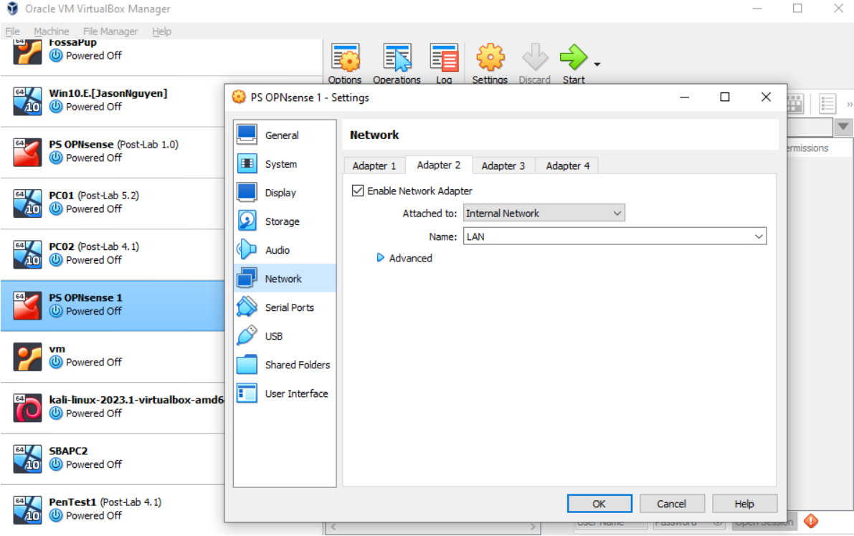

Running the OPNsense VM is the initial step. Upon running it, the Firewall needs configuration before it becomes operational. We'll start by choosing Option 1 - Assigning Interfaces and allocate our WAN network with the designated 192.168.10.0/24 address. For the LAN, enter the prompted configuration after selecting 1. Following the Assignment of Interfaces, we'll move on to Option 2 - Set Interface IP address, where you can customize the settings as desired. Upon completion, OPNsense will provide a link to access the firewall panel in the browser, as shown below:

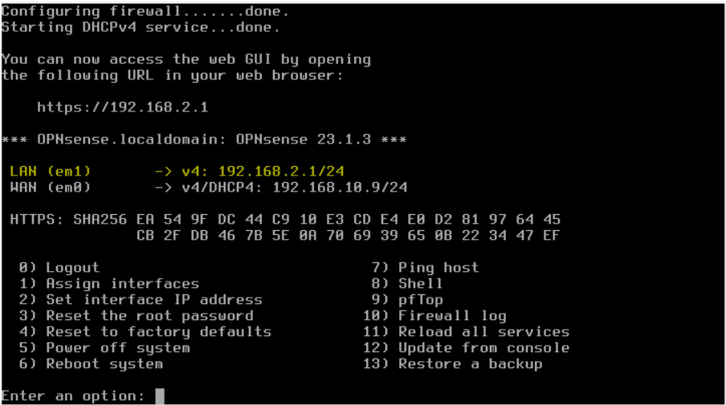

Utilize the provided link to configure and secure your Firewall. In my instance, the IP is [http://192.168.2.1](http://192.168.2.1/), and the default login credentials should be username: root & password: opnsense. Alternatively, you can access the OPNsense VM and choose option 3 to reset the password. After logging in, navigate to Lobby > Password to change the default password. Additionally, ensure to go into Systems and update to the latest version.

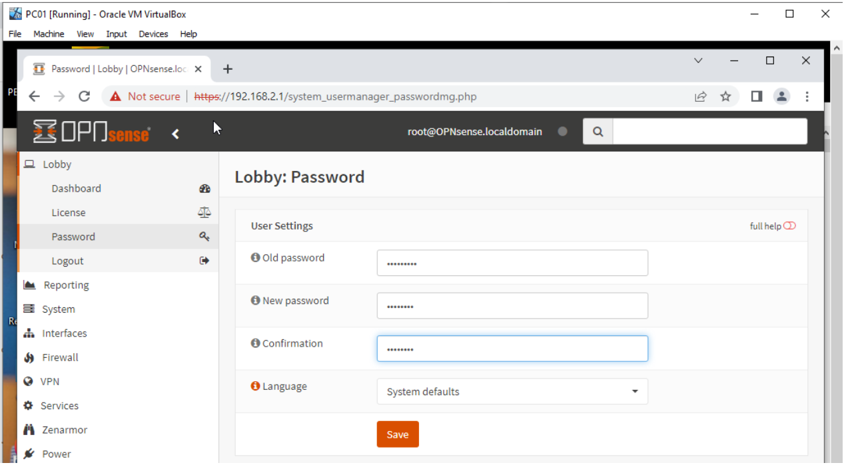

Now, with WAN and LAN Networks set up by default, we need to add the 3rd network through OPNsense, as DHCP-assigned IPs will be managed by OPNsense. In the panel, navigate to Interfaces > Assignments, add the 3rd Network, and name it Guest_LAN. Our Multi-LAN Network should now be fully operational.

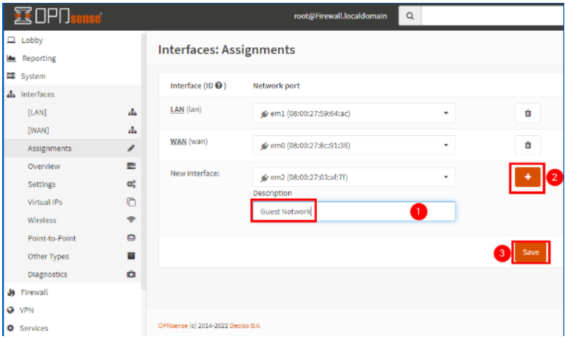

Navigate to Services > DHCPv4 > Guest_LAN. Set the IP address for this network; I simply used 192.168.3.1. Ensure it's enabled and configured correctly. When you boot up PC1 and PC2, PC1 should be on the LAN Network (192.168.2.x), and PC2 should be on Guest_LAN (192.168.3.x).