|  |  |
| --- | --- |
|  |  |

**Faculty of Technology and Engineering**

**Chandubhai S. Patel Institute of Technology (CSPIT)**

**Department of Computer Science & Engineering**

Date: / /

**Laboratory Manual**

|  |  |  |  |  |  |
| --- | --- | --- | --- | --- | --- |
| Academic Year | : | 2024-25 | Semester | : | 4 |
| Course code | : | CSE206 | Course name | : | DATABASE MANAGEMENT SYSTEM |

|  |
| --- |
| **Practical - 10** |
| **Aim:** - You are a database developer for a financial application that requires frequent mathematical calculations. One critical operation is multiplying two numbers provided by users and returning the result. To achieve this, you must create a robust PL/SQL procedure that handles various scenarios, including positive and negative numbers, zero values, and floating-point numbers. Create a PL/SQL procedure that calculates the product of two numbers, ensuring error handling for invalid inputs and consistent results. |

**Tasks:-**

1. A user wants to calculate the product of two positive numbers, e.g., 10 and 5, to determine total costs.

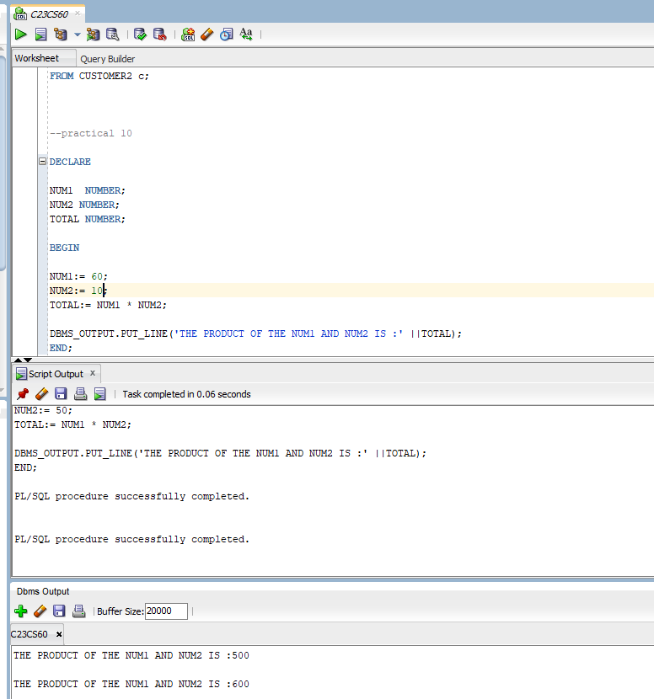

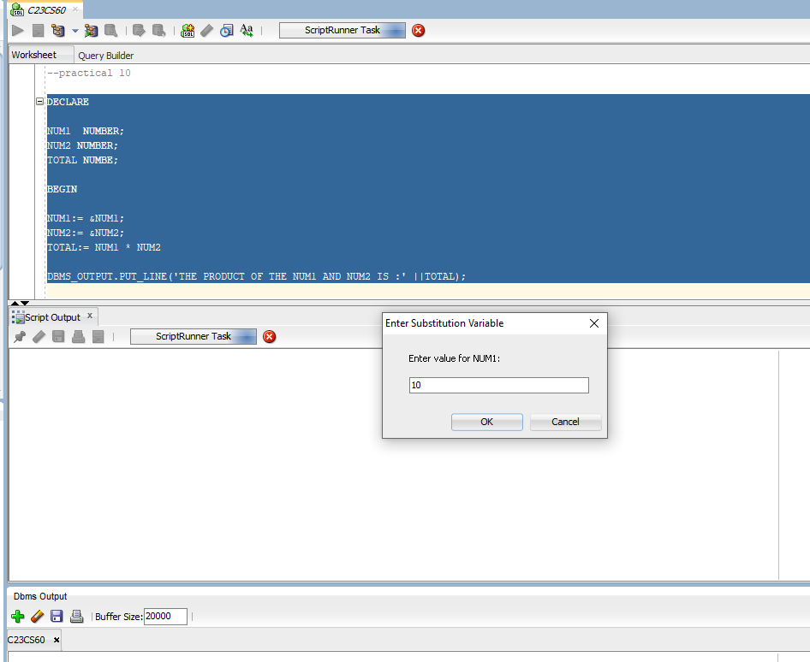

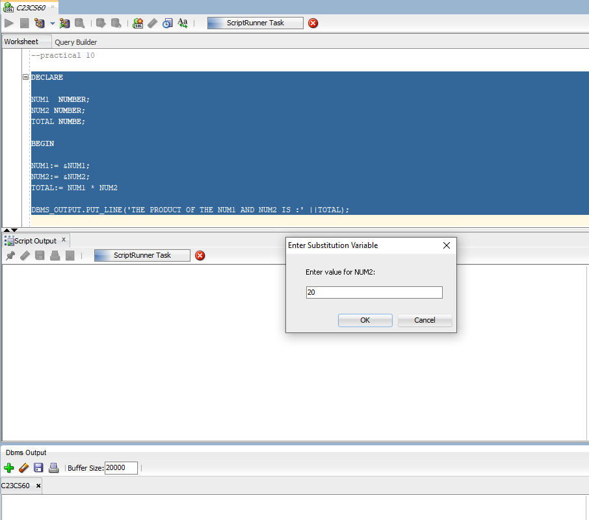

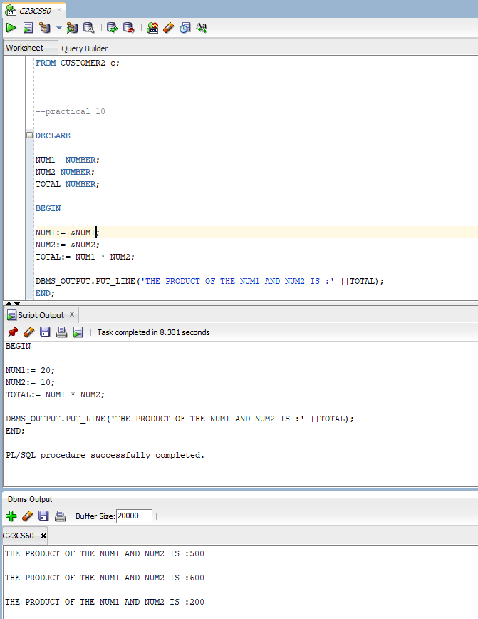

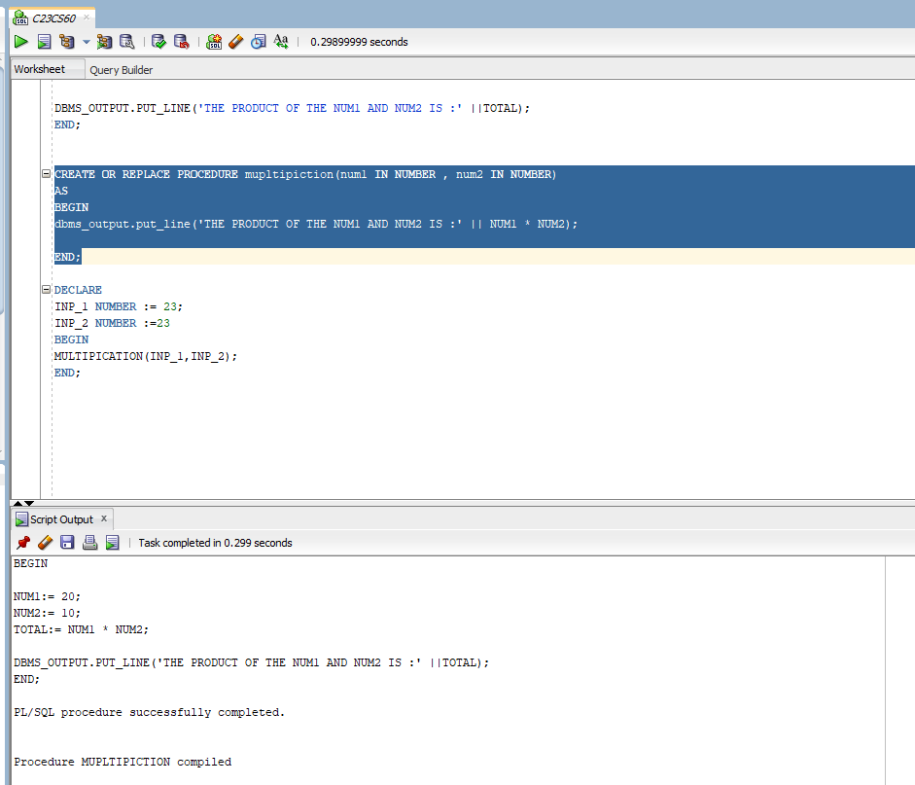

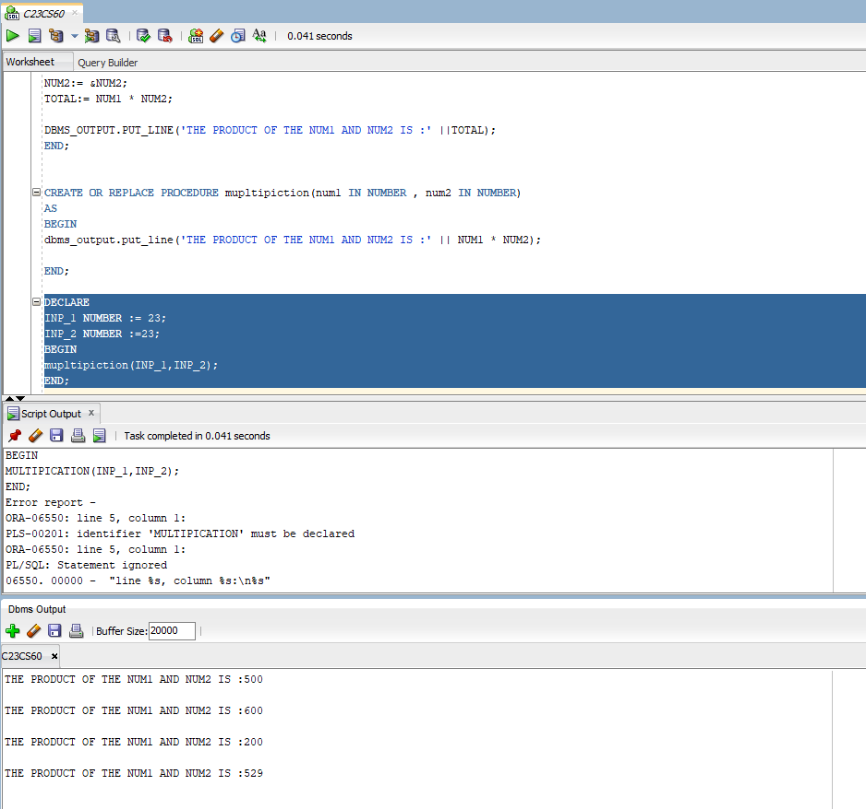

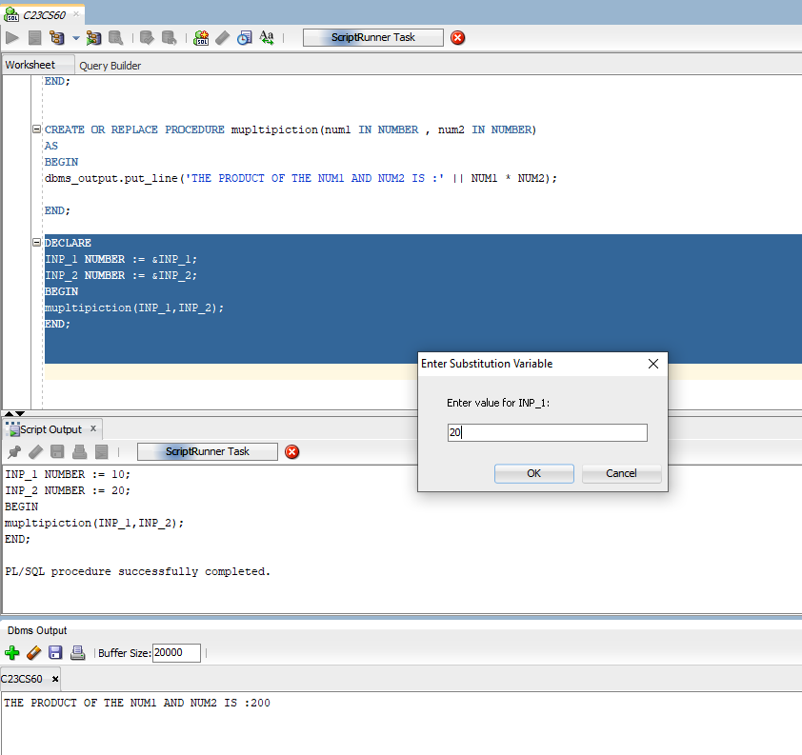

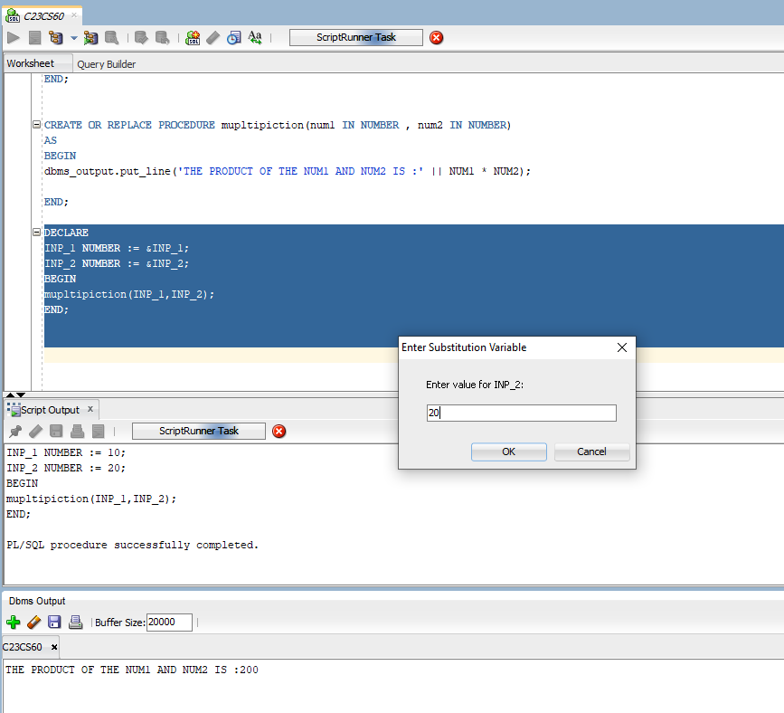

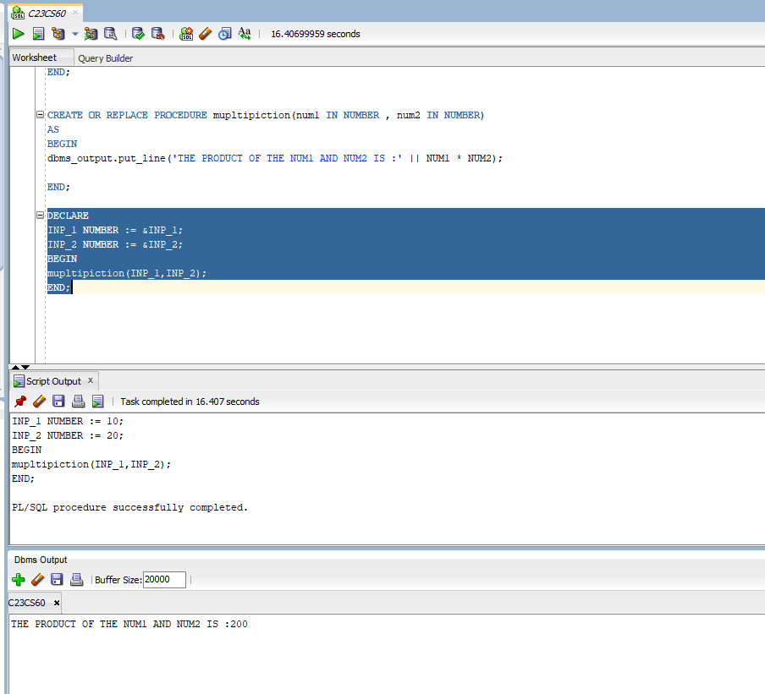

1. A user wants to verify that multiplying any number with zero results in zero, e.g., 15 and 0.

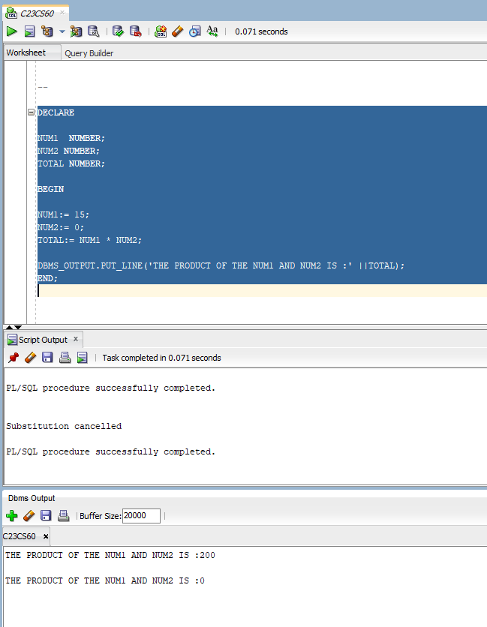

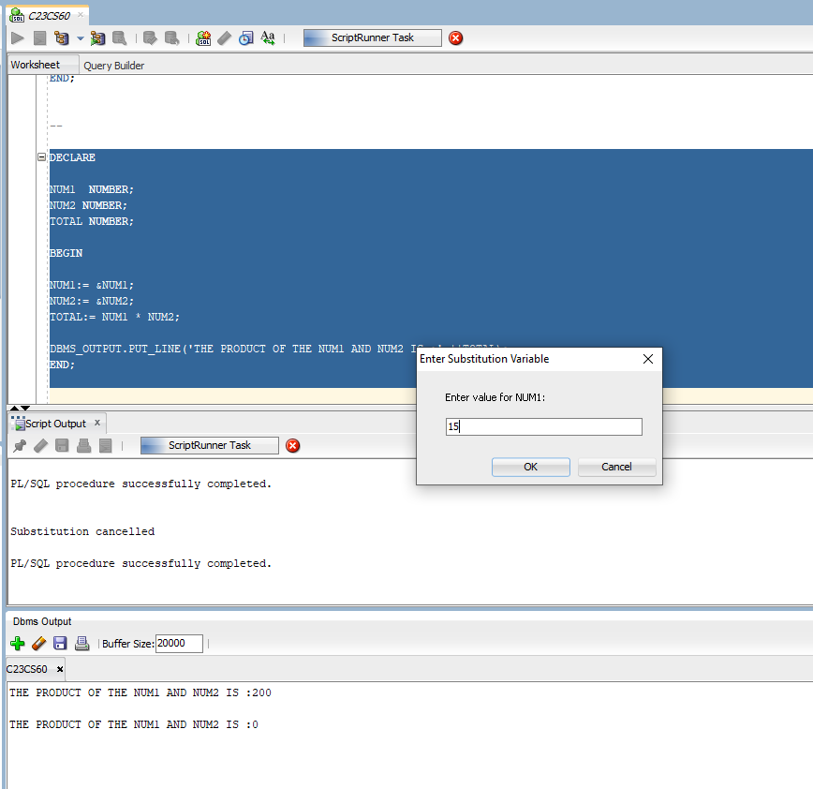

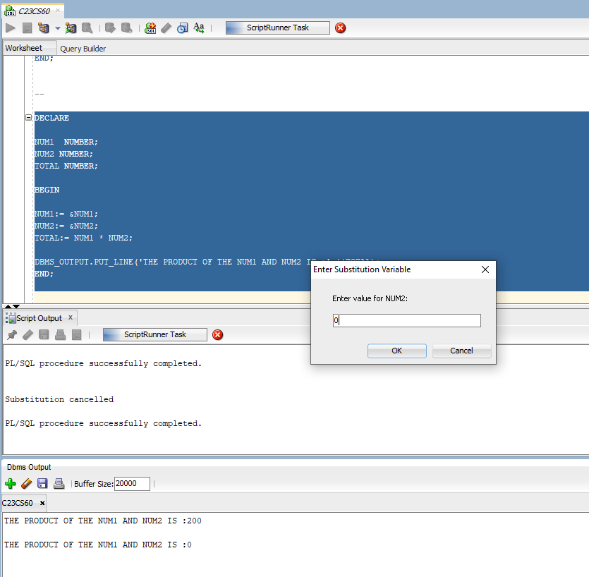

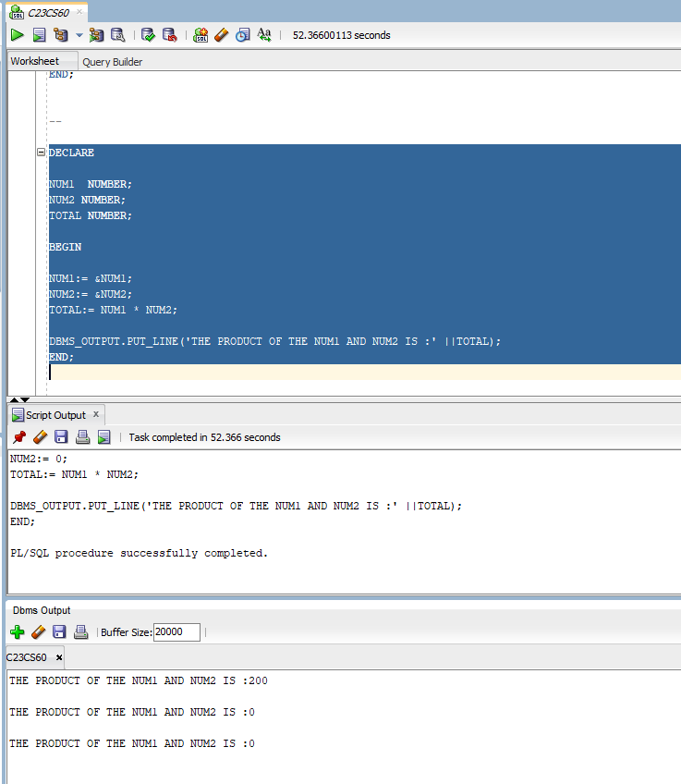

1. 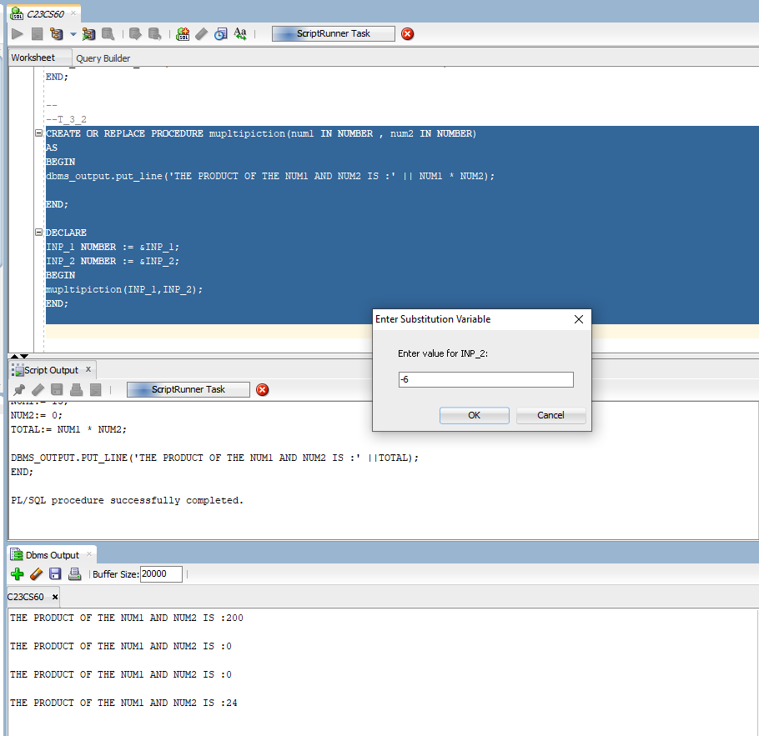A user is calculating the product of two negative numbers, e.g., -4 and -6, which should result in a positive product.

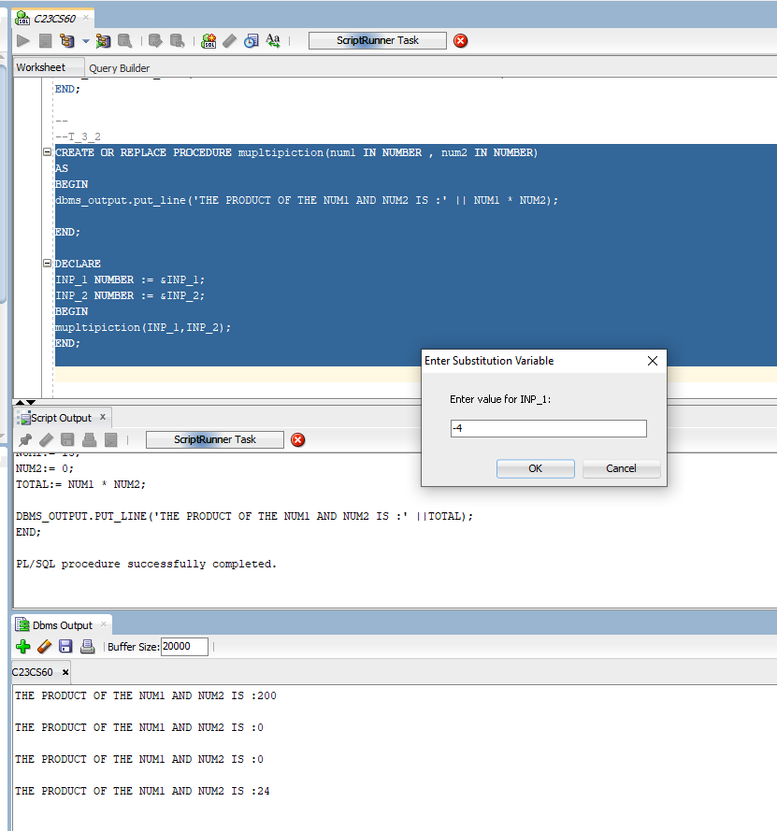

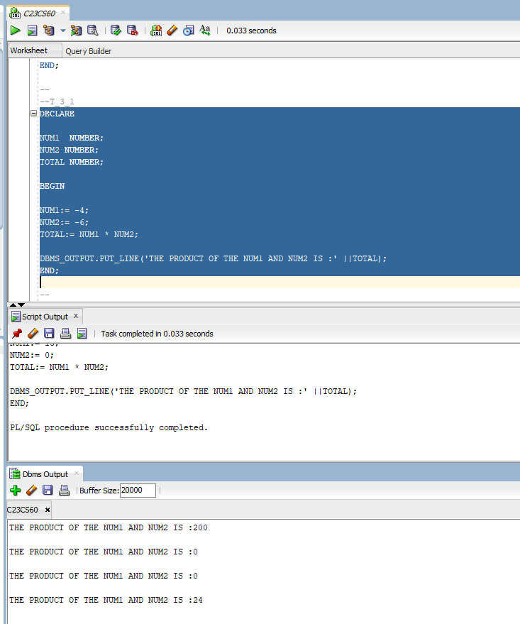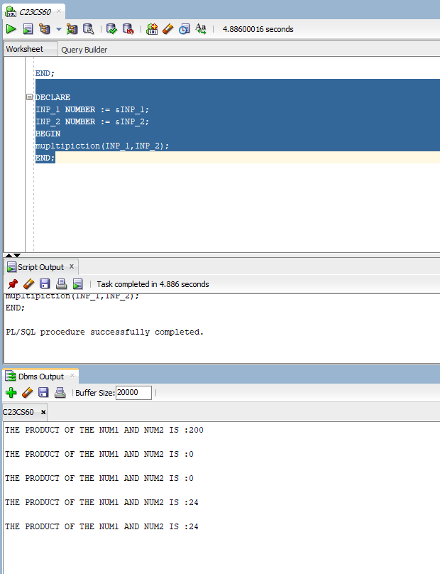

1. A user is calculating the product of a positive and a negative number, e.g., 7 and -3, to validate the outcome as negative.

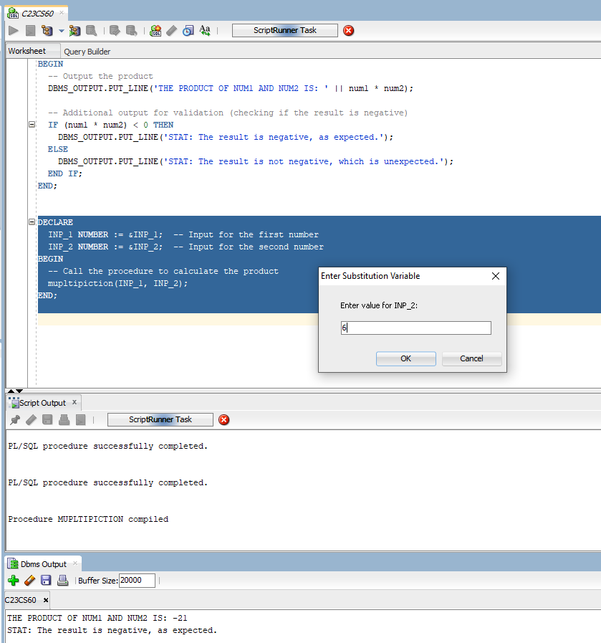

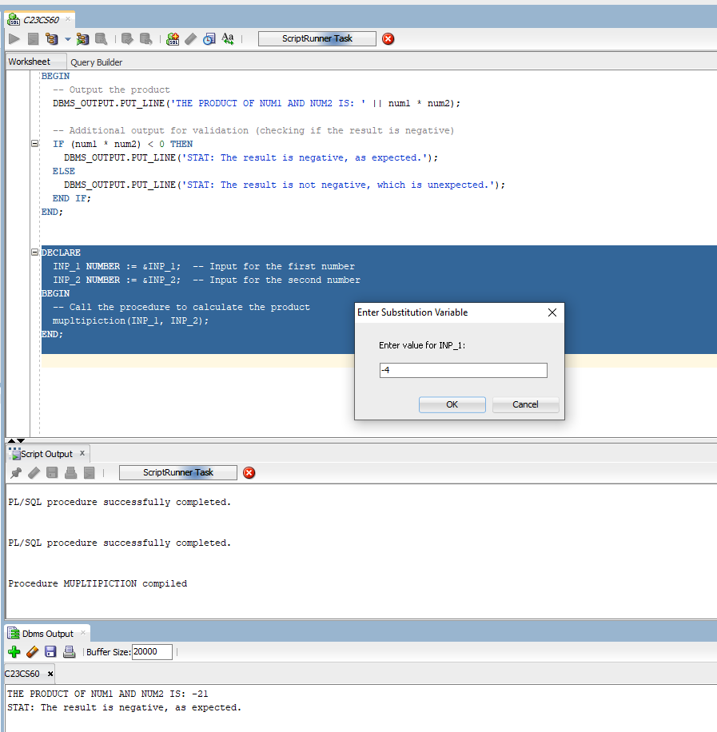

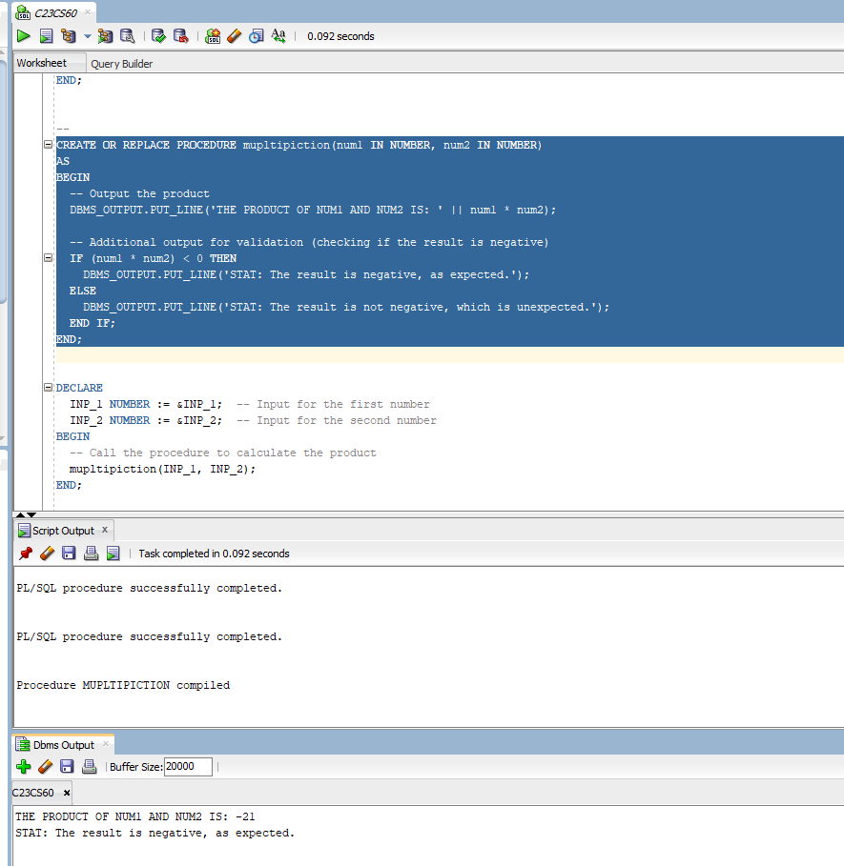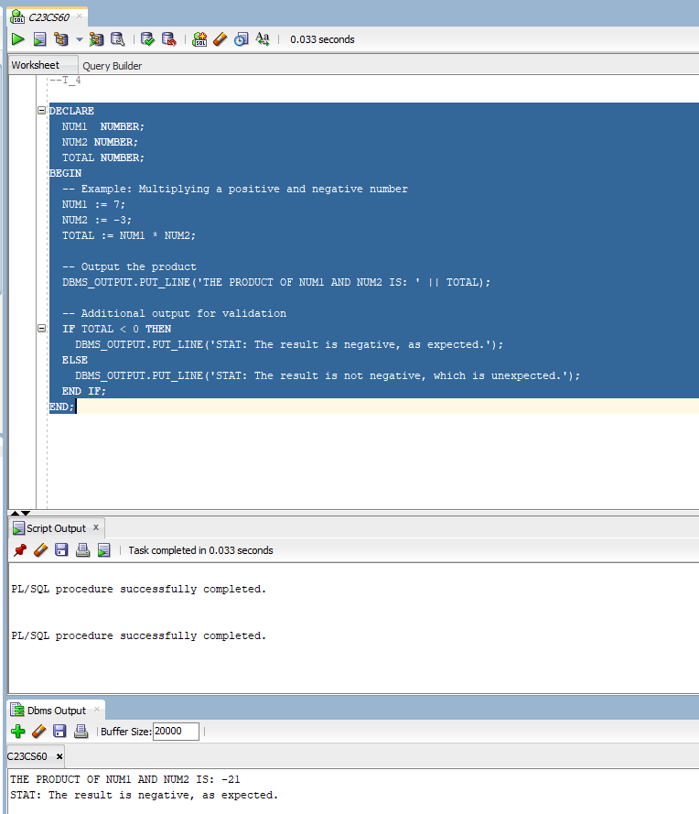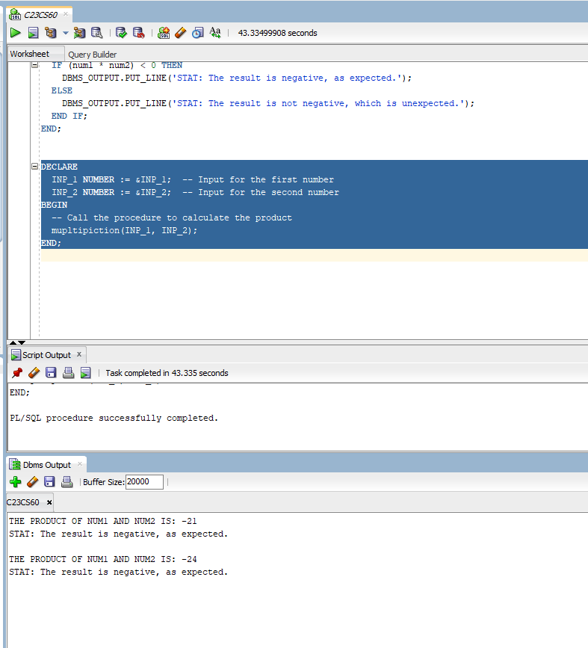

1. A user wants to calculate the product of two decimal numbers, e.g., 2.5 and 4.2, for precision-sensitive operations.

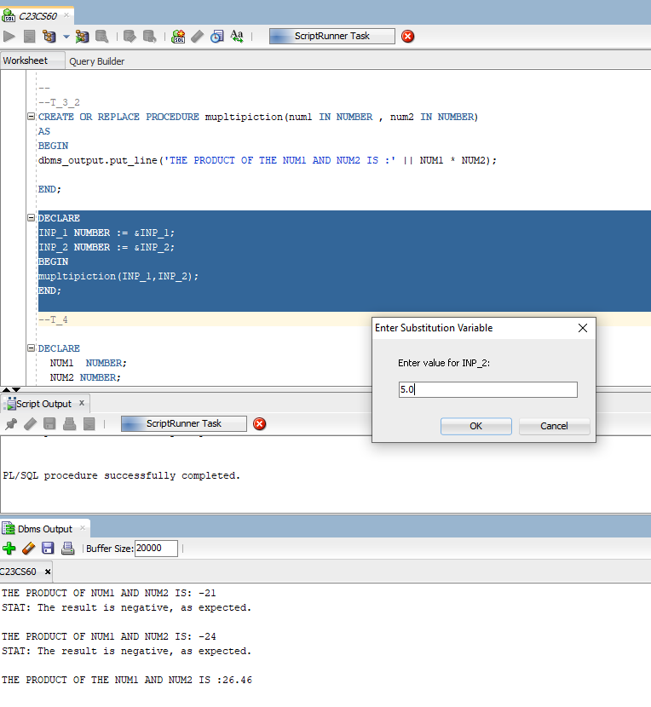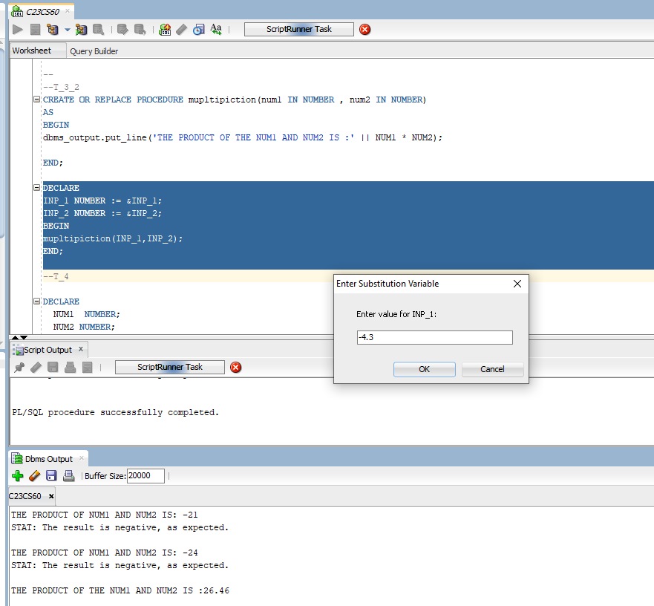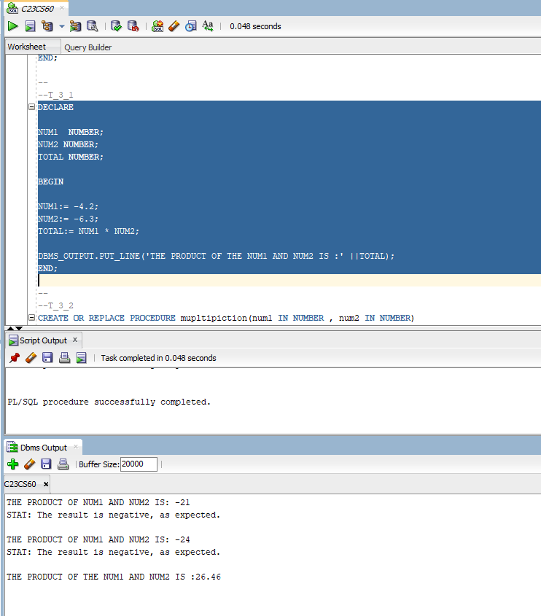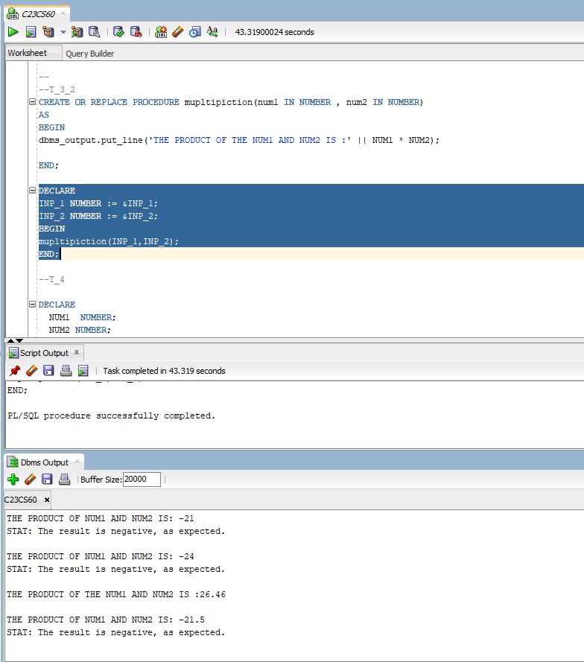

**EXTRA QUERY:-**

