|  |  |
| --- | --- |
|  |  |

**Faculty of Technology and Engineering**

**Chandubhai S. Patel Institute of Technology (CSPIT)**

**Department of Computer Science & Engineering**

Date: / /

**Laboratory Manual**

|  |  |  |  |  |  |
| --- | --- | --- | --- | --- | --- |
| Academic Year | : | 2024-25 | Semester | : | 4 |
| Course code | : | CSE206 | Course name | : | DATABASE MANAGEMENT SYSTEM |

|  |
| --- |
| **Practical - 11** |
| **Aim:** -   |  | | --- | | **Your organization maintains an employee database that includes details like names and ages. To ensure data integrity and audit compliance, any record deleted due to specific conditions must first be archived. You are tasked with implementing a system where records of employees aged 21 are deleted from the main table but saved in an archive table before deletion.** | |

**Tasks:-**

The HR department wants to remove all records of employees aged 21 from the Employee table as part of a policy update. Use a PL/SQL block to delete records from the main table based on the condition.

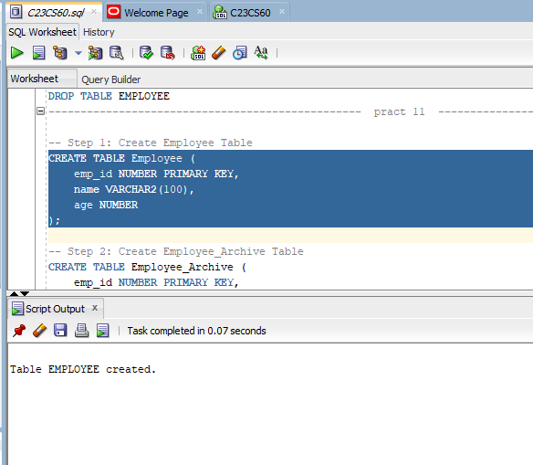

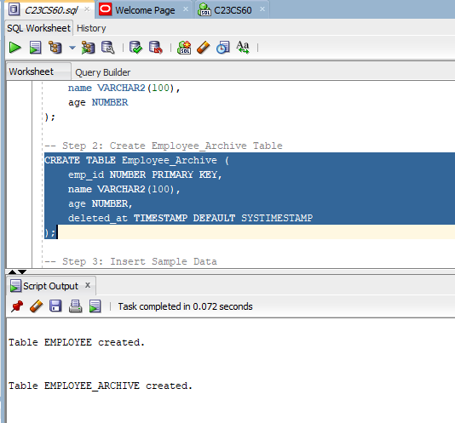

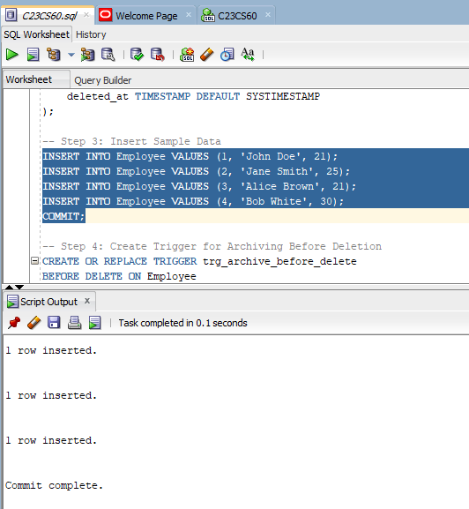

2. **Implement a trigger that automatically archives the original record in a separate table before deletion**



