|  |  |
| --- | --- |
|  |  |

**Faculty of Technology and Engineering**

**Chandubhai S. Patel Institute of Technology (CSPIT)**

**Department of Computer Science & Engineering**

Date: / /

**Laboratory Manual**

|  |  |  |  |  |  |
| --- | --- | --- | --- | --- | --- |
| Academic Year | : | 2024-25 | Semester | : | 4 |
| Course code | : | CSE206 | Course name | : | DATABASE MANAGEMENT SYSTEM |

|  |
| --- |
| **Practical - 8** |
| **Aim:** You are tasked with designing a database for managing a sales and client management system. The database should support the creation, updating, and querying of data related to salespeople, customers, orders, and clients while ensuring data integrity through constraints. (Refer the attached excel sheet for Database) |

**Tasks:-**

1. **Managing Salespeople Information:**

The organization needs a table to store data about its salespeople. Each salesperson must have a unique ID, a name, and optionally, a city and commission rate.

Tasks: 1. Create the Salespeople Table: o Attributes:

▪ Snum: Salesperson ID (Primary Key, number).

▪ Sname: Salesperson Name (Not Null).

▪ City: City (nullable).

▪ Comm: Commission Rate (nullable).

**Constraints:**

o Primary Key Constraint: Ensure Snum uniquely identifies each record.

o Not Null Constraint: Ensure Sname is not null.

**Test Cases:**

o Insert valid records to ensure successful insertion.

o Try inserting a record with duplicate Snum and ensure the system rejects it.

o Attempt to insert a record with a null Sname and ensure it fails.

o Insert a record with null City and Comm and ensure it is allowed.

o Retrieve all records from the Salespeople table to verify data integrity

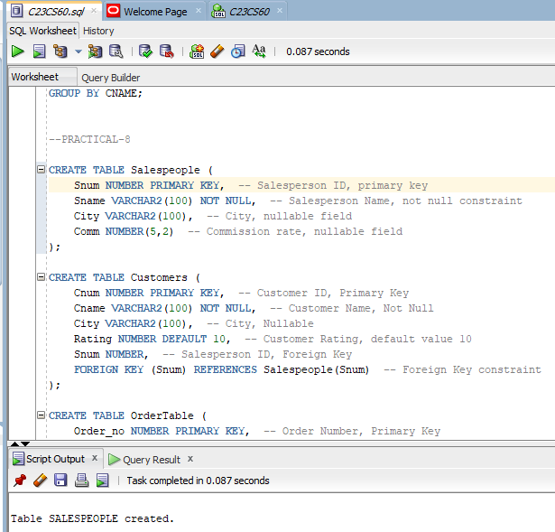

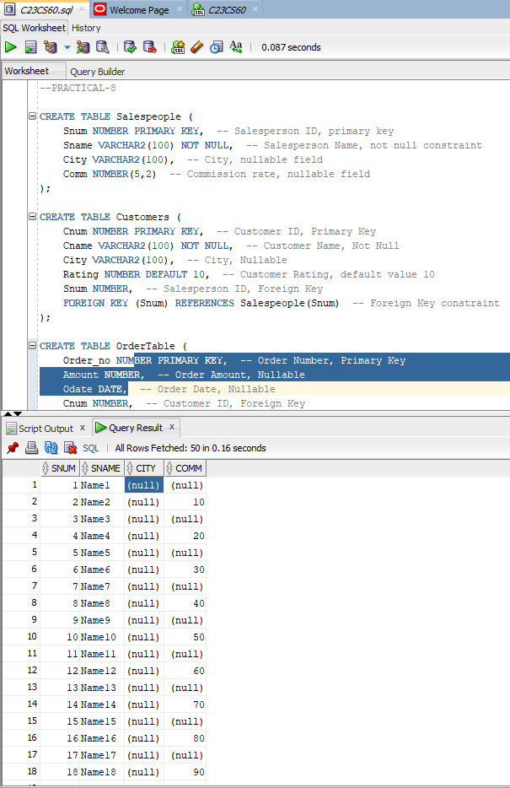

1. Managing Customer Information:

The system must store customer details, including their relationship with salespeople.

Customers have unique IDs, names, and optionally a city. They also have a rating with a default value.

Tasks: 1. Create the Customer Table:

o Attributes:

▪ Cnum: Customer ID (Primary Key, number).

▪ Cname: Customer Name (Not Null).

▪ City: City (nullable).

▪ Rating: Customer rating (Default: 10).

▪ Snum: Salesperson ID (Foreign Key references Salespeople). Constraints:

o Primary Key Constraint: Ensure Cnum uniquely identifies each record.

o Foreign Key Constraint: Ensure Snum references Salespeople(Snum).

o Default Constraint: Ensure Rating defaults to 10 when not provided.

2. Test Cases: o Insert valid records to verify proper insertion.

o Insert records with missing Rating to ensure the default value is applied.

o Attempt to insert a record with null Cname and ensure it fails.

o Try inserting a record with a non-existent Snum and ensure it fails

. o Insert records with null City and verify successful insertion.

o Retrieve all records from the Customer table to verify the data.

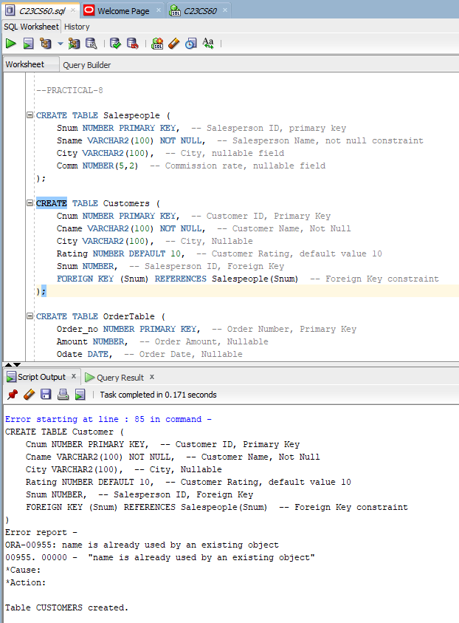

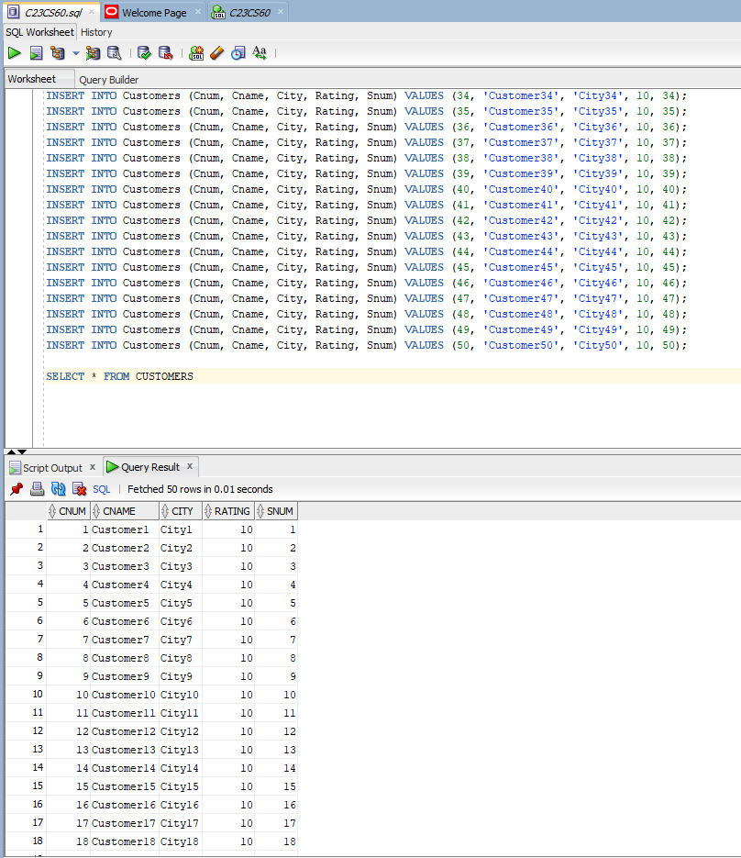

1. Managing Orders:

The company tracks orders placed by customers, which are managed by salespeople. Each order has an ID, amount, date, and links to customers and salespeople.

Tasks:

1. Create the Order Table:

o Attributes:

▪ Order_no: Order Number (Primary Key, number).

▪ Amount: Order Amount (nullable).

▪ Odate: Order Date (nullable).

▪ Cnum: Customer ID (Foreign Key references Customer).

▪ Snum: Salesperson ID (Foreign Key references Salespeople). Constraints:

o Primary Key Constraint: Ensure Order_no uniquely identifies each record.

o Foreign Key Constraint: Ensure Cnum references Customer(Cnum).

o Foreign Key Constraint: Ensure Snum references Salespeople(Snum).

1. Test Cases:

o Insert valid records to verify proper insertion.

o Attempt to insert records with non-existent Cnum or Snum and ensure the system rejects them.

o Insert records with null Amount or Odate and ensure they are allowed.

o Retrieve all records from the Order table to verify data integrity.

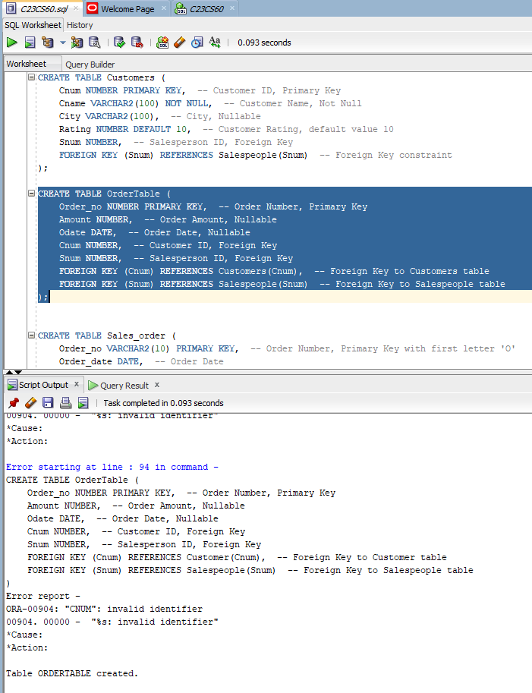

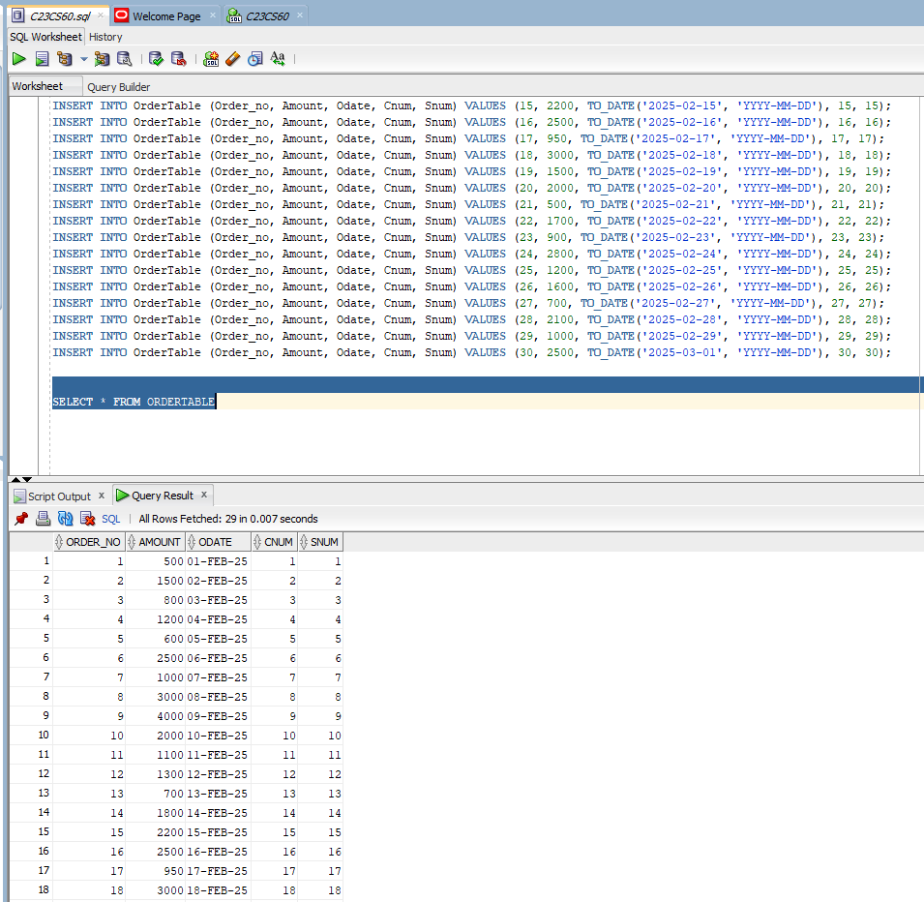

1. Managing Sales Orders:

Sales orders track additional details such as delivery type and order status, with constraints to ensure consistency.

Tasks: 1. Create the Sales_order Table:

o Attributes:

▪ Order_no: Order Number (Primary Key, first letter must start with ‘O’).

▪ Order_date: Date of the Order.

▪ Client_no: Client ID (Foreign Key references Client_master).

▪ Dely_addr: Delivery Address.

▪ Salesman_no: Salesperson ID (Foreign Key references Salesman_master).

▪ Dely_type: Delivery Type (Default: ‘F’).

▪ Order_status: Order Status (Allowed Values: In Process, Fulfilled, Backorder, Cancelled). Constraints:

o Primary Key, Foreign Key, Check, and Default constraints.

Test Cases:

o Verify that all constraints, including the primary key, check constraints, and default values, are applied correctly.

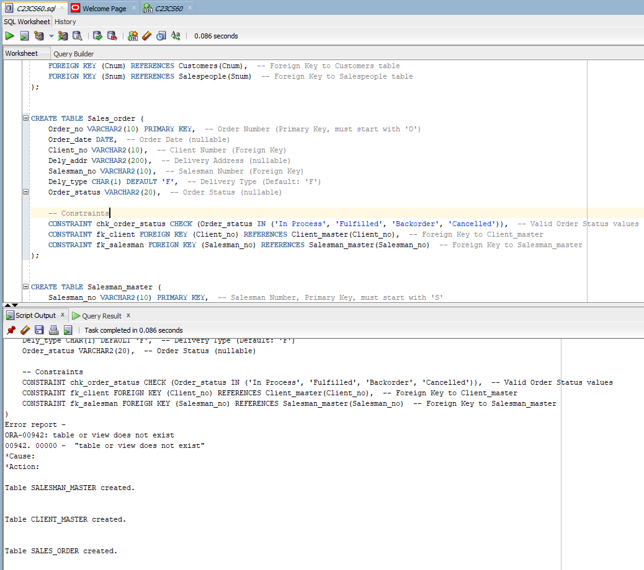

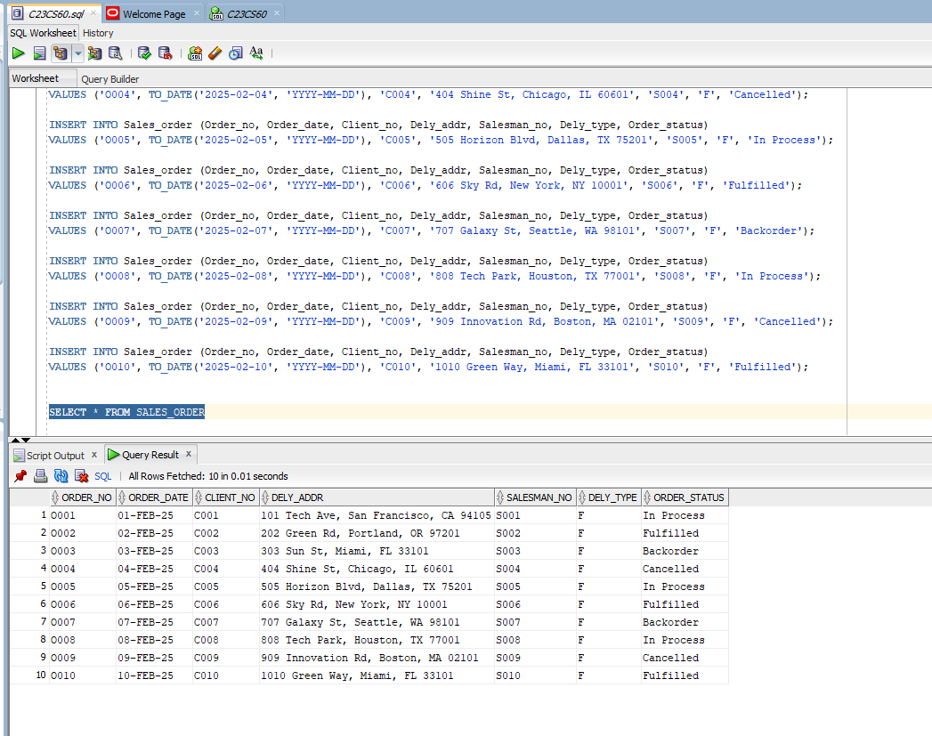

1. Managing Salesman Details: The organization needs to maintain records of salesmen, including their target and year-to-date sales, with strict constraints for validation.

Tasks: 1. Create the Salesman_master Table:

o Attributes:

▪ Salesman_no: Salesman Number (Primary Key, must start with ‘S’).

▪ Salesman_name: Salesman Name (Not Null).

▪ Address, City, Pincode, State: Additional details.

▪ Sal_amt: Salary (Not Null, cannot be 0).

▪ Ytd_sales: Year-to-date Sales (Not Null, cannot be 0).

▪ Tgt_sales: Target Sales (Not Null). Constraints:

o Primary Key, Not Null, and Check constraints.

Test Cases: o Verify that records with invalid Sal_amt or Ytd_sales are rejected.

 o Ensure all constraints are correctly applied.

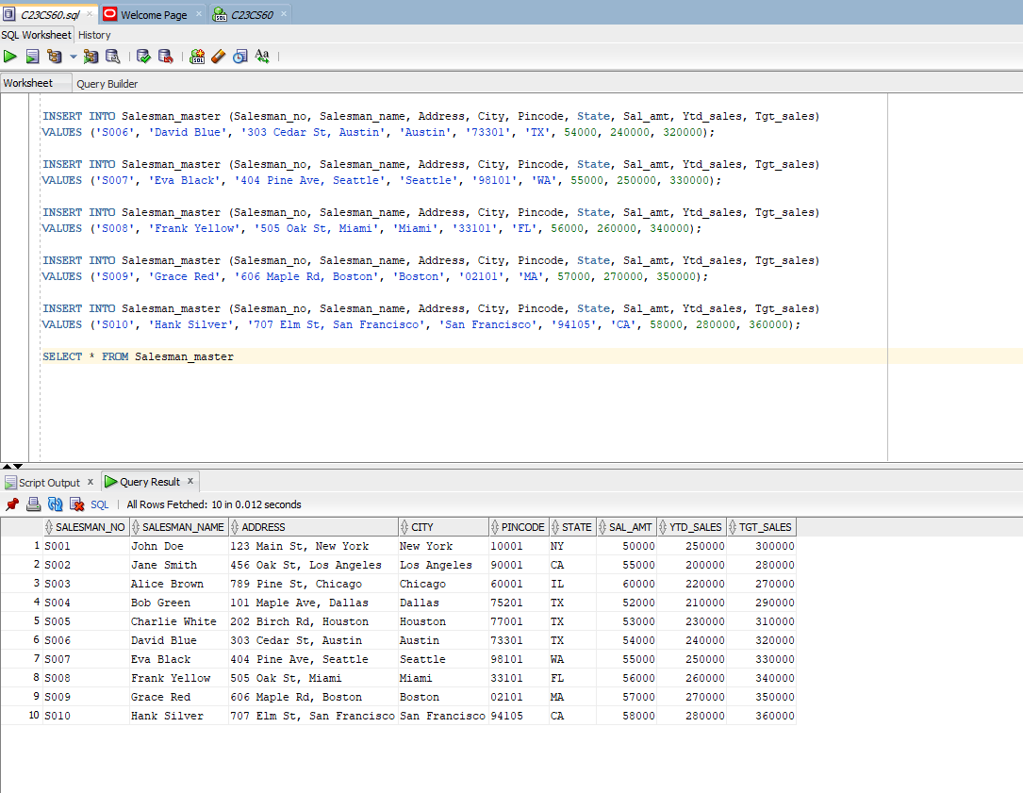

1. Managing Client Details: Clients are key stakeholders in the sales process.

Their data must be consistent and adhere to specific constraints. Tasks:

1. Create the Client_master Table: o Attributes:

▪ Client_no: Client Number (Primary Key, must start with ‘C’).

▪ Name: Client Name (Not Null).

▪ Address, City, State, Pincode: Client details.

▪ Bal_due: Balance Due. Constraints:

o Primary Key, Not Null, and Check constraints.

1. Test Cases:

o Verify that all constraints, including the primary key, not null, and check constraints, are correctly applied.

o Ensure invalid records are rejected.

