

*DELIVERING SATISFACTION*

**25th February, 2020**

The Coordinator,

NYSC Secretariat,

Abuja, FCT.

**FINAL CLEARANCE FOR GABRIEL IKO-OJO, VICTORIA (CALL UP: NYSC/FUM/2019/032609)**

**Reference: Gabriel, Iko-Ojo Victoria**

**State Code: FC/19A/5092**

**Call Up No: NYSC/FUM/2019/032609**

**Discipline: Information And Media Technology**

This is to certify that the above corp member has fully completed her service year with SQT Web Solutions. Her conduct was satisfactory and she is not Indebted to the authority.

You may wish to process with everything necessary for her successful completion.

I

Most thankful for your cooperation and understanding.

Yours Faithfully

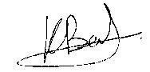

Benedict K.C. Ezeh 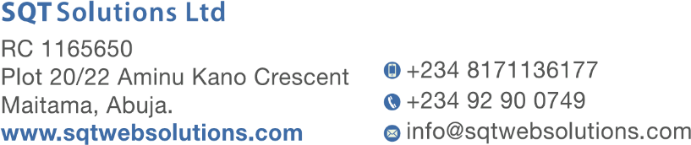(  
Managing Director)