The University Of Northampton

Web Development-CSY1018

Submitted by-Sujan Dulal

UN ID-16418508

GitHub URL-https://webber360.github.io/webber_work/

Contents Page no

1. Introduction-------------------------------------------------------------------- 2

2. Design-------------------------------------------------------------------------- 2-15

2.1 Sketches--------------------------------------------------------------- 2

2.2 Wireframes----------------------------------------------------------- 5

2.3 Final Design---------------------------------------------------------- 11

3. Prototype----------------------------------------------------------------------- 15

4. Work Progression------------------------------------------------------------- 16

5. Validation---------------------------------------------------------------------- 16

6. Good practice------------------------------------------------------------------ 17

7. Conclusion--------------------------------------------------------------------- 18

8. Reference----------------------------------------------------------------------- 19

1. Introduction

Before the creation of this web portfolio, I did some research on the web of some existing portfolio templates and I took an inspiration from their designs, which helped to me to design this site later. Though most of the templates were designed using Bootstrap and JavaScript, I didn’t use those front end framework and language to design my site. This portfolio of mine is the complete result of HTML5 and CSS3.Some of the templates that I researched are mentioned below: This entire site can be accessed through this link <https://webber360.github.io/webber_work/>

2. Designs

To put the ideas together I first developed sketches and wireframes of four different pages, (Including wireframes for mobile responsiveness) namely: Home, CV, Bio, and Contact. After the development of the sketches and wireframes then only I did the actual coding part.

2.1 Sketches (Desktop)

Home page:

The home page particularly consists of three different sections, Header, Main section and footer. The header holds logo of the page and at the bottom of the header there are links to other pages. Likewise footer portion holds similar links with links for Social Medias and Copyright information is displayed there. The middle section is the main part where three round images are displayed which enlarges on hover and are linked to other pages. Different colors are used in different sections and for the middle section repeating image is used to give a paper like texture. The header and footer are same in all pages.

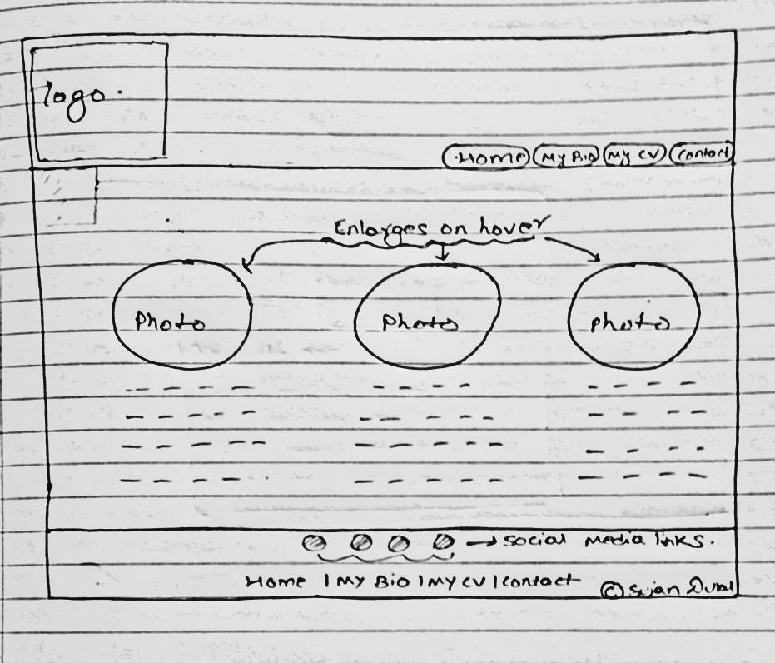

My Bio (Sketch)

This page has the same header and footer from the home page and nothing is changed there. The middle div is surrounded by two different div which has an image following by a paragraph. To Include simplicity and good material design, header is given some shadow effect and the middle div is rounded for enhance the look.

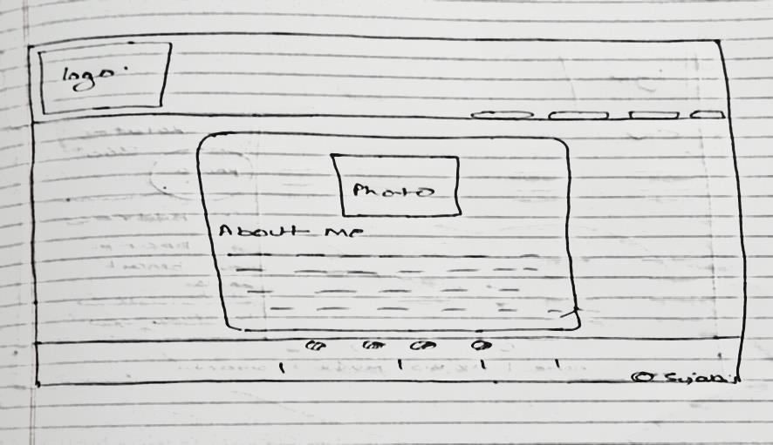

My CV(Sketch)

There are two main divs to separate the information section and the design section (for skills and address.). The main section displays two categories in a row and other categories are displayed below it. To give a unique design, rounded corner is given to the topmost div in the design section (right-side) where an image is placed that rotates in 360 degree clockwise on hover. Moreover the design section also has a box-shadow. New feature of skill bar is also added on the design section by adding an article inside an article giving the article (inbound) width and colour according to skill’s percentage

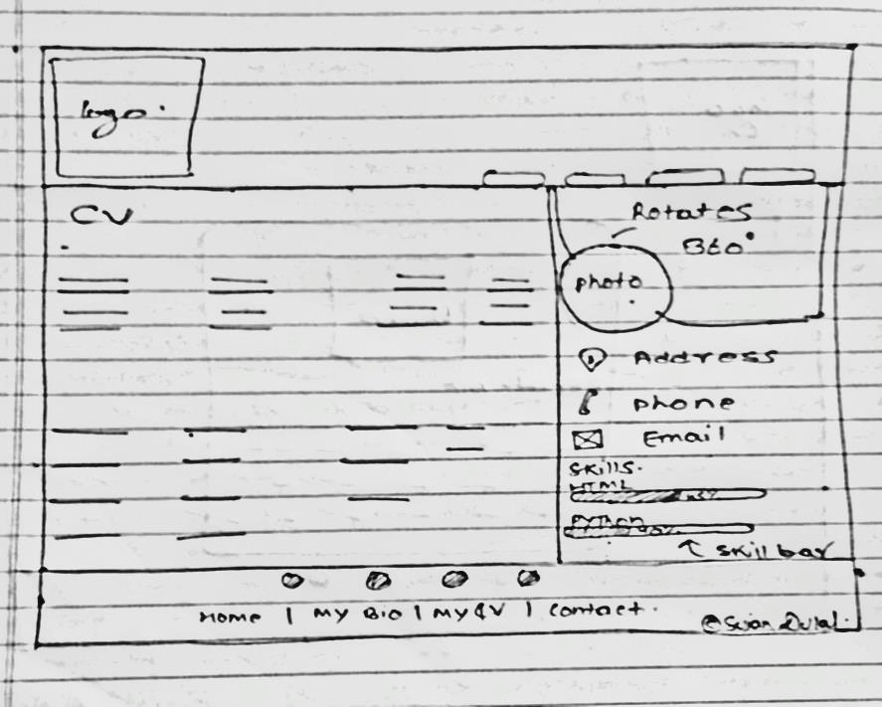

Contact (Sketch)

For the proper navigation the contact page is made very simple and only contains a form in the middle with a rounded look and shadow effect. The header and footer are same as that of other pages.

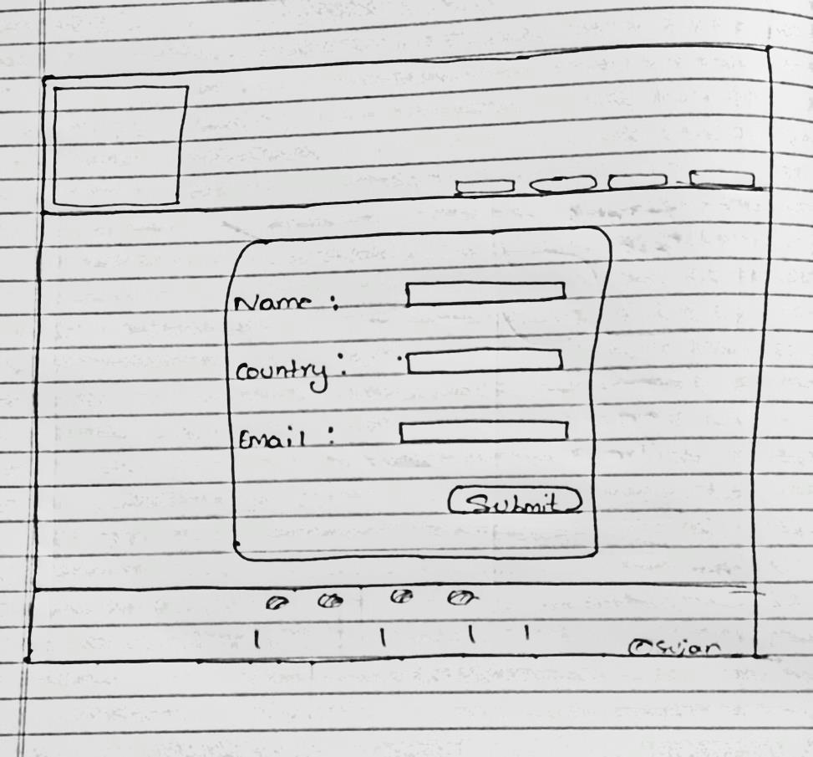

2.2 Wireframes (Desktop)

After the completion of sketches a proper and systematic wireframes were made so that it would give an impression of the real product consisting all content in detail.

Home page:

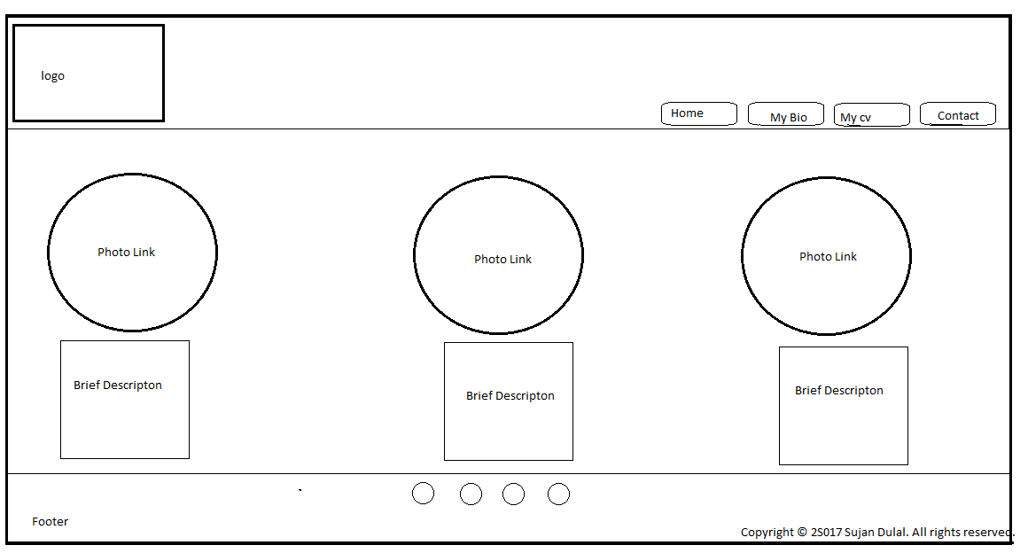

My Bio page:

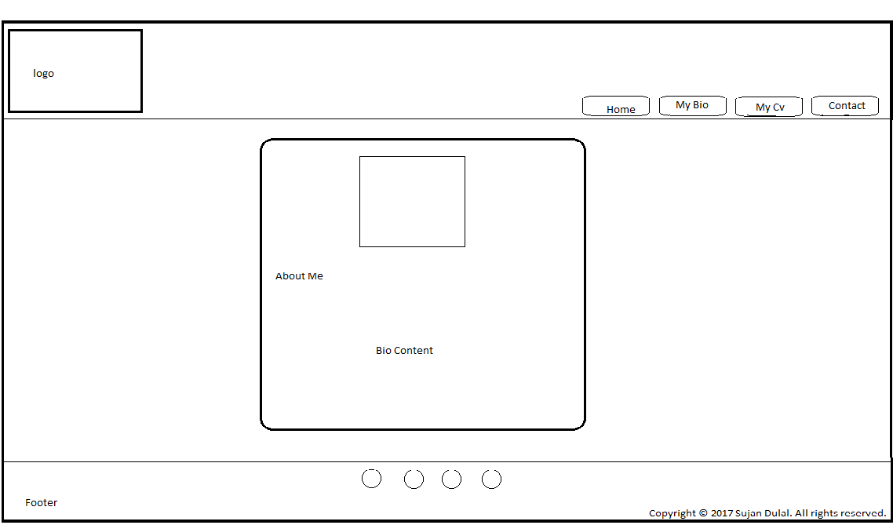

My CV page:

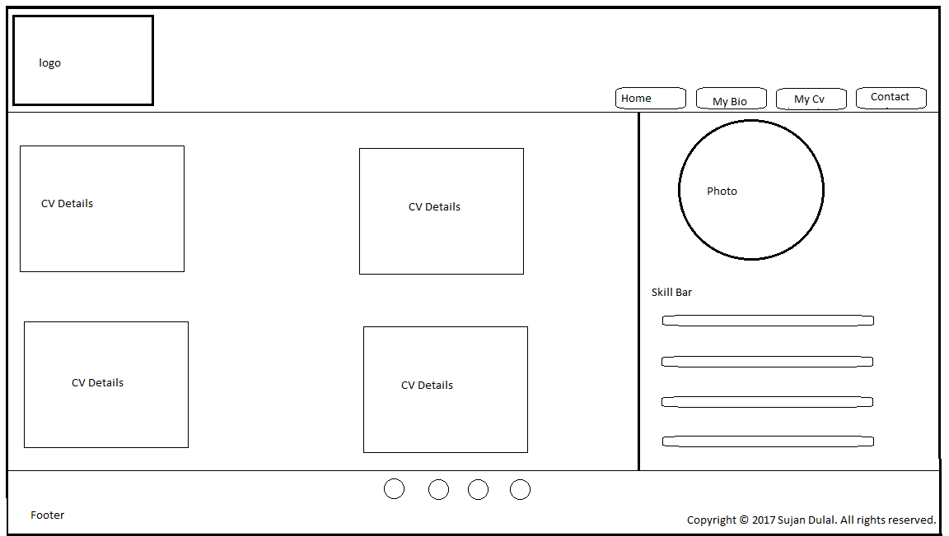

Contact page:

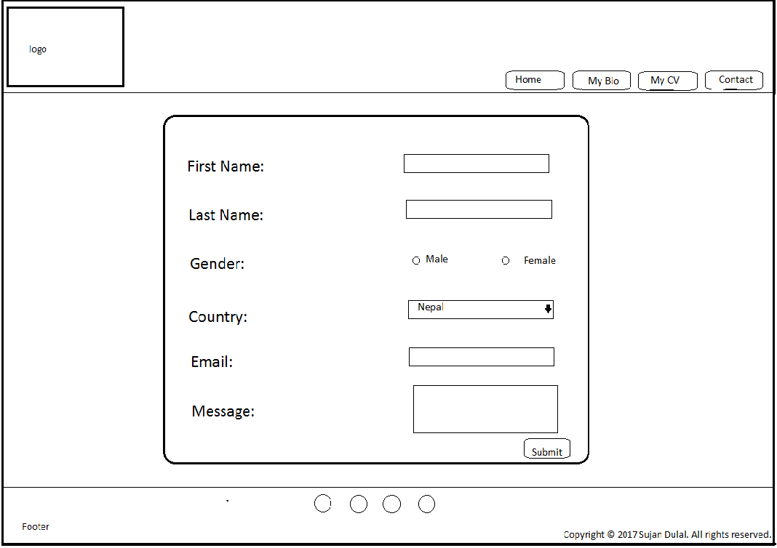

Wireframes (Mobile responsive)

Wireframes were also made to depict how the site will look in smaller screen devices i.e mobile and notebooks. In this design most of the content (divs) are filled with width and are displayed in column.

Homepage:

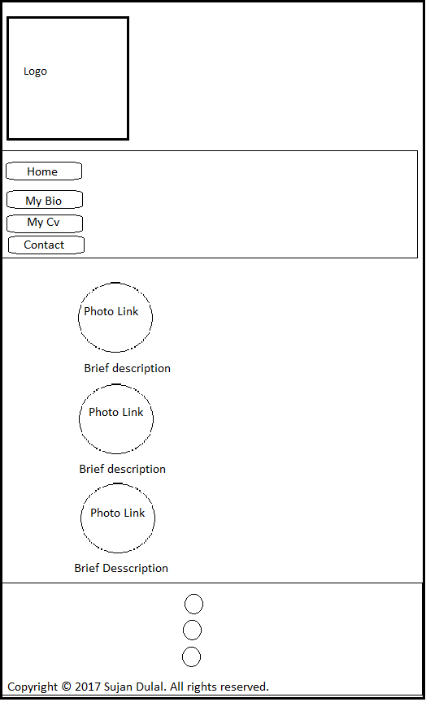

My Bio page:

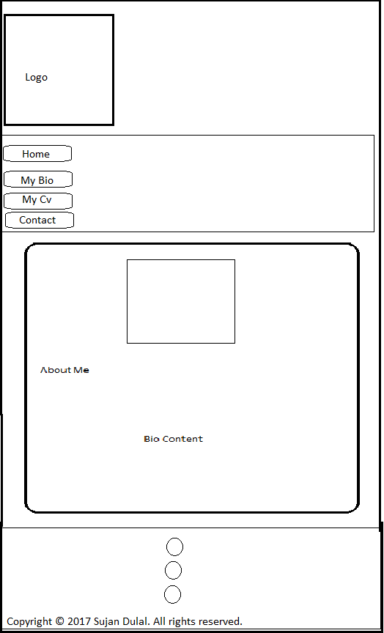

My CV page:

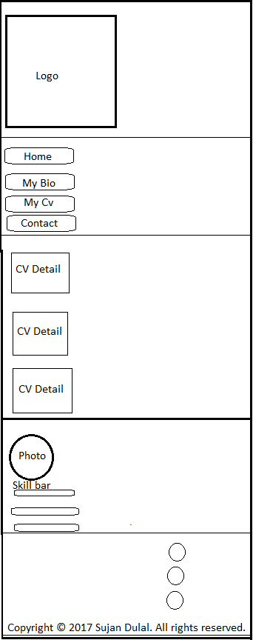

My Contact page:

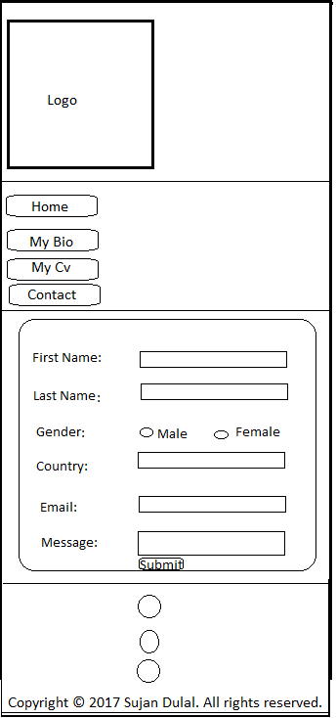

2.3 Final Design:

In the final design to achieve a grid like look flex property was used in the CSS. To display items in row, flex row was used and flex column helped to arrange content in column for better mobile responsiveness. Moreover in the header section, navigation links were justified by flex end property which helped to arrange the links in right side.

Homepage: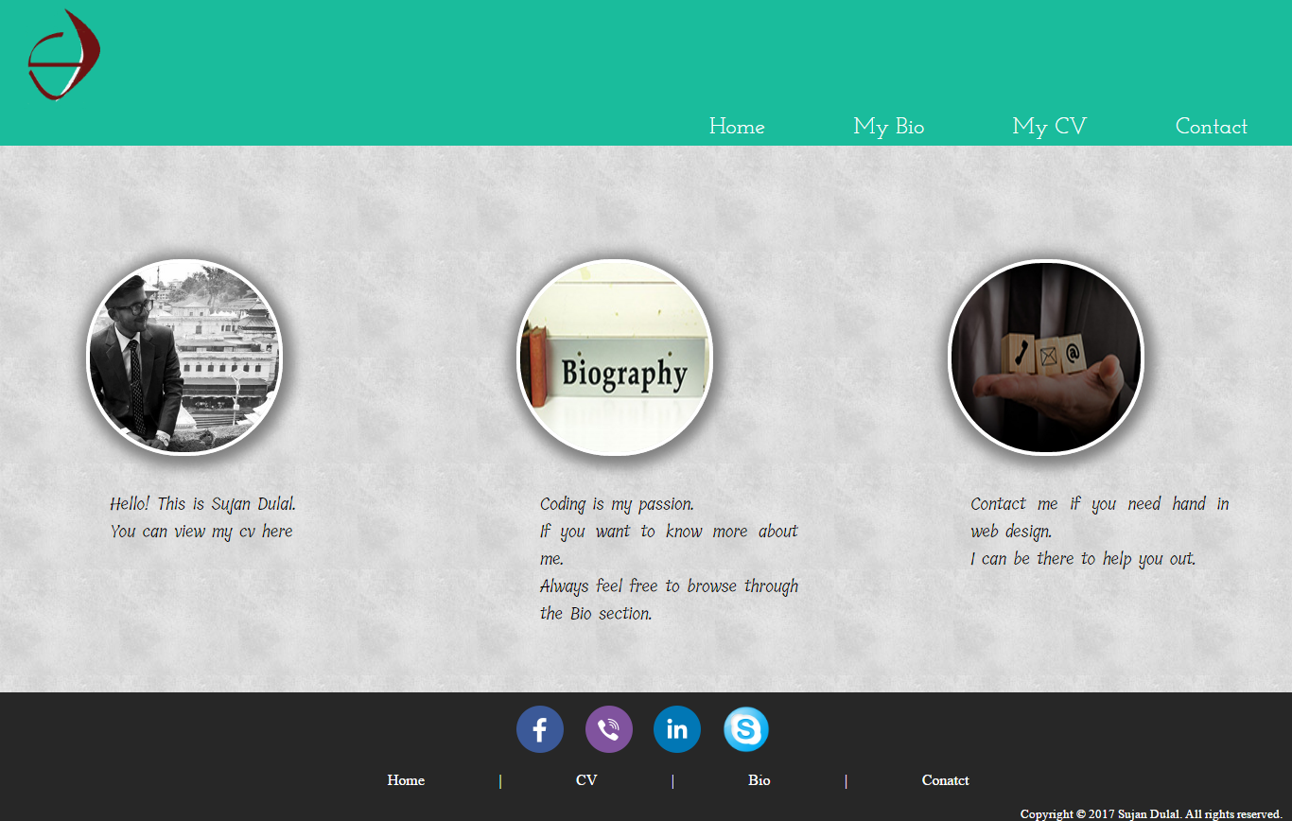

My Bio page:

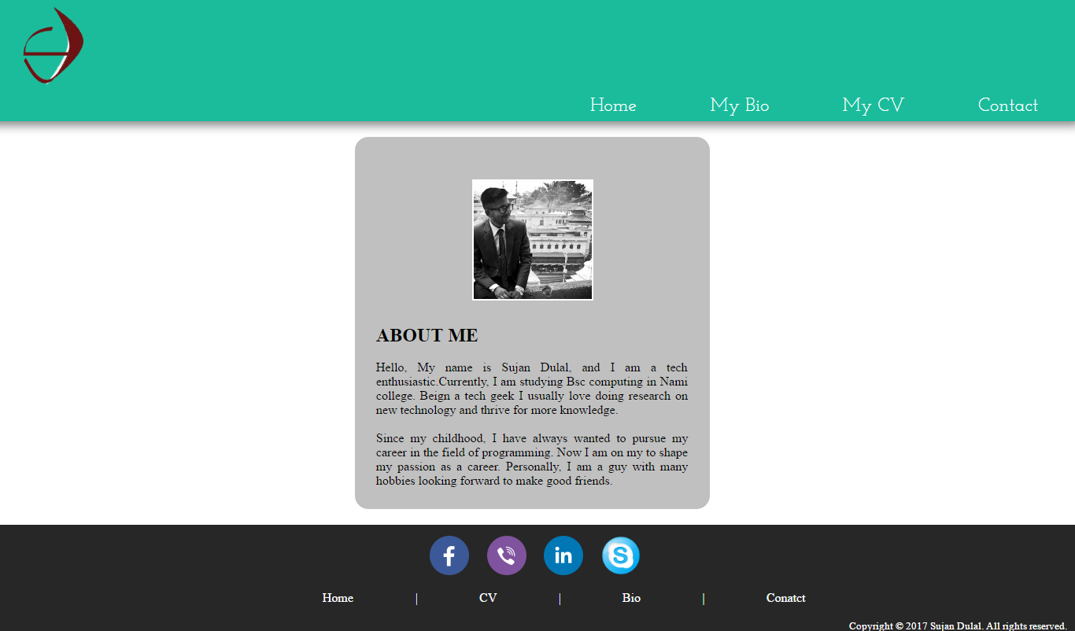

My CV page:

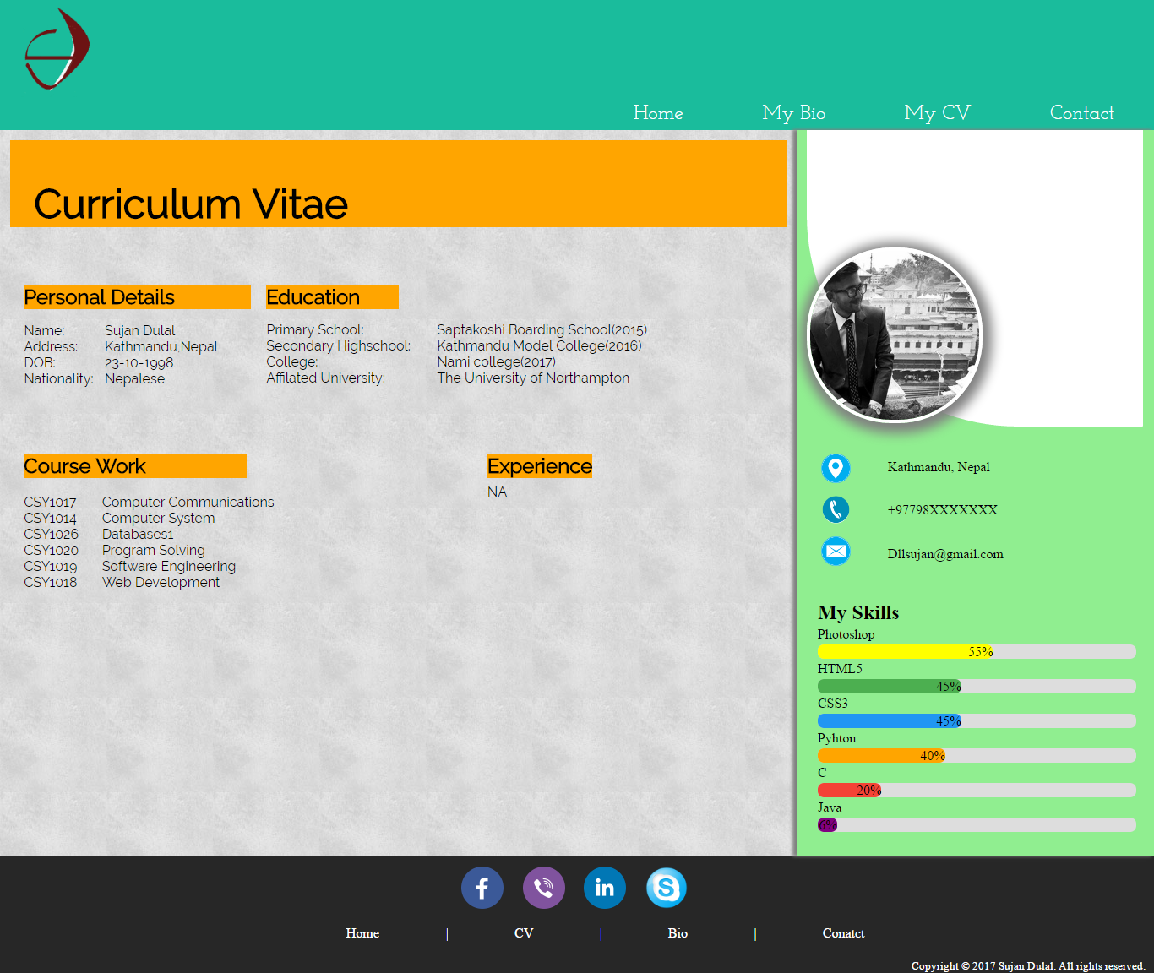

Contact-page: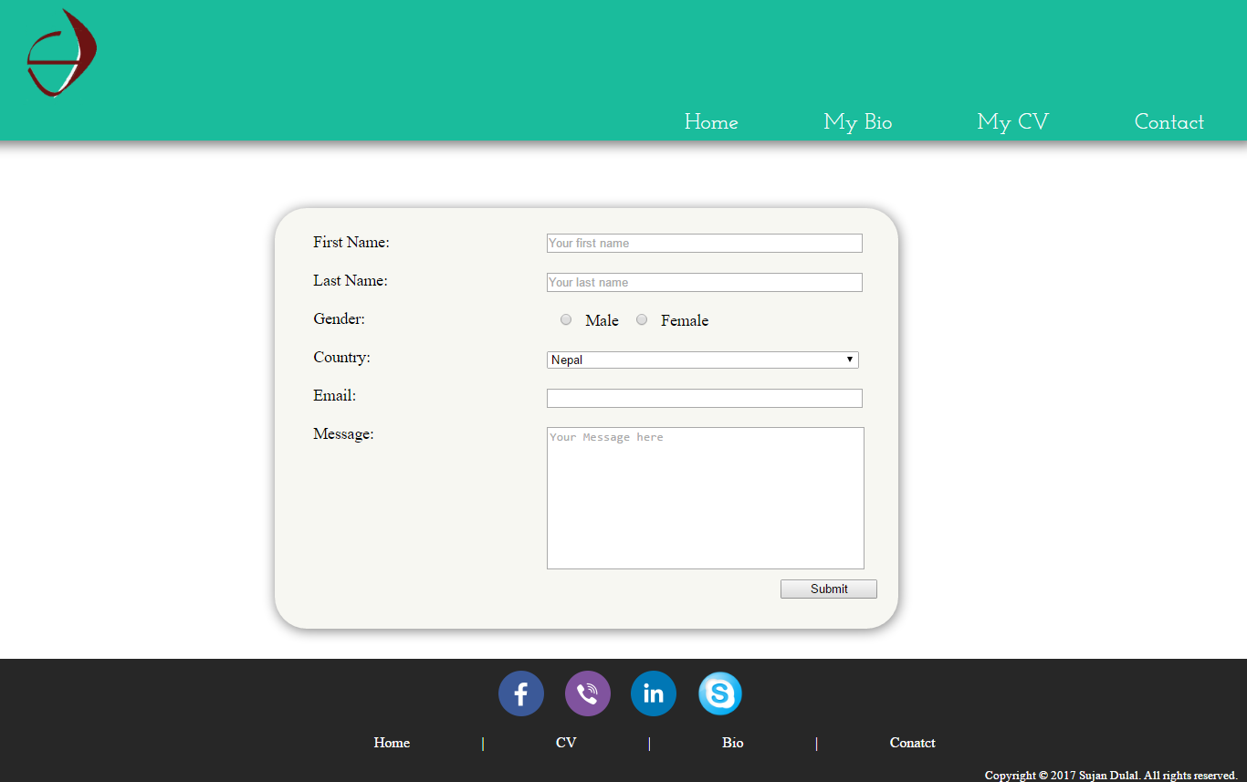

**3. Prototypes:**

Initially prototypes were developed and gradually those prototypes were shaped and given some extra features to achieve the design level as presented in the wireframe. Some of the prototypes of my web development are shown below. In first phase, in home page I had used an image as a background but later on I changed it into a repeating texture image background. Likewise the bio page had no any material design and proper margin and padding in the prototype.

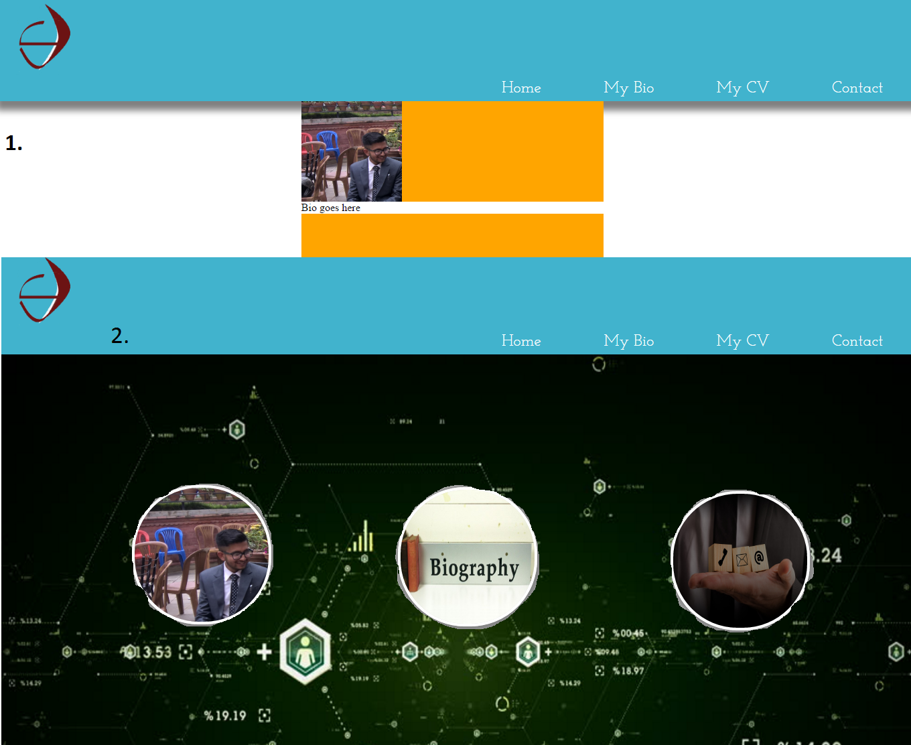

**4. Work Progression:**

Before the end of 11th weeks I started working on the development from scratch First I developed sketches and wireframes and then began to code. After the completion of prototypes I added material design to some of the pages and managed the margins and padding to make it look good. Until this time no any animation and transitional effect was present. Later on, animation and transitional effects were added in the CSS. During the development, all files were committed in the Git repository i.e. https://github.com/webber360/webber_work/ Also all pages were made mobile responsive afterwards. As there were many minor errors in the code, all errors were eliminated after the completion of the total design. This over all development took about a month. And this entire site can be accessed through this Git link https://webber360.github.io/webber_work/

**5. Validation:**

After completion of coding part, all pages were put through validator to validate the proper use of HTML5 and CSS3. In Html there were only few warnings and there were no any errors. And also CSS code had no any warnings or errors. The whole site was validated to have HTML5 and CSS3 code.

CSS Validator:

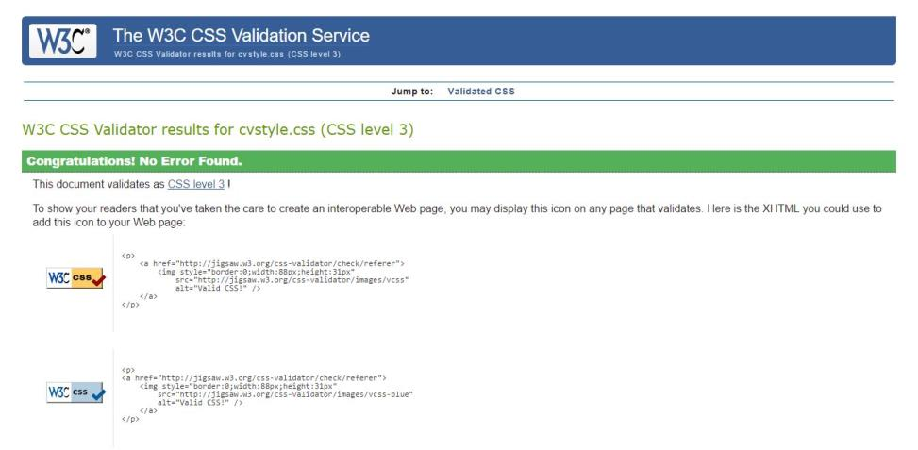

HTML Validator:

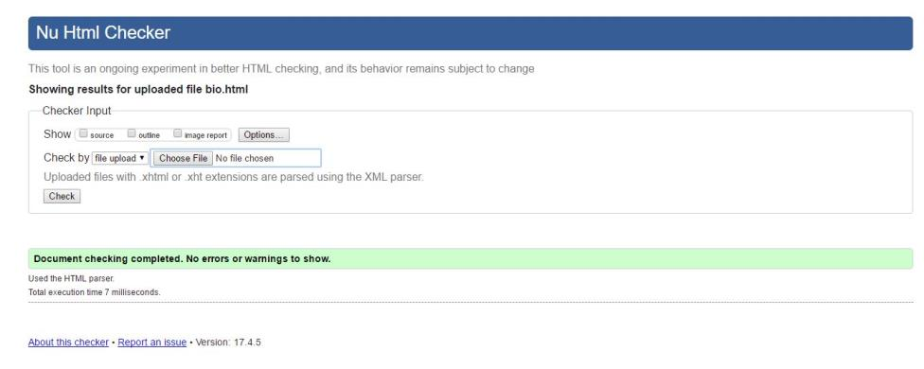

**6. Good Practice:**

Good practice in a website generally incudes Speed, Appearance and navigation. To follow this model efforts have been taken. For example: All images are compressed and no heavy images were used in the site due to which the page loading time is extremely fast. Also clear fonts, attractive colours and design concepts were used to enhance the appearance. Lastly not the least, all links are clearly placed on the top and also in the footer for the easy navigation. Footer links saves user from scrolling up to get the navigation bar.

**7. Conclusion:**

A complete portfolio was made using HTML5 and CSS 3 in a month following all the lectures and some other extra ideas from the internet. The site stills lacks many more feature of material design which I couldn’t add .Using the material design feature it can be designed in a best way. Overall this entire site can be a simple example of portfolio with good design.

**8. References**

w3schools. 2017. How To Create a Skill Bar CSS. [ONLINE] Available at: https://www.w3schools.com/howto/howto_css_skill_bar.asp. [Accessed 19 March 2017].