**QuickSearch eXtended** for Total Commander 7.5+

Freeware by Samuel Plentz - [www.familie-plentz.de](http://www.familie-plentz.de/)

1. Installation

2. Features

3. Customize

4. Limitations

5. History

1. Installation

* Download the file: “[QuickSearch eXtended.zip](http://www.ghisler.ch/board/viewtopic.php?t=22592)”
* Install the plugin automatically by opening it from within Total Commander and choose “yes” in the popup. To manually install, extract the archive to the folder of Total Commander.
* To activate “QuickSearch eXtended” you will need to restart Total Commander.
* Press Ctrl+S and type your search string to use “QuickSearch eXtended”.
* To uninstall “QuickSearch eXtended” remove “tcmatch\*.\*” from your Total Commander folder.

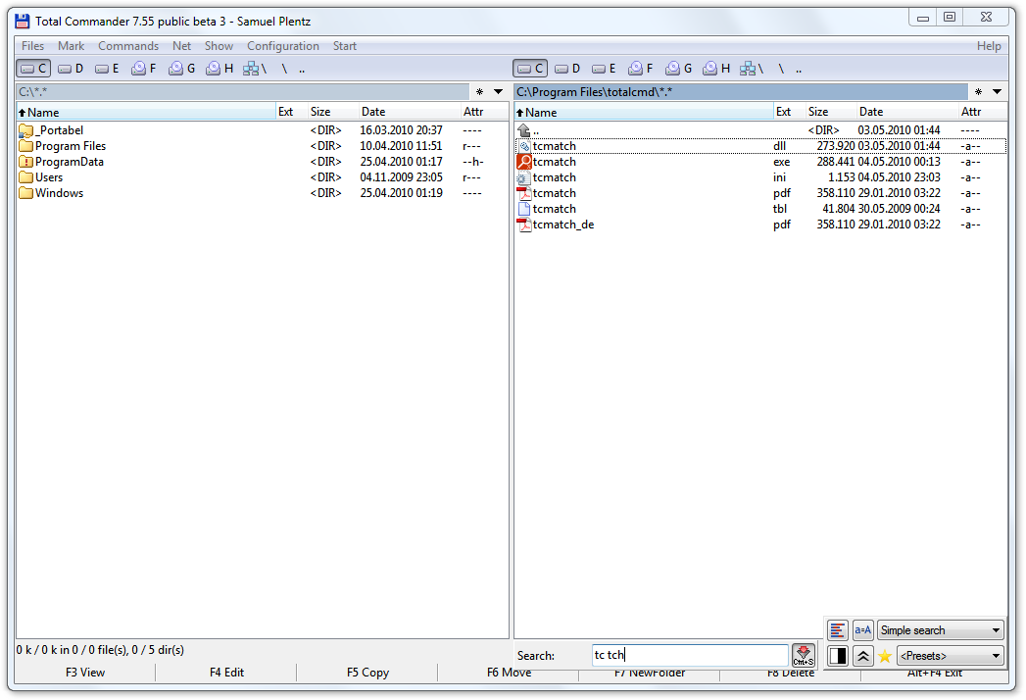

How “QuickSearch eXtended” looks and behaves like after installation.

2. Features

The main feature is that the search string is divided in substrings at each space. A file matches the search string if all substrings are found in it. You can use the char “|” to find either the string to the left or the string to the right. Use the char “!” in front of a search string to invert the result list.

Simple search:

Search for: “cat dog”

Find: A dog and a cat moved to china.txt

CaTs and dOgs.avi

bulldog catalysator.doc

Search for: “cat music|dog fun”

Find: Musical cats.pdf

funny Dog.avi

Search for: “!.pdf”

Find: cat.bmp

Find not: dog.pdf

[RegEx](http://en.wikipedia.org/wiki/RegEx) search:

Search for: “?exe \_\d”

Find: tcmd\_75b4.exe

AutoHotkey\_104800\_Install.exe

IZArc\_4b1.exe

Similarity search: (using [Levenshtein Distance](http://en.wikipedia.org/wiki/Levenshtein_distance))

Search for: “<color my”

Find: colorful.bmp

my favorite Colour.jpg

Search for: “<2lefenstein”

Find: Levenshtein.cpp

Srch: (used by Quick Silver on Mac)

Search for: “\*dwn”

Find: Download.zip

dewdrops.png

Sandra went to town.docx

By default the simple search doesn’t need activation. Just write your search string and it will work. Write a “?” before a regular expression to use the RegEx search. To use the “Similarity search” write a “<” before the search text. You can specify the number of differences per word by appending a number to it: “<2syncronise”. To use the search Srch the search text has to start with a “\*”.

PinYin search:

Search for: “ext sz zgrand”

Find: 中国randomtext 神舟.bmp

There is full PinYin support for the simple search, the similarity search and the search Srch. This means the Chinese char is equivalent to one of its PinYin chars. In the “RegEx search” every substring is also searched as a PinYin string, but it’s not supported to use PinYin chars within regular expressions. If the system language is Chinese, PinYin is activated on first launch. Otherwise it has to be activated for slightly performance reasons.

Korean lead syllable search:

Search for: “ㅍㅇ 야펴 ㅂrand”

Find: 정법randomtext평양양평.bmp

There is full lead syllable search support for the simple search, the similarity search and the search Srch. This means the Korean char is equivalent to each of its leading syllables. In the “RegEx search” every substring is also searched with the lead syllable search string, but it’s not supported to use lead syllables within regular expressions. If the system language is Korean, the lead syllable search is activated on first launch. Otherwise it has to be activated for slightly performance reasons.

Presets:

Save Preset: “.pdf|.doc|.ppt|.xls|.txt>1”

Restore it: “>1”

You may add a search string to the presets by appending “>[char]”, where “[char]” is any character you like. Later you just need to search for “>[char]” to load the preset.

Additional user interface

With the additionally user interface you may change important settings, chose the active search and use presets. The user interface for further customizations could be reached with this button: E:\Work\C++\Total Commander\QuickSearch eXtended\_output\Artwork\icon4.bmp

E:\Work\C++\Total Commander\QuickSearch eXtended\_output\Artwork\Bild 7_en.bmp

If you deactivated the additionally user interface, you may also start the user interface for further customizations by running “tcmatch.exe”. (or “tcmatch64.exe”)

Content plugins: (\*.wdx)

Additionally to the filename you may also search in the content plugins used by Total Commander. You have to specify a wdx group for every content plugin you want to use. The content of all fields in the first wdx group is filtered with the filename itself. To access fields of other wdx groups you may use the wdx separator char: “/”.

The following example uses a content plugin with the field “Author” in the first wdx group and another content plugin with the field “Description” in the second wdx group:

Search for: “doc Samuel/Total”

Find: tcmatch.doc Author: Samuel Description: ...total...

Samuel.docx Author: Peter Description: …subtotal...

Samuel.xls Author: Doctor K. Description: ...totals...

In 32-bit Total Commander you may only use “\*.wdx” plugins und in 64-bit Total Commander you may only use “\*.wdx64” plugins. This can be customized in the according additionally user interface. (“tcmatch.exe” or “tcmatch64.exe”)

Replacement rules

Beside the char replacement rules available in the user interface, it is possible to replace words with help of a dictionary. If there is a file named “tcmatch.dic” (Format: UTF16-LE) then it will be parsed for valid entries. A valid entry in that file is a line that contains a key and a value divided by a tab stop character. The file is not allowed to contain the same key twice.

When the search is in progress, every occurrence of any key in the filename or in the filter string is replaced by the according value. When more than one replacement is possible, replacing long keys has higher priority.

Disadvantages:

* Changes in the file “tcmatch.dic” will be activated after a restart of Total Commander.
* Already replaced parts of the string are not considered for further replacements, because this could lead to infinite loops.
* Any key that consists of more than one character will not be found when searching for the leading part of the key. For example the key is “kya” and the value is “きゃ”. If the file is named “kya.txt” and the search string is “ky” so far, then the file “kya.txt” will not be found. The new filename would be “きゃ.txt”, but the new search string is not yet “きゃ” but still “ky”.

Suggestions are appreciated.

3. Customize

On first run “QuickSearch eXtended” creates “tcmatch.ini” in the same folder where “tcmatch.dll” is located. If this location is write protected the folder of “wincmd.ini” is used. You may customize it easily with the user interface:

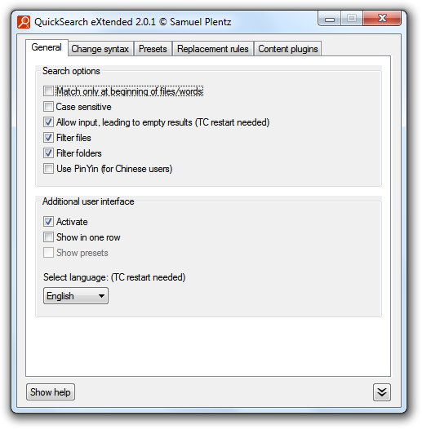 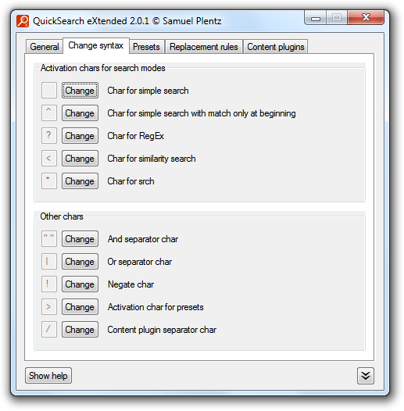

Beside basic options you may activate the additional user interface and change its look.

You can decide which chars should activate the different search types. To specify a default search type, just use nothing as activation char. You may also change other chars used by the search.

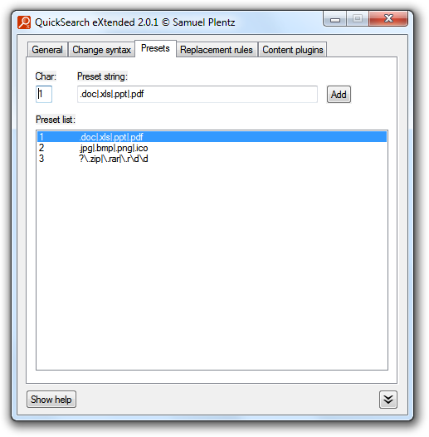 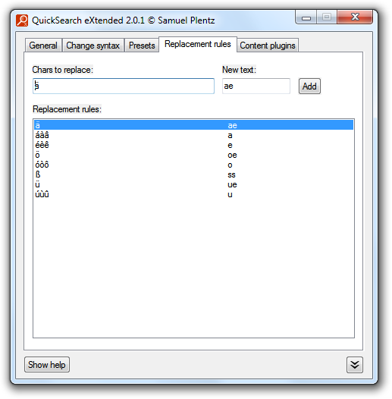

You may create presets for use in the additional user interface or by writing “>[char]”

You can create several replacement rules. When the search is in progress, every occurrence of a char from the chars to replace in the filename or in the filter string is replaced by the new text.

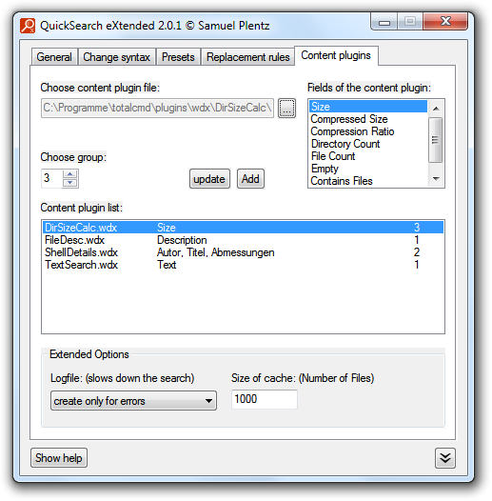

Here you may customize the content plugins. With the cache value you can specify for how much files the content plugin values are cached. Use the logfile if the content plugins doesn’t seem to work. The file “tcmatch.log” is created at same path like “tcmatch.ini”.

4. Known limitations

* Quick Search options from “Total Commander” > “Configuration” > “Quick Search” are ignored. (Exact beginning and ending)
* RegEx: “case insensitive” doesn’t work for some chars of some languages.
* Content plugins: “ContentGetDetectString” and “Units” are ignored.
* Content plugins: Translated Fieldnames can’t be used.
* Content plugins & filter files/folders: No support for network drives, FTP and archives.

5. History

Version 2.2.7

* Fixed a memory leak resulting in a big grow of memory consumption of TC in folders with many files – thank you DrShark
* Fixed long time bug of displaying numbers instead of the correct strings in the GUI - thank you majkinetor !
* Added pressing and holding ESC interrupts the matching process. Could be used when the match process is slow, because a long text is pasted or plugins slow down the process.

Version 2.2.6

* possible Bugfix for problems (freeze) with Windows 10 Creators Update - thank you stifani

Version 2.2.5

* Added Korean translation for the user interface - thank you sheppaul

Version 2.2.4

* Updated Russian translation

Version 2.2.3

* Added Polish translation for the user interface - thank you Krzysztof Klimaszewski
* Added Ukrainian translation for the user interface - thank you Pavel
* Added Russian translation for the user interface - thank you unknown author (submitted by Pavel)

Version 2.2.2

* Added Hungarian readme and translation for the user interface - thank you Bluestar

Version 2.2.1

* Added Spanish translation for the user interface - thank you Victor Emmanuel

Version 2.2.0

* Added support for Korean lead syllable search
* Added support for dictionaries (tcmatch.dic) - see help file for details
* Added example dictionary for Japanese
* Added Korean readme - thank you sheppaul

Version 2.1.2

* Fixed: Pinyin search was broken in x64 version

Version 2.1.1

* Fixed: additionally user interface is always shown at the right position now

Version 2.1.0

* Added support for the new 64-bit Total Commander. (Total Commander (x64) 8.0ß2 and later)
* Also added support for the new 64-bit content plugins: “\*.wdx64”

Version 2.0.1

* Reworked the readme (formulations (especially for content plugins), translated forgotten text to German, created German images)
* Added customization of content plugins to the user interface
* Added language dropdown to user interface
* Added: the additional user interface may now hide the preset dropdown
* Added tooltips to the additional user interface
* Fixed: It’s now possible to store “tcmatch.ini” in “UTF16 LE” instead of ANSI (thanks to AHK\_L)
* Fixed: the additional user interface closes when TC is minimized to tray
* Fixed: the user interface is closed if TC is not running

Version 2.0.0

* Added an additional user interface, to choose the search mode, change most important search options and to use presets
* Added an user interface to customize all options beside the content plugin options. (they still need to be changed in the ini)
* Improved the speed, when content plugins are activated but not used. (thanks Hacker)
* Added ini option “wdx\_cache” to allow caching of content plugin searches.
* Reworked the readme.
* Added German readme and language for user interface.

Version 1.6.0

* Added a new search-mode: “srch” (default activation char: “\*”) With this search you may skip letters of the filename. So the filter “dwn” will find the files “Download.zip” and “Sandra went to town.docx”.

Version 1.5.3

* Added a new [replace] section to the ini where it’s possible to replace chars by a string. Could be used to replace diacritics by any other char or string. See “readme > 3. Customize > Replace section” for details and examples.
* Fixed a bug when converting ANSI wdx output to Unicode. Diacritics were not translated properly.

Version 1.5.2

* Greatly improved the performance by around 80%-90%! It’s just like a lightning now in a folder with 10.000 files.
* Added uninstall information’s in the readme.

Version 1.5.1

* Important change: The name “Google like Quicksearch” changed to “QuickSearch eXtended”.
* Clean up the first post, so that the user will more likely read the readme. ;-) (Full history is now only available in readme.)
* Change: Default value of “wdx\_separator\_char” is now “/” instead of “\”. The backslash prevented to use the RegEx search.
* Fixed: Filtering files in FTP mode is possible again. (broken in Version 1.5)
* Disabled wdx and “filter\_files\_and\_folders” for network drives, FTP and inside of zip files.
* Some readme cleanup and redesign.

Version 1.5+ (silent update)

* Fixed: Filtering files in FTP mode is possible again.

Version 1.5

* Added: New activate char “simple\_search\_match\_beginning\_activate\_char=^” available in ini.
* Added: Changes in the ini have immediately effect. Restart TC only necessary for: “allow\_empty\_result”
* Fixed: The option “case\_sensitive” was ignored for Russian language. (and probably other languages too) Didn’t fix it for the RegEx library.
* Improved wdx support:
  + Added: Groups for wdx plugins. Create them by adding a “wdx\_group=...” entry to the ini. (see readme for syntax) Use groups with the new “wdx\_separator\_char=\”.
  + Dirsizecalc seems to work.
  + Unicode filenames are converted to 8.3 when calling plugins without Unicode support.
  + “ft\_fulltext” should work now without size limit. (not tested)
  + Changed: Ini option "debug\_output" has now 4 states: 0=no output, 1=output wdx errors (default), 2=additional information about wdx values, 3=output all wdx function calls
  + For performance reasons wdx content is only taken from the file if the file is not already included because of the filename.

Version 1.4.2

* Change for ini option “match\_beginning”: If there is a space before the first written substring the substring can match anywhere in the filename.

Version 1.4.1

* Added: New ini parameter “negate\_char=!” to invert the search. The char must be written in front of the whole search string to invert the search.
* Changed: The ini is now searched at path of “tcmatch.dll” first. If not found it is searched in path of “wincmd.ini”. If both no ini does exist at all it is tried to create the ini in the same order.
* Changed: The default value of “allow\_empty\_result” is now 1. (Not changed for existing inis)
* Change for ini option “match\_beginning”: Just the first written substring must match the beginning of the filename.
* Improved readme file

Version 1.4

* Added: Limited wdx plugin support. See “3. Customizing” of readme for usage.
  + does not work with real unicode files and nonunicode plugins (The conversion from unicode filename to nonunicode filename is currently done char by char.)
  + “ContentGetDetectString” and “Units” are ignored
  + only untranslated Fieldnames can be used
  + only 8192 chars are extracted for long strings
  + DirSizeCalc doesn’t work for an unknown reason
* Added: “match\_beginning” to match only when the substrings match either the beginning of the filename or a part of it which follows a space immediately (just try it)
* Changed: A new entry with standard value is created in ini file if it doesn’t exist or has an invalid value. (through ini files from previous installations)
* Rewrote and cleaned up big parts of code. Look out for inconsistencies and bugs.
* Fixed: Small mismatches (case sensitive and pinyin).
* Due to a small bugfix TC 7.5 public beta 6 should be used.

Version 1.3

* Changed: Renamed “separator\_char” to “and\_separator\_char” in ini.
* Added: “or\_separator\_char” to search either one substring or the other one - use “allow\_empty\_result=1” in ini to make them work better
* Added: ability to create and use presets
* Added: ini option “filter\_files\_and\_folders” to only filter files or only filter folders (doesn’t work in zip files)
* Added: Auto detect system language on first run to set PinYin ini option to “use\_pinyin=1” for Chinese
* Did not fix PinYin support again :-D

Version 1.2.2

* Fixed PinYin support again ;-)

Version 1.2.1

* Fixed PinYin support

Version 1.2

* Added (untested) support for PinYin - thanks to Christian Ghisler and Shanny (Because of slightly performance reasons it has to be activated in the ini: “use\_pinyin=1”
* Added new ini parameter to be able to change the Separator from space to any other Separator. Example “separator\_char=/”
* Added some more comments to source code.

Version 1.1

* Added the introduced function “MatchGetSetOptions” from Total Commander 7.5 public beta 5
* Drop support for Total Commander 7.5 public beta 4
* Added: always override internal search
* Added: always remove leading/trailing asterisk
* Removed workarounds needed for Total Commander 7.5 public beta 4
* Added history to the readme
* Added new option to ini: “allow\_empty\_result=0/1”

Version 1.0.2

* Added version informations to dll
* Added readme to the package
* Added readme and history to the post in the Total Commander forum

Version 1.0.1

* Changed: The “tcmatch.ini” isn’t bundled anymore. It’s created on first run in same folder like “wincmd.ini”.
* Changed: Renamed “google\_search\_activate\_char” to “simple\_search\_activate\_char” in ini.

Version 1.0

* Added a similarity search. (Levenshtein)
* Added Google like search for RegEx.
* Added a workaround for open, but not closed parenthesis. (“()[]{}”)
* Added support for an ini file. (activation chars, case sensitivity)
* Fixed absolute paths in source.

Version 1.0 pre3

* Fixed RegEx - thx to “j” it works

Version 1.0 pre2

* Added buggy RegEx :-D

Version 1.0 pre1

* Support for simple search