AIN-109
AnchorInsightOS™ Executive Operations Center
Executive Operations Architecture Standard | Version 1.0
Document ID | AIN-109
System | AnchorInsightOS™
Platform Host | AnchorOS
Governance Layer | AnchorStack
Product Role | Commercial Intelligence Operating System
Status | Architecture Candidate

AnchorOS runs the platform.
AnchorStack governs continuation.
AnchorInsightOS operates commercial intelligence.

1. Mission
Provide executives and commercial operators with one coherent operating center for monitoring intelligence, opportunities, relationships, reports, actions, and platform health while preserving evidence provenance, governed recommendations, and clear human authority.

2. Operational Layer Architecture
AnchorInsightOS SHALL operate as an application-layer operating environment hosted by AnchorOS and governed by AnchorStack. The three layers are complementary and SHALL remain architecturally distinct.
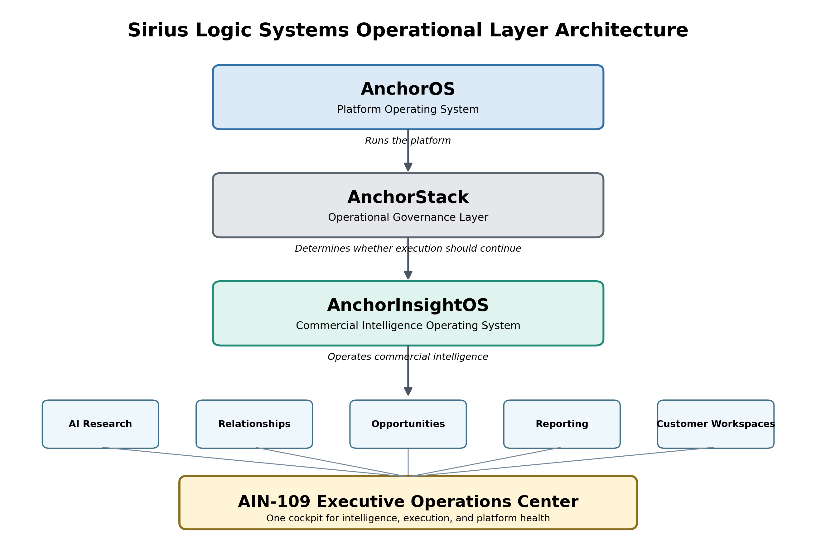
Figure 1 — Sirius Logic Systems Three Operating Layers
Layer | System | Primary Question | Responsibility
Platform | AnchorOS | Can the platform run? | Services, lifecycle, events, health, data, APIs, applications
Governance | AnchorStack | Should execution continue? | Continuation validity, evidence, constraints, verification, replay
Intelligence | AnchorInsightOS | What deserves commercial attention? | Research, relationships, opportunities, reports, executive operations

3. Core Architecture
AIN-109 is the executive orchestration surface for the AnchorInsightOS service family. It SHALL consume existing services rather than duplicate their data or logic.
- Executive Briefing
- Commercial Radar
- Opportunity Operations
- Relationship Intelligence
- AI Research Monitor
- Reporting Operations
- Market Intelligence
- Customer Workspace Overview
- Platform and Governance Health
- Alerts, Reviews, and Next Actions

4. Executive Operations Center
The Executive Operations Center SHALL provide a single cockpit that answers:
- What changed?
- What requires attention?
- Which opportunities are strongest?
- Which relationships are weakening or improving?
- Which evidence and research findings require review?
- What actions are due?
- Is the platform healthy?
- Is governed execution intact?

5. Operating Panels
Panel | Purpose
Executive Briefing | Morning summary, top priorities, current decisions, urgent reviews, major changes
Commercial Radar | New signals, leadership changes, grants, capital projects, market events
Opportunity Operations | Pipeline, opportunity confidence, lifecycle, value, dependencies, next action
Relationship Intelligence | Key contacts, buying committees, influence, relationship health, dormant relationships
AI Research Monitor | Research runs, evidence queue, low-confidence findings, source health, review backlog
Reporting Operations | Recent reports, report freshness, archived artifacts, pending generation requests
Market Intelligence | Market trends, target organizations, comparative confidence, opportunity themes
Platform Health | AnchorOS services, registry, database, scheduler, APIs, application status
Governance Health | AnchorStack status, continuation-validity checks, unresolved constraints, replay state

6. Executive Briefing Contract
The briefing SHALL be concise, traceable, and action-oriented. Every material item SHALL link to its underlying organization, evidence, scorecard, research run, relationship, opportunity, or report.
- Current date and briefing generation time
- Top five recommended actions
- New or materially changed opportunities
- Evidence requiring human review
- Relationship changes
- Research failures or stale coverage
- Platform or governance degradation

7. Health Model
AIN-109 SHALL present health in three separate dimensions so operational, governance, and commercial concerns are never blended.
Dimension | Source | Example Measures
Platform Health | AnchorOS | Services, database, APIs, scheduler, event bus, applications
Governance Health | AnchorStack | Validity, constraints, unresolved exceptions, verification, replay
Intelligence Health | AnchorInsightOS | Research freshness, evidence coverage, review backlog, opportunity confidence

8. Alerts and Attention Management
AIN-109 SHALL prioritize attention rather than merely display information.
- Critical — platform or governance failure; immediate response required
- High — material opportunity, risk, or evidence condition requiring prompt review
- Medium — scheduled review, stale intelligence, or relationship decay
- Low — informational change or routine follow-up

9. Decision Support
AIN-109 SHALL summarize recommendations but SHALL NOT become the authority for commercial commitment. Recommendations SHALL remain traceable to approved scores, evidence, relationships, opportunities, and human review.

10. Data and Service Dependencies
Source | Contribution
AIN-101 | Commercial Intelligence Registry Service
AIN-102 | Scoring and Decision Service
AIN-103 | Organization Intelligence Profile Service
AIN-104 | Web Application Adapter and Organization Dashboard
AIN-105 | AI Research and Intelligence Engine
AIN-106 | Relationship Intelligence Engine
AIN-107 | Intelligence Reporting and Decision Support Engine
AIN-108 | Opportunity Intelligence Engine
AnchorOS | Platform runtime, health, lifecycle, services, events
AnchorStack | Continuation-validity and operational governance status

11. Non-Goals
- AIN-109 SHALL NOT replace AIN-101 through AIN-108.
- AIN-109 SHALL NOT duplicate authoritative registry data.
- AIN-109 SHALL NOT invent facts, contacts, opportunities, or scores.
- AIN-109 SHALL NOT override AnchorStack governance status.
- AIN-109 SHALL NOT automatically commit commercial actions.
- AIN-109 SHALL NOT hide contradictory evidence or degraded health.

12. Acceptance Criteria
- AIN-109-V01 — The Three Operating Layers diagram is displayed in the Executive Operations Center.
- AIN-109-V02 — AnchorOS, AnchorStack, and AnchorInsightOS health are shown separately.
- AIN-109-V03 — The briefing presents traceable priorities and next actions.
- AIN-109-V04 — Opportunity, relationship, research, and reporting panels use authoritative service outputs.
- AIN-109-V05 — Material alerts are ranked by severity.
- AIN-109-V06 — Missing or stale intelligence remains visible.
- AIN-109-V07 — No panel performs unmanaged SQL or duplicates service logic.
- AIN-109-V08 — Every recommendation links to its supporting evidence and decision basis.

13. Strategic Position
AIN-109 establishes AnchorInsightOS as a commercial intelligence operating system rather than a collection of isolated tools. It provides one executive environment where the business can observe intelligence, understand evidence, review opportunities, monitor relationships, verify platform health, and select the next justified action.
⚒ Strike true. Build clean. Verify everything.
AI augments judgment. It does not replace evidence. Stay disciplined.

