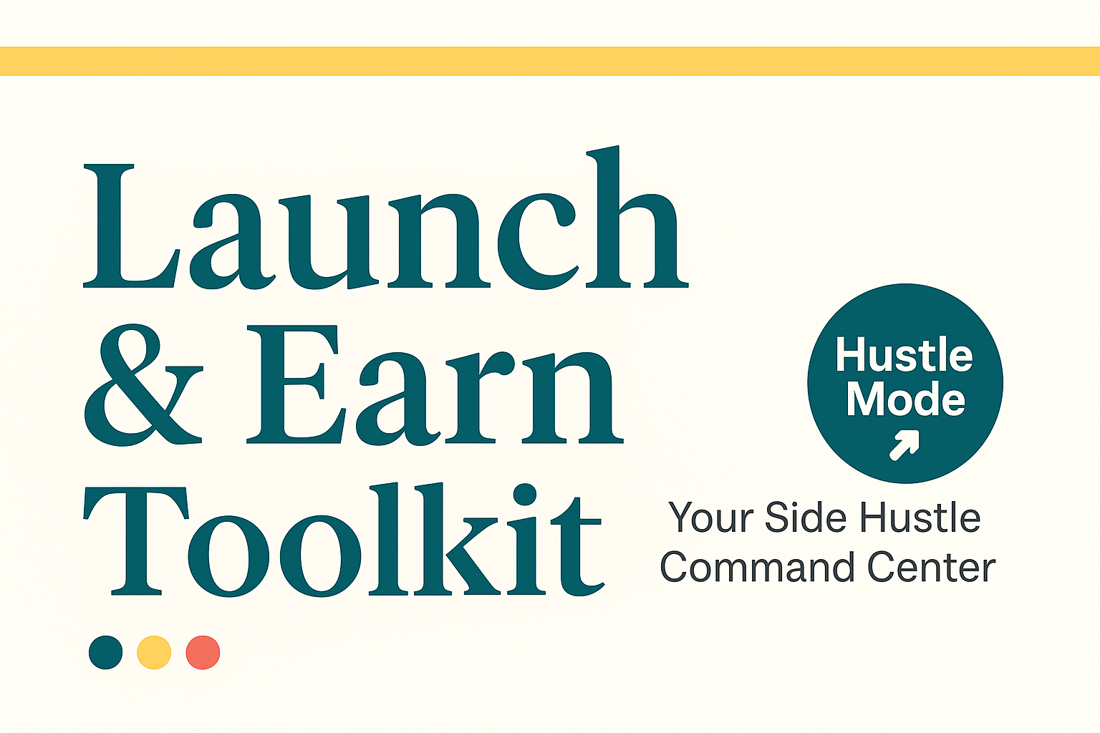

The 30-Day Product Sprint

Build, Launch, and Earn — One Day at a Time

**By Ricky Jarnagin • HustleMode Toolkit**

# Welcome to the 30-Day Product Sprint

This is your fast-track path from idea to income.  
  
You don’t need to be a design expert. You don’t need a huge audience. You just need 30 days of focused action.  
  
This sprint is built to help you plan, build, and launch a simple digital product without burning out or overthinking it.  
  
Each week has a theme. Each day has a doable step. Follow the prompts, trust the process, and adjust it to your pace if needed.  
  
Let’s go from dreaming to doing.

# Week 1: Brainstorm + Validate

🎯 Goal: Pick the right product idea and test it fast.

## Day 1

Brain dump 10 product ideas. Don’t judge — just list.

## Day 2

Pick your top 3. Who needs this? What’s the promise?

## Day 3

Research — is anyone already selling it? (That’s good.)

## Day 4

What format will it be? PDF, Notion template, worksheet, etc.

## Day 5

Define your MVP: what’s the *simplest* version you can launch?

## Day 6

Share your idea publicly or with a friend for feedback.

## Day 7

Decision time: Lock in the ONE product you’ll build.

# Week 2: Build It

🛠️ Goal: Create the simplest version of your product that delivers value.

## Day 8

Outline your product. What sections or components does it need?

## Day 9

Draft the first 25%. Focus on clarity, not perfection.

## Day 10

Finish the first half. You can always refine later.

## Day 11

Complete a rough draft of the full product.

## Day 12

Add visuals or formatting if needed (e.g., tables, checklists).

## Day 13

Create a simple cover or preview image (Canva is fine).

## Day 14

Step back and review: does this version *deliver* the promise?

# Week 3: Polish + Prep

🎨 Goal: Finalize the look, assets, and launch content for your product.

## Day 15

Do a full edit of your draft. Make it readable and tight.

## Day 16

Add branding: fonts, colors, and consistent formatting.

## Day 17

Write a simple product description (100–150 words).

## Day 18

Create 2–3 promo graphics or mockups (Canva works great).

## Day 19

Write your Gumroad/Substack listing text.

## Day 20

Prep delivery files: PDFs, thumbnails, CSVs, ZIPs.

## Day 21

Run a final QA check — fix any broken links or typos.

# Week 4: Launch Week

🚀 Goal: Ship your product, promote it with clarity, and reflect on your sprint.

## Day 22

Pick a launch date and time. Circle it. It’s real.

## Day 23

Upload your product to Gumroad, Etsy, or your platform.

## Day 24

Write your launch email or announcement post.

## Day 25

Schedule or send your first promotion.

## Day 26

Post behind-the-scenes content (build-in-public).

## Day 27

Send a follow-up email or share testimonials.

## Day 28

Celebrate the launch. Reflect on what worked.

## Day 29

Make a list of future updates or spin-off products.

## Day 30

Document your results. Share your story.

Yet another amazing product from [AnchorStack.pro](http://AnchorStack.pro/)