Design and Implementation of
Memory Management Simulator
Overview
This project implements a memory management simulator that simulates key operating system and computer architecture concepts, including:
- Contiguous memory allocation strategies
- Buddy system memory allocation
- Multi-level CPU cache hierarchy
- Virtual memory using paging
- Address translation from virtual to physical memory via page table.

Memory Layout and Assumptions
- Physical Memory Assumptions
- Physical memory is modelled as a contiguous array of bytes.
- Memory addresses are byte-addressable.
- Physical memory is divided into:
  - Blocks (for contiguous allocation)
  - Frames (for paging)
  - Power-of-two blocks (for buddy allocation)
- Virtual Memory Assumptions

- Virtual memory is divided into fixed-size pages
- Each page maps to one physical frame
- In the virtual memory, we have also kept it byte addressable.
- Page size is configurable (e.g., 4 KB)
- A single-level page table is used per simulation
- Disk is simulated using an in-memory backing store

- Cache Assumptions
- Cache accesses use physical addresses only
- Cache blocks (cache lines) are fixed size(taken into input by user).
- Cache hierarchy may include L1, L2, and L3.
- Inclusive cache behaviour is assumed for simplicity(i.e. if a data is in higher level of cache must also be present in lower level of cache).
- No cache write operations have been implemented here.
Contiguous Physical Memory Allocation
Dynamic Contiguous Memory Allocation
- Contiguous memory allocation is implemented using a doubly linked list.
- Each node (block) in the list stores:
  - Starting address
  - Block size
  - Free/allocated status
- On allocation:
  - The list is searched for a suitable free block.
  - If the block is larger than required, it is split.
- On deallocation:
  - The block is marked free.
  - Adjacent free blocks are merged(coalesced) to reduce fragmentation.

Allocation Strategies
- First Fit
  - Allocates the first free block that is large enough.
  - Fast allocation with minimal search overhead.
- Best Fit
  - Allocates the smallest free block that can satisfy the request.
  - Reduces immediate wasted space but may increase fragmentation.
- Worst Fit
  - Allocates the largest available free block.
  - Leaves larger remaining blocks but often performs poorly
Statistics Tracked
- External fragmentation (Total size of memory out of all free memory)
- Allocation success count
- Allocation failure count
- Memory utilization
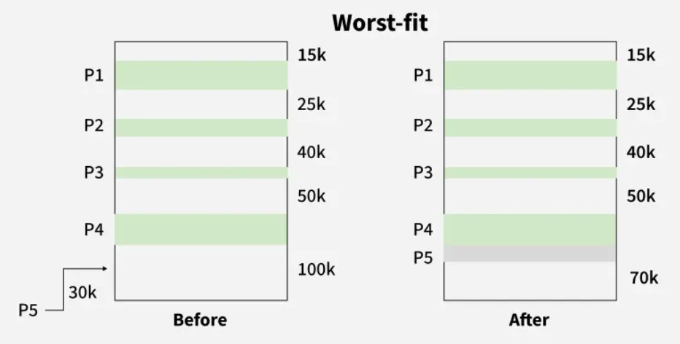
Fig 1. An example showing worst fit allocation.

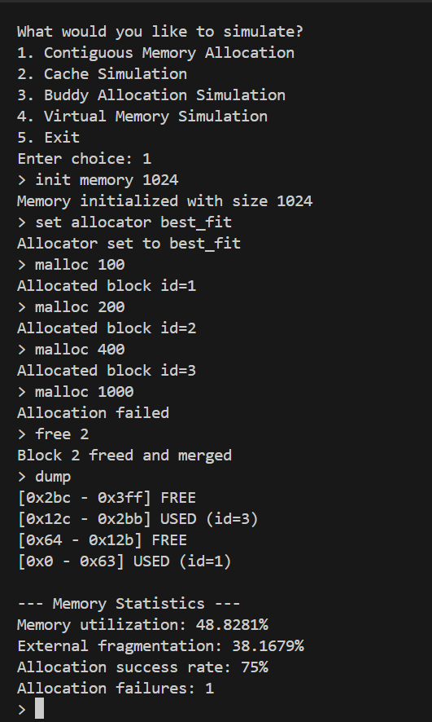
Fig 2: Allocation simulation (Image 1)

Instructions to execute:
- For initialisation of memory use ,init memory memory_size(1024 , 2000.. etc) ,command. (**Since we are using string stream to take the input kindly don’t forget to type memory as then the size would be taken any arbitrarily large number.)
- For setting allocator, type set allocator first_fit/best_fit/worst_fit
- For allocation type, malloc size (100,200…)
- For freeing type, free id.
- For checking stats, type dump.
- For exiting, exit.
- For instruction panel , help

Cache Hierarchy and Replacement Policy
Cache Organization
- The cache is implemented as a set-associative cache.
- Each cache consists of multiple sets, and each set contains multiple cache lines.
- The cache is internally represented as a vector of vectors of CacheLine structures.
- Each CacheLine stores:
  - Valid bit
  - Tag
  - Arrival time (for FIFO replacement)
  - Last used time (for LRU replacement)
  - Access frequency (for LFU replacement)
- Cache parameters include:
  - Cache size
  - Block (cache line) size
  - Associativity
  - Replacement policy
  - Hit latency (in cycles)
- The cache subsystem models a three-level hierarchy (L1, L2, L3), with decreasing speed and increasing capacity, where misses propagate to lower levels and hits result in data promotion to upper levels.
CPU
↓
L1 Cache (fast, small)
↓ miss
L2 Cache (bigger, slower)
↓ miss
L3 Cache (largest)
↓ miss
Main Memory
(*By default, we have taken the Ram latency to be 100 cycles)

Cache Access Mechanism
- All cache accesses use physical addresses.
- Each address is divided into:
  - Block offset (based on block size)
  - Set index (used to select a cache set)
  - Tag (used for tag comparison)
- The set index selects the appropriate cache set.
- Tag matching is performed across all cache lines within the selected set.
- A valid tag match results in a cache hit.
- If no match is found, a cache miss occurs and a victim cache line is selected.
- Each cache access adds the cache’s hit latency to the total cycle count.
- Cache statistics such as hits, misses, and total cycles are maintained.
Address Breakdown Diagram
- Physical Address
+----------------+------------+-------------+
| TAG | SET INDEX | BLOCK OFFSET|
+----------------+------------+-------------+
- Block Offset → selects byte within cache line
- Set Index → selects cache set
- Tag → used for tag comparison

Replacement Policies
- The simulator supports three cache replacement policies:
FIFO (First-In-First-Out)
- Replaces the cache line that was loaded earliest into the set.
- Uses the arrival time stored in each cache line.
- Simple to implement but does not consider access patterns.
LRU (Least Recently Used)
- Replaces the cache line that has not been accessed for the longest time.
- Uses the last-used timestamp stored in each cache line.
- Exploits temporal locality and generally provides better performance.
LFU (Least Frequently Used)
- Replaces the cache line with the lowest access frequency.
- Uses an access counter stored in each cache line.
- Effective for repetitive access patterns but may retain stale data.

Instructions to execute
- init → initialize L1, L2, L3 caches
- access <addr> → access a physical address
- stats → show cache statistics
- exit → go back to main menu.
- help → command menu
(*block size is only initialised in L1 cache , other block sizes are kept same)
Example: Multilevel Cache Access
- The cache simulator was initialized with three cache levels (L1, L2, and L3) using the FIFO replacement policy.
- The first access to address 0 resulted in a miss at all cache levels, causing a main memory (RAM) access.
- The first access to address 524288 also resulted in a miss at all cache levels, leading to another RAM access.
- Re-accessing address 524288 produced an L1 cache hit, demonstrating temporal locality.
- A subsequent access to address 0 resulted in an L2 cache hit, indicating that the block was evicted from L1 but retained in L2.
- This sequence verifies correct multilevel cache lookup, replacement behaviour, and miss penalty propagation

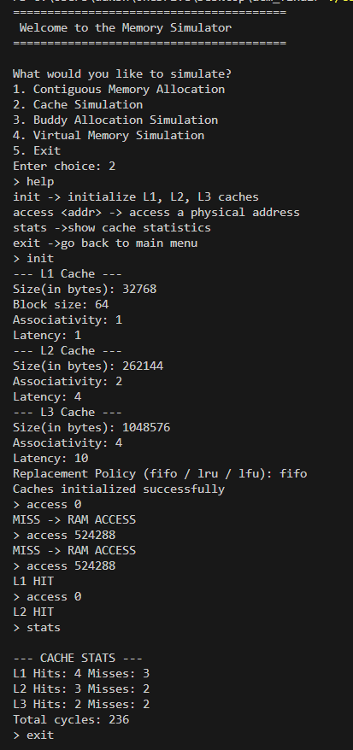
Fig : Cache Simulator

Buddy Allocation Design
Overview
- The Buddy Allocation System is a dynamic memory allocation technique that manages memory in blocks whose sizes are powers of two.
- Memory is initially available as a single large block and is recursively split into smaller blocks to satisfy allocation requests.
- On deallocation, adjacent free blocks of the same size (buddies) are merged to reduce external fragmentation.
- This approach provides fast allocation and deallocation while keeping fragmentation manageable.

Memory Organization
- The total memory is assumed to be a contiguous region starting at address 0.
- Memory is divided into blocks of size
min_block_size × 2^order.
- The largest block size corresponds to the maximum order (max_order).

Data Structures Used
- Free Lists
  - Implemented using std::map<int, std::set<size_t>>.
  - Each key represents an order.
  - Each value is a set of starting addresses of free blocks of that order.
- Allocated Map
  - Implemented using std::map<size_t, int>.
  - Stores allocated block addresses mapped to their corresponding order.
- Order Representation
  - Order represents the exponent of two relative to the minimum block size.

Allocation Procedure
- The requested size is converted to the smallest suitable order using get_order().
- The allocator searches for a free block of the required order.
- If no block is available, it searches for a larger block.
- Larger blocks are recursively split into two equal halves until the required order is reached.
- One half is allocated and the other is inserted into the appropriate free list.
- The allocated block address and its order are recorded in the allocated map.

Deallocation Procedure
- The block address is validated using the allocated map.
- The corresponding order of the block is retrieved.
- The allocator computes the block’s buddy address.
- If the buddy is free and of the same order:
  - The two blocks are merged.
  - The merged block moves to the next higher order.
- This merging continues recursively until no further merge is possible.
- The final merged block is inserted back into the free list.

Buddy Identification
- The buddy of a block is calculated using a bitwise XOR operation:
- buddy_address = block_address XOR block_size
- Since buddy blocks differ by exactly one bit at the block-size position, XOR efficiently computes the buddy address.

Fragmentation Handling
- External fragmentation is reduced by merging free buddy blocks during deallocation.
- Internal fragmentation may occur due to power-of-two block sizing.
- The design ensures fast and deterministic memory operations.

Instruction to execute
- free <address> → Frees the allocated block starting at the given address.
- dump → Displays the current state of all free lists in the buddy allocator.
- help → Shows all available buddy allocator commands.
- back → Exits the buddy allocator interface and returns to the main menu.
- alloc <size> → Allocates a memory block of at least the requested size.

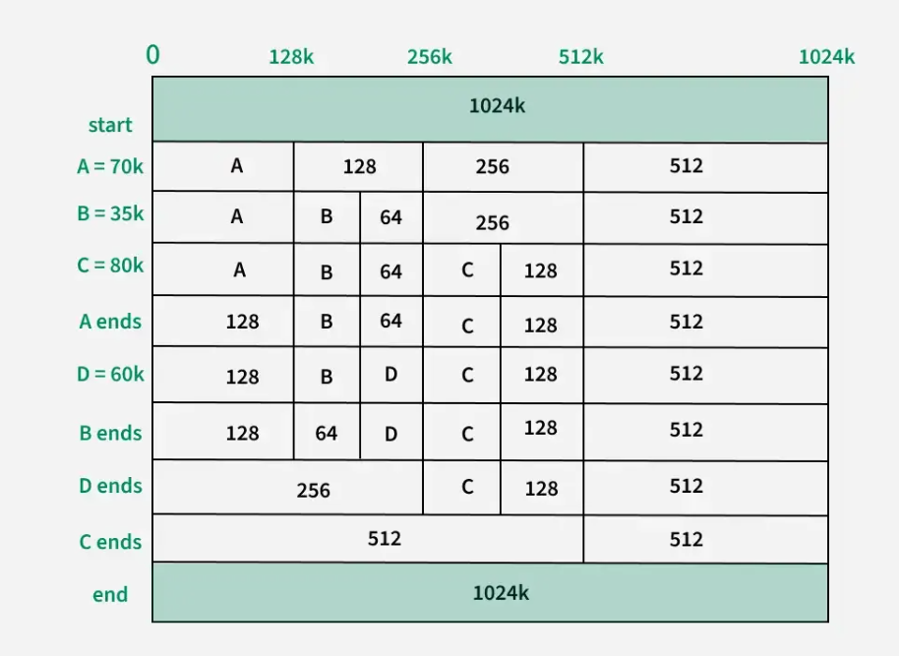
Fig : Example of buddy allocation(GFG)

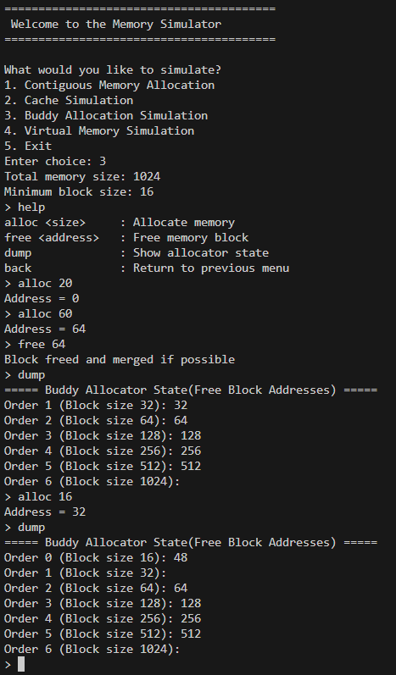
Fig : Buddy allocation simulation example

Virtual Memory Simulation
Virtual Memory Organisation
- The virtual memory system is implemented using paging.
- Each process is identified by a process ID (pid) and maintains its own page table.
- A page table stores metadata required for address translation and page replacement.
- Page table entries track:
  - Whether the page is present in physical memory
  - The physical frame number
  - Arrival time (for FIFO)
  - Last access time (for LRU)
  - Reference bit (for CLOCK)
- A global frame table is maintained to record:
  - Which process occupies a frame
  - Which virtual page is stored in that frame
- Physical memory is divided into fixed-size frames.
- Virtual memory is divided into fixed-size pages of equal size.
- A simulated disk (backing store) is used to store pages that are not currently in memory.
- Page replacement decisions are made globally across all processes.
- Maps of integer to vector has been used to store the page table of each process.

Virtual to Physical Memory Translation
- Virtual memory is byte addressable.
- Each virtual address is divided into:
  - Virtual Page Number (VPN)
  - Offset within the page
- The VPN is used to index into the process’s page table.
- If the page table entry is valid:
  - The frame number is obtained
  - Physical address is formed using frame number and offset
- If the page table entry is invalid:
  - A page fault occurs
  - The required page is loaded into physical memory
- The offset remains unchanged during translation.
- Page hits and page faults are tracked for performance analysis.

Page Replacement Policies
FIFO (First-In First-Out)
- Pages are evicted in the order they were loaded into memory.
- The page with the earliest arrival time is selected as the victim.
- Simple to implement but does not consider access patterns.
LRU (Least Recently Used)
- Pages that have not been accessed for the longest time are evicted.
- Uses access history to approximate optimal replacement.
- Performs better than FIFO for most workloads.
CLOCK (Second-Chance Algorithm)
- Uses a circular list of frames.
- Each page maintains a reference bit.
- Pages with the reference bit set are given a second chance.
- A page with reference bit unset is selected for eviction.
- Reference bit is set on page access and on page load after a page fault.

Instructions

Virtual Memory Commands
• access <pid> <virtual address> → Access a virtual address of a process
• stats → Display page hits and page faults
• exit → Exit virtual memory simulation

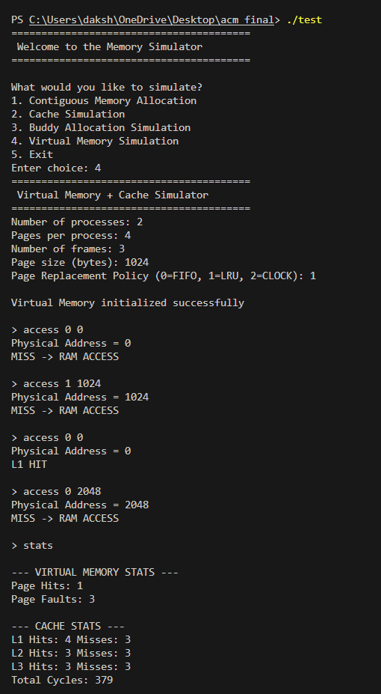
Fig : Virtual Memory Simulator

