Overview – ERS Project

This project is an expense reimbursement system. Employee expense reimbursement software allows you to input expenses for approval through one application. In short, you are building an API (Application Programming Interface) for employees to submit reimbursement requests and managers to approve or deny the submitted requests.

Project Setup

1. Understand the use-cases of the ERS system

Any good developer needs to understand what the requirements are really asking. When starting from scratch, it is imperative that a developer begins with a plan for the user experience and an outline of the functionality requirements. Review the diagram below:

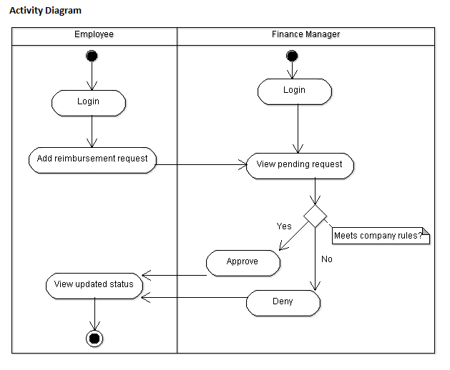

Functional Requirements

Core MVP Features:

1. Login/Register Feature

The login/register feature is meant to give you preliminary experience handling authentication within an application. These features allow you to ensure you can track or maintain who can connect to your application. Here are the user stories:

* + As an Employee or Manager, I should be able to log into the application.
    1. Must be able to log in with an email and password
  + Ability to register a new account
    1. You must ensure the email is not already registered
    2. Default to an employee role
    3. Should register with at least an email and password

1. Submit Ticket Feature

The submit ticket feature is meant to guide you through input acceptance, validation, and error handling. The ability to submit a reimbursement request ticket is the core functionality of this application. Here is the user story:

* + Employees can submit a new reimbursement ticket
    1. Must have an amount
    2. Must have a description
    3. Should have a default status of Pending

1. Ticketing System Feature

The ticketing system feature is meant to act as the primary interface for internal managers. Managers will use this interface to process the pending reimbursement request tickets and either approve or deny these requests. Here is the user story:

* + Managers can process tickets submitted by employees
    1. Tickets can be Approved or Denied
    2. Tickets cannot change status after processing
  + Pending tickets should be added to a queue or list that managers can see
    1. Tickets should be removed from the list, or queue, once processed (approved/denied) by a manager

1. View Previous Tickets Feature

The view previous tickets feature is meant for employees to see their request submission history. Employees will leverage this to see outstanding pending tickets along with tickets that have been processed by managers. Here is the user story:

* + As an Employee, I should be able to view all previous reimbursement ticket submissions.
    1. Employees should be able to filter by status (pending, approved, or denied)
  + Previous tickets should also show the details of submission.

Completion Checklist:

The checklist below is the project evaluation standard.

This list will be utilized during the project presentation to demonstrate that the application meets all the functionality requirements.

Using Postman or Swagger, make sure the application can complete the following tasks:

1. Can use a username and password to log in
2. Can register a new account with username and password
3. Will notify the user if the username is unavailable
4. Can submit new reimbursement tickets
5. Will make sure the reimbursement ticket author provides a description and amount during submission
6. Pending tickets are in a queue/list that can only be seen by Managers
7. Tickets can be processed (approved or denied) by Managers
8. Employees can see a list of their previous submissions

Optional Stretch Goals

These features are possible extensions to the application. Refer to the features below to see the options:

Optional Stretch Features:

1. Reimbursement Types Features
   * Employees can add Reimbursement Types
     1. Travel, Lodging, Food, Other
     2. Employees can view previous requests filtered by type
2. Change Roles Feature
   * Creation of an Admin role
   * Admins can change other users’ roles
     1. Employee to Manager or back to Employee
3. Upload Receipts Feature
   * Employees can add images of receipts to their reimbursement requests
     1. Upload and store images (in SQL or cloud storage)
4. User Accounts Feature
   * Track additional user information (name, address, etc.)
   * Users can edit their account
   * Users can add a profile picture