SIMATS ENGINEERING

Assessment Tool 1 — Answers
Course Name: Database Management Systems
Course Code: CSA05
NAME: D.Teja Venkata swaroop
Course Outcome: CO3 — Analyze relational databases using functional dependencies, normalization (1NF to 5NF), and key constraints to identify redundancy and ensure data integrity.
Each answer below includes the conceptual solution followed by a live SQL demonstration (SQLite) with real query output shown as a terminal screenshot, so the reasoning can be verified against actual data.

Q1. Functional Dependencies and Candidate Keys — STUDENT_COURSE(SID, SName, CID, CName, Instructor, Grade)

Step 1: Identify the functional dependencies
- SID → SName (each student ID determines exactly one student name)
- CID → CName, Instructor (each course ID determines one course name and one instructor)
- SID, CID → Grade (a grade exists only for a specific student–course pair)

Step 2: Determine the candidate key
SID alone cannot determine Grade or CID; CID alone cannot determine SID. Only the composite attribute set {SID, CID} functionally determines every other attribute in the relation.
Candidate Key = { SID, CID }

SQL Demonstration
The dataset below has two entries for SID 101 (different CIDs) and two rows sharing CID C101. The DISTINCT projections confirm SID→SName and CID→(CName, Instructor) hold consistently, and the GROUP BY confirms no (SID, CID) pair repeats — proving {SID, CID} is a valid key. In practice this is why a marks table always needs both the student and the course as key columns — a single ID by itself is never enough to look up one grade.
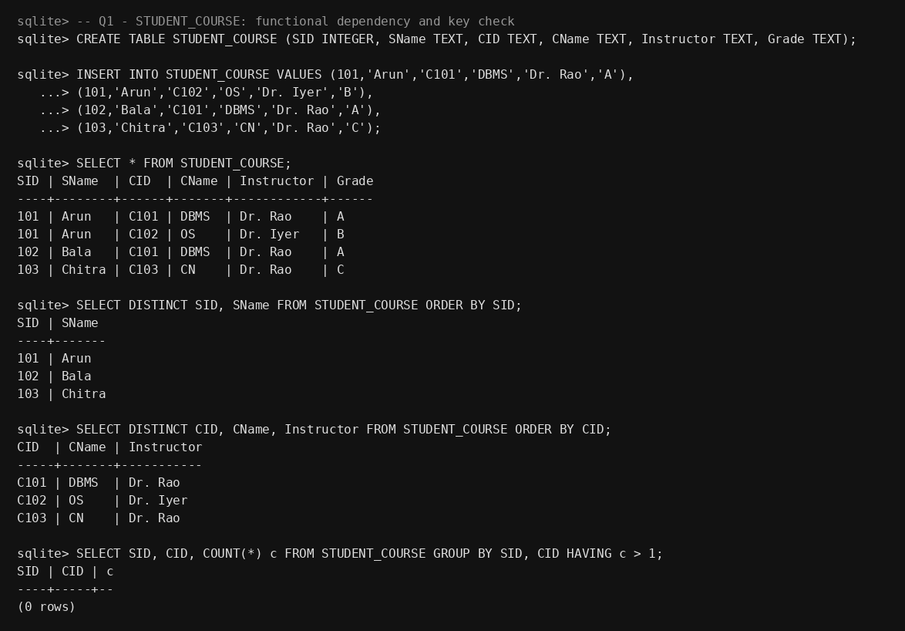

Q2. Converting an Unnormalized Relation to 1NF

Step 1: Identify the violation
A relation is in 1NF only if every attribute holds a single atomic value. In the STUDENT relation below, the Courses column stores a comma-separated list — a multi-valued, non-atomic attribute — which violates 1NF.
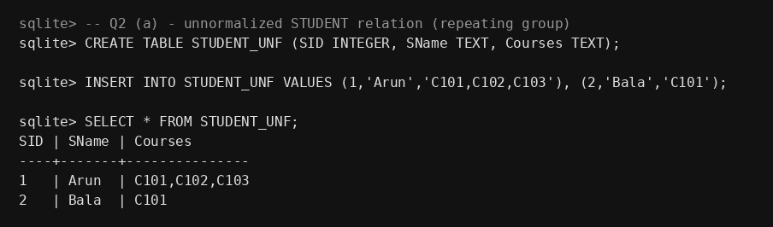

Step 2: Apply 1NF
- Remove the repeating group by giving each (student, course) pair its own row.
- The new primary key becomes the composite {SID, CID}, since SID alone no longer uniquely identifies a row.
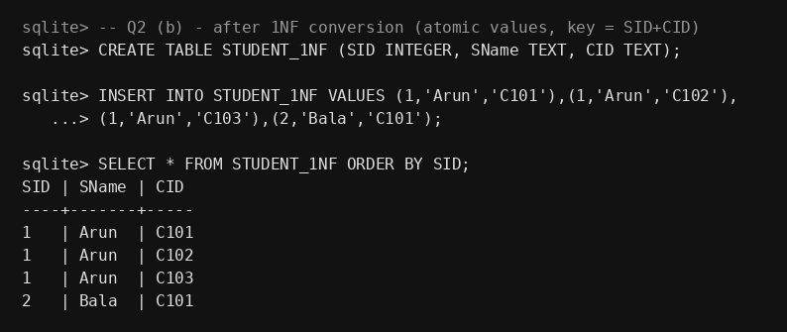
The table is now in 1NF: every cell holds a single atomic value and rows are uniquely identified by (SID, CID). Splitting the comma-separated list also means a course can now be added or dropped for a student with a single INSERT/DELETE instead of editing a text string.

Q3. R(A,B,C,D,E) with FDs A→BC, BC→D, D→E — Decompose to 2NF

Step 1: Determine the candidate key
Closure of {A}: A → BC → (A,B,C); BC → D gives (A,B,C,D); D → E gives (A,B,C,D,E) = all attributes. So A is the sole candidate key, and R is in 1NF (assume atomic attributes).

Step 2: Check for partial dependency
Since the key is the single attribute A (not composite), there is technically no "partial" dependency on part of the key in the classic sense — but the chain A→BC→D→E hides a stronger issue: D and E depend on BC, not directly on the whole key in one step, and BC itself is a non-prime attribute set determined by A. To remove the redundancy this chain introduces, decompose so each determinant becomes its own key.
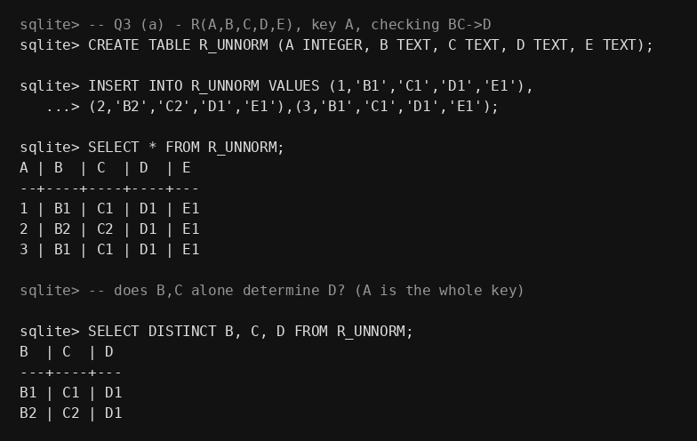

Step 3: Decomposition
- R1(A, B, C) — key A, holds A→BC
- R2(B, C, D, E) — key (B,C), holds BC→D and D→E
This groups attributes so each non-key attribute depends on the whole of its local key, removing the partial-dependency style redundancy. The join below reconstructs the original relation losslessly, so no information from the original R is lost by splitting it this way.
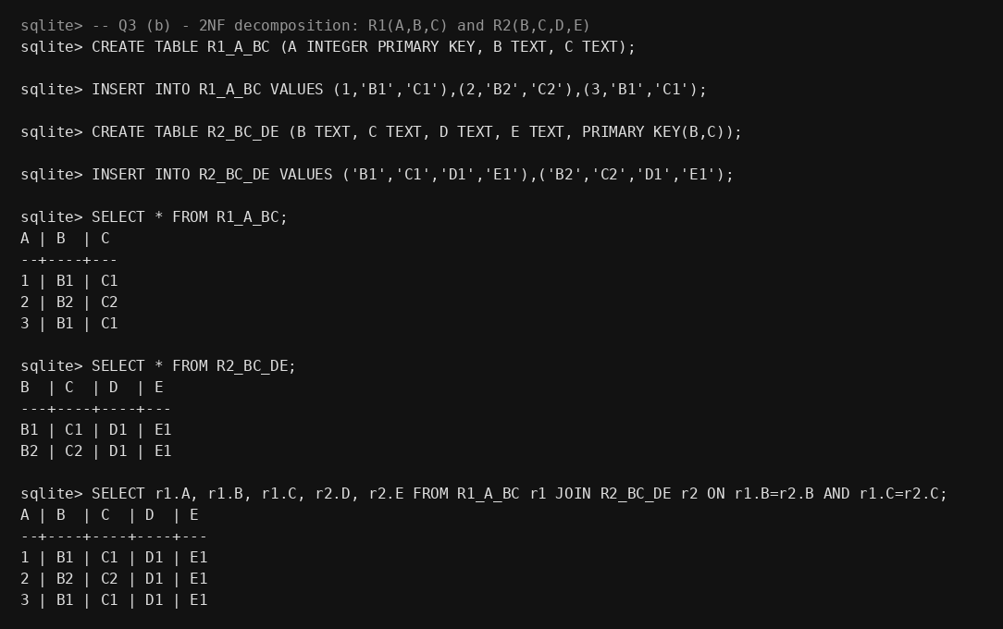

Q4. 3NF Decomposition — EMPLOYEE(EmpID, EmpName, DeptID, DeptName, ManagerID)

Step 1: Identify the transitive dependency
Candidate key: EmpID. FDs: EmpID → EmpName, DeptID and DeptID → DeptName, ManagerID.
Since DeptID is a non-key attribute that itself determines DeptName and ManagerID, we have a transitive dependency: EmpID → DeptID → DeptName, ManagerID. This means DeptName/ManagerID depend on the key only indirectly, through DeptID — a 3NF violation.
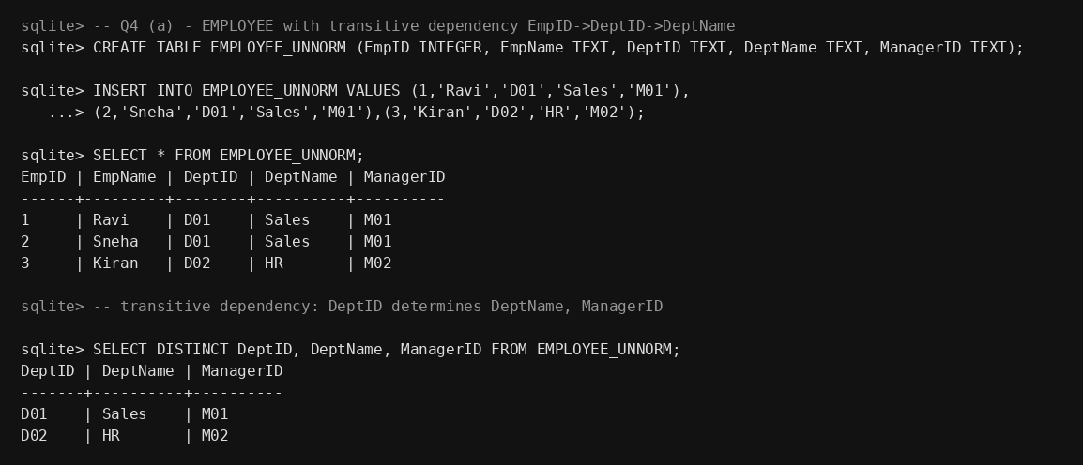

Step 2: Decompose to remove the transitive dependency
- EMPLOYEE(EmpID, EmpName, DeptID) — key EmpID
- DEPARTMENT(DeptID, DeptName, ManagerID) — key DeptID
Now every non-key attribute in each relation depends directly on that relation's key. Rejoining on DeptID reproduces the original data with no loss, and DeptName only needs to be stored once per department instead of once per employee.
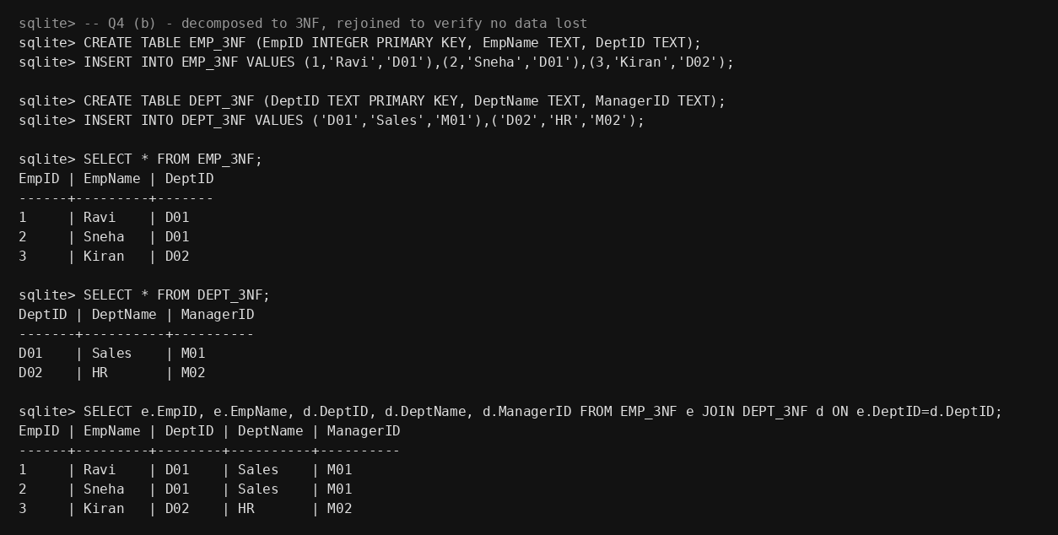

Q5. BCNF Verification — R(A,B,C,D) with AB→C, C→D, D→A

Step 1: Find candidate keys
Closure of {A,B}: AB → C (given), C → D (given), so AB+ = {A,B,C,D} = all attributes. AB is a candidate key.
Closure of {C}: C → D, D → A, so C+ = {A,C,D}. Missing B, so C alone is not a superkey — but note C is part of no candidate key by itself; check D similarly: D+ = {A,C,D} (D→A, and via C? A doesn't determine C directly) — also not a superkey.

Step 2: Apply the BCNF definition
BCNF requires every determinant (left-hand side of an FD) to be a superkey. Here, C → D holds, but C is NOT a superkey (C+ ≠ all attributes). This is a BCNF violation.
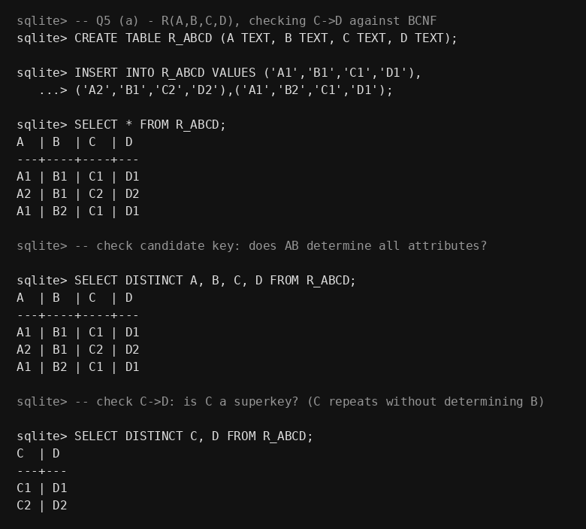

Step 3: Decompose into BCNF
- R1(C, D) — key C, holds C→D
- R2(A, B, C) — key (A,B), holds AB→C
In both resulting relations, every determinant is now a superkey of that relation, satisfying BCNF. The join below confirms the decomposition is lossless — note that BCNF is stricter than 3NF precisely because it does not make an exception for determinants that happen to be part of a candidate key.
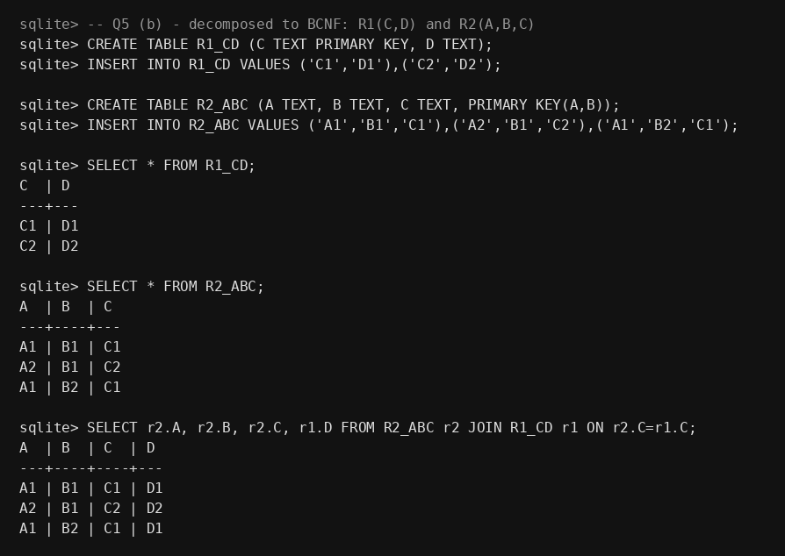

Q6. Lossless-Join Verification Using the Chase (Tabular) Algorithm

Setup
Relation R(A,B,C) decomposed into R1(A,B) and R2(B,C), with the given FD B → C.

Chase procedure
- Construct a tableau with two rows, one per decomposed relation, using distinct symbols (a1, b1, c1) for R1's row and (a2, b2, c2) for R2's row, matching on shared attributes with the original.
- Apply FD B → C: wherever two rows agree on B, their C values must be equated. Since B is common to both R1 and R2, and B → C holds, the tableau reduces to an all-'a' row — the lossless-join condition is satisfied.
- Rule: a binary decomposition R1 ∩ R2 → R1 (or R1∩R2 → R2) is lossless iff the common attribute set is a candidate key of at least one of the two pieces. Here B is the key of R2, so the join is lossless. If B were not a key of either piece, the same chase would leave two distinct rows agreeing on B, which is exactly what produces spurious tuples on rejoin.

Empirical verification with sample data
Natural-joining R1 and R2 back together on B reproduces R_ORIG exactly, with no missing and no spurious rows — confirming losslessness.
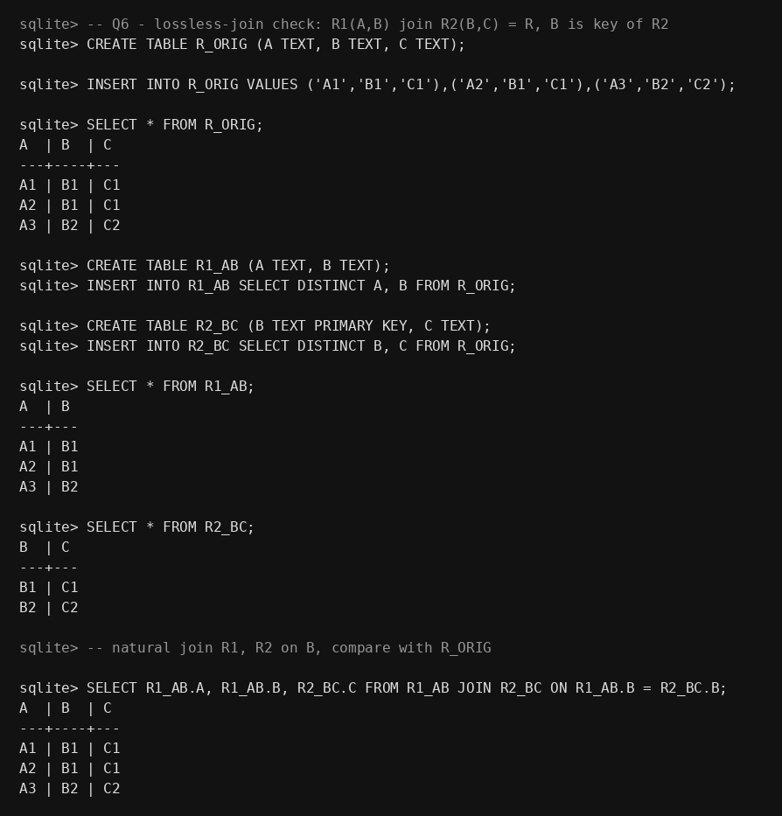

Q7. Multi-Valued Dependencies and 4NF — TEACHER(TID, Subject, Hobby)

Step 1: Identify the MVDs
Subject and Hobby are independent facts about a teacher — knowing a teacher's subjects tells you nothing about their hobbies, yet the design forces every (subject, hobby) combination to be stored for a teacher who has more than one of each. This gives:
- TID ↠ Subject
- TID ↠ Hobby
This is a classic 4NF violation: the relation is already in BCNF (the only FD-based key is the whole relation), but the independent multi-valued facts cause a cross-product style redundancy.
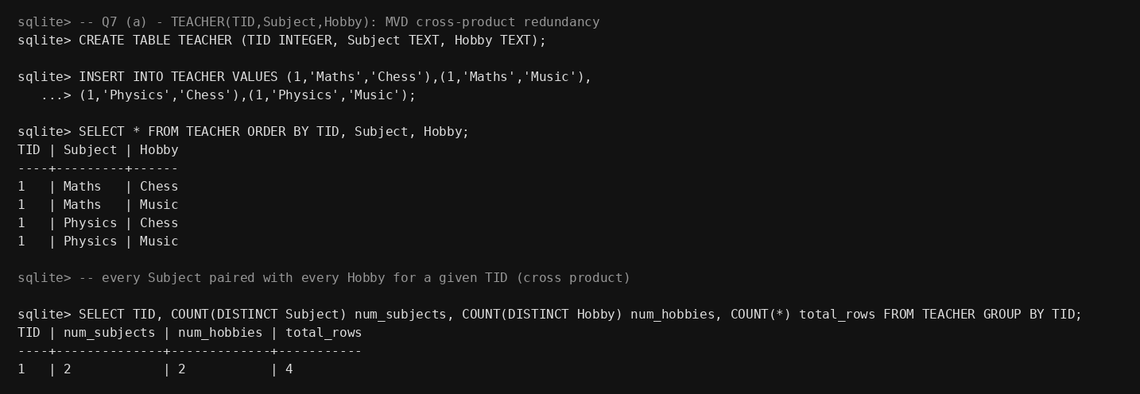

Step 2: Decompose to 4NF
- TEACHER_SUBJECT(TID, Subject)
- TEACHER_HOBBY(TID, Hobby)
Each MVD is now isolated in its own relation, eliminating the redundant cross-product of subjects and hobbies. Adding a new hobby for a teacher now means one row in TEACHER_HOBBY, not one new row per existing subject.
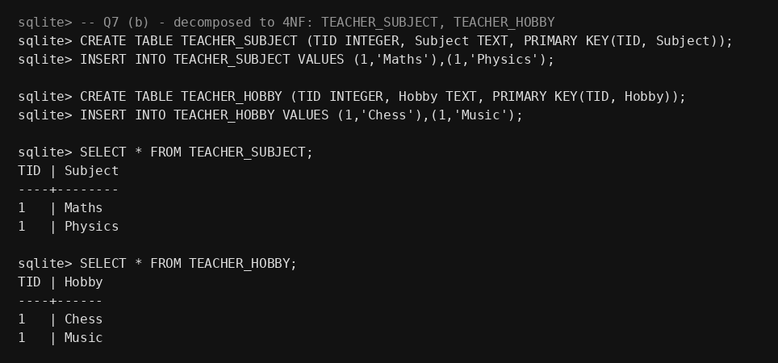

Q8. Join Dependencies and 5NF

Concept
A join dependency JD(R1, R2, ..., Rn) holds on R if R is always equal to the natural join of R1..Rn. A relation can be in 4NF yet still hold redundancy caused by a join dependency that isn't implied by any candidate key — this is exactly what 5NF (Project-Join Normal Form) eliminates.

Example: SUPPLY(Agent, Company, Product)
Business rule: "if agent A represents company C, company C makes product P, and agent A sells product P somewhere, then A supplies P for C." This is a genuine 3-way (ternary) relationship that cannot be losslessly captured by any 2-way decomposition — it requires all three pairwise projections together.
- R1(Agent, Company)
- R2(Company, Product)
- R3(Agent, Product)
The demonstration below rejoins all three projections and reproduces the original SUPPLY table exactly (no spurious tuples), confirming the ternary join dependency and validating the 5NF decomposition. A naive two-table split (say, just R1 and R2) would not carry this constraint and could reintroduce a combination that never actually happened.
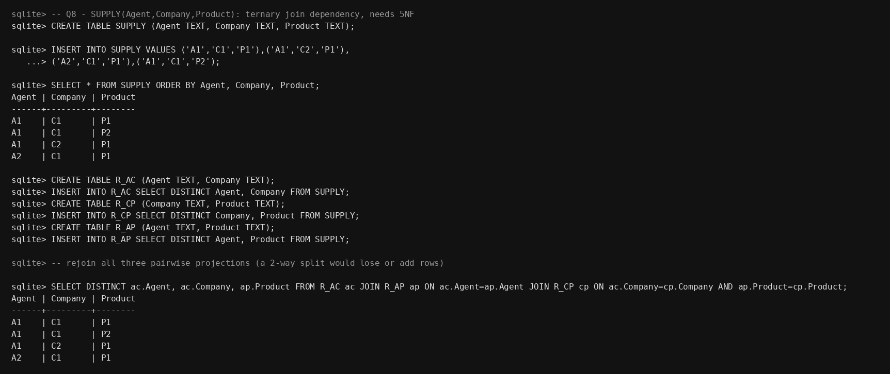

Q9. Anomalies in a Poorly Designed College Schema — Normalize to 3NF

Step 1: Identify anomalies in the unnormalized design
COLLEGE(StudID, StudName, DeptID, DeptName, HOD, CourseID, CourseName) mixes student, department, and course facts into one relation.
- Insertion anomaly: a new department cannot be recorded until at least one student enrolls in one of its courses.
- Deletion anomaly: deleting the only student record for a department also erases that department's DeptName and HOD.
- Update anomaly: since DeptName/HOD are repeated on every course row for a department, updating the HOD requires touching every matching row — miss one, and the data becomes inconsistent.
The demonstration below updates HOD on only one row and shows the resulting inconsistency.
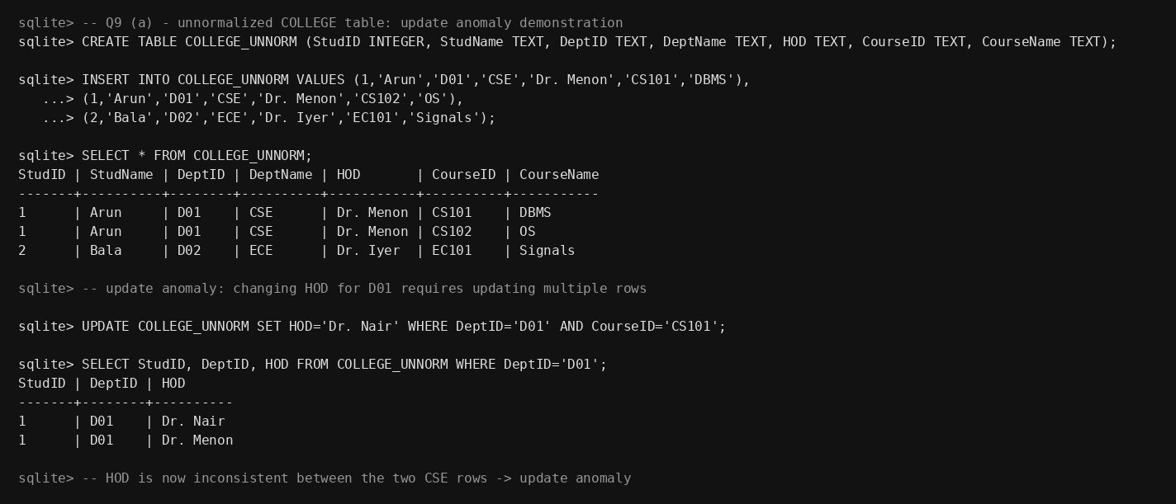

Step 2: Normalize to 3NF
- STUDENT(StudID, StudName, DeptID)
- DEPARTMENT(DeptID, DeptName, HOD)
- COURSE(CourseID, CourseName, DeptID)
- ENROLL(StudID, CourseID) — resolves the many-to-many student↔course relationship
HOD is now stored exactly once per department, so a single UPDATE on DEPARTMENT fixes it everywhere with no inconsistency, as shown below. The ENROLL table also fixes the insertion anomaly, since a department and its courses can exist before any student enrolls.
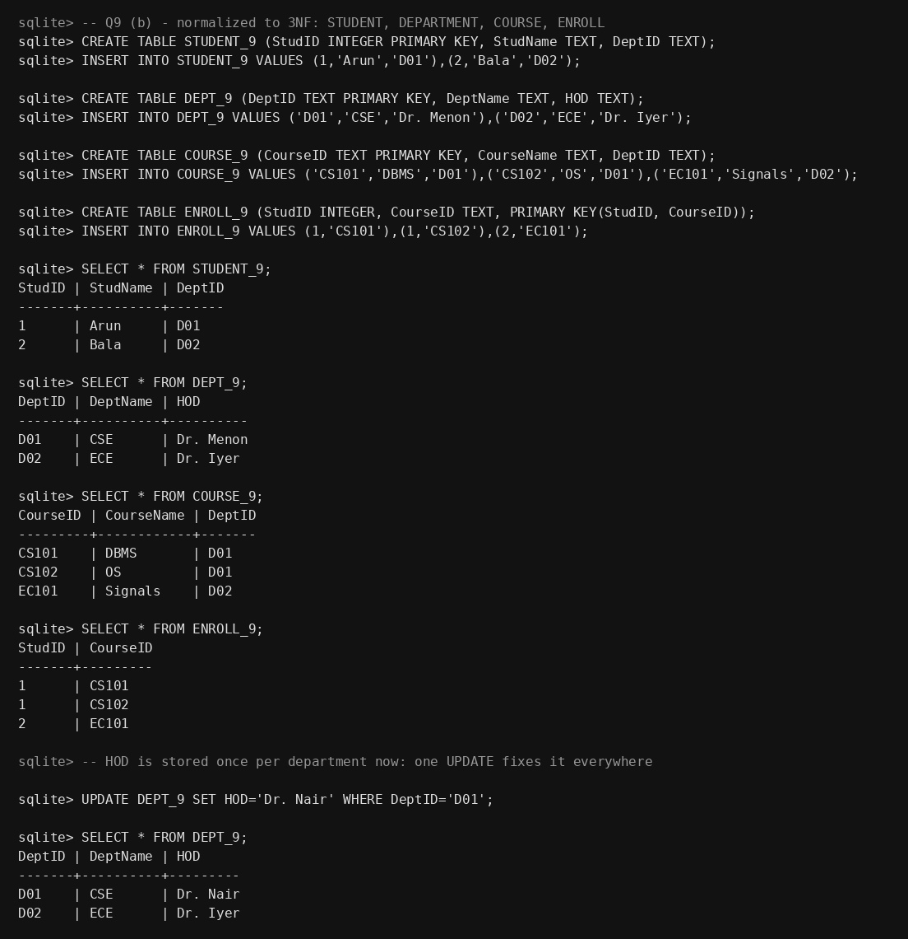

Q10. Attribute Closure and Candidate Keys

Relation and FDs
R(A,B,C,D,E) with FDs: A→B, B→C, C→D, D→E

Closure algorithm
For each attribute set X, start result = X, then repeatedly apply any FD whose left side is already inside result, adding its right side, until no more attributes can be added.
Computing the closure of every single attribute shows that only A+ expands (via the chain A→B→C→D→E) to cover all five attributes, so only A is a superkey among the singletons; the others' closures fall short.
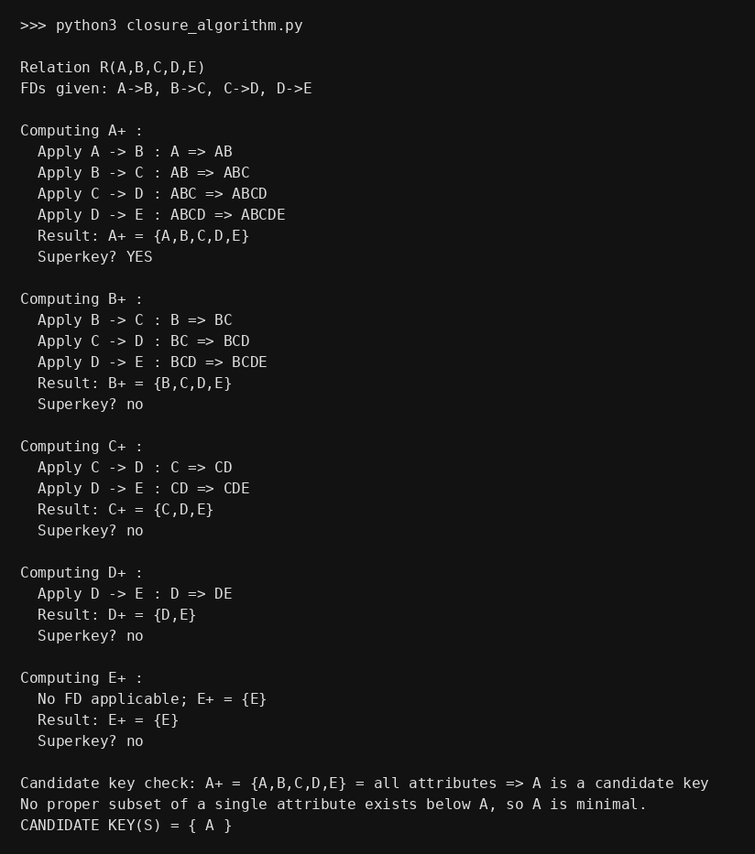

Conclusion
Candidate Key = { A }. Since A+ = {A,B,C,D,E} (all attributes) and no proper subset of {A} (i.e. the empty set) achieves this, A is both a superkey and minimal — hence a candidate key. B, C, D, E are non-prime attributes. Because the FDs form a single chain (A→B→C→D→E), this relation also happens to already satisfy 3NF and BCNF, with no further decomposition needed.

