# User Guide

1. Open PassportScanner.exe. (Recommended as Administrator)
2. Select device and click connect.

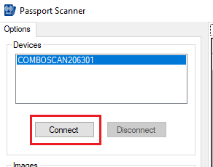

1. First time on opening page ,,Prezenta la vot,, allow the notification like in the example bellow.

