1. Feladat

|  |  |  |  |  |  |
| --- | --- | --- | --- | --- | --- |
| FCFS | Érkező | CPU idő | Indulás | Befejezés | Várakozás |
| p1 | 0 | 3 | 0 | 3 | 0 |
| p2 | 1 | 8 | 3 | 11 | 2 |
| p3 | 3 | 2 | 11 | 13 | 8 |
| p4 | 9 | 20 | 13 | 33 | 4 |
| p5 | 12 | 5 | 33 | 38 | 21 |
|  |  |  |  | Átl.: | 7 |

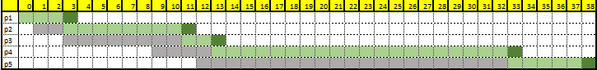

|  |  |  |  |  |  |  |
| --- | --- | --- | --- | --- | --- | --- |
| Érkezés | CPU idő | Indulás | Befejezés | Várakozás | Legrövidebb |  |
| 0 | 3 | 0 | 3 | 0 | p3 | 1 |
| 1 | 5 | 5 | 10 | 4 | p4 | 3 |
| 3 | 2 | 3 | 5 | 0 | p2 | 2 |
| 9 | 5 | 10 | 15 | 1 | p5 | 4 |
| 12 | 5 | 15 | 20 | 3 |  | 5 |
|  |  |  | Átl.: | 1,6 |  |  |

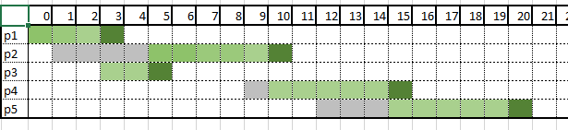

|  |  |  |  |  |  |  |
| --- | --- | --- | --- | --- | --- | --- |
| RR: 5ms | Érkezés | CPU idő | indulás | Befejezés | Várakozás | Várakozó proc |
| p1 | 0 | 3 | 0 | 3 | 0 | p2 |
| p2 | 1 | 8 | 3, 20 | 8, 23 | 14 |  |
| p3 | 3 | 2 | 8 | 10 |  |  |
| p4 | 9 | 20 | 10, 23 | 15, 30 | 1 |  |
| p5 | 12 | 5 | 15 | 20 | 3 |  |

