Environment monitoring

IOT

**Problem** **Statement** :

Map plotted of Earth quake

**Problem** **Definition** :

The advancement of hardware and software technologies makes it possible to use smartphones or Internet of things for monitoring environments in realtime. In recent years, much effort has been made to develop a smartphone based earthquake early warning system, where low-cost acceleration sensors inside a smartphones are used for capturing earthquake signals. However, because a smartphone comes with a powerful CPU, spacious memory, and several sensors, it is waste of such resources to use it only for detecting earthquakes. Furthermore, because a smartphone is mostly in use during the daytime, the acquired data cannot be used for detecting earthquakes due to human activities. Therefore, in this article, we introduce a stand-alone device equipped with a low-cost acceleration sensor and least computing resources to detect earthquakes. To that end, we first select an appropriate acceleration sensor by assessing the performance and accuracy of four different sensors. Then, we design and develop an earthquake alert device. To detect earthquakes, we employ a simple machine learning technique which trains an earthquake detection model with daily motions, noise data recorded in buildings, and earthquakes recorded in the past. Furthermore, we evaluate the four acceleration sensors by recording two realistic earthquakes on a shake-table. In the experiments, the results show that the developed earthquake alert device can successfully detect earthquakes and send a warning message to nearby devices, thereby enabling proactive responses to earthquakes

**Design** **thinking** :

Related Work

In this section, we introduce the background technologies used in this work and the relevant

projects that are somehow related to or have inﬂuenced our work.

In the past few years, seismologists have adopted smartphones or low-cost acceleration sensors to

detect earthquakes. In this regard, Myshake is one of the most recent contributions which utilizes the

smartphone as an earthquake detection sensors The sensor captures the data from the user’s

phone using MyShake application and then process that data by using artiﬁcial neural network for

earthquake detection. If the algorithm detects any earthquake like signals then it sends that timestampt

data to the server. MyShake application runs on volunteers’ smartphones and they are asked to

install the application. It is the ﬁrst world-wide earthquake alert system using smartphone sensors.

However, because MyShake heavily relies on the volunteers smartphones, when the smartphones

are in active mode, they cannot be used as a seismic station or earthquake detector. In addition,

the earthquake detection model trained using earthquakes and human activities can be good enough

to distinguish earthquakes from human activities but cannot detect earthquakes from various types of

tremors generated from buildings

## Approach:

This section, we discuss our earthquake alert device. To develop the earthquake alert device,we ﬁrst compare several acceleration sensors and then provide benchmark results to select anappropriate sensor used for detecting earthquakes as a stand-alone sensor. Then, the implementationdetails of the earthquake alert device including hardware and software systems will be provided.The overview of our proposed earthquake detection and response system is shown in Figure 1.Because the earthquake alert device operates as a stand-alone device, it does collaborate with otherearthquake alert devices or servers for further processing. However, we maintain a database server to preserve earthquake events

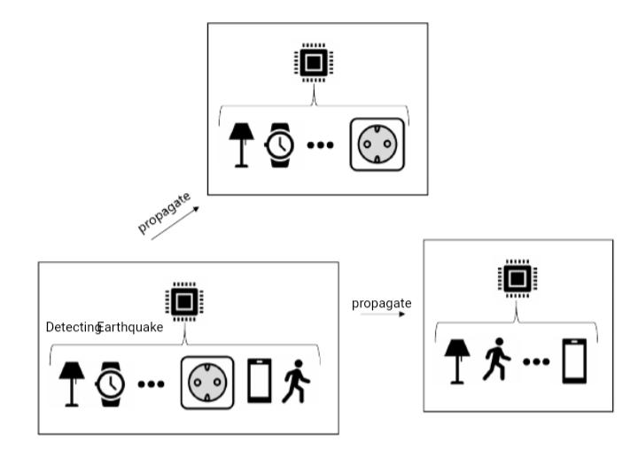The system overview