Art John T. Amaro

I102

Final Lab Task 5

   Using SQL views and Stored Procedures   
and Stored Functions

TASK 1 QUERY:

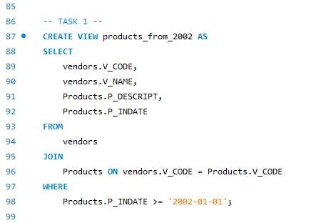

TASK 1 OUTPUT:

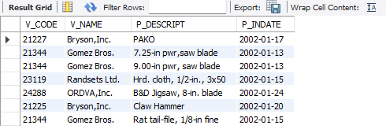

TASK 2 QUERY:

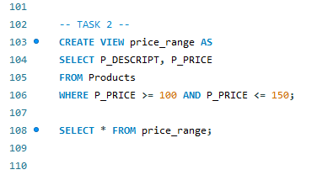

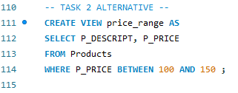

TASK 2 OUTPUT:

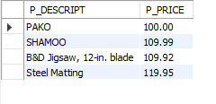

TASK 3 QUERY:

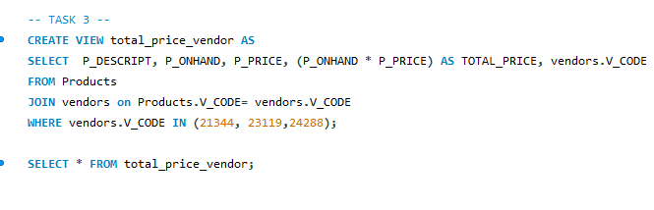TASK 3 OUTPUT:

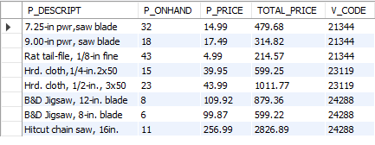

TASK 4 QUERY:

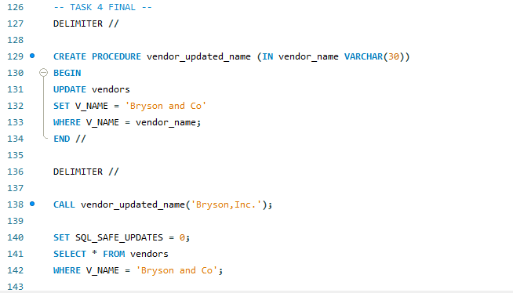

TASK 4 OUTPUT:

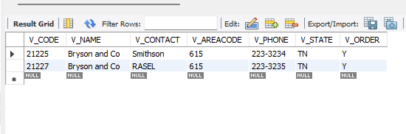

TASK 5 QUERY:

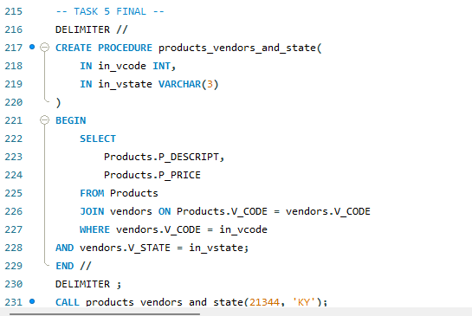

TASK 5 OUTPUT:

