# Yeast_ACDC Installation:

1. Download and install (with default settings) “Miniconda” for Python 3.8 from here <https://docs.conda.io/en/latest/miniconda.html>
2. Download and install “GitHub Desktop” from here <https://desktop.github.com/>
3. Open “GitHub Desktop” and click on “Sign in to GitHub.com”. This will open a browser tab where you can Login to your GitHub account. **NOTE**: not all browsers are supported. Makes sure that you login onto a supported browser. I think the only one not being supported is Internet Explorer, but if your browser is not supported you will get a message. If the automatically opened browser is a non-supported one you have to change the default browser in your OS settings (in Windows type in the search “Default Apps” and change the default Web Browser) and the click again on “Sign in to GitHub.com” in “GitHub Desktop”. If the default browser was changed successfully now GitHub Desktop should open in the default browser.
4. If the login was successful, “GitHub Desktop” should now look like this:

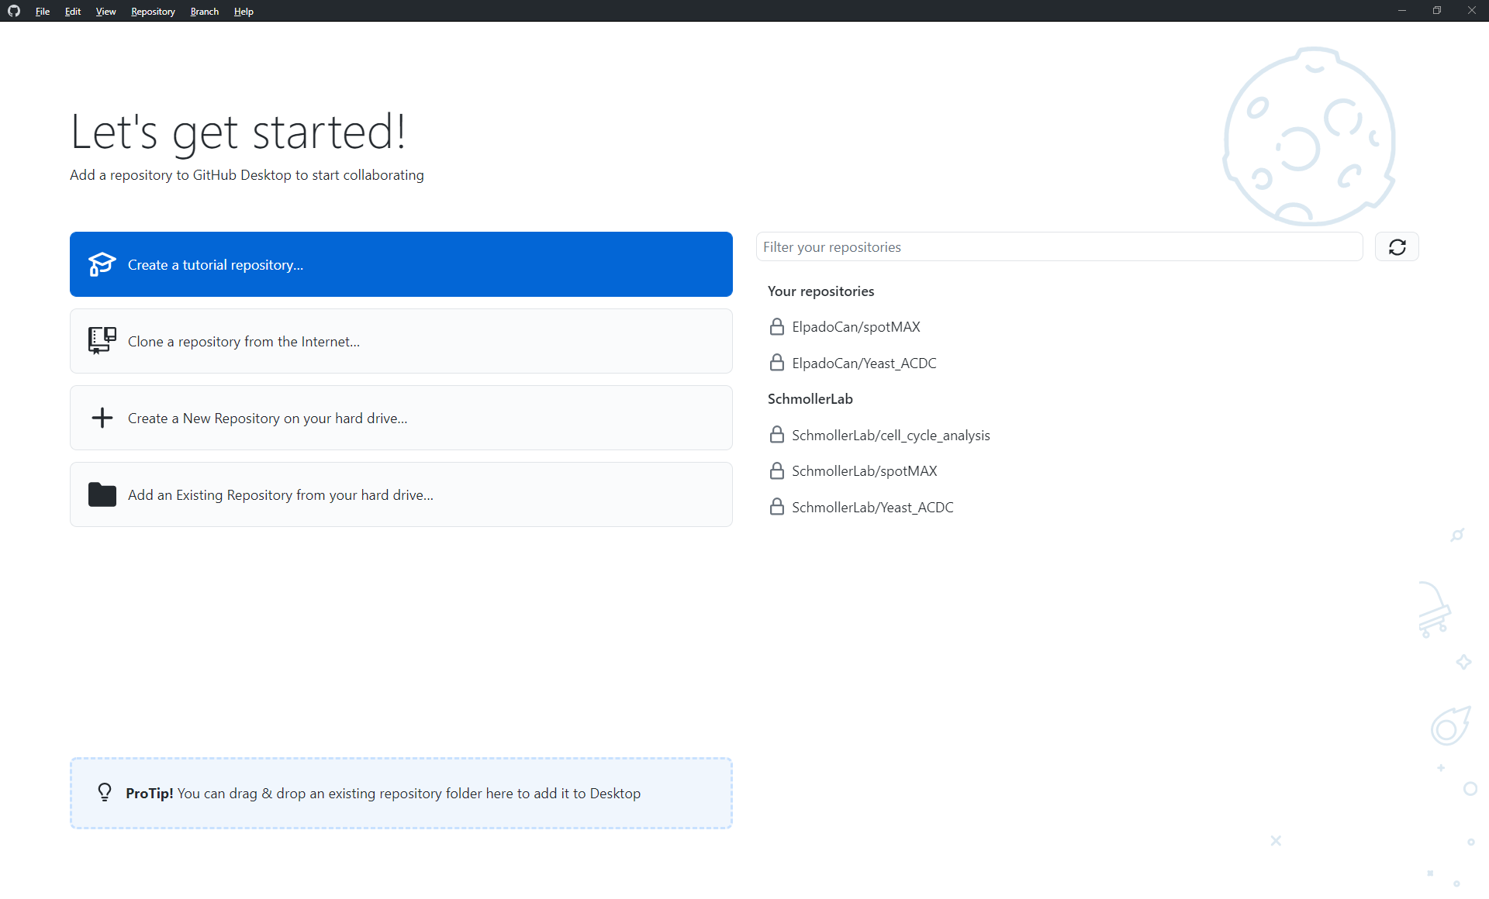

1. Click on “SchmollerLab/Yeast_ACDC” and then “Clone SchmollerLab/Yeast_ACDC” (bottom-right)
2. In the “Local path” choose where you want to install ACDC and then clone.

1. Close GitHub desktop
2. Open “Anaconda prompt”. In Windows you should be able to just search it

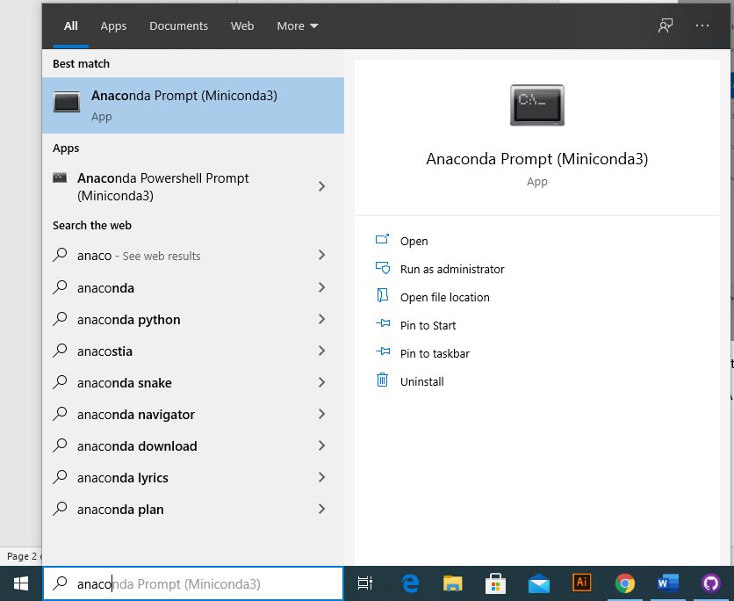

1. In the Anaconda Prompt you have to navigate first to Yeast_ACDC location. To navigate to a specific folder type cd "<insert-path-here>" so in my example would be cd " G:\My Drive\01_Postdoc_HMGU\Python_MyScripts\MIA\Git\Yeast_ACDC" and press “Enter”. Note that if you have to change drive letteryou first change the letter by typing G: and then you can cd to specific G: subfolder. If successful, the path should have changed

1. Now we are ready to install Python and all the modules required for Yeast_ACDC. This is all automatically managed by Anaconda. Python and the packages will be installed in a folder called “envs” where Anaconda was installed (in my case for example it is “C:\Users\LaboSchmoller\Miniconda3\envs”. Note that if you don’t have environments installed yet the folder “envs” might be not existing yet). This is the best-practice for any new Python project. Always create a new environment for each new Python project.

For Yeast_ACDC we provide a pre-configured environment file. To install the environment, type conda env create -f acdc.yml and press “Enter”. This process will take several minutes depending on the speed of your internet connection.

# Preparing your data for Yeast_ACDC:

1. Yeast_ACDC automatically upload all the data it needs, but it needs it with a specific structure. To facilitate the creation of this structure we provide Fiji (ImageJ) scripts that automatically structure the data from any microscopy file (.czi, .nd2, .tif etc.). So first, if you don’t have Fiji install it from here <https://imagej.net/software/fiji/>
2. Extract the content of the downloaded Fiji folder and run “Fiji.app/ ImageJ-win64”
3. File 🡪 Open and select either “frames_to_tifs.ijm” or “snapshots_to_tifs.ijm” file from “/Yeast_ACDC/FijiMacros/” folder.
4. Before running the macro you have to edit the channels. At line 3 modify the “channels” variable by writing a name for each channel in your file. They need to be in the exact same order they are in the original microscopy file. If you don’t know the order, open the file in Fiji first and check the order of the channels there.
5. Run the script with the Run button. The script will ask you to select a folder containing the microscopy files (create a specific experiment folder for each different set of files). Select the folder (it MUST contain ONLY the microscopy files) and wait. You can see the progress in the Log Window. The script will silently open the microscopy files and save each Position (if the file contains multiple positions) into a separate folder. This is the structure that Yeast_ACDC requires for automatic loading of the relevant files.

# Running Yeast_ACDC:

1. To run Yeast_ACDC we use the Anaconda prompt again.

In the prompt type conda activate acdc (note in the prompt that the environment changed from “base” to “acdc”)

1. Navigate to ACDC folder as in point 9 and then we navigate to “src” sub-folder by typing cd src
2. Now we can run Yeast_ACDC by typing python acdc_yeaz.py or python gui.py