Tokens

Tokens are made from Imported Acrylic which has been further processed and laser cut according to our requirements and we have integrated a notch on the right of every token which helps the visually impaired children

The Token Design is shown below for reference

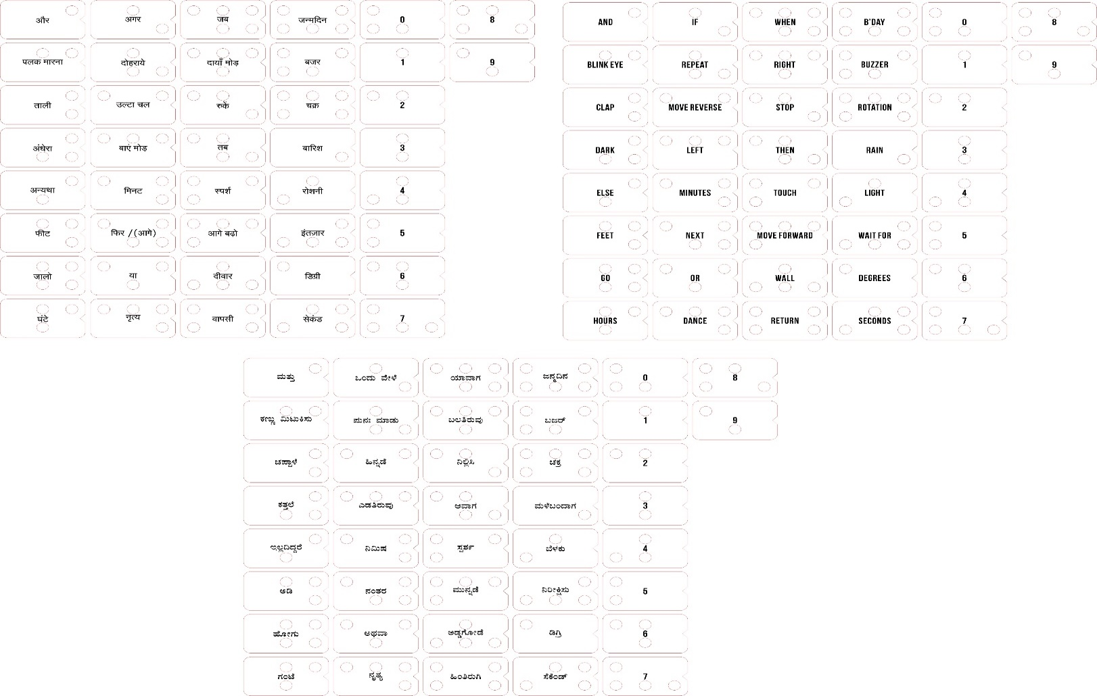

Our tokens are available in three different languages: Hindi, Kannada & English

These tokens are placed on slate in the order which you want the program to run then slide “The slider” on top of it from left hand side to the right which then sends the same information to the Arduino which does the compilation work and will then transmits this program using the 433Mhz RF module to the bot where it executes the same

Slider consists of two parts: IR transmitter array & IR receiver array. These two are arranged in such a way that both slide on the slate at the top and bottom at the same time. When scanning has started the transmitter sends the IR rays and receiver receives the IR from the hole arrangement made on the tokens And then based on the matrix of data received from the slider, the controller coverts this data into the pre programmed keywords which is then sent to the RF transmitter which then send it to the bot

Braille combinations and details

We have taken alphabets and characters from braille and assigned it to our keywords that are being used in our product so that as soon as they read a letter from the token then with the help of the Helper sheet (given below)they should be able to know what is the keyword that is assigned to it

|  |  |  |  |  |
| --- | --- | --- | --- | --- |
| S.no | Assigned character | braille | keyword | braille |
| 1 | a | ⠁ | and | ⠁⠝⠙ |
| 2 | b | ⠃ | blink eyes | ⠃⠇⠊⠝⠅⠀⠑⠽⠑⠎ |
| 3 | c | ⠉ | clap | ⠉⠇⠁⠏ |
| 4 | d | ⠙ | dark | ⠙⠁⠗⠅ |
| 5 | e | ⠑ | else | ⠑⠇⠎⠑ |
| 6 | f | ⠋ | feet | ⠋⠑⠑⠞ |
| 7 | g | ⠛ | go | ⠛⠕ |
| 8 | h | ⠓ | hours | ⠓⠕⠥⠗⠎ |
| 9 | i | ⠊ | if | ⠊⠋ |
| 10 | j | ⠚ | repeat | ⠗⠑⠏⠑⠁⠞ |
| 11 | k | ⠅ | move reverse | ⠍⠕⠧⠑⠀⠗⠑⠧⠑⠗⠎⠑ |
| 12 | l | ⠇ | left | ⠇⠑⠋⠞ |
| 13 | m | ⠍ | minutes | ⠍⠊⠝⠥⠞⠑⠎ |
| 14 | n | ⠝ | next | ⠝⠑⠭⠞ |
| 15 | o | ⠕ | or | ⠕⠗ |
| 16 | p | ⠏ | Dance | ⠠⠙⠁⠝⠉⠑ |
| 17 | q | ⠟ | when | ⠺⠓⠑⠝ |
| 18 | r | ⠗ | right | ⠗⠊⠛⠓⠞ |
| 19 | s | ⠎ | stop | ⠎⠞⠕⠏ |
| 20 | t | ⠞ | then | ⠞⠓⠑⠝ |
| 21 | u | ⠥ | touch | ⠞⠕⠥⠉⠓ |
| 22 | v | ⠧ | move forward | ⠍⠕⠧⠑⠀⠋⠕⠗⠺⠁⠗⠙ |
| 23 | w | ⠺ | wall | ⠺⠁⠇⠇ |
| 24 | x | ⠭ | return | ⠗⠑⠞⠥⠗⠝ |
| 25 | y | ⠽ | bday | ⠃⠙⠁⠽ |
| 26 | z | ⠵ | buzzer | ⠃⠥⠵⠵⠑⠗ |
| 27 | and | ⠯ | rotations | ⠗⠕⠞⠁⠞⠊⠕⠝⠎ |
| 28 | ^ | ⠢ | light | ⠇⠊⠛⠓⠞ |
| 29 | # | ⠹ | wait for | ⠺⠁⠊⠞⠀⠋⠕⠗ |
| 30 | @ | ⠈⠁ | rain | ⠗⠁⠊⠝ |
| 31 | ed | ⠫ | seconds | ⠎⠑⠉⠕⠝⠙⠎ |
| 32 | apostrophe' | ⠄ | degrees | ⠙⠑⠛⠗⠑⠑⠎ |
| 33 | " | .: | 0 | ⠼⠚ |
| 34 | , | ⠂ | 1 | ⠼⠁ |
| 35 | ; | ⠆ | 2 | ⠼⠃ |
| 36 | : | ⠒ | 3 | ⠼⠉ |
| 37 | . | ⠲ | 4 | ⠼⠙ |
| 38 | - | ⠤ | 5 | ⠼⠑ |
| 39 | ! | ⠖ | 6 | ⠼⠋ |
| 40 | number sign | ⠼ | 7 | ⠼⠛ |
| 41 | the | ⠮ | 8 | ⠼⠓ |
| 42 | * | ⠔ | 9 | ⠼⠊ |