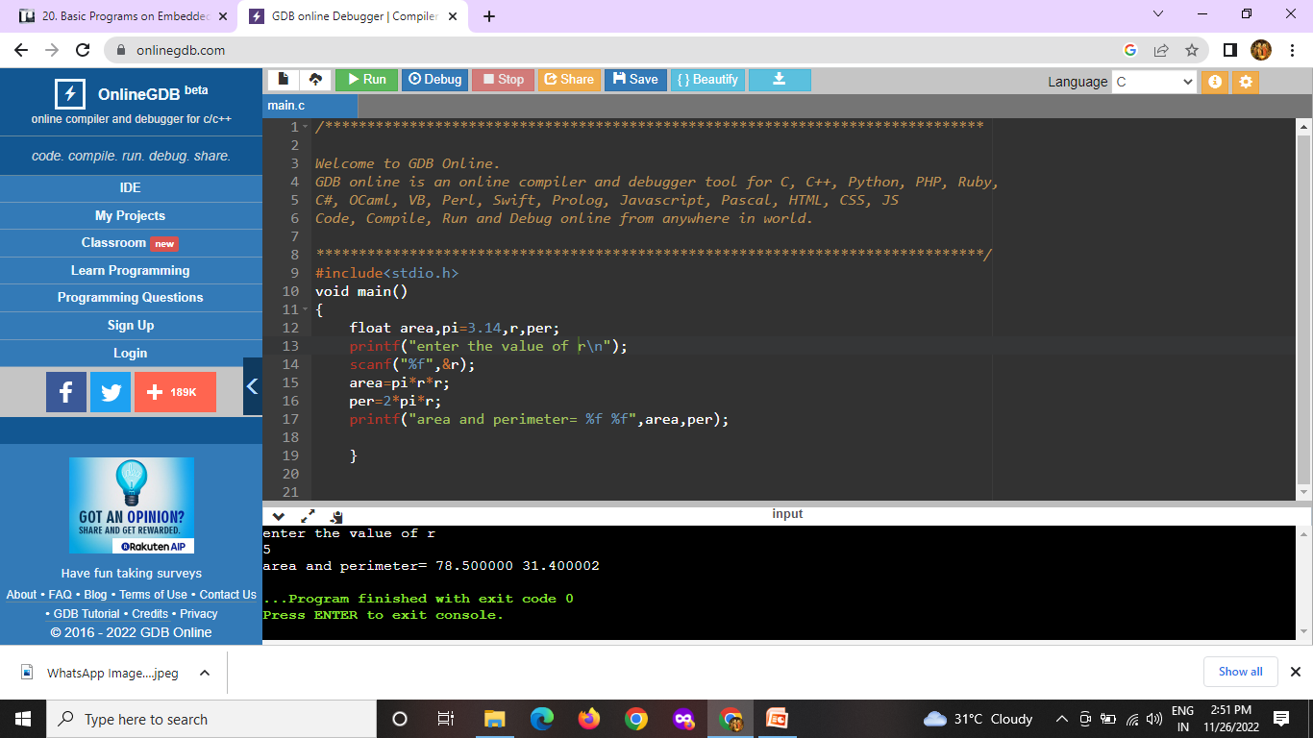

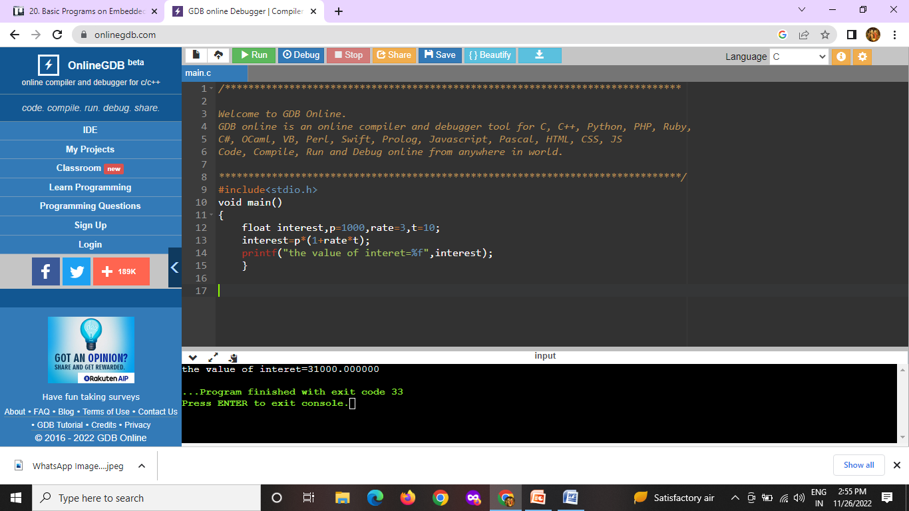

1)area and perimeter

#include<stdio.h>

void main()

{

float area,pi=3.14,r,per;

printf("enter the value of r\n");

scanf("%f",&r);

area=pi\*r\*r;

per=2\*pi\*r;

printf("area and perimeter= %f %f",area,per);

}

2.simple interest

#include<stdio.h>

void main()

{

float interest,p=1000,rate=3,t=10;

interest=p\*(1+rate\*t);

printf("the value of interest=%f",interest);

}