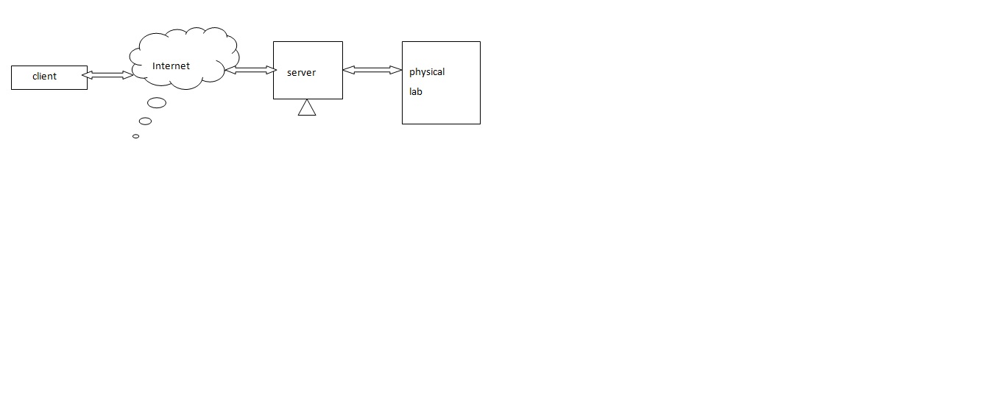

fig: Design of virtual lab

**Circuit designing software tool**:

Using GUI tools in python, a drawing canvas is developed in the form of a grid ,where, the electronic and electrical components can be dragged fron the toolbars and dropped onto a drawing canvas that acts as a breadboard. The connections are made among the components . Every node in the grid is defined by the rectangular coordinate axes .

Whenever a connection is established between the two components, the coordinate axes values at the junction of the two components are loaded to the context/net file. The details of the components used and their specification along with the position(x and y coordinates) are written to the context file. Upon saving the circuit design, a context file is generated and is dumped to a microcontroller or Arduino board through RS232 ,that drives the physical smart breadboard.

**Smart breadboard:**

A smart breadboard is a breadboard consisting of all the electronic and electrical components that are internally connected through relays or analog switches. A microcontroller drives the smart bread board . Based on the data in the context file, the components are automatically switched and connected in the smart breadboard through the signals generated by the microcontroller.