**Virtual Lab**

**Abstract:**

The purpose of this virtual lab project is to enable an user to access the lab which includes hardware from a remote place.

The first version of the project includes 9 setups interfaced to a virtual board which is connected to a virtual machine. Users from a remote place will be connected to a virtual machine via team viewer or any desk. Once the user is connected to a virtual machine, they can control the setups by properly configuring the board.

This project enables the user who is unavailable at the lab to make use of every setups in the lab. This is helpful to a group of users to share a very high cost hardware among them.

**Block diagram**

The following diagram shows a typical block diagram of virtual lab setup.

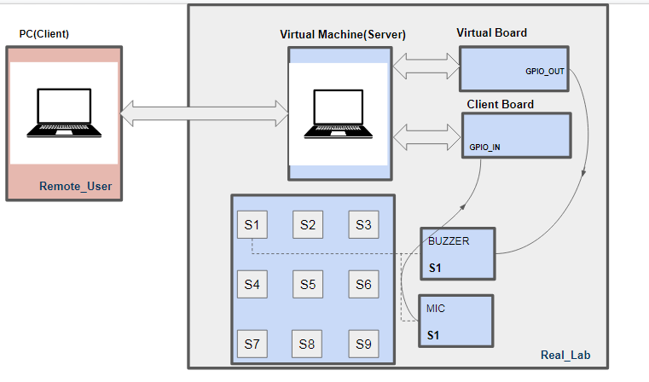

Virtual Lab setup

**PC(client):** This represents an user who is located at a remote place from which he wishes to access the hardware components present in the real lab. This machine is connected to a virtual lab via team viewer or any desk.

Virtual Machine(Server): This represents the machine which is connected to real hardware setups in a real lab. This virtual machine is installed with a user interface to choose the hardware required. The input to the chosen hardware is given from the GUI in the virtual machine similarly the output from the hardware will be displayed in the virtual machine and hence in client PC for the user to check.

**Virtual board:** This is the board to which the hardware to be actuated is connected. The hardware connected to the virtual board is an actuator. Based on the input signal the actuator will run. Ex: In MIC-BUZZER set up, BUZZER is the actuator which will be set using GUI command.

**Client hardware:** This is the board to which the hardware to be sensed the actuator response is connected. The hardware connected to the client board is always a sensor.

Ex: In MIC-BUZZER set up, MIC is the sound sensor which senses the sound of BUZZER and produces corresponding output.

There are about 9 setups are designed in this project, it is shown as below

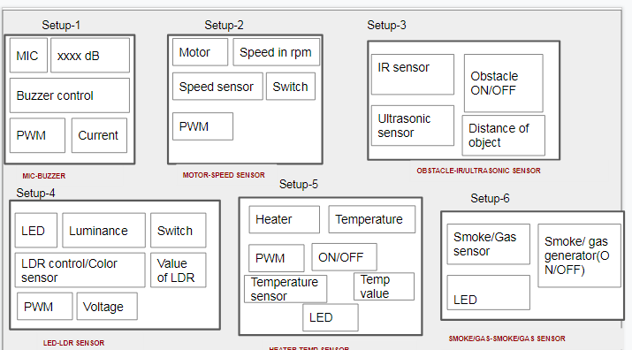

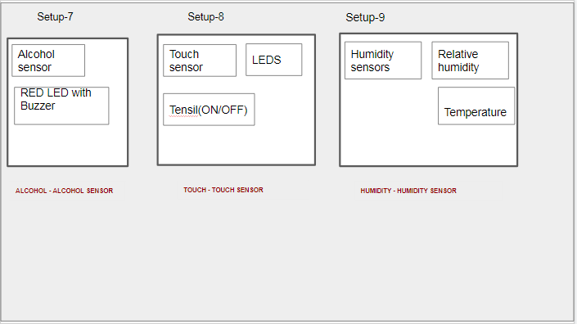

Set ups in real lab

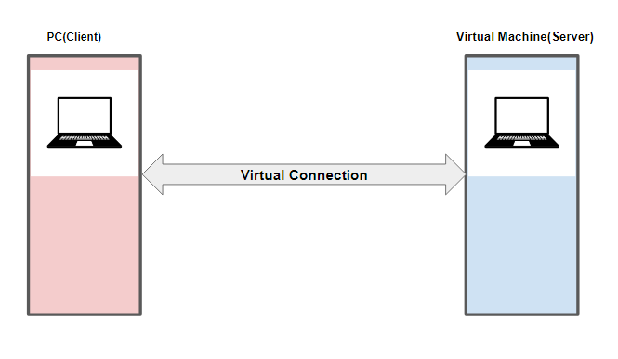Virtual connection between remote user an virtual machine

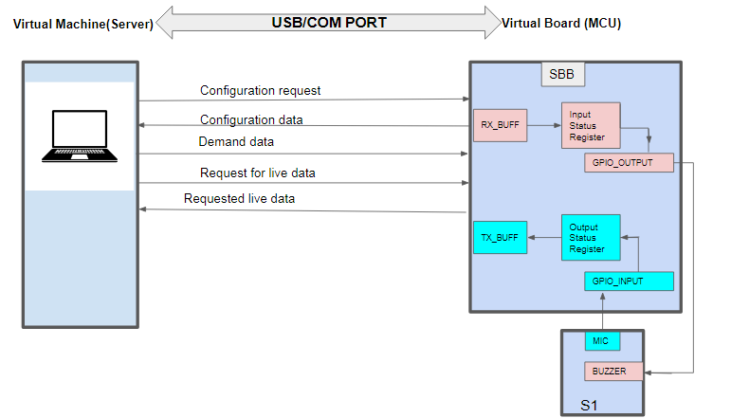

Hand shaking diagram between Virtual machine and Virtual Board

**Message Format**

There are five message frames that exist in the communication between virtual machine virtual boards. The Message format for these five frames is as shown below.

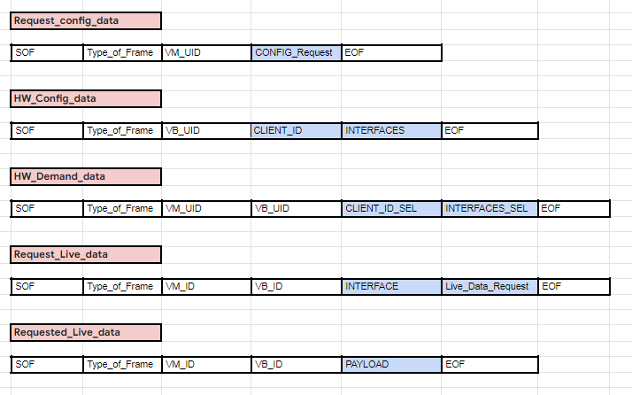

Message format of five frames

1. **Request_config_data**

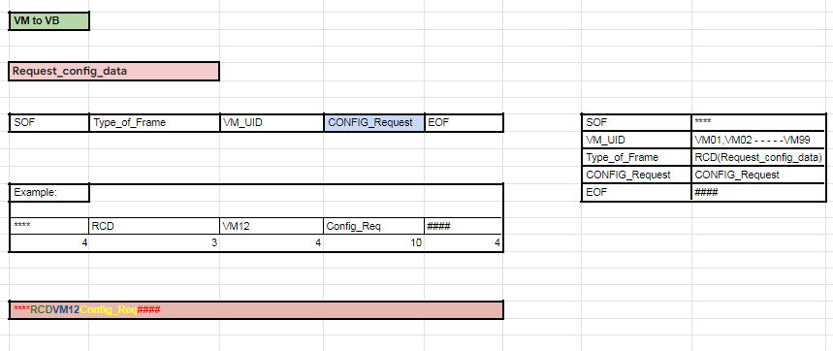

1. **HW_Config_data**

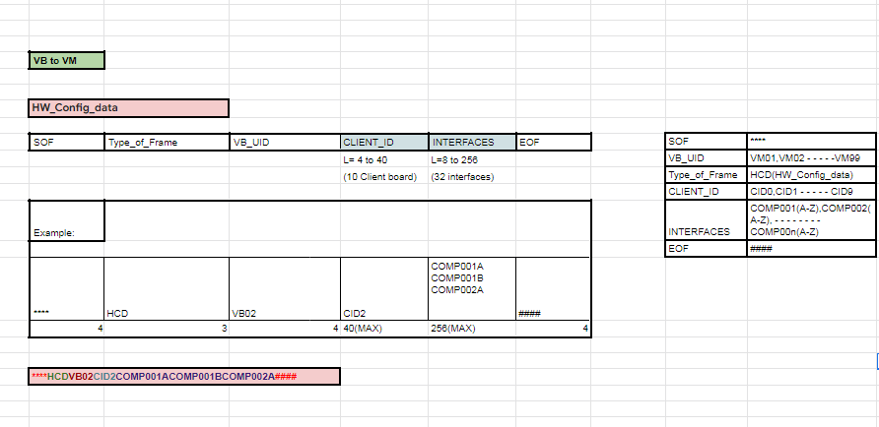

1. **HW_Demand_data**

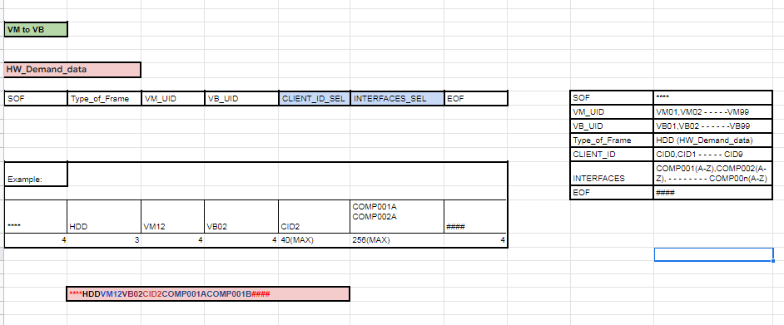

1. **Request_Live_data**

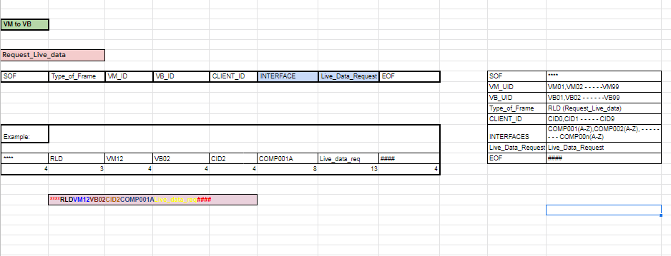

1. **Requested_Live_data**

