1. Create a Client application running on RPI that connects at startup on port 55000 to Server (IP: 192.168.0.100, Port 55000).
2. The client should be able to receive from the server the following data frame of 512 bytes:

* MSG_ID, SEQ_CNT and CRC32 are uint32 types
* PAYLOAD is an array of uint8[500];

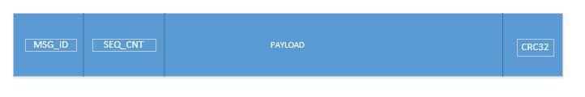

1. The client should be able to store a “synchronized package” of 3 frames (IDs: 1, 2 and 3) based on the SEQ_CNT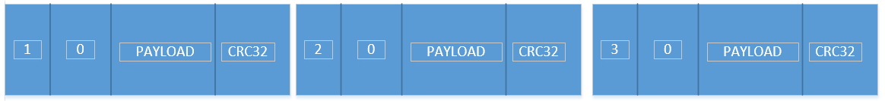
2. The client should be able to store the last 3 synchronized packages, in a circular buffer. The highest SEQ_CNT has the highest priority

* Use the provided Server application, that listens on Port 55000 for any incoming connection. The server will send the data frame with incremental SEQ_CNT for each transmission at on “key press” events as follows:
  + “1” -> data frame with MSG_ID = 1
  + “2” -> data frame with MSG_ID = 2
  + “3” -> data frame with MSG_ID = 3

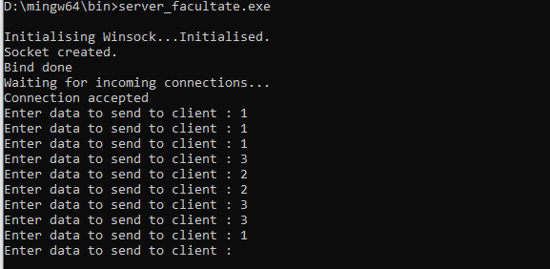

Evaluation:

1. 1p
2. 1p
3. 2p
4. 1p

1p bonus for usage of coding guidelines and robustness of the application