**DuDev – Testing Guide**

**Version 001**

**2021/09/27**

**Testing Pyramid**

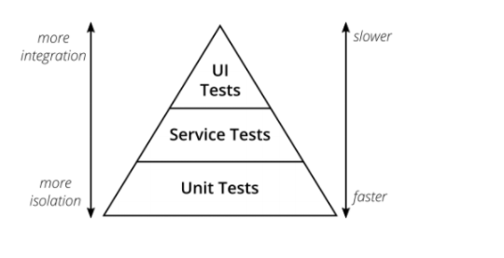

Do simplest test possible 60% should be level 1 Unit Test, 30% Level 2 Service Tests, 10% UI Test

**Backend Python**

Unit Test

Robot framework for most testing

**Front-end**

Robot framework

UI – Selenium / Robot