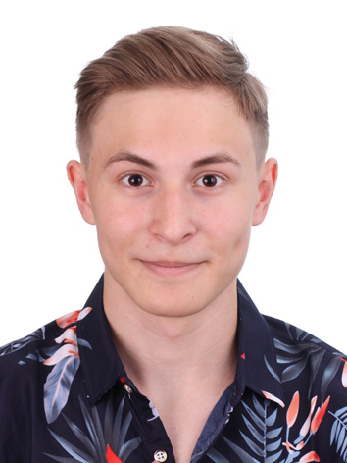 |  | oleksander  liashenko
Personal info  Phone:  +380 095 746 9874  +421 950 426 302  E-mail:  sasha1boss@gmail.com  Telegram:  https://t.me/Dudosinka_38 |  | career objective: Junior Web developer  Skills:  - Proficient in HTML5/CSS (utilizing Bootstrap) for responsive web design  - Strong knowledge of JavaScript and jQuery for dynamic web interactions  - Experienced in building web applications using React.js, including Redux (saga, axios) and Route integration  - Familiar with TypeScript for type-safe JavaScript development  - Experienced in OOP and Java  - In-progress learning of Java and Node.js  - English proficiency: B2 level  experience:  Pet-Project Development | Self-taught | 2022-Present  Demonstrated proactive self-learning by conceptualizing and executing a diverse array of personal pet-projects.  Leveraged HTML5, CSS, JavaScript, jQuery, React.js, and TypeScript to bring creative ideas to life.  Notable projects include:  Wheel of Fortune: Developed a captivating interactive game using JavaScript, HTML, and CSS.  To-Do List: Created a task management application using React and Redux, showcasing proficiency in state management.  Market Page: Designed and implemented an intuitive web page for markets, combining React and JavaScript for enhanced user experiences.  Complex Project with Server: Successfully undertook a substantial project involving server-side development using React and Node.js, highlighting versatility in full-stack development.  Regularly maintained and enhanced projects, refining skills and staying up-to-date with emerging technologies.  And some other projects  Repository showcasing projects: https://github.com/DuDosiNka38?tab=repositories  Education  Student | Technical University of Kosice  [09.2022- Present]  Currently pursuing a Computer Science degree at the prestigious Technical University of Kosice.  Engaging in advanced coursework related to front-end development, enhancing technical proficiency and problem-solving skills.  Student | State University of Telecommunications in Kyiv | [09.2021- Present]  Concurrently enrolled in studies at the State University of Telecommunications in Kyiv.  about me:  - 18-year-old aspiring web developer hailing from Ukraine, Kyiv.  - Relocating to Slovakia due to the unfortunate circumstances of the war in my home country.  - Two years of dedicated self-study in web design and development.  - Enthusiastic about video games, traveling, and sports.  - Possesses strong interpersonal skills and thrives in collaborative team environments.  - Committed to continuous growth and improvement in the field of front-end development.

