Graph Database Project Report

s188026 Yifei Liu

1. Assumption & Business domain

This database records the information of Word Championship (Worlds 2022) of LOL (League of Legends).

It contains all teams (24 teams) attend this tournament, 5-6 professional player in each team, and matched they performed.

It should record important data for each match. Because of time limit and there are hundreds of games totally, I only record 11 games in Quarter Finals (last weekend), 2 game in Play-in, 1 game in Groups.

1. Description
   1. Team

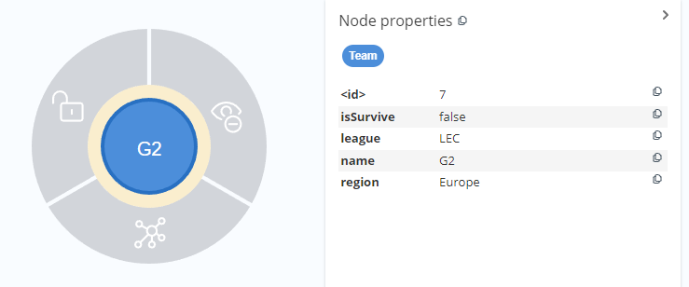

* 1. Player

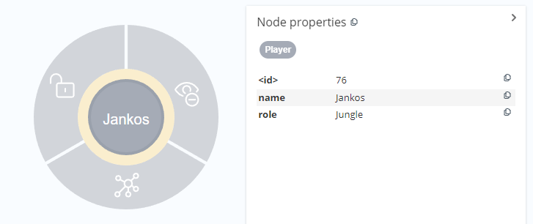

* 1. Match

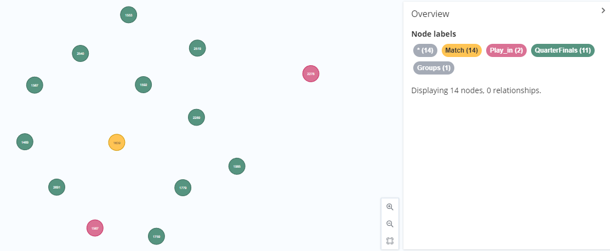

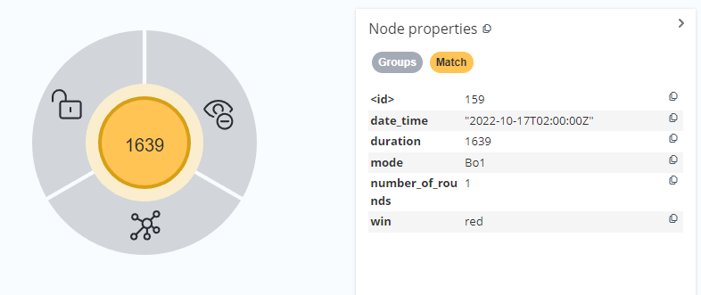

* 1. IS_MEMBER_OF

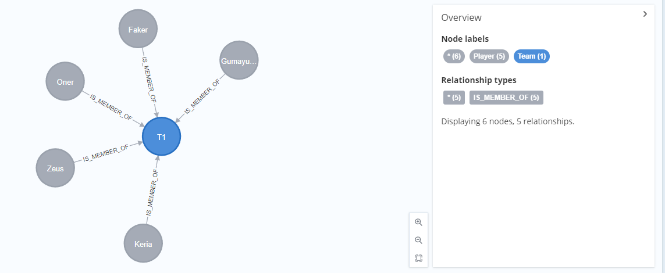

* 1. FIGHT_IN

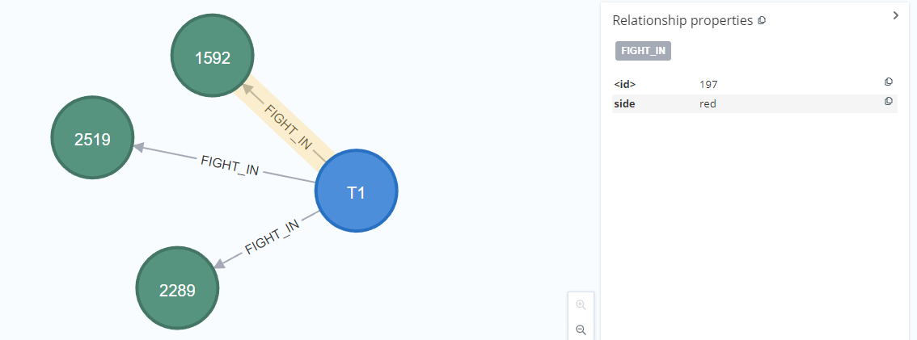

* 1. ATTEND

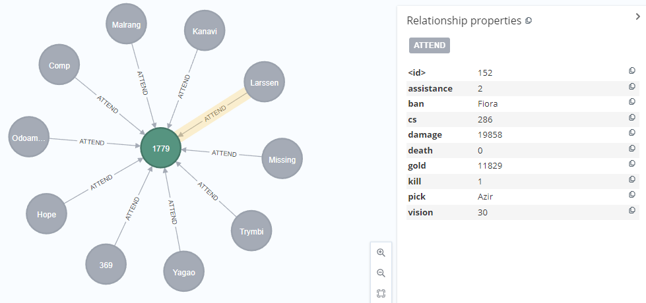

Information:

1. KDA (kill, death, assistance)
2. Ban & Pick (characters be banned and picked)
3. CS (minion killed)
4. Gold
5. Vision score
6. Damage

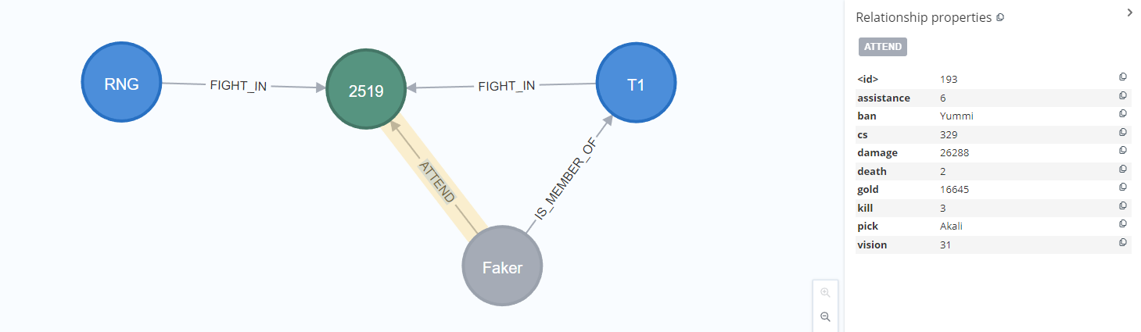

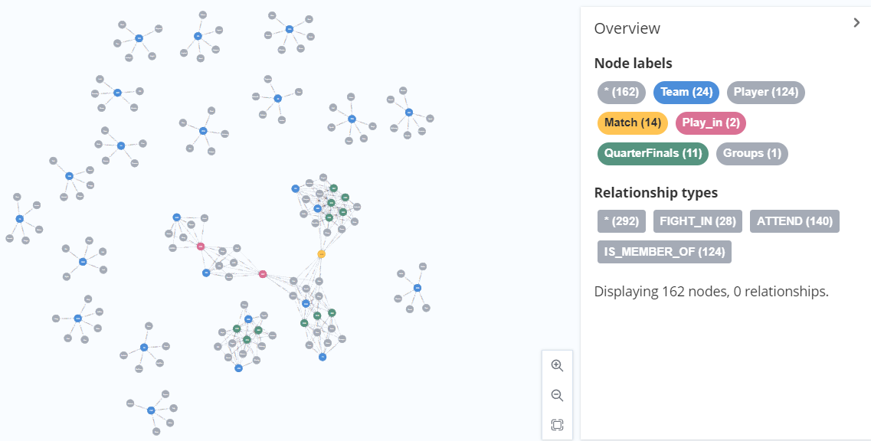

1. Competency queries
2. On Saturday night, Team GEN and Team DK showed a really wonderful performance in 5 games.

In each game, which lane of each team contribute the highest damage for their team?



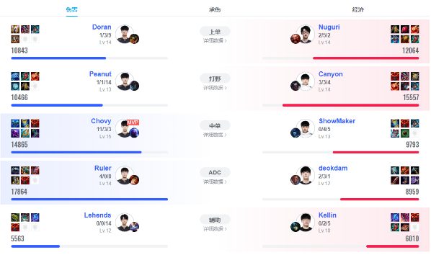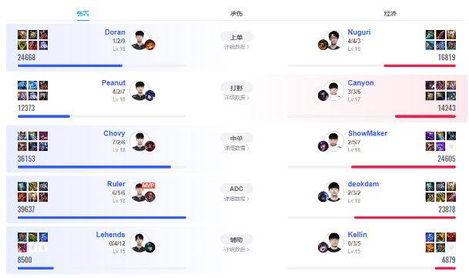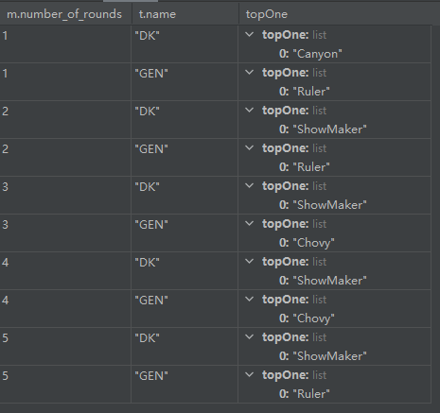

Comparing to the results (round 1 and 5) in the Internet, it is correct.

1. Next week, GEN will fight with DRX. Assume you are coach of DRX, try to find the champion which is picked most frequently by GEN?



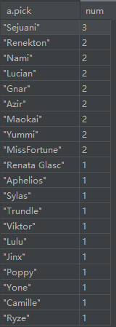

Before next match, you want to analyze which champions are stronger in this patch. So,

1. you want to know which champions were usually be banned?



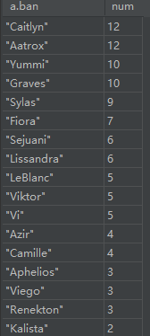

1. you want to know which champions have higher win rate (The champion should be picked more than once)

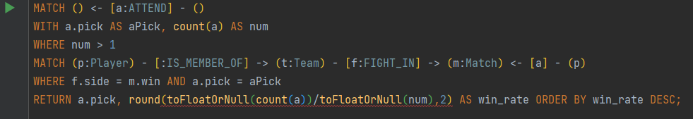

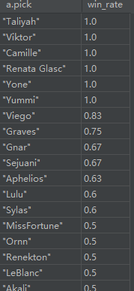

1. Sort the players by DPM (damage per minute) in all games.



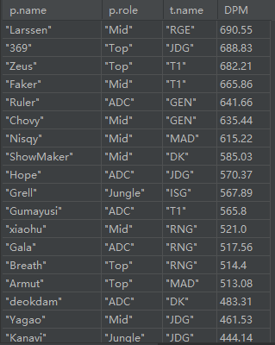

1. Is there big gape of vision score between teams in Quarter Finals and teams which are eliminated in Play-in? Choose MAD and DK to compare here.



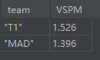

1. Who is the most important role to control vision in a team to except for support? Mid or jungle?



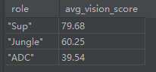

1. According to KDA ((kill + assistance) / death), who is the best player in s12 world championship?



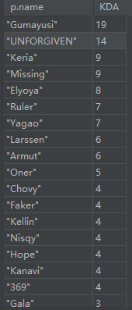

1. Sort the teams by W-L (win-lose).

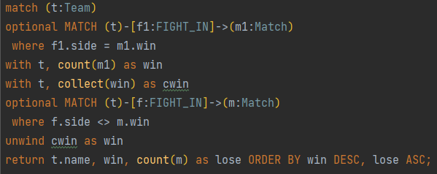

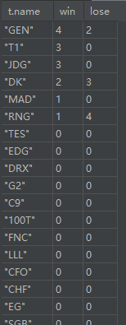

1. showed the attribute of player in radar charts.

attributes:

KDA ((Kill + Assistance)/Death)

DPM (Damage Per Minute)

GPM (Gold Per Minute)

KP% ((Personal Kill + Personal Assistance)/Team Kill)

DMG% (Personal Damage/Team Damage)

Damage Gold Conversion Rate (DMG%/GOLD% * 100%)

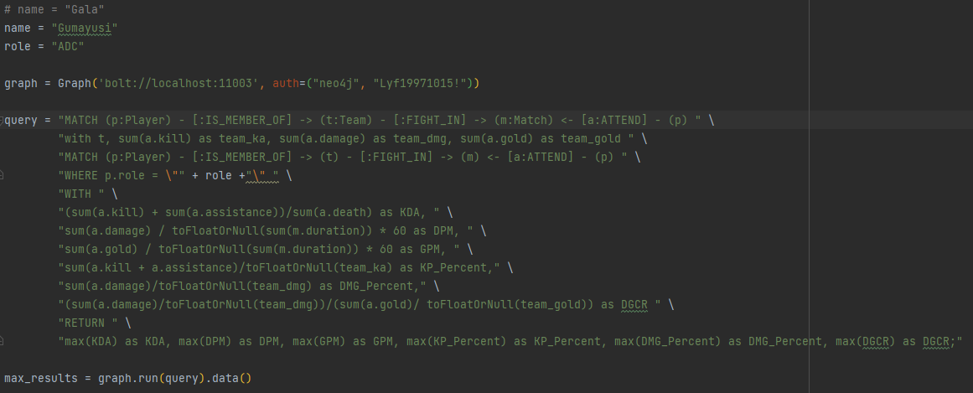

Firstly, Link to get the maximum of each attribute in this role (e.g. ADC here).



Then calculate the coefficient which can help us convert the range of score to 100 points.

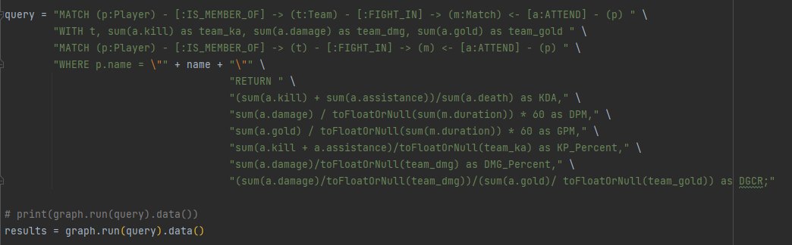

Then calculate the attributes of one player, and use result of query to draw the radar chart.

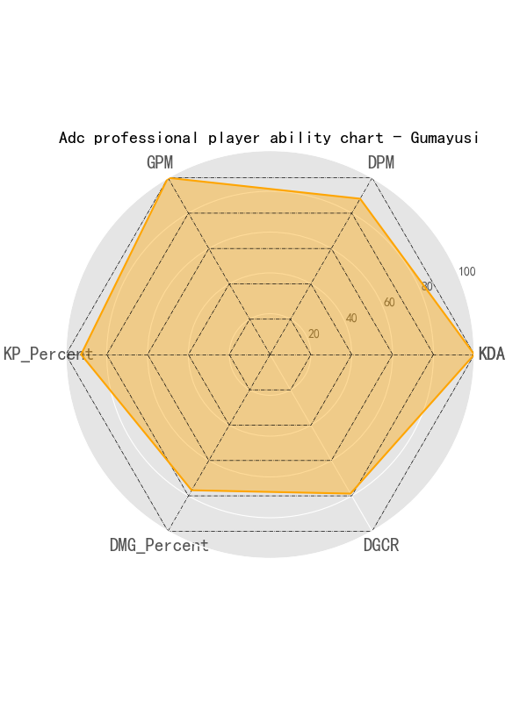 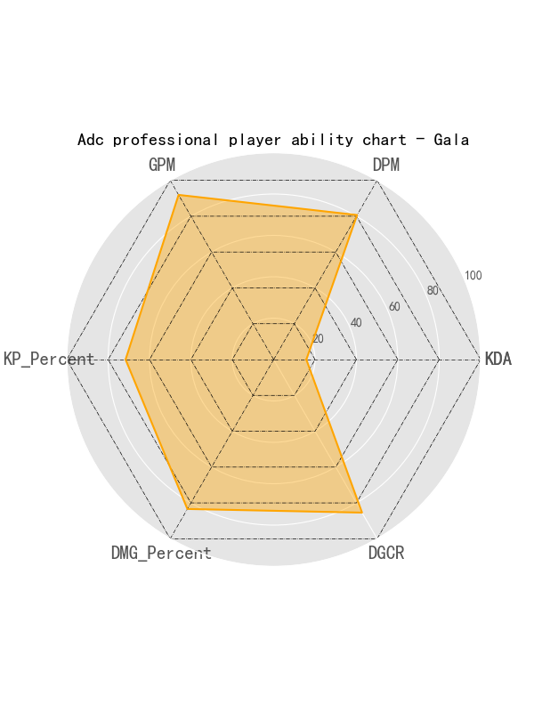

1. Graph analysis
2. Community detection algorithms

Use projection to get a new graph and use **Labeled propagation algorithm** to divide them into different communities.

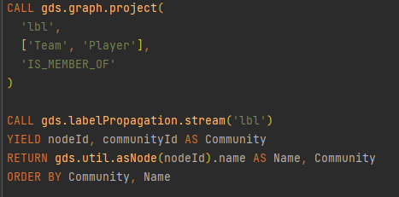

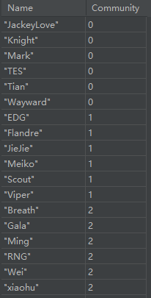

It is understandable that each team and their team members are in the same community.

1. Similarity algorithms

Use **Jaccard similarity** to get the most similar node in all Players to get his team members.

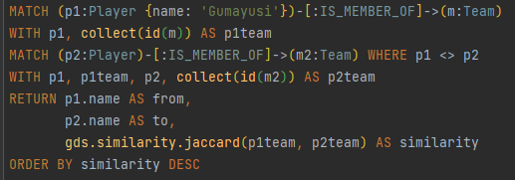

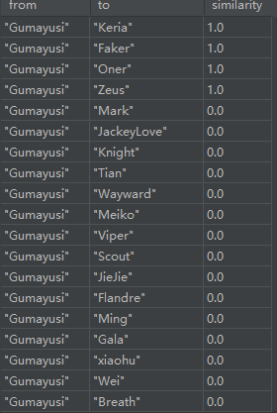

It is also obviously that their team member will have the similarity equal to 1.

1. Centrality algorithms

Use **Degree centrality** to find which team will have more matches than others.

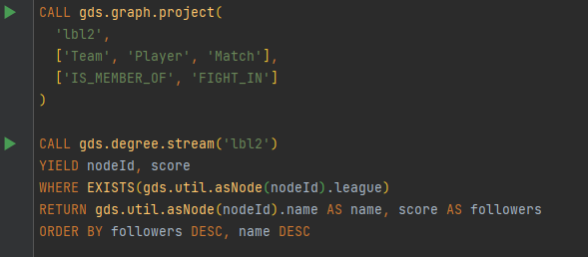

Use Exists attribute {league} to make sure return team nodes and sort the result as followers.

