Junhao Du

**Chat-App Project location:/Junhao Du/Assignment7-Code /** **Chat-App**

**Chat-App Record location: /Junhao Du /** **ChatApp.mp4**

Some important points:

Firstly, We need to approve the wakeLock operation in the manifest. It’s fucking missed in the codes.

<**uses-permission android:name="android.permission.WAKE_LOCK"** />

2nd ly, we need to make sure the ChatServer.jar is running under the JAVA1.8 environment. It’s not compatible with java9 and java10.

3rd ly, We cannot use the default baseURI 127.0.0.1:8080 to access the server. Also we cannot use the address like the following :

<http://DESKTOP-CTNEM40.fios-router.home:8080/>

This address is assigned when it bounds to the server in the log. 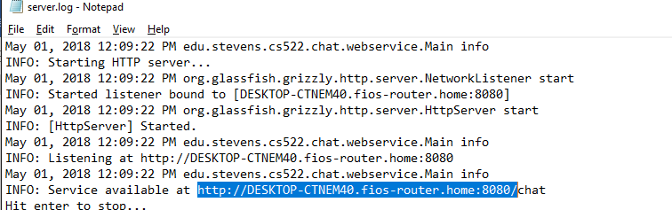

We need to use the ethernet address like 192.168.1.63:8080.

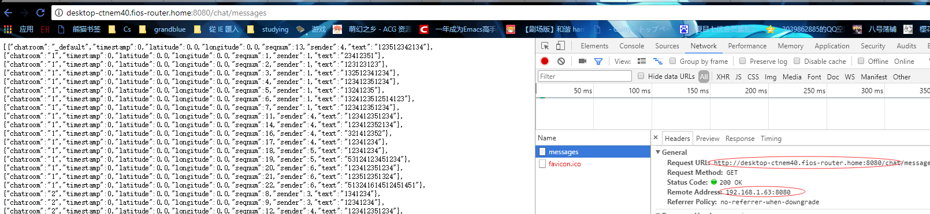

4thly, we need to make sure the json type is like this {"chatroom":"1","text":"123123123"}

The fields must be chatroom and text and they are case sensitive.