Junhao Du

Find the first solution in the folder named “Solution1”, the first kind of Treatment in the file “Treatment1.xsd”, and the each instance file named “instance1.xml”. So find the second solution in the folder named “Solution2” and so on.

Observation and Decision:

1. The element substitution is like the type substitution. They are very similar that the element substitution just extend the range of the substitution
2. Think about the relationship between primary key and foreign key of patient Id and Provider Id in the database. We need to consider the relationship among the treatments, patient and provider.

It deserves to think it over again.

Overview:

The UML class diagram:

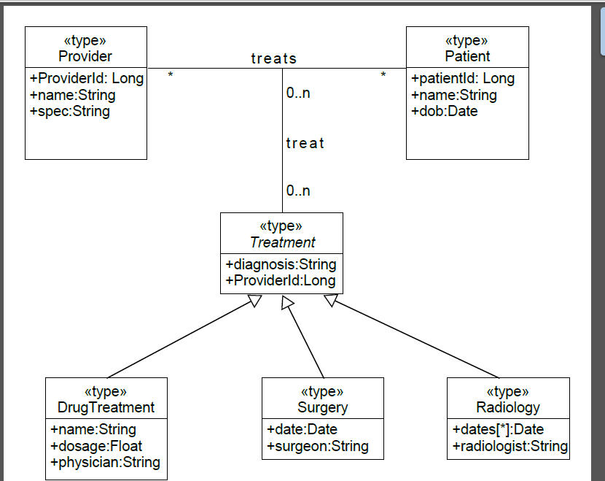

Schemas:

Clinic

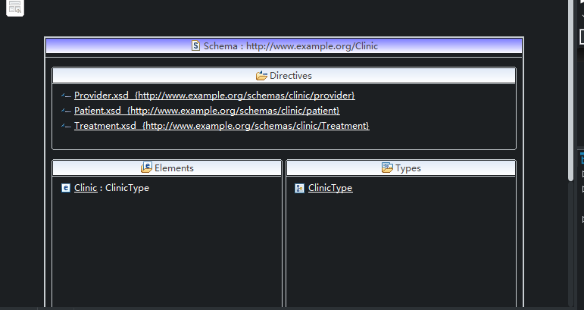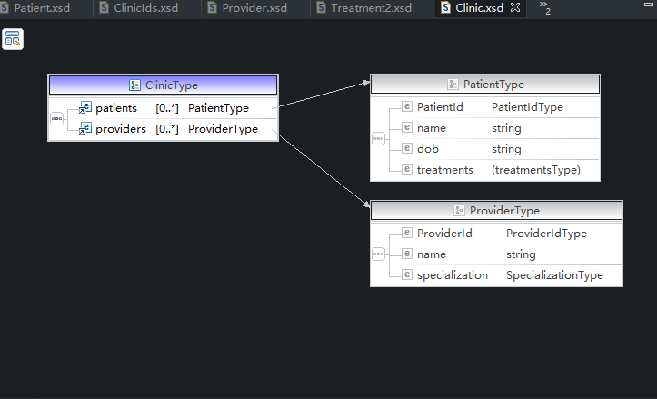

Clinic_Ids:

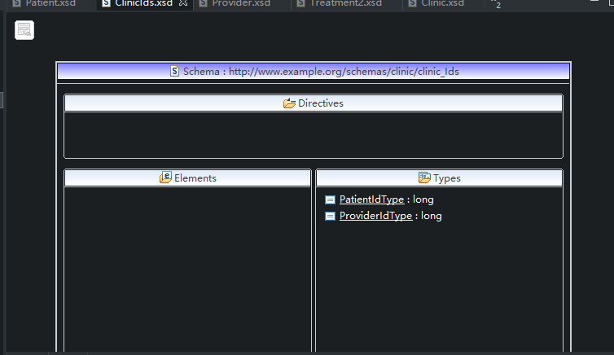Patient: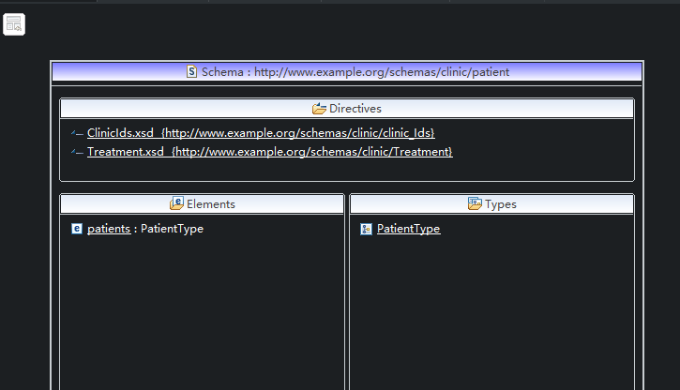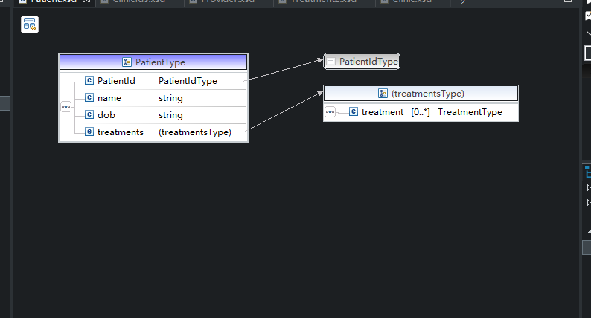

Provider: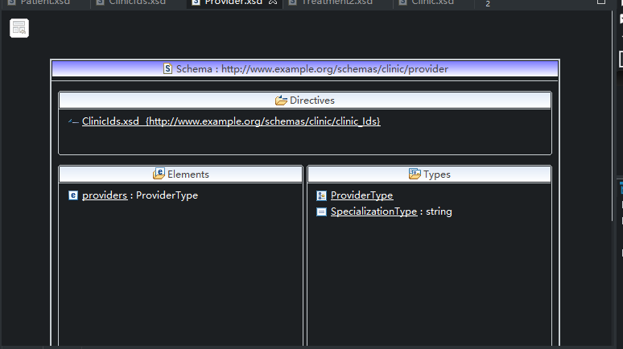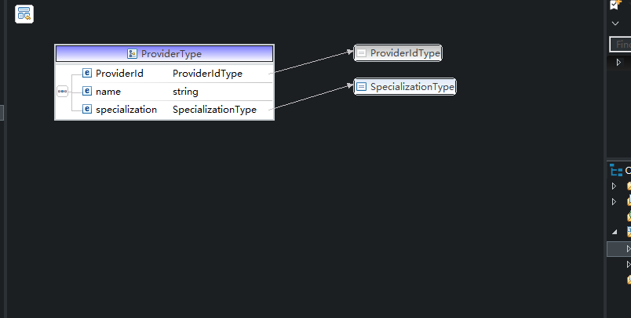

Treatment1: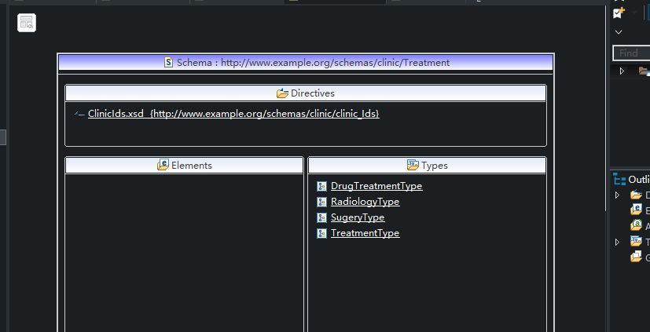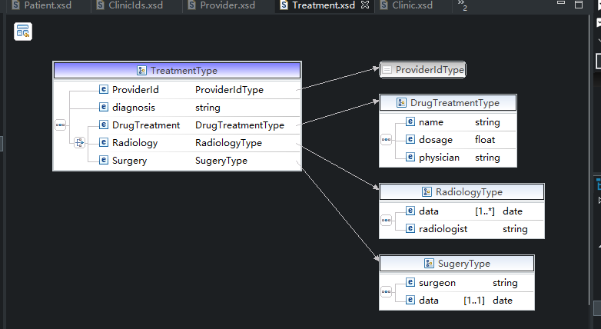

Treatment2:

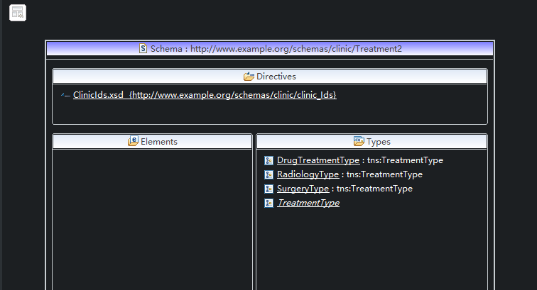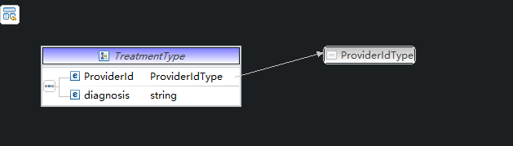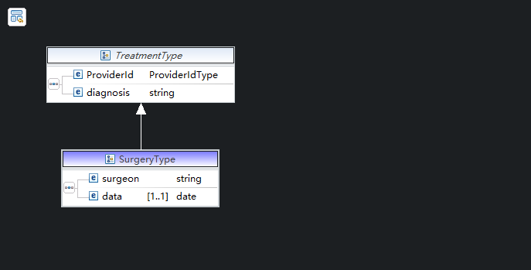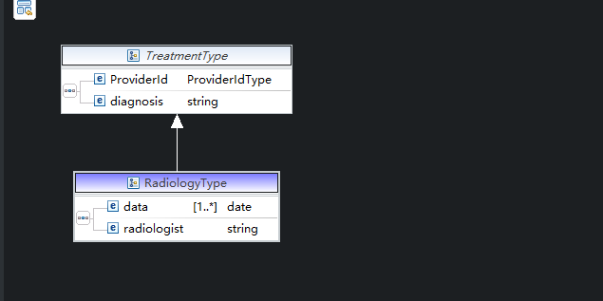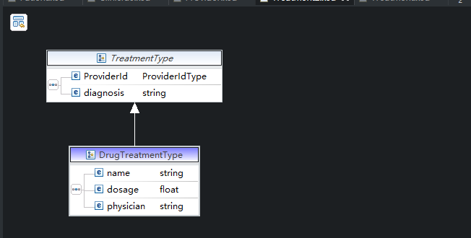

Treatment3: 