Junhao Du

**Project Files location:/ftp**

**Video Location:/ftp.mp4**

**Jar Files Location: /RemoteJarFiles, /LocalJarFiles**

**Scripts Location: CMD.txt**

**Something Deserved to be mentioned:**

**1)**

/*

* TOD: Get a server proxy.

*/

Registry registry=LocateRegistry.*getRegistry*(serverIp, serverPort, **new** ClientRMISocketFactory());

IServer server=(IServer) registry.lookup("//"+serverIp+":"+serverPort+"/"+serverName);

Through Google, I find that the RMI need the address like the code above.

**2)**

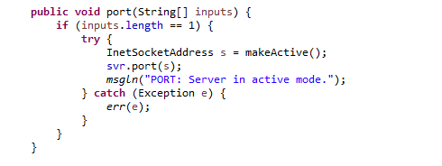

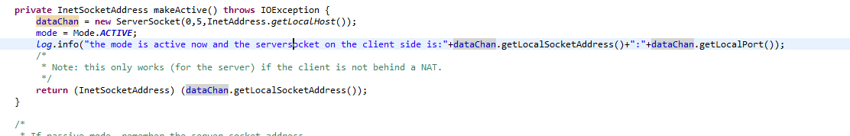

On the client side, to makeActive, I find that the original code:

New ServerSocket(0) is not effective because the AWS EC2 Linux is behind a NAT by default, So I must to set the the IP Address as the localhost on my ec2 manually.

**3)**

jar xf ftpd.jar ftpd.sh server.policy

bash ftpd.sh --serverIp 172.31.27.217 --serverPort 5050

jar xf ftp.jar ftp.sh client.policy

bash ftp.sh --clientIp 172.31.46.40 --serverAddr ip-172-31-27-217.ec2.internal --serverPort 5050

bash ftp.sh --clientIp 172.31.46.40 --serverAddr 172.31.27.217 --serverPort 5050

Through Google, I find that the aws ec2 interact themselves throught the Intranet. So if we set the ip as the ethernet, it doesn’t work at all.

But we can also have 2 aws account, and own the 2 ec2 separately. And then we need to make sure the security group is like for example: 111122223333/OtherSecurityGroup.

