Junhao Du

**Project Files location:/** **Assignment2-Resources.zip/Assignment2-Code**

**Video Location:/ Assignment2-Resources.zip/ assignment2.mp4**

**Jar Files Location: /dht.jar**

**Scripts Location: script.txt**

**Rubric location:/** **Assignment2-RESTful-DHT-rubric.pdf**

**Something Deserved to be mentioned:**

**1)**

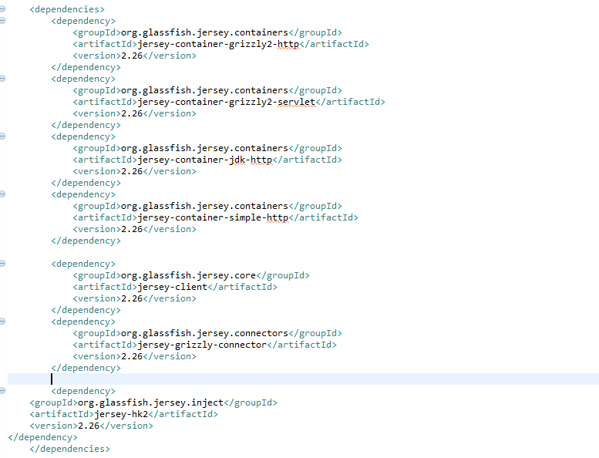

The original dependencies of this maven project is 2.27, but we need to downgrade to 2.26 after I met some problems and googled it.

2) 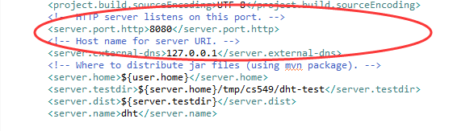

In the pom file, we can add these properties so that we can debug it locally without overriding the options.

3) 

The options in the rubric are like the picture above, but we need to override 3 options like the codes below.

