Junhao Du

**Project Files location:/** **Assignment3-Resources.zip/Assignment3-Code**

**Video Location:/ Assignment3-Resources.zip/ assignment3.mp4**

**Jar Files Location: /dht.jar**

**Scripts Location: script.txt**

**Rubric location:/** **Assignment3-RESTful-DHT-rubric.pdf**

**Something Deserved to be mentioned:**

**1)**

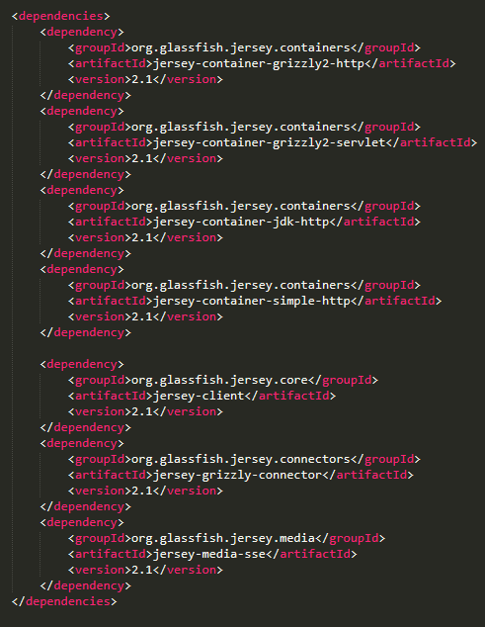

The original dependencies of this maven project is 2.23.1, but I downgrade it to 2.1 after I met some problems and googled it.

After I find this hints, it works：

**2)**

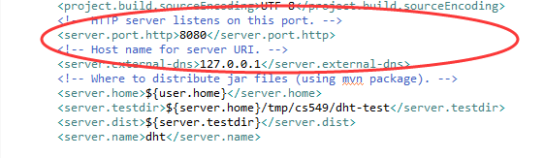

In the pom file, we can add these properties so that we can debug it locally without overriding the options.

**3)** 

The options in the rubric are like the picture above, but we need to override 3 options like the codes below.

