Junhao Du

**Project Files location:/** **Assignment4-Resources.zip/Assignment4-Code**

**Video Location:/ Assignment4-Resources.zip/ assignment4.mp4**

**Jar Files Location: /dht.jar**

**Scripts Location: CMD.txt**

**Rubric location:/** **Assignment4-Websockets-rubric.pdf**

**Something Deserved to be mentioned:**

**1)**

In this assignment, we should use the public DNS for the ec2 instead of the private IP previously like this:

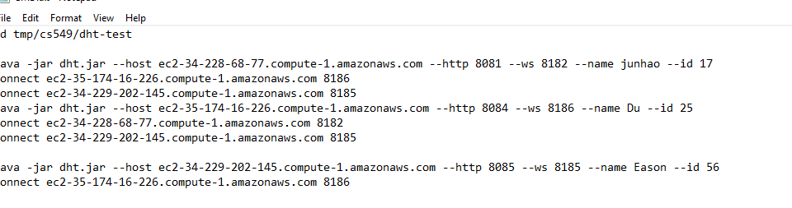

Because we use the websocket to connect each others.

**2)**

The most important part of this assignment is the websocket annotation.

Without the annotation in the ControllerServer.class, it doesn’t work.

