Junhao Du

**Codes Position:** / codes

**Pictures Position**: /results

**Explaination:** /README.pdf

**Observation:**

As the rubric, I have 4 functions: KMeans (),MySLIC (), GetGradient (), localShift ()

1)The KMeans function is for the problem 1.

2)MySLIC function is for the problem 2 and it uses the localShift function to get the point within 3*3 pixels with local minimum gradient.

**The most important** thing is that after I searched the paper through google. I found there’s another equation working better in CIE-LAB space than the equation in the RGB space provided by the requirement.

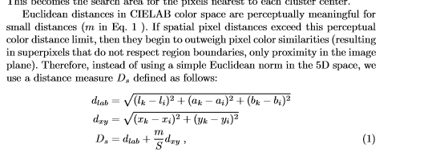

I also implement the equation provided by the requirement like the following but finally I comment it.



3)The localShift function uses the GetGradient function.

4)The GetGradient function is to compute the gradient of this pixel. Using the following equations:

**I**x(x,y) =**I**(x+1,y) - **I**(x-1,y)

**I**y(x,y) =**I**(x,y+1) -**I**(x,y-1)

**M**(x,y) = sqrt(**I**x(x,y)\***I**x(x,y) +**I**y(x,y)\***I**y(x,y) )

The source of the paper: 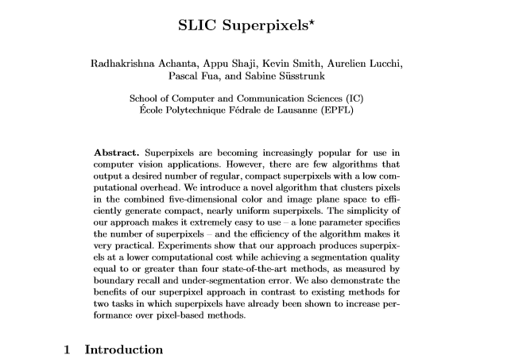

Results: D:\OneDrive - stevens.edu\universityGraduate\CS558ComputerVision\Assignments\assignment3\documents\results\Kmeans.tif D:\OneDrive - stevens.edu\universityGraduate\CS558ComputerVision\Assignments\assignment3\documents\results\SLIC with better equation.tif