Junhao Du

1.

Solution:

U(Win, bet)=W-B

U(lose, bet)=L-B

So U(bet)=Pw*U(win, bet)+Pl*U(lose, bet)

=Pw*(W-B)+(1-Pw)*(L-B)

If U(bet)>0 we would like to bet so

U(bet)>0🡺 Pw*(W-B)+(1-Pw)*(L-B)>0

Pw*W-Pw*B+L-B-Pw*L+Pw*B>0

Pw*W+L-B-Pw*L>0

Because W>L

Pw>(B-L)/(W-L)

2.

Solution:

For the green wallet, the probability to pull a dime followed by two pennies= (4/10) x (6/9) x (5/8) = 120/720=1/6

For the black wallet, the probability pulled a dime followed by two pennies= (2/10) x (8/9) x (7/8) = 112/720

**. Which wallet were you more likely to have picked if you pulled a dime followed by two pennies from it?**

For this question:

We assume that the probability to use one of the wallets is same and equal to ½=50%;

So:

For the green wallet, the P=

(0.5*(120/720))/(0.5*(120/720)+0.5*(112/720))=120/(120+112)= 0.517241379

For the black wallet, the P=

(0.5*(112/720))/(0.5*(120/720)+0.5*(112/720))=112/(120+112)= 0.482758621

**.What is the probability that the optimal answer you gave in the previous question was wrong?**

Because we should consider about the past experience, the probability of using the wallet is not equal to ½=0.5

The Pb=1/5 and the Pg=4/5

So

For the green wallet, the P=

(4/5*(120/720))/(4/5*(120/720)+1/5*(112/720))= 0.810810811

For the black wallet, the P=

(1/5*(112/720))/(4/5*(120/720)+1/5*(112/720))= 0.189189189

3.

1).

function data=part1(mean,var,n)

data = mean+var.*randn(n,1);

figure(1)

plot(data);

I also attach my codes below

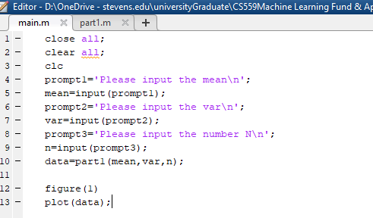

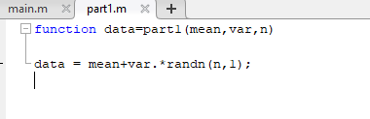

2).

We all know the function randn() generates datasets with a normal distribution.

So:

We all know the formula of variance:

formula and var=s

**Mean3= (2000*1+1000*4)/(2000+1000)=2**

Var1^2=∑(X1-1)^2/2000=2

Var2^2=∑(X2-4)^2/1000=3

Var3^2==∑(X3-mean3)^2/(n1+n2)

**Important:**

Var3^2=[n1(var1^2+mean1^2)+n2(var2^2+mean2^2)]/(n1+n2) -mean3^2

n1*var1^2=∑(X1-mean)^2

n2*var^2=∑(X2-mean)^2

Var3^2= [n1*var1^2+n2*var^2+n1*(mean1-mean3)^2+n2*(mean2-mean3)^2] /(n1+n2)

There’s a formula for the combined variance:

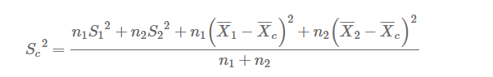(Picture is from www. Emathzone.com)

Apparently We can see that:

Var3^2=(2000*4+1000*9+2000*(1-2)^2+1000*(4-2)^2)/3000

=(8000+9000+2000+4000)/3000

=23/3

**So var3=sqrt(23/3)=2.77**

I also attach my Codes:

close all;

clear all;

clc

data1=part1(1,2,2000);

data2=part1(4,3,1000);

data3=[data1;data2];

figure(1)

histfit(data1,2000);

figure(2)

histfit(data2,1000);

figure(3)

histfit(data3,3000);

The following is my plots in matlab:

