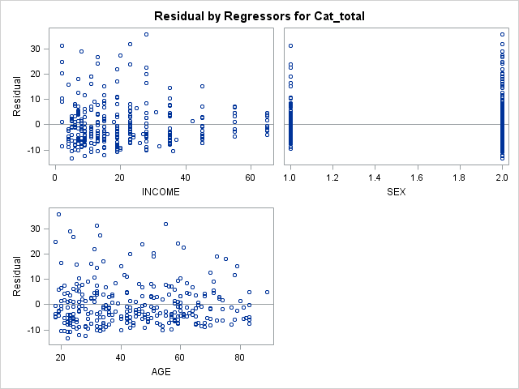

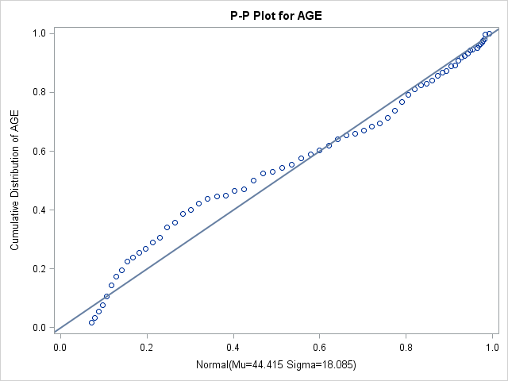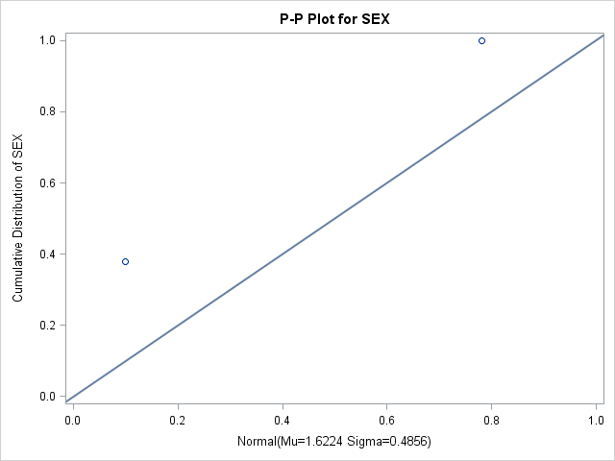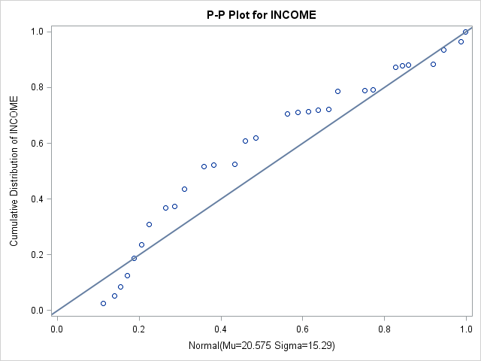

In a normal probability plot (also called a "normal plot"), the sorted data are plotted vs. values selected to make the resulting image look close to a straight line if the data are approximately normally distributed. (From the Wikipedia).

**As the picture above, we can say that the sex and income don’t follow the normal distribution.**

**But the age follows the normal distribution.**