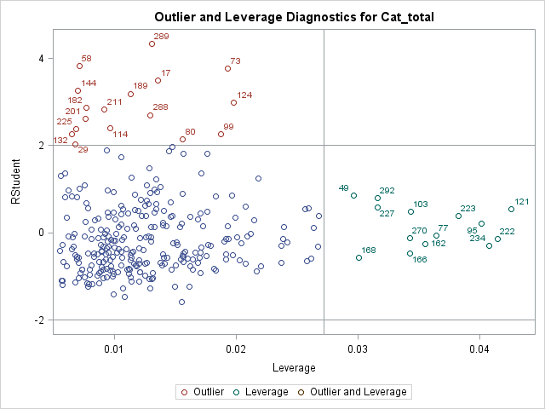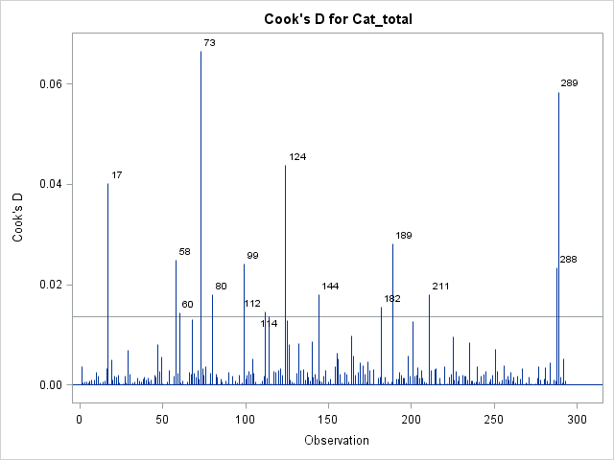

For the picture above, to remove the outliner, we delete the following 15 rows:

**17 58 60 73 80 99 112 114 124 144 182 189 211 289 288**