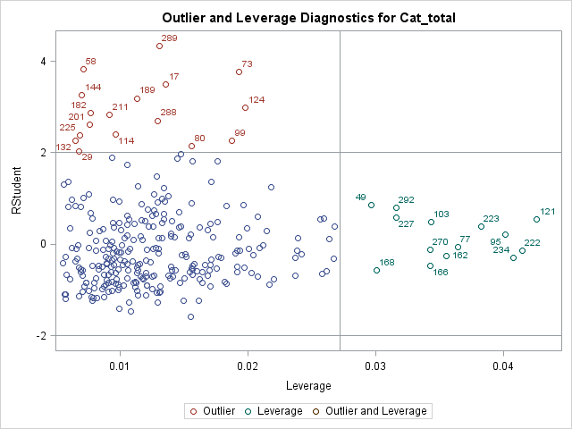

To remove the observations which have the most leverage, we delete the following 15 rows:

**49 292 227 168 103 270 166 77 162 223 95 234 222 121 43**

**We could also view it in this file**

|  |  |
| --- | --- |
| lev | ID |
| 0.042604 | 121 |
| 0.041481 | 222 |
| 0.04081 | 234 |
| 0.040179 | 95 |
| 0.038251 | 223 |
| 0.036429 | 77 |
| 0.0355 | 162 |
| 0.034324 | 103 |
| 0.034274 | 166 |
| 0.034274 | 270 |
| 0.031624 | 292 |
| 0.031573 | 227 |
| 0.030059 | 168 |
| 0.029632 | 49 |
| 0.026767 | 43 |