Author: Oghenekevwe Jeffery Onodje
Title: Confidentiality and Integrity in Cybersecurity (Encryption and Hashing)
Tools Used: Command Prompt, OpenSSL, SHA256
Date: 7th May, 2026

Objective: To show a real-world application of Confidentiality and Integrity, two of the core principles of Cybersecurity.

METHODOLOGY: A private hospital record was created by a company for a hypertension study. This record contained both Sensitive Personally Identifiable Information (SPII) and Personal Health Information (PHI) hence, it has to be secured properly. The Hospital implemented two cryptographic controls:
- The file was hashed using SHA256 to ensure Integrity
- The file was encrypted using OpenSSL to ensure Confidentiality

PROCESS (WITH EVIDENCE):
- The hospital record was located on command prompt
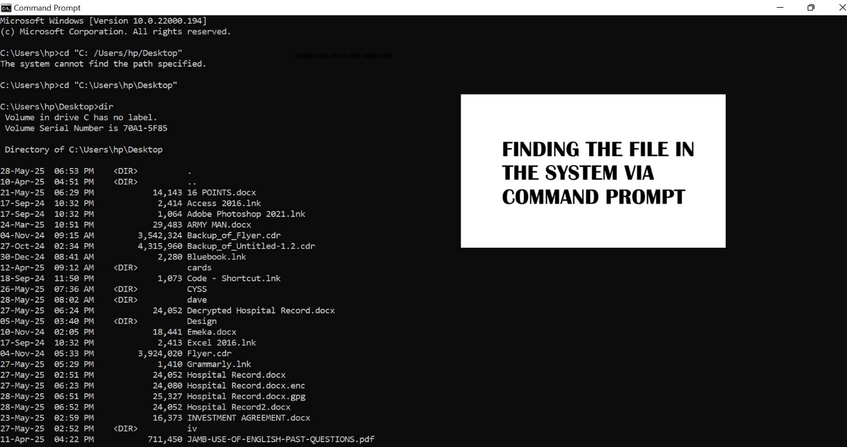

- A Hash-file was then created using SHA256
Note: SHA256 was selected because it is a cryptographic hash function from the SHA-2 family and is widely used for integrity verification due to its collision resistance and strong security properties.

Command: certutil -hashfile “Hospital Record.docx” SHA256
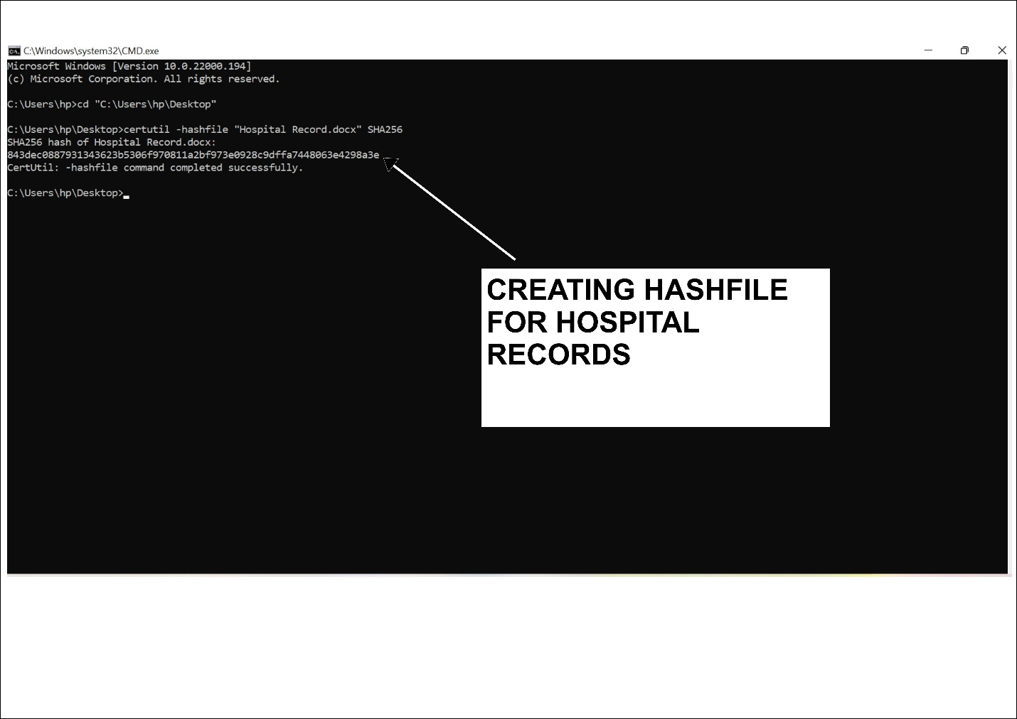
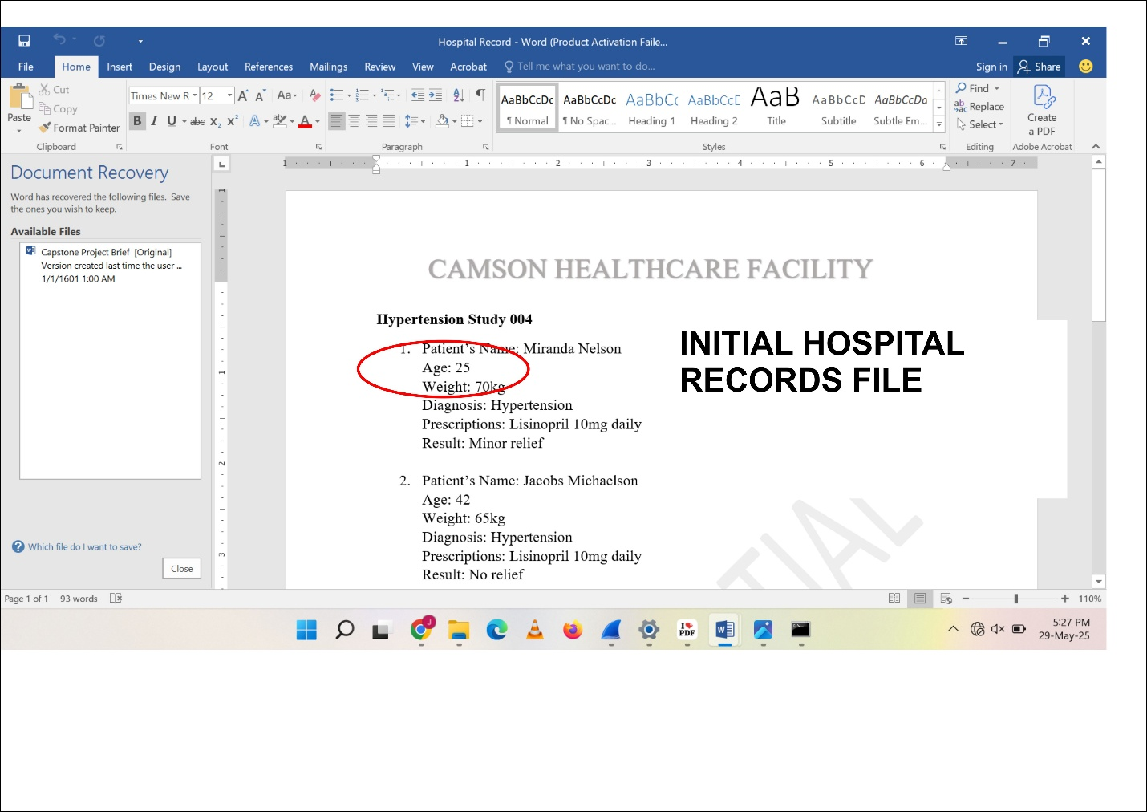
- To test the integrity of hashing; the hash value was checked when there was no change to the file and then checked again when a slight change was made to the file.

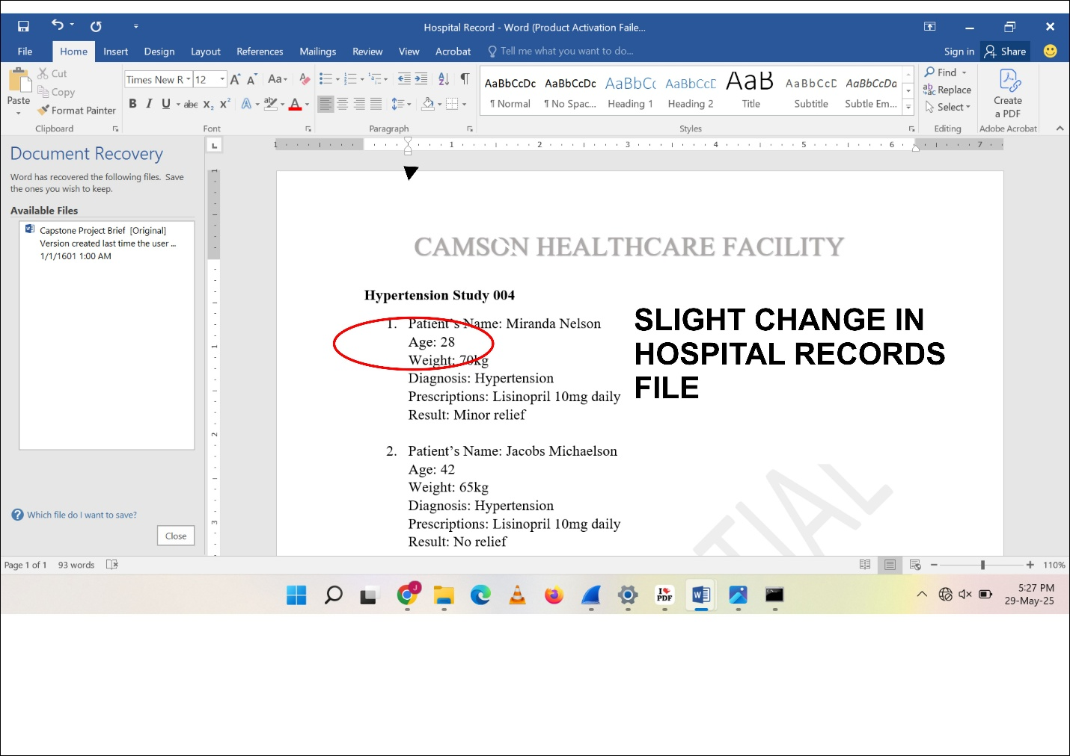
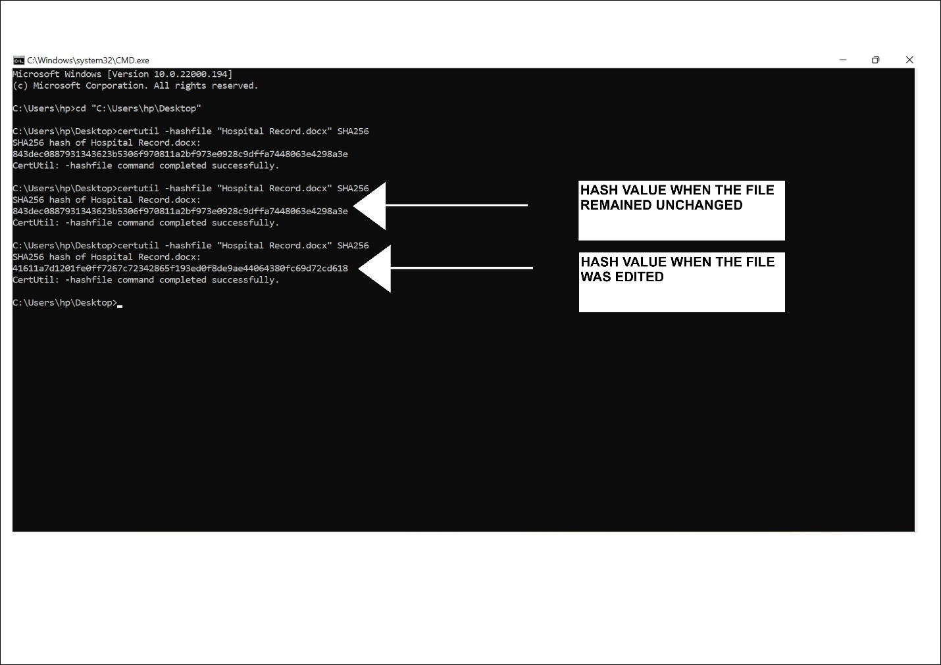
As depicted in the images above, the hash value remains unchanged in the first instance when there was no change to the file. But when the file was altered slightly, the hash value completely changes. This lets the hospital to detect if the file was altered by an unauthorized personnel.
- To prevent unauthorized access to the file (ensuring confidentiality), the file was encrypted using OpenSSL encryption.
Command: openssl enc -aes-256-cbc -salt -in "Hospital Record.docx" -out "Hospital Record.docx.enc"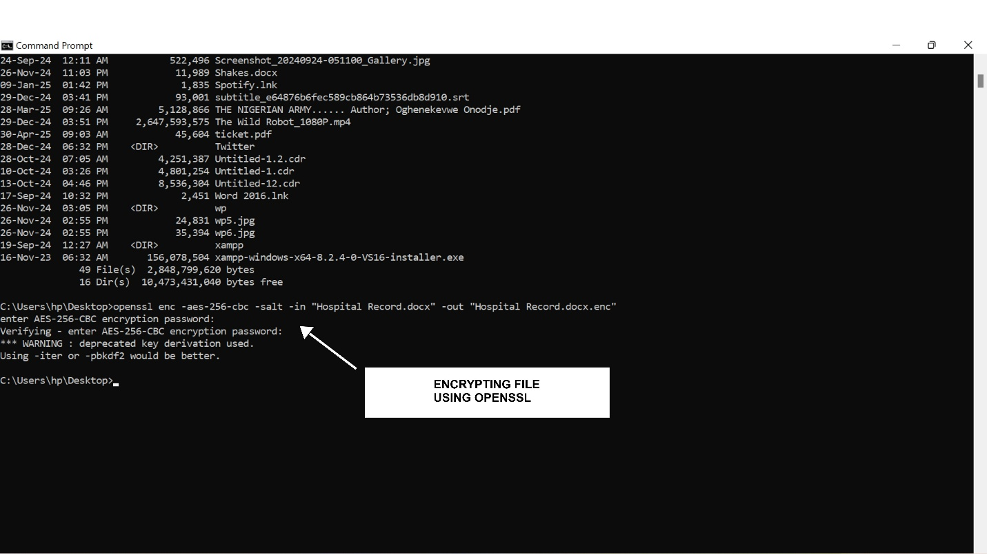
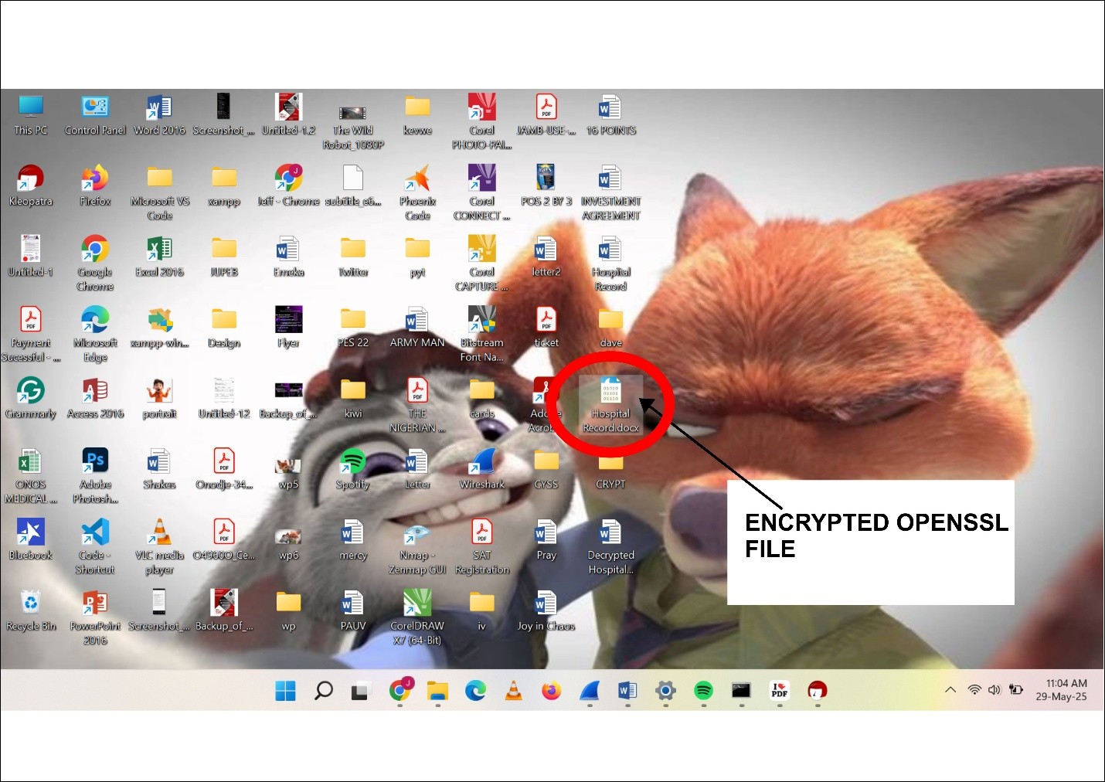

The encrypted file becomes ciphertext and cannot be interpreted without the decryption key/password.
- An authorized user can decrypt the file using the decryption key.
Command: openssl enc -d -aes-256-cbc -in "Hospital Record.docx".enc -out "Hospital Record.docx"
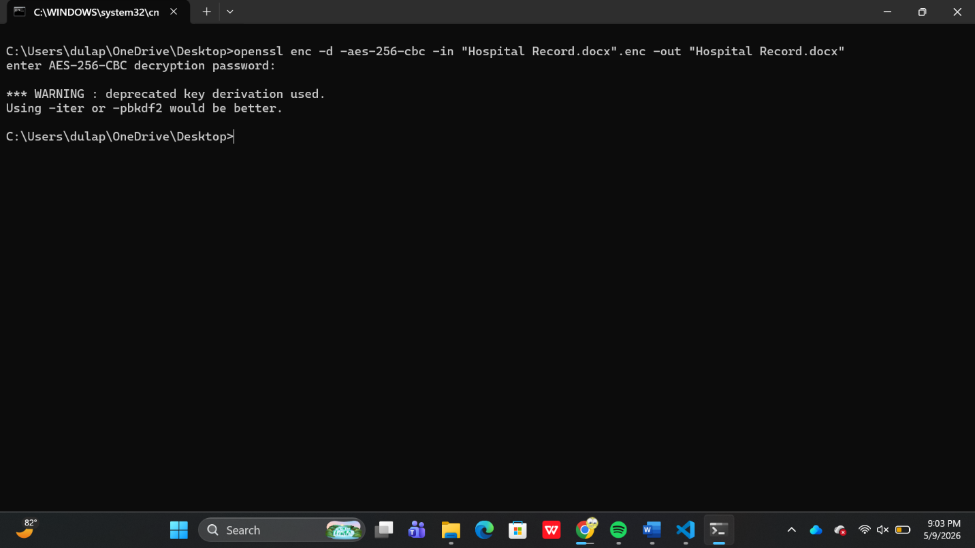
DIFFERENCE BETWEEN HASHING AND ENCRTPYION
Feature | Hashing | Encryption
Purpose | Integrity | Confidentiality
Reversible? | No | Yes
Uses key? | No | Yes
Output | Hash value | Ciphertext

SECURITY ANALYSIS:
The CIA triad is highly revered in all companies that deal with data, especially institutions like Hospitals that handle Sensitive Personally Identifiable Information. There is a myriad of damages that an attacker can cause if he gets his hands on sensitive information. Some of the attacks include but are not limited to:
- identity theft
- financial fraud
- unauthorized disclosure of PHI/SPII
- compliance violations
- reputational damage
- ransomware targeting healthcare institutions
Hence, encryption and hashing are very important in preventing such attacks.
Confidentiality depicts that information must be kept safe from unauthorized users, while integrity is concerned with the accuracy of the information i.e making sure the data is not falsely altered. Hashing and encryption are just two of the multiple ways of upholding the CIA triad; in a real-world scenario there are a host of other protection techniques like using secure passwords, multi-factor authentication, biometric authentication etc.

CONCLUSION
One of the core aspects of cybersecurity is keeping data accurate and secure. This project clearly highlights two ways in which that feat can be achieved. Encryption ensures the security of data (confidentiality), while hashing ensures its accuracy (integrity).

FUTURE WORK
- Compare MD5, SHA1, and SHA256 security differences
- Demonstrate digital signatures
- Integrate file integrity monitoring

