FIN3080 HW3 REPORT

Q1:

1. Data processing:
2. Download the closing index and manually filter the CSI 300 index, and calculating the monthly return of the index
3. Then I calculate the mean, std, skewness, and kurtosis of the monthly return.
4. Then I use matplotlib to draw the histogram
5. Report and Discussion:

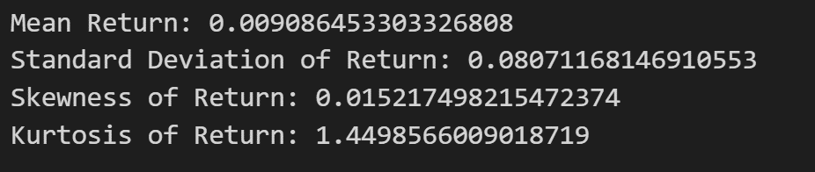

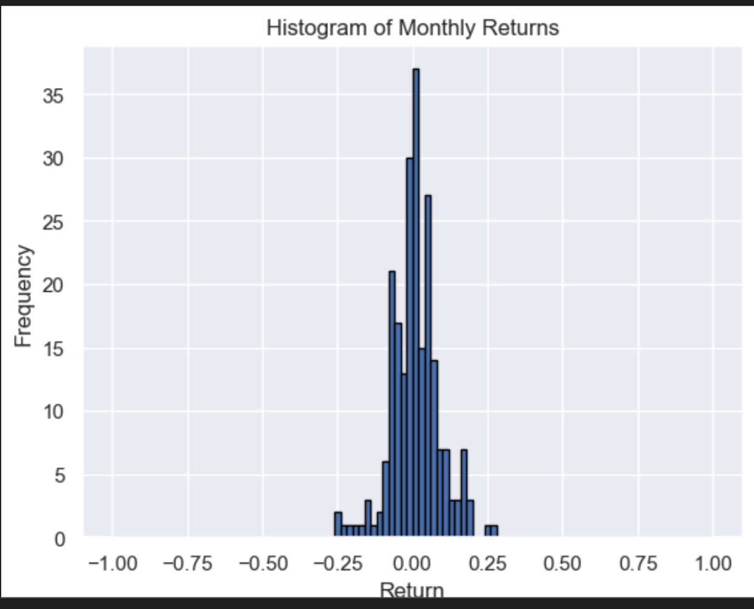

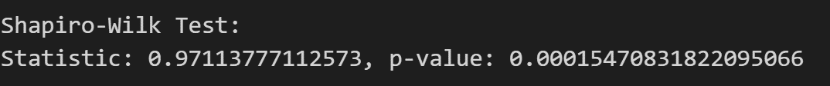

1. The monthly returns of the CSI 300 index follow a normal distribution.
2. As depicted in the picture, the frequency of monthly returns are similar to a normal distribution. The skewness and Kurtosis are about 0 and 1~3.
3. The Shapiro_wilk Test’s result: The p-value < 0.05.

Q2:

1. Data processing:

1 Download the weekly return data and filter the main-board A-shares.

2.Calculate the weekly market return by grouping all the main_board A-shares.

3. Download the risk_free xlsx. And merge these two table.

4. Divide the week into 3 equal groups.

5. Fill the nan value of return with the mean value.

6. For group 1 data, do the first regression and get the beta value.

7. Based on the beta value for the group1 , divide the shares into 10 equal groups.

8. For group 2 data, calculating the mean value of each group in each week to get the rp. Then I do the second the regression to get the Table 2 and new beta value for each group.

9. For group 3 data, calculating the rp and calculate the mean of rp of each group. Then, I do the third regression to get the Table 3 .

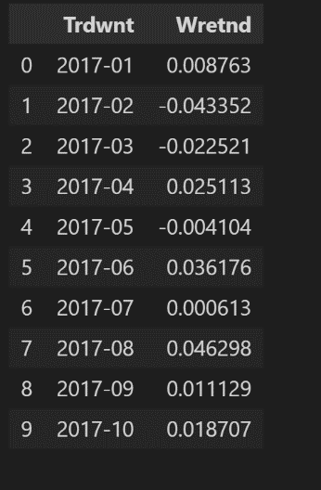

Report Table:

b mean value of weekly return: head(10) rows

Table 2

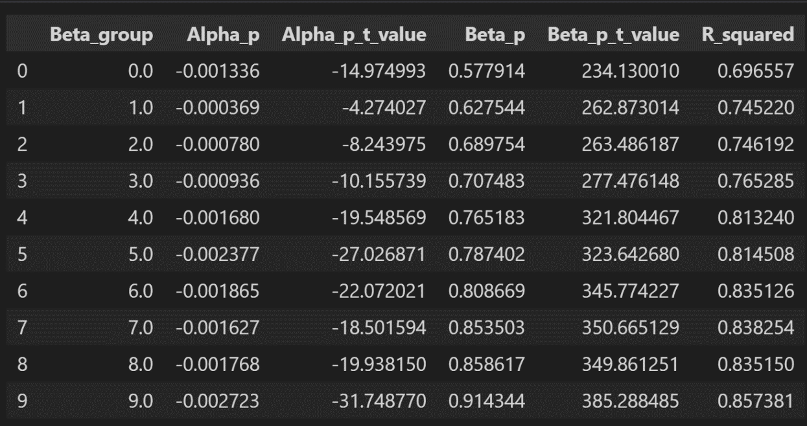

Table 3



From Table 3, we know that the value of F_statistic is 15.286512, and the value of P_value is 0.004482. This means that the F statistic is relatively large, and the corresponding P-value is small, far less than the significance level of 0.05, so it can be concluded that the model is significant. The return is positively correlated with the system risk. The results show that the return increases with the increase in risk, which is consistent with the CAPM model. The constant γ0 is non-zero, indicating the presence of Factors other than systemic risk.